Supplementary Information for Campbell et al.

Terrestrial sensitivity to abrupt climate changes recorded by aeolian activity in northwest Ohio, U.S.A.

Optically stimulated luminescence (OSL) methodology

Samples were processed at the Luminescence Geochronology Lab in the Department of Geosciences at the University of Nebraska–Lincoln. All samples except UNL2450 were collected a little less than 1 m depth by driving 15 cm long x 7.5 cm diameter sections of aluminum tubing into hand excavated pits or sand pit excavations. Locations are listed in Table S1. To minimize contamination with younger sand through pedogenesis or bioturbation, samples were taken from within the C horizon. Additional samples were taken within 30 cm of the sampling tube for determination of water content and for chemical analysis (Table S2). In-situ water content was measured by weight loss upon drying at 100°C. Elemental concentrations (U, Th, K) for the calculation of the dose rate (Aitken, 1998) were determined by ICP-MS, ICP-AES, and XRFS at Chemex Laboratories, Sparks, Nevada (UNL1913–1916), Activation Laboratories Ltd., Ancaster, Ontario (UNL2102–2106), or by high-resolution gamma spectrometry at the University of Nebraska-Lincoln (U, Th, K; UNL2450–2451). The cosmic ray contribution to the dose rate was calculated from Prescott and Hutton (1994). The dose rate and associated errors were calculated using the methods and data from Aitken and Alldred (1972), Aitken (1976, 1985), Adamiec and Aitken (1998), Aitken (1998), and Brennan (2003).
Samples were opened in the laboratory under dim amber light and the outer ~5 cm of sediment removed from the ends of the tube to avoid contamination by bleached grains. The remaining sample was wet sieved to isolate the 90–150 or 150–250 μm fraction, treated with 1N HCl to remove carbonates, 30% hydrogen peroxide to remove organics, and, if necessary, a citrate-dithionite-bicarbonate (CBD) solution to remove iron oxide staining.
Quartz and feldspar was separated from heavy minerals by flotation in sodium polytungstate (ρ = 2.7 g/cm³). Quartz grains were etched and feldspars removed by 60 minutes agitation in 48% HF. Samples were rinsed, dried, and resieved to remove the <90 or <150 μm fraction. Quartz grains were mounted on aluminum disks with a 5 mm mask (~1000 grains per disk) or 2 mm mask (~200 grains per disk) using silicon spray. Infrared stimulation was used to check for feldspar contamination. Optical measurements were performed on a Risø TL/OSL-DA-15B/C reader with blue-green light stimulation (470 nm), Hoya U-340 filter and a ⁹⁰Sr beta source (80mCi) providing ~0.25 Gy/s. Equivalent doses were determined using the single aliquot regenerative (SAR) protocol (Murray and Wintle, 2000). Four regenerative doses were used to bracket the natural signal, with the fourth dose being a repeat of the first regenerative dose. Regenerative growth curves were fit with saturating exponential, or saturating exponential with linear component equations to estimate the equivalent dose. Test doses were applied after measurement of the natural and regenerative signal to monitor and correct for changes in sensitivity. Errors on individual D_{e} determinations include an assumed 1% instrumental error (Duller, 2007), statistical counting errors, and calculated errors for the regression curve (Neter et al., 1996). To determine preheat parameters, preheat plateau tests were conducted on UNL1916 (Figure S1) and UNL2104, and dose recovery tests (Murray and Wintle, 2003) were performed on all samples (Table S3 and Figures S1 and S2). With the exception of UNL2450 and UNL2451 (±7%), dose recoveries were within 4%, and generally within 2% (Table S3 and Figure S2). A 240°C, 10 second preheat and 220°C cutheat were used, with optical measurements at 125°C. Optical ages were calculated using the Central Age Model (Galbraith et al., 1999). In D_{e} analysis, individual aliquots were accepted or rejected based on recycling ratios (<10%), test dose and/or D_{e} error (<10%), anomalous decay curves with strong intermediate components in the OSL signal indicating contribution from non-quartz sources, and IR decay curves (peak/background < 2). D_{e} frequency distributions (Olley et al., 1998, 1999), cumulative probability density function plots, and skewness and kurtosis values (Bailey and Arnold, 2006) were examined in order to detect potential partial bleaching. Results suggest partial bleaching is not a significant factor. Skewness and kurtosis values were found to be within limits set forth by Bailey and Arnold (2006) for usage of the Central Age Model. Use of models to account for non-normal distribution was deemed unnecessary. Representative probability density function and radial plots for samples UNL2104 and UNL2106 are shown in Figures S3 and S4. Representative decay and growth curves for UNL2104 are shown in Figures S5 and S6. Linear Modulation OSL data for the natural signal from UNL2104 (Figure S7) show the presence of a strong fast component; a similar curve prepared for a 15 Gy regenerative dose failed to detect the presence of an ultrafast component.
References

Adamiec, G. and Aitken, M.J., 1998. Dose-rate conversion factors update. Ancient TL 16, 37-50.
Aitken, M.J., 1976. Thermoluminescent age evaluation and assessment of error limits: revised system. Archaeometry 18, 233–238.
Aitken, M.J., 1985. Thermoluminescence Dating. Academic Press, London, 359p.
Aitken, M.J., 1998. An Introduction to Optical Dating: The dating of Quaternary sediments by the use of photon-stimulated luminescence. Oxford University Press, New York, 280p.
Aitken, M.J., Alldred, J.C., 1972. The assessment of error limits in thermoluminescent dating. Archaeometry 14, 257–267.
Bailey, R.M. and Arnold, L.J., 2006. Statistical modeling of single grain quartz De distributions and an assessment of procedures for estimating burial dose. Quaternary Science Reviews 25, 2475-2502.
Brennan, B.J., 2003. Beta doses to spherical grains. Radiation Measurements 37, 299–303.
Bulur, E., Botter-Jensen, L. & Murray, A.S. (2000): Optically stimulated luminescence from quartz measured using the linear modulation technique. Radiation Measurements 32, 407-411.
Duller, G.A.T. (2007): Assessing the error on equivalent dose estimates derived from single aliquot regenerative dose measurements. Ancient TL 25, 15-24.
Galbraith, R.F., 1988. Graphical display of estimates having differing standard errors. Technometrics 30, 271–281.
Galbraith, R.F., Roberts, R.G., Laslett, G.M., Yoshida, H. and Olley, J.M., 1999. Optical dating of single and multiple grains of quartz from Jinmium rock shelter, northern Australia. Archaeometry 41, 339-364.
Murray, A.S., Olley, J.M., 2002. Precision and accuracy in the optically stimulated luminescence dating of sedimentary quartz: a status review. Geochronometria 21, 1–16.
Murray, A. and Wintle, A.G., 2000. Luminescence dating of quartz using and improved single-aliquot regenerative protocol. Radiation Measurements 32, 571-577.
Murray, A.S. and Wintle, A.G., 2003. The single aliquot regenerative dose protocol: potential for improvements in reliability. Radiation Measurements 37, 377-381.
Neter, J., Kutner, M.H., Nachtsheim, C.J. & Wasserman, W. (1996): Applied Linear Regression Models, 3rd Edition. Irwin, Chicago.
Olley, J., Caitcheon, G. & Murray, A. 1998. The distribution of apparent dose as determined by optically stimulated luminescence in small aliquots of fluvial quartz: implications for dating young sediments. Quaternary Geochronology 17, 1033-1040.
Olley, J.M., Caitcheon, G.G. & Roberts, R.G. 1999. The origin of dose distributions in fluvial sediments, and the prospect of dating single grains from fluvial deposits using optically stimulated luminescence. Radiation Measurements 30, 207-217.
Prescott, J.R. and Hutton, J.T., 1994. Cosmic ray contributions to dose rates for luminescence and ESR dating: large depths and long-term time variations. Radiation Measurements 2/3, 497-500.

Table S1 Sampling Locations

# Field # Site Easting (m) Northing (m) Elev. (m)
1 WHOSL01 dune 17T 269507 4609398 198
2 WHOSL02 dune 17T 267333 4611267 207
3 WHOSL03 dune 17T 262399 4609413 205
4 WHOSL04 dune 17T 263214 4604275 206
5 MC08-05 strandline 17T 253099 4608863 222
6 MC08-06 dune 17T 252157 4603211 211
7 MC08-07 strandline 16T 743682 4621783 236
8 MC08-08 dune 17T 250305 4614313 229
9 MC08-10 dune 16T 740221 4618443 238
10 MC08-12 strandline 17T 266524 4609995 204
11 MC08-13 dune 17T 274192 4613580 199
12 Griffith Hines Pit strandline 17T 266524 4609928 206

Table S2 OSL Ages

# | UNL # | Burial | H2O | K2O | U | Th | Cosmic | Dose Rate | De | No. of | Age
 |  | Depth (m) | (%)* | (%) | (ppm) | (ppm) | (Gy) | (Gy/ka) | (Gy)** | Aliquots | (ka)***
1 | UNL1913 | 0.96 | 1.1 | 1.10 | 0.6 | 1.8 | 0.19 | 1.35±0.06 | 16.94±0.72 | 40 | 12.5±0.8
2 | UNL1914 | 0.95 | 1.4 | 1.14 | 0.6 | 1.9 | 0.19 | 1.39±0.06 | 17.11±0.68 | 41 | 12.3±0.8
3 | UNL1915 | 0.60 | 2.3 | 1.41 | 0.7 | 1.8 | 0.19 | 1.62±0.07 | 14.16±0.56 | 46 | 8.76±0.56
4 | UNL1916 | 0.90 | 1.9 | 1.19 | 0.6 | 1.7 | 0.19 | 1.41±0.06 | 17.66±0.66 | 48 | 12.5±0.7
5 | UNL2102 | 0.66 | 5.8 | 1.42 | 1.52 | 2.76 | 0.2 | 1.81±0.07 | 18.35±0.55 | 48 | 10.2±0.6
6 | UNL2103 | 0.65 | 4.2 | 1.65 | 0.81 | 2.05 | 0.20 | 1.81±0.07 | 18.14±0.57 | 46 | 10.0±0.6
7 | UNL2104 | 0.80 | 6.1 | 1.44 | 1.10 | 2.23 | 0.19 | 1.68±0.06 | 14.78±0.39 | 47 | 8.78±0.48
8 | UNL2105 | 0.56 | 7.8 | 1.55 | 0.65 | 1.77 | 0.20 | 1.61±0.06 | 18.91±0.56 | 39 | 11.7±0.7
9 | UNL2106 | 0.61 | 4.6 | 1.38 | 0.75 | 1.87 | 0.20 | 1.57±0.06 | 1.24±0.06 | 75 | 0.79±0.06
10 | UNL2450 | 2.05 | 3.4 | 1.53 | 0.99 | 1.82 | 0.16 | 1.38±0.07 | 19.46±0.65 | 44 | 14.1±1.0
11 | UNL2451 | 0.75 | 3.3 | 1.16 | 0.66 | 1.96 | 0.19 | 1.37±0.05 | 13.16±0.68 | 37 | 9.63±0.69

* In-situ Moisture Content; saturation moisture content of 25% assumed for UNL2450
** Error on De is 1 standard error
*** Error on age includes random and systematic errors calculated in quadrature

Table S3. OSL Age data
Dose Dose
UNL # Recuperation Recovery Recovery Skew/2σ_{c} Kurt/2σ_{k} Overdisp. CAM/Med CAM/PDF Fit CAM/Mode CAM/Ave
(%) (Rec/Appl) (+/-) (%)
UNL1913 1 1.02 0.02 0.1 -0.5 26 0.99 0.97 1.08 0.98
UNL1914 1 0.98 0.06 0.3 -0.6 24 1.04 1.00 1.02 0.99
UNL1915 1 0.98 0.05 0.4 -0.6 26 1.00 1.03 0.98 0.97
UNL1916 1 0.96 0.04 -0.2 -0.3 18 0.99 1.00 0.94 0.99
UNL2102 1 0.99 0.02 0.0 0.2 20 0.97 0.98 0.90 0.98
UNL2103 1 0.96 0.03 -0.1 -0.4 20 0.97 0.98 0.97 0.98
UNL2104 1 0.99 0.01 0.3 -0.3 18 0.98 1.00 0.96 0.99
UNL2105 1 0.97 0.01 0.5 -0.5 17 1.04 1.02 1.03 0.99
UNL2106 2 1.02 0.01 0.3 -0.7 39 0.99 0.99 1.29 0.96
UNL2450 1 1.07 0.03 0.7 -0.5 20 1.06 1.05 1.10 1.00
UNL2451 1 0.93 0.02 0.3 -0.1 29 0.99 1.02 0.85 0.99
CAM = Central Age Model
Med = Median
PDF Fit = Mean and standard deviation calculated for cumulative probability density function
Mode = Mode
Ave = Unweighted Mean.

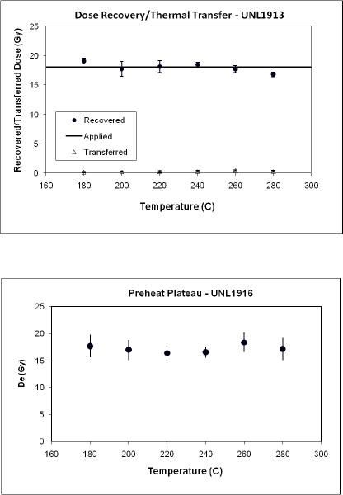
Figure S1. Dose recovery and thermal transfer for sample UNL1913 (top) and preheat plateau for sample UNL 1916 (bottom).

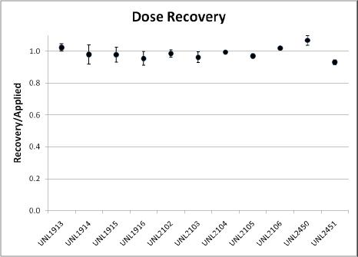
Figure S2. Dose recovery (Murray and Wintle, 2003) for all samples (1-sigma errors).

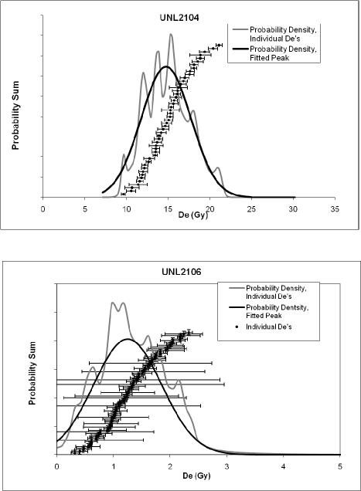
Figure S3. OSL D_{e} data and rank order plots for two representative samples (UNL2104 and UNL2106). Individual D_{e} values (n=47 and n=75, respectively) are shown as black squares (±1 standard deviation). The summed probability density function based upon the individual D_{e} values (±1 standard error) is shown as the grey line. The probability density function fit to a mean D_{e} and standard deviation is shown by the black line.

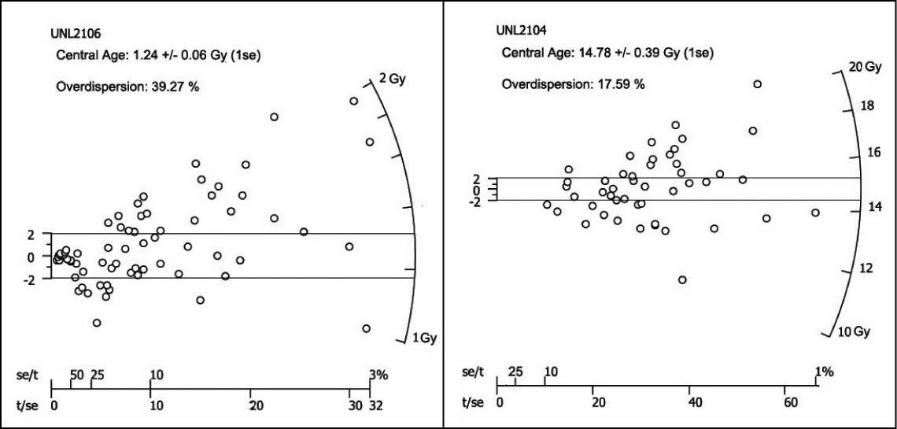
Figure S4. Radial plots (Galbraith, 1988) for UNL2106, 2104 Horizontal lines represent the ±2 standard deviation. Overdispersion was calculated as per Galbraith et al. (1999).

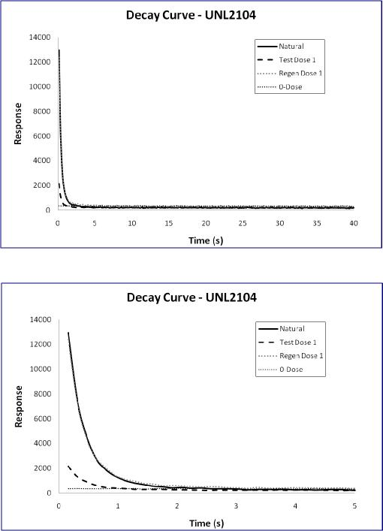
Figure S5. Example decay curves for samples UNL2104 (40s and initial 5 s).
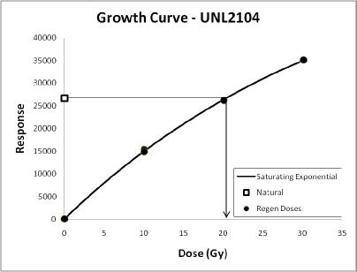
Figure S6. Example growth curve for sample UNL2104.

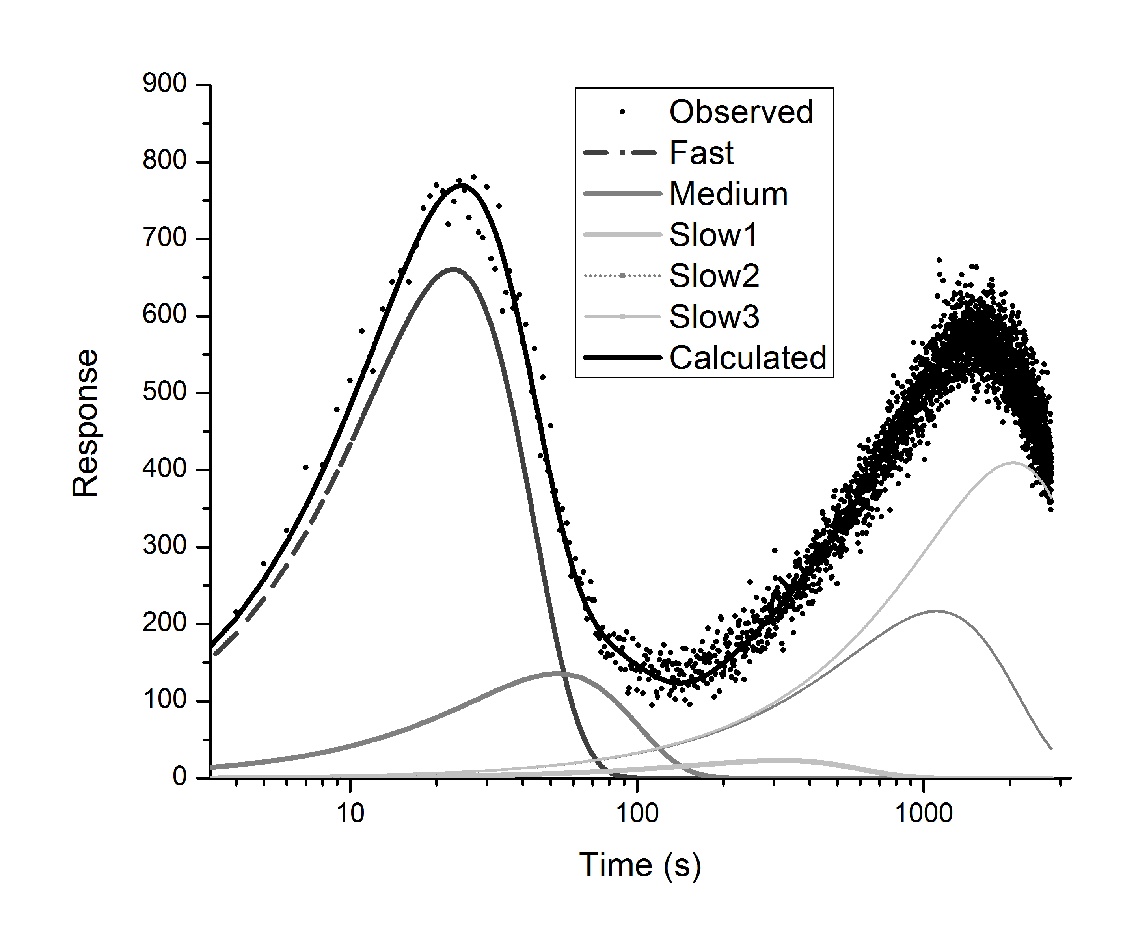
Figure S7. LM-OSL data (0–100% power) for the natural signal from sample UNL2104. The calculated curve (Bulur et al., 2000) uses five components. LM-OSL data collected following a 15 Gy regenerative dose are virtually identical, with no evidence of an ultrafast component.

