Supplementary Information for Loope et al., Early Holocene dune activity linked with final destruction of glacial Lake Minong, eastern Upper Michigan, USA

Table 1 contains geographic coordinates of OSL sample sites and core locations

Optically stimulated luminescence (OSL) methodology

All samples were collected at 1 m depth by driving 20 cm x 7.5 cm sections of aluminum tubing into vertical walls of soil pits or road cuts. Samples were taken from the C horizon in order to minimize effects of pedoturbation and/or pedogenesis. Additional samples were taken within 30 cm of the sampling tube for determination of water content and for chemical analysis. In-situ water content was measured by weight loss upon drying at 100ºC. Elemental concentrations (U, Th, K, Rb) for the calculation of the dose rate (Aitken, 1998) were determined by ICP-MS, ICP-AES, and XRFS at Chemex Laboratories, Sparks, Nevada. The cosmic ray contribution to the dose rate was calculated from Prescott and Hutton (1994). The dose rate and associated errors were calculated using Aitken and Alldred (1972), Aitken (1976, 1985), Adamiec and Aitken (1998), Aitken (1998), and Brennan (2003).
Samples were processed at the Luminescence Geochronology Lab in the Department of Geosciences at the University of Nebraska–Lincoln. Samples were opened under dim amber light and the outer ~5 cm of sediment was removed from the ends of the tube to avoid contamination by bleached grains. The remaining sample was wet sieved to isolate the 90–150 μm fraction, treated with 1N HCl to remove carbonates and a citrate-dithionite-bicarbonate (CBD) solution to remove iron oxide staining.
Quartz and feldspar was separated from heavy minerals by flotation in sodium polytungstate (ρ = 2.7 g/cm³). Quartz grains were etched and feldspars removed by HF (10% and 48%) and H₂SiF₆ (23%) treatments and samples were resieved to remove the <90 μm fraction. Quartz grains were mounted on aluminum disks with a 5 mm mask (~1000 grains per disk) using silicon spray. Infrared stimulation was used to check for feldspar contamination. Optical measurements were performed both on a Risø TL/OSL-DA-15B/C reader with blue-green light stimulation (470 nm) and Hoya U-340 filter and a Daybreak Nuclear and Medical Systems OSL/TL reader (Model 1100) with blue-green light stimulation, EMI 9635Q photomultiplier, UG-11 filters, and a ⁹⁰Sr beta source (100mCi) providing ~0.05 Gy/s. Equivalent doses were determined using the single aliquot regenerative (SAR) protocol (Murray and Wintle, 2000). Four regenerative doses were used to bracket the natural signal, with the fourth dose being a repeat of the first regenerative dose. Regenerative growth curves were fit with quadratic, saturating exponential, or saturating exponential with linear component equations to estimate the equivalent dose. Test doses (~2 Gy) were applied after measurement of the natural and regenerative signal to monitor changes in sensitivity. To determine preheat parameters, a preheat plateau test was conducted on UNL819 (Figure 1). A dose recovery test (Murray and Wintle, 2003) was also performed on UNL819 (Figure 1). A 260°C, 10 second preheat and 220°C cutheat were used in this study and optical measurements were made at 125°C. Optical ages were calculated using the mean of the D_{e} distribution for each sample (two examples in Figure 2 [UNL819 and UNL1215]). In D_{e} analysis, individual aliquots were accepted or rejected based on recycling ratios (above ±10%) (Murray and Olley, 2002), test dose and/or D_{e} error (>10%), anomalous shine-down curves indicating contribution from non-quartz sources or intermediate/slow components of the OSL signal. D_{e} frequency distributions (Olley et al., 1998, 1999), cumulative probability plots, plots of standardized D_{e} vs. signal intensity (Colls et al., 2001), and D_{e}(t) plots (Bailey et al., 2002) were analyzed in order to detect potential partial bleaching. These results suggest partial bleaching is not a significant factor in the age determination of eolian sand in eastern Upper Michigan. Skewness and kurtosis values were found to be within limits set forth by Bailey and Arnold (2006) for usage of the mean D_{e} or central age model. Use of models to account for non-normal distribution was deemed unnecessary. The variability of dose rate among the 21 samples (Table 1 in primary paper) is likely a result of variable mineralogy since sediment source is broad (derived mainly from glacial sediment sourced from the Canadian Shield). Optical ages in this study are reported as years before 2004 (±1 standard deviation).

Table 1. Geographic coordinates (NAD83 datum) of OSL sample sites (1-21) and core sites (Clark Lake and Goose Marsh).

Lab Number (UNL) Site Number Site Name Latitude (°N) Latitude (°W)
819 1 West Branch Hill 46°39.15' 85°32.61'
696 2 Stuart Lake 46°35.50' 85°30.59'
659 3 Little Lake Hill 46°43.03' 85°21.20' 666 4 Benchmark 715 46°38.03' 85°21.70'
662 5 Swamp Lakes 46°36.69' 85°22.22'
660 6 Roadcut 46°36.49' 85°20.61'
661 7 Big Hill 46°35.62' 85°20.36'
695 8 Big Tree 46°35.69' 85°18.86'
877 9 Tahq Falls 1 46°35.63' 85°15.07'
580 10 Browns Lake Rim 46°44.82' 85°12.94'
575 11 Maple Block North 46°42.00' 85°10.88'
578 12 Bearadise 46°41.03' 85°11.32'
577 13 Brooks Lane 46°40.79' 85°10.52'
665 14 Paradise 46°38.14' 85°03.88'
697 15 Camp 10 46°33.99' 85°08.40'
579 16 Vermilion Rod and Gun 46°44.57' 85°12.52'
876 17 Ladue Lake 46°34.24' 85°42.82'
875 18 Whorl Pond 46°30.02' 85°40.90'
825 19 Tahq Falls 2 46°34.75' 85°16.74'
- 20 Bear Lake 46°42.49' 85°12.05'
1215 21 Speedway 46°29.96' 84°29.33'
-- -- Clark Lake 46°37.13' 85°14.21'
-- -- Goose Marsh 46°39.07' 85°10.93'

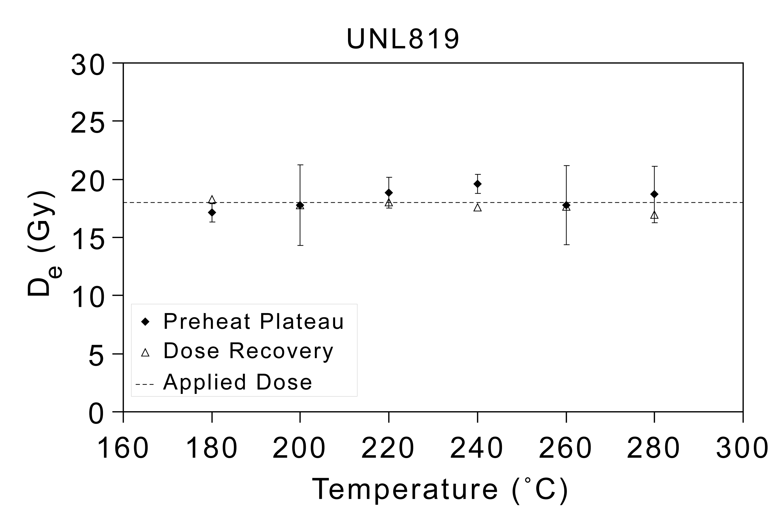
Figure 1. Dose recovery (Murray and Wintle, 2003) and preheat plateau data for UNL819 (Table 1).
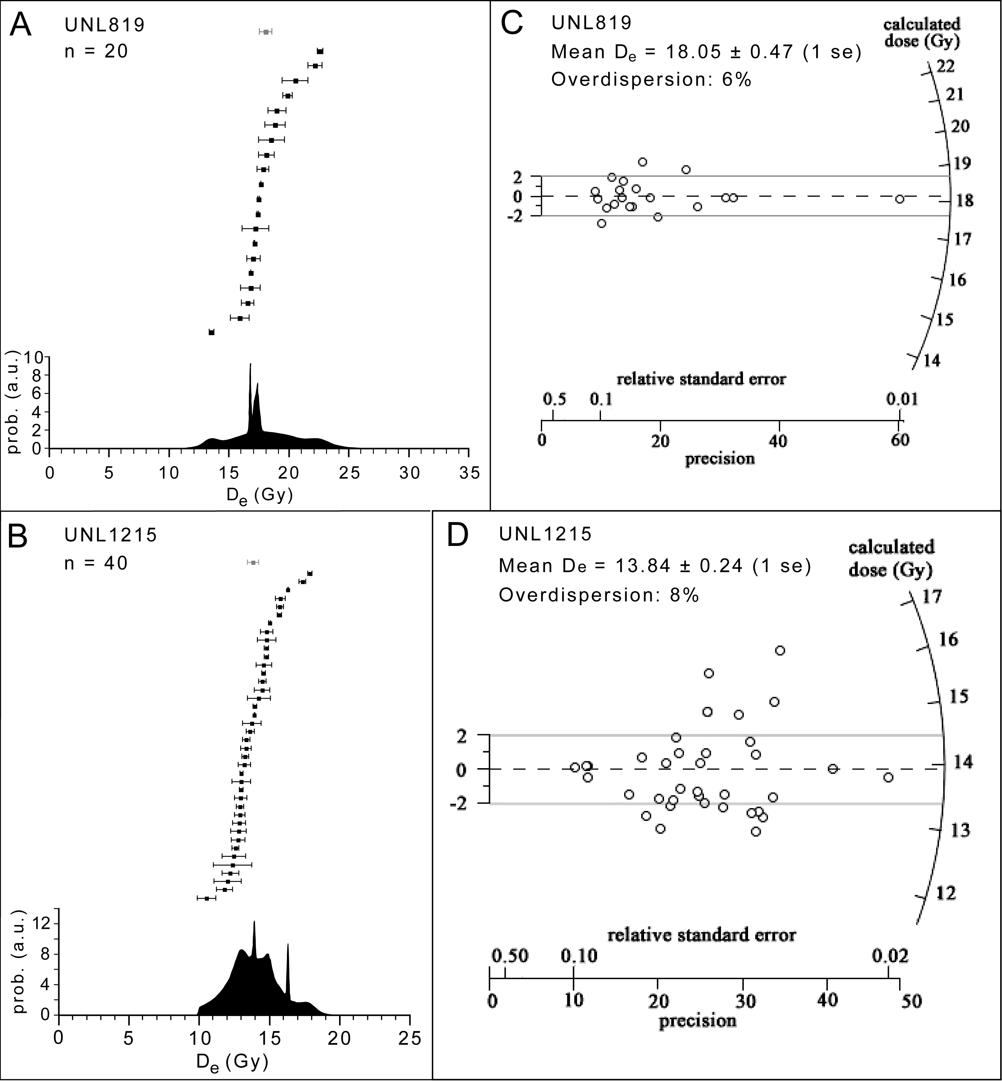

Figure 2. OSL D_{e} data for two representative samples (UNL819 and UNL1215 [Table 1]). Rank order plots of D_{e} values and probability density functions for A) UNL819 and B) UNL1215. Individual D_{e} values (n=20 and n=40, respectively) are shown as black squares (±1 standard deviation). The mean D_{e} (±1 standard error) is shown as a grey square. Probability density functions are sums of normal distributions (±3σ) of individual D_{e} values. Radial plots (Galbraith, 1988) for C) UNL819 and D) UNL1215. Dashed line represents the standardized estimate (mean D_{e}) with ±2 standard deviation denoted by grey lines. Overdispersion was calculated as per Galbraith et al. (1999).

Modeling glacial Lake Algonquin shorelines

In a geographic information system (GIS) environment, shorelines of glacial Lake Algonquin were modeled with National Elevation Dataset (NED) products and Futyma’s research findings (Futyma, 1981). Futyma found five Lake Algonquin shorelines and their modern elevations. Futyma’s work, specifically Figure 4 in his paper, was scanned and rectified in ArcGIS (http://www.esri.com/). After digitizing his survey points with the scanned image placed as a backdrop, the digitized point layers were exported to XY-format files. Using the XY coordinates, the profile of elevations in each shoreline in direction of maximum uplift (N 15º E) was mathematically modeled with DatafitTM (http://www.oakdaleengr.com/). Figure 3 shows the modeling results. In the figure, the variable Y indicates current elevation, and X indicates the distance along line in direction of maximum uplift.

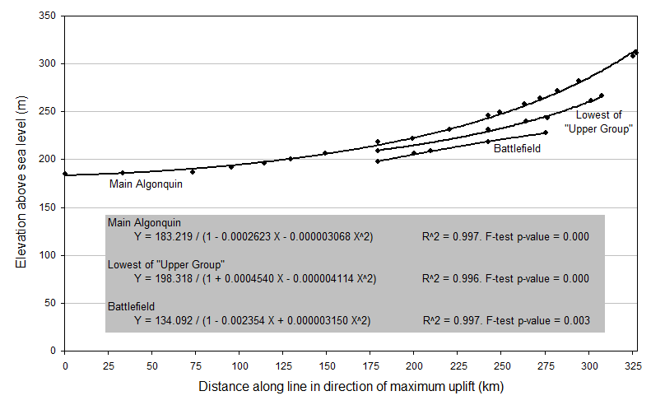
Figure 3. Original survey points and modeling results

In order to determine the amounts of uplift, the distance along the line in direction of maximum uplift in the Michigan Georef coordinate system needs to be calculated. This task was performed by building an equation using the Futyma’s survey point located in the Delta County, named “Burnt Bluff.” The XY coordinates of Burnt Bluff are 445139mN, 569054mE in the MI Georef coordinate system NAD83, and the distance along line in direction of maximum uplift is 181427m. Using the coordinates and the distance, the line that rebound starts can be determined as [y = -tan(15) x + 500502]. The shortest distance from a point (X, Y) in Michigan Georef coordinates to the rebound line is, therefore, [d = (0.267949X + Y – 500502) / 1.035276]. Using the distance and the equations in Figure 3, the uplift amount in each pixel can be calculated.
A 32-bit C++ console-application program was developed with MS Visual Studio 6.0 (http://www.microsoft.com/) in order to create raster images containing the amount of uplift. The program is freely available at http://www.westga.edu/~jseong/geologicuplift/. The program creates three images in the ASCII format with the upper left corner coordinates of 152133mN, 868359mE and the pixel size of 30 m. In the program, a constant value of 183.219m was subtracted from each pixel in order to calculate the net uplift amounts. Each raster image size is 12464 lines and 18567 samples. The Michigan Georef Coordinate System in NAD83 (http://www.michigan.gov/documents/DNR_Map_Proj_and_MI_Georef_Info_20889_7.pdf) should be used to rectify the band sequential (BSQ) format images. Finally, the net uplift amounts were subtracted from the NED 30 m digital elevation model (http://ned.usgs.gov/). The NED dataset was used in this research because it does not represent canopy surface heights but ground terrain heights. Figures 4, 5 and 6 show three different shorelines in the yellow-tone color which indicates 180–190 m above sea level during the Algonquin period. Pink to white tones indicate elevations above 190 m, and dark tones indicate below 180 m. Red lines indicate major roads, and black lines are county boundaries.

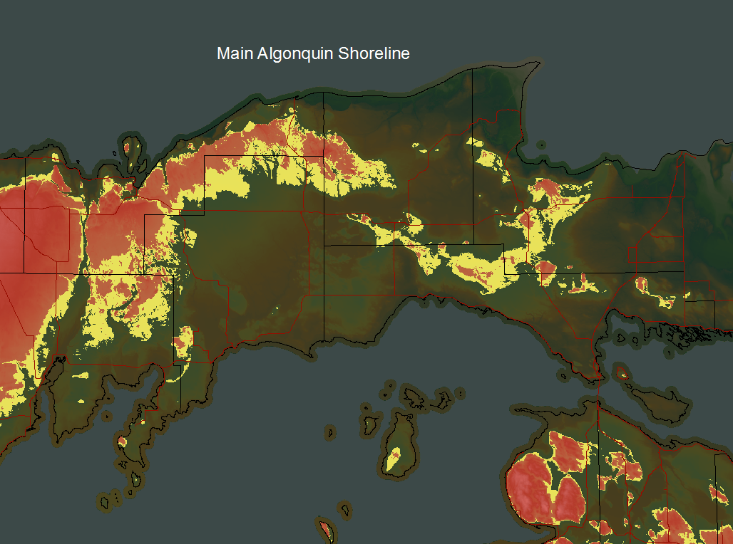

Figure 4. Main Algonquin shoreline

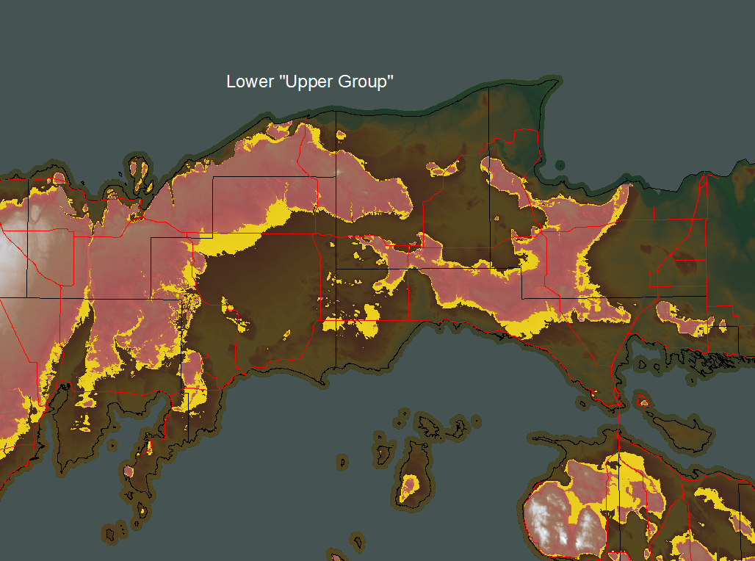

Figure 5. Lower “Upper Group” shoreline

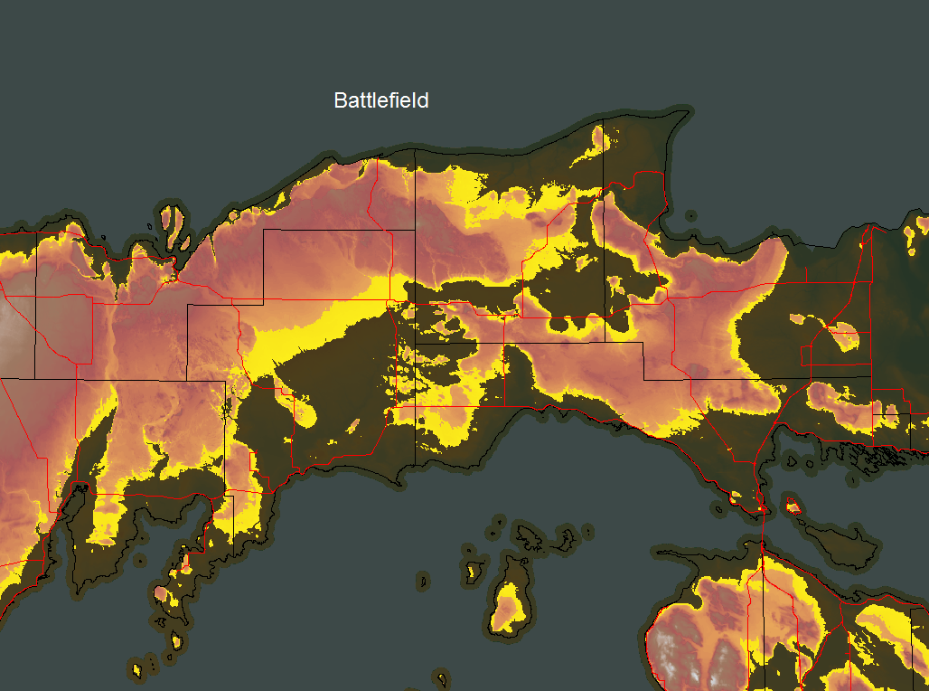

Figure 6. Battlefield shoreline

References

Adamiec, G., Aitken, M., 1998. Dose-rate conversion factors: update. Ancient TL 16, 37–50.

Aitken, M.J., 1976. Thermoluminescent age evaluation and assessment of error limits: revised system. Archaeometry 18, 233–238.

Aitken, M.J., 1985. Thermoluminescence Dating. Academic Press. 359 p.
Aitken, M.J., 1998. An Introduction to Optical Dating. Oxford University Press. 267 p.
Aitken, M.J., Alldred, J.C., 1972. The assessment of error limits in thermoluminescent dating. Archaeometry 14, 257–267.
Bailey, R.M., Singarayer, J.S., Ward, S., Stokes, S., 2003. Identification of partial resetting using D_{e} as a function of illumination time. Radiation Measurements 37, 511–518.
Bailey, R.M., Arnold, L.J., 2006. Statistical modeling of single grain quartz D_{e}: distribution and an assessment for estimating burial dose. Quaternary Science Reviews 25, 2475–2502.
Brennan, B.J., 2003. Beta doses to spherical grains. Radiation Measurements 37, 299–303.
Colls, A.E., Stokes, S., Blum, M.D., Straffin, E., 2001. Age limits on the Late Quaternary evolution of the upper Loire River. Quaternary Science Reviews 20, 743–750.
Futyma, R., 1981. The northern limits of glacial Lake Algonquin in Upper Michigan. Quaternary Research 15, 291–310.
Galbraith, R.F., 1988. Graphical display of estimates having differing standard errors. Technometrics 30, 271–281.
Galbraith, R.F., Roberts, R.G., Laslett, G.M., Yoshida, H., Olley, J.M., 1999. Optical dating of single and multiple grains of quartz from Jinmium rock shelter, northern Australia: Part I, experimental design and statistical models. Archaeometry 41, 339–364.
Murray, A.S., Wintle, A.G., 2000. Luminescence dating of quartz using an improved single-aliquot regenerative-dose protocol. Radiation Measurements 32, 57–73.
Murray, A.S., Olley, J.M., 2002. Precision and accuracy in the optically stimulated luminescence dating of sedimentary quartz: a status review. Geochronometria 21, 1–16.
Murray, A.S., Wintle, A.G., 2003. The single aliquot regenerative dose protocol: potential for improvements in reliability. Radiation Measurements 37, 377–381.
Olley, J.M., Caitcheon, G.G., Murray, A.S., 1998. The distribution of apparent dose as determined by optically stimulated luminescence in small aliquots of fluvial quartz: implications for dating young samples. Quaternary Science Reviews 17, 1033–1040.
Olley, J.M., Caitcheon, G., Roberts, R.G., 1999. The origin of dose distributions in fluvial sediments, and the prospect of dating single grains from fluvial deposits using optically stimulated luminescence. Radiation Measurements 30, 207–217.
Prescott, J.R., Hutton, J.T., 1994. Cosmic ray contributions to dose rates for luminescence and ESR dating: large depths and long-term time variations. Radiation Measurements 23, 497–500.

