Supplementary Materials for

A southern and northern control on speleothem-based ASM variability during MIS 4
Dianbing Liu^{a,*}, Shushuang Liu ª, Yifan Fang ª

ª School of Geography, Nanjing Normal University, Nanjing 210023, China

*Corresponding Author Present Address: School of Geography, Nanjing Normal University, Nanjing 210023, China. Tel: +86 25 83598125; Fax: +86 25 83598125
Email Address:

ldb9921@njnu.edu.cn (D.B. Liu), Lss0817njnuv@163.com (S.S. Liu)
fyifan0810@163.com (Y.F. Fang)

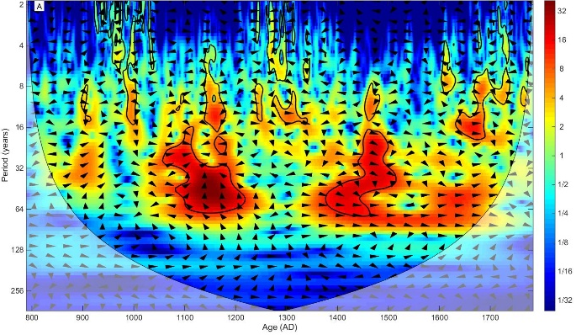
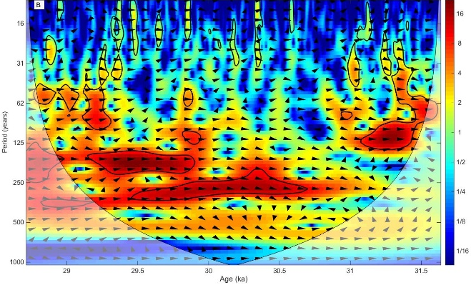

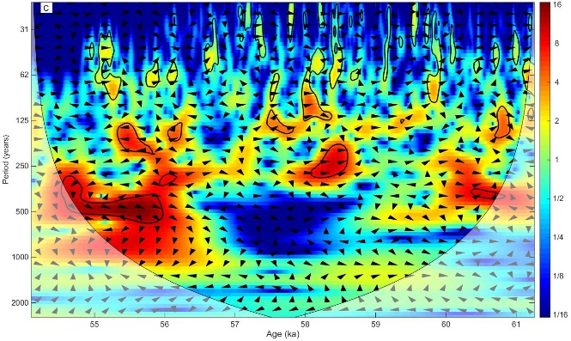
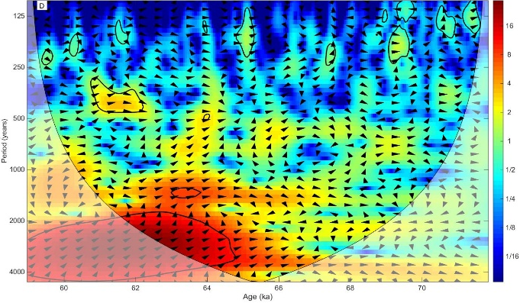

Supplementary Fig. 1 Cross-wavelet analysis on δ¹⁸O_{d} and δ¹³C_{d} data from Heilong Cave, central China (A) (Cui et al., 2012), Wulu Cave, southern China (B, C) (Liu et al., 2010; 2016), and Tian’e Cave, central China (D) (Zhang et al., 2019). These detrended sequences were also shown in the middle of each panel as shown in Fig. 5. Note that Sw12 record (D) was analyzed with the data across the continuous section, i.e., after the growth hiatus (after 71.9 ka). These analyses show that weaker oscillations are evident during interstadials as indicated in Fig. 5, consistent with the result from Wu87 (Fig. 4).

