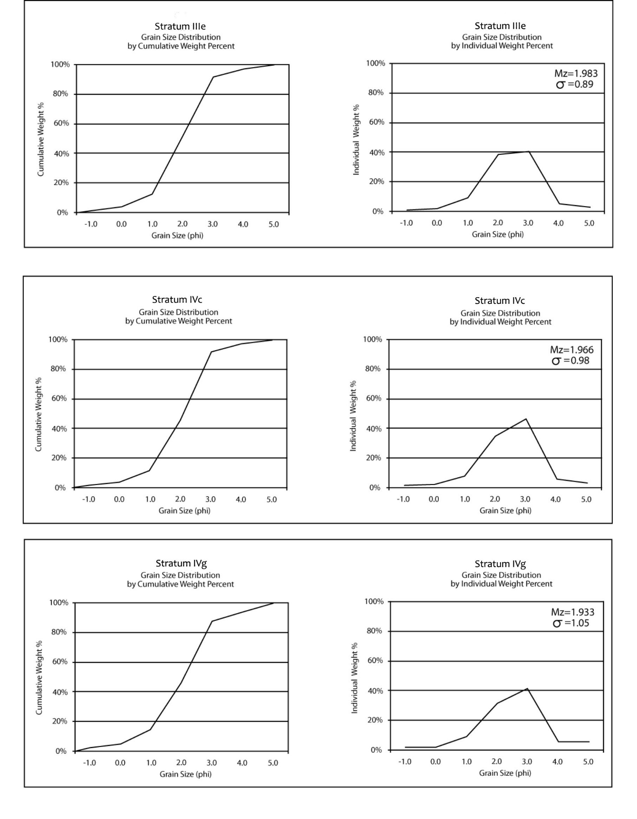Supplementary Figure 1. Frequency and cumulative curves for the seven sediment samples taken from North Creek Shelter. The top right corner of the frequency curve shows the mean (Mz) and one standard deviation (σ) for each sample (Morris and Hicks 2009).

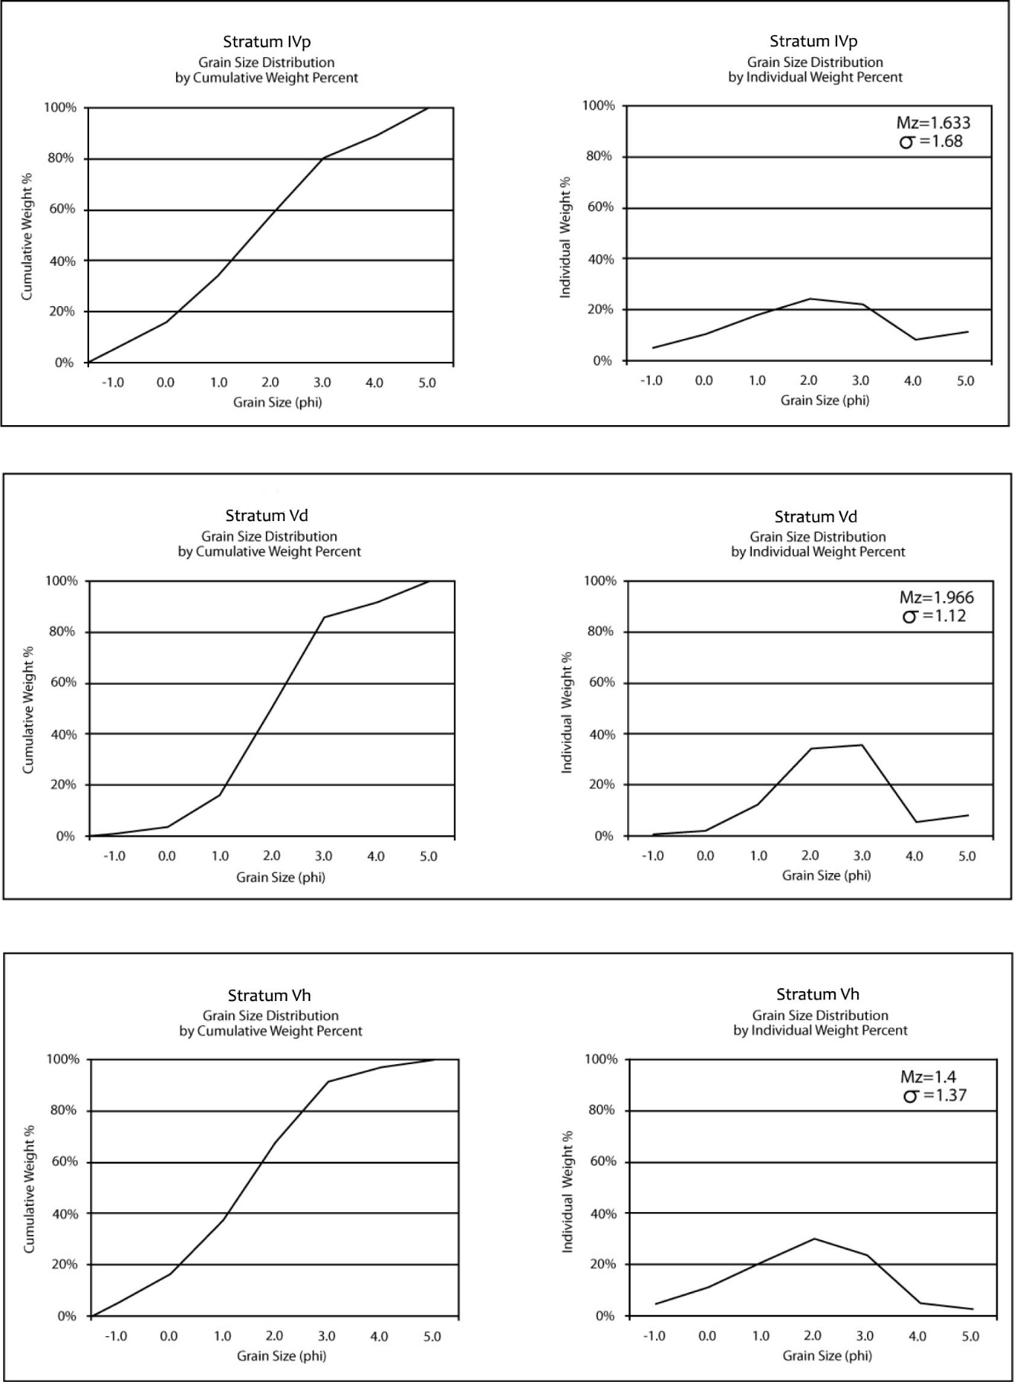Supplementary Figure 1 (con’t).

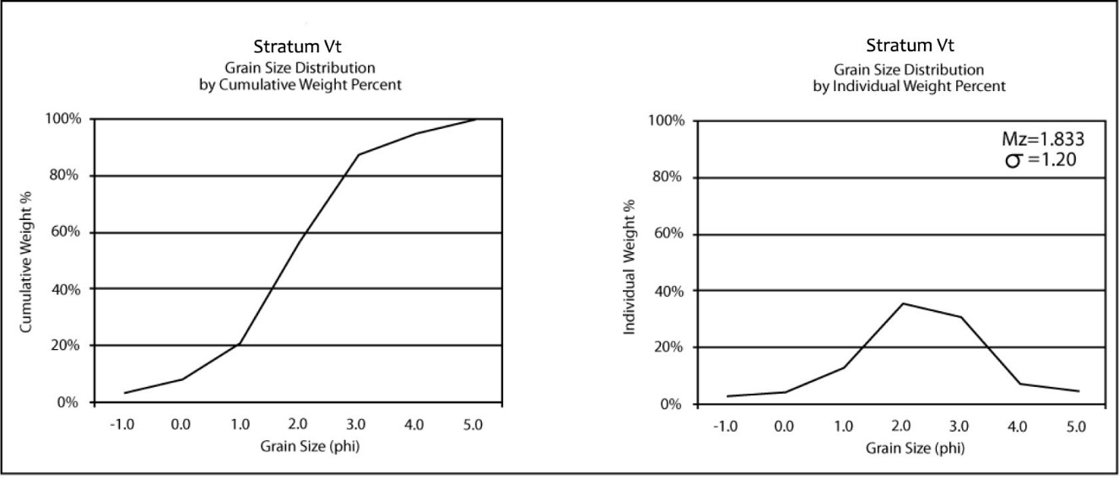Supplementary Figure 1 (con’t).