**Supplemental Online Material**

The ESI contains extra information related to the main paper, including the circuit diagrams and printed circuit board layouts for the differential amplifier and glow discharge driver used to generate the data in the main paper.

Figure S1



The schematic differential amplifier is shown. The fourth order low pass filter is flexible in design, so the parameters shown are for the configuration used in the manuscript.

Figure S2

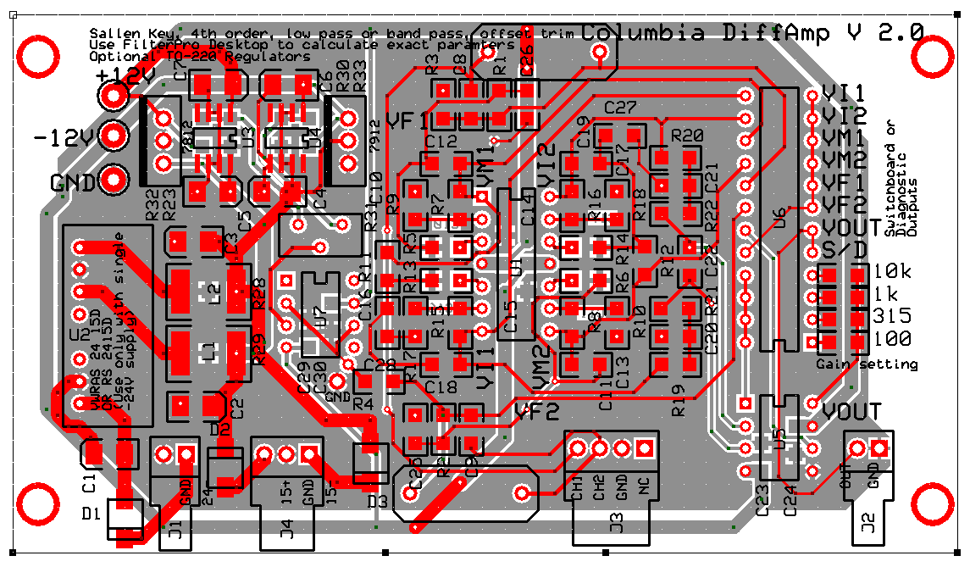

The printed circuit board layout for the differential amplifier is shown, incorporating an active filter, a new instrumentation amplifier, and an offset adjustment (R31).

Figure S3



The schematic of the glow discharge driver is shown.

Figure S4

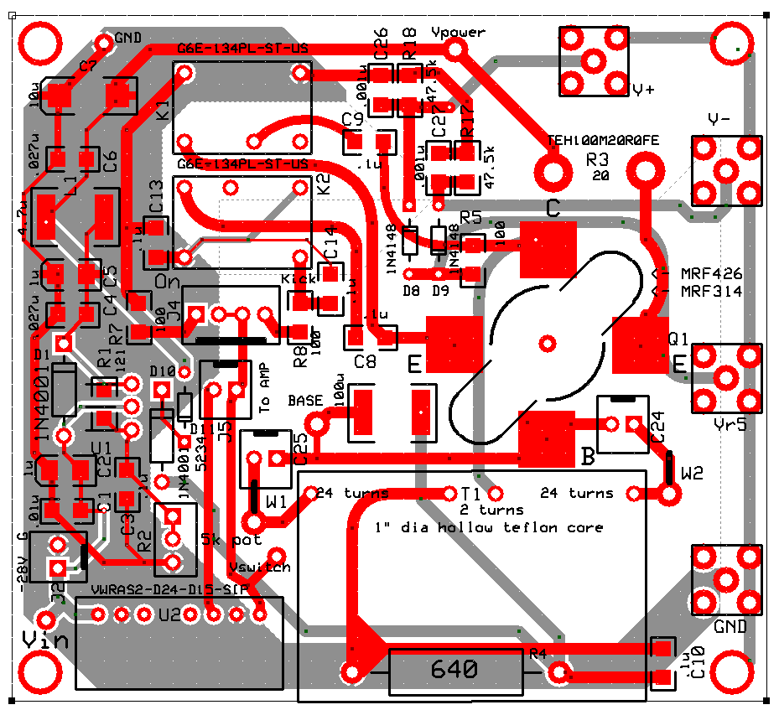

The printed circuit board layout of the glow discharge circuit is shown.

Figure S5

|  |  |  |  |  |  |  |  |  |
| --- | --- | --- | --- | --- | --- | --- | --- | --- |
| C1 | 0.01uF | 445-1375-1-ND | C25 | 2.5-11 | SG9012DKR-ND | Q1 | MRF426 | MOUSER:937-MRF426 |
| C2 | 1uF | 718-1309-1-ND | C26 | 0.001uF | 490-1749-1-ND | R1 | 121 | RMCF1206FT121RCT-ND |
| C3 | 0.1uF | 478-3797-1-ND | C27 | 0.001uF | 490-1749-1-ND | R2 | 5K | 804-1013-ND |
| C4 | 0.027uF | 490-1762-1-ND | D1 | 1n4001 | S2KDICT-ND | R3 | 20 | TEH100M20R0JE-ND |
| C5 | 1uF | 718-1309-1-ND | D8 | 1N4148-T | ZLLS350TACT-ND | R4 | 620 | PT620KXCT-ND |
| C6 | 0.027uF | 490-1762-1-ND | D9 | 1N4148-T | ZLLS350TACT-ND | R5 | 100 | MR102-100-.01-ND |
| C7 | 10uF | 495-2288-1-ND | D10 | 1N4001 | S2KDICT-ND | R7 | 100 | PHP100ACT-ND |
| C8 | 0.1uF | 478-3797-1-ND | D11 | 1N5234B | 1N5234B-TPCT-ND | R8 | 100 | PHP100ACT-ND |
| C9 | 0.1uF | 478-3797-1-ND | J2 | WM4300 | WM4300 | R17 | 47.5k | 989-1170-1-ND |
| C10 | 0.1uF | 478-3797-1-ND | K1 | G6E | Z831-ND | R18 | 47.5k | 989-1170-1-ND |
| C13 | 0.1uF | 478-3797-1-ND | K2 | G6E | Z831-ND | T1 | 2/50-turn trans |  |
| C14 | 0.1uF | 478-3797-1-ND | L1 | 4.7uH | DN7773-ND | U1 | LM337T | LM337TFS-ND |
| C24 | 2.5-11 | SG9012DKR-ND | L2 | 100uH | DN7843-ND |  |  |  |

The part values and part numbers from Digikey™ for the glow discharge circuit are shown.