Otolith-based chronology of Brazilian Shellmounds

Carla Carvalho^{a,b}*, Kita Macario^{b}, Tania Lima^{c}, Ingrid Chanca^{b}, Fabiana Oliveira^{b}, Eduardo Q. Alves^{d}, Thayse Bertucci^{e} and Orangel Aguilera^{e}

ªDepartamento de Geoquímica, Instituto de Química, Universidade Federal Fluminense, Outeiro São João Batista, s/n, Niterói, 24020-141, RJ, Brazil.
^{b}Laboratório de Radiocarbono, Instituto de Física, Universidade Federal Fluminense, Av. Gal. Milton Tavares de Souza, s/n, Niterói, 24210-346, RJ, Brazil.
^{c}Departamento de Antropologia, Museu Nacional, Universidade Federal do Rio de Janeiro, Quinta da Boa Vista, s/n, Rio de Janeiro, 20940-040, RJ, Brazil.
^{d}Oxford Radiocarbon Accelerator Unit, University of Oxford, Dyson Perrins Building, South Parks Road, Oxford, OX1 3QY, United Kingdom.
^{e}Departamento de Biologia Marinha, Laboratorio de Paleoecologia e Mudanças Globais, Universidade Federal Fluminense, Campus do Gragoatá, Bloco M, Rua Alexandre Moura, Niterói, 24210-200, RJ, Brazil.
*Corresponding author: carlac@id.uff.br

SUPPLEMENTARY MATERIAL

Code 1: OxCal code for Tarioba shellmound

Plot()
{
Curve("Marine13","Marine13.14c");
Curve("SHCal13","SHCal13.14c");
Sequence()
{
Boundary("Start Tarioba");
Phase("Tarioba")
{
Curve("=Marine13");
Delta_R("TariobadeltaR",-127,67);
R_Date("LAC-UFF 140099", 3661, 47)
{
color="green";
};
R_Date("LAC-UFF 140100", 3663, 48)
{
color="green";
};
R_Date("LAC-UFF 140101", 3790, 47)
{
color="green";
};
R_Date("LAC-UFF 140102", 3664, 47)
{
color="green";
};
R_Date("LAC-UFF 140103", 3714, 46)
{
color="green";
};
R_Date("LAC-UFF 140104", 3684, 48)
{
color="green";
};
R_Date("LAC-UFF 140105", 3730, 47)
{
color="green";
};
R_Date("LAC-UFF 140106", 3627, 47)
{
color="green";
};
R_Date("LAC-UFF 140107", 3634, 46)
{
color="green";
};
R_Date("LAC-UFF 140108", 3964, 47)
{
color="green";
};
R_Date("LAC-UFF 140109", 3735, 47)
{
color="green";
};
R_Date("LAC-UFF 12043", 3662, 64)
{
color="red";
};
R_Date("LAC-UFF 12045", 3692, 68)
{
color="red";
};
R_Date("LAC-UFF 12046", 3710, 68)
{
color="red";
};
R_Date("LAC-UFF 12047", 3588, 65)
{
color="red";
};
R_Date("LAC-UFF 12048", 3662, 66)
{
color="red";
};
R_Date("LAC-UFF 13028", 3391, 26)
{
color="red";
};
R_Date("LAC-UFF 13029", 3747, 62)
{
color="red";
};
R_Date("LAC-UFF 13030", 3567, 50)
{
color="red";
};
R_Date("LAC-UFF 13031", 3567, 27)
{
color="red";
};
R_Date("LAC-UFF 13032", 3507, 22)
{
color="red";
};
R_Date("LAC-UFF 13033", 3743, 26)
{
color="red";
};
R_Date("LAC-UFF 13034", 4043, 26)
{
color="red";
};
R_Date("LAC-UFF 13035", 3852, 31)
{
color="red";
};
R_Date("LAC-UFF 13036", 3510, 36)
{
color="red";
};
R_Date("LAC-UFF 13037", 3473, 25)
{
color="red";
};
R_Date("LAC-UFF 13038", 3729, 35)
{
color="red";
};
R_Date("LAC-UFF 13039", 3800, 49)
{
color="red";
};
R_Date("LAC-UFF 13040", 3533, 29)
{
color="red";
};
R_Date("LAC-UFF 13041", 3654, 32)
{
color="red";
};
R_Date("LAC-UFF 13042", 3968, 31)
{
color="red";
};
R_Date("LAC-UFF 13043", 3979, 35)
{
color="red";
};
R_Date("LAC-UFF 13044", 4127, 24)
{
color="red";
};
R_Date("BETA-335464", 3720, 30)
{
color="red";
};
R_Date("BETA-335465", 3860, 40)
{
color="red";
};
R_Date("BETA-335466", 3670, 30)
{
color="red";
};
R_Date("BETA-335467", 3660, 30)
{
color="red";
};
R_Date("BETA-335468", 3810, 30)
{
color="red";
};
R_Date("BETA-335469", 3780, 40)
{
color="red";
};
R_Date("BETA-335470", 3910, 30)
{
color="red";
};
R_Date("BETA-335471", 3740, 30)
{
color="red";
};
R_Date("BETA-335472", 3620, 30)
{
color="red";
};
R_Date("BETA-335473", 3810, 40)
{
color="red";
};
R_Date("BETA-335474", 3820, 40)
{
color="red";
};
Curve("=SHCal13");
R_Date("LAC-UFF 13045", 3172, 33)
{
color="black";
};
R_Date("LAC-UFF 13046", 3420, 61)
{
color="black";
};
R_Date("LAC-UFF 13047", 3479, 38)
{
color="black";
};
R_Date("LAC-UFF 13048", 3561, 53)
{
color="black";
};
};
Boundary("End Tarioba");
};
};

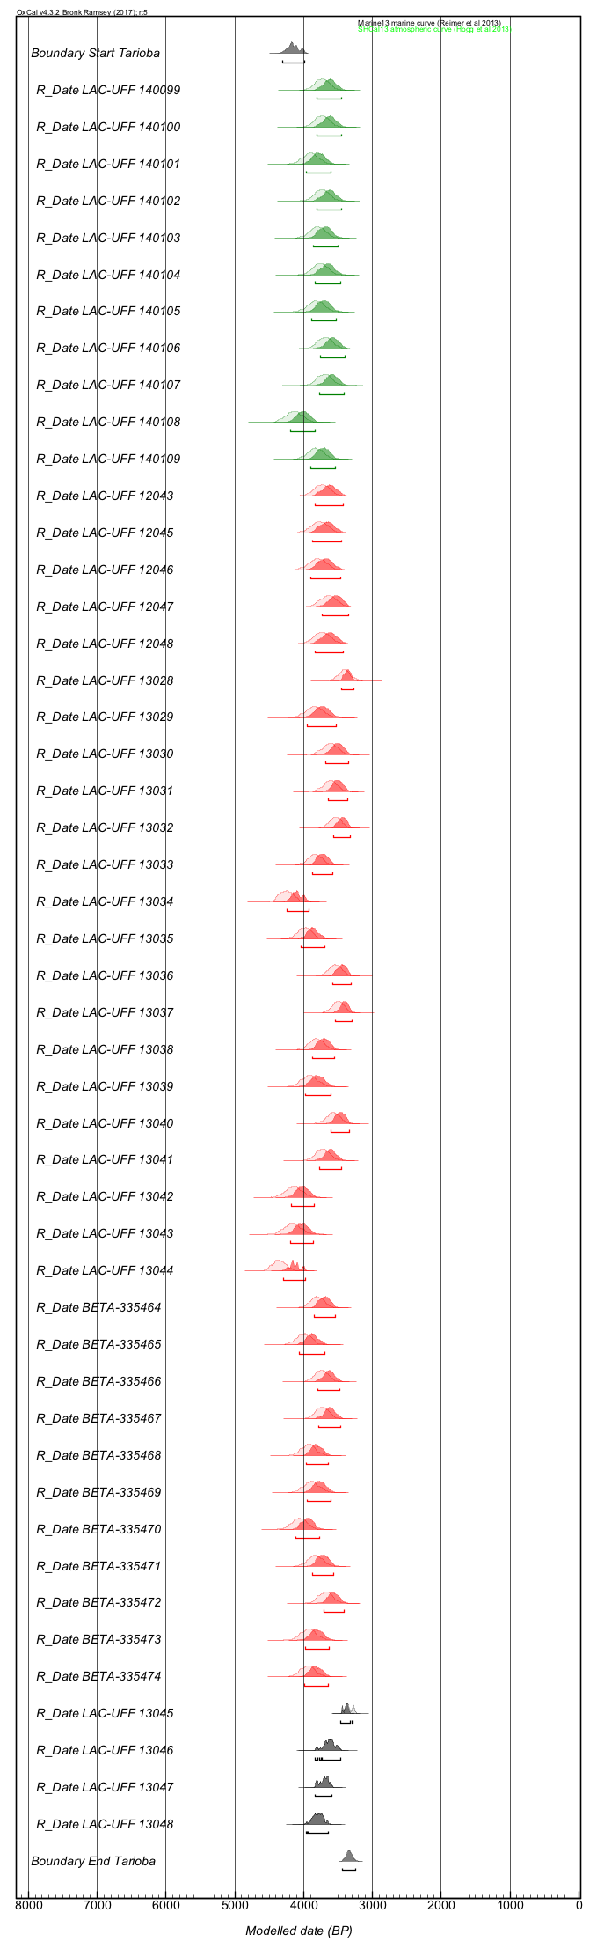
Figure 1: Multiplot OxCal output for Tarioba shellmound
Code 2: OxCal code for Ponte do Girau shellmound

Plot()
{
Curve("Marine13","Marine13.14c");
Curve("SHCal13","SHCal13.14c");
Sequence()
{
Boundary("Start Ponte do Girau");
Phase("Ponte do Girau")
{
Curve("=Marine13");
Delta_R("geraldeltaR", 32, 44);
R_Date("LAC-UFF 140110", 3977, 49)
{
color="green";
};
R_Date("LAC-UFF 140111", 3695, 59)
{
color="green";
};
R_Date("LAC-UFF 140112", 3686, 46)
{
color="green";
};
R_Date("LAC-UFF 140113", 3730, 59)
{
color="green";
};
R_Date("LAC-UFF 140114", 3872, 60)
{
color="green";
};
R_Date("LAC-UFF 140115", 3690, 59)
{
color="green";
};
};
Boundary("End Ponte do Girau");
};
};

Figure 2: Multiplot OxCal output for Ponte do Girau shellmound
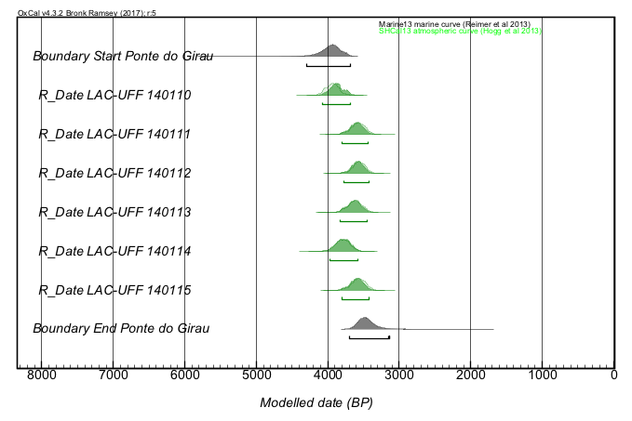
Code 3: OxCal code for Manitiba shellmound

Plot()
{
Curve("Marine13","Marine13.14c");
Curve("SHCal13","SHCal13.14c");
Sequence()
{
Boundary("Start Manitiba");
Phase("Manitiba")
{
Curve("=Marine13");
Delta_R("ManitibadeltaR",-82,71);
R_Date("LAC-UFF 140096", 3846, 40)
{
color="green";
};
R_Date("LAC-UFF 140223", 3756, 48)
{
color="green";
};
R_Date("LAC-UFF 140224", 3658, 54)
{
color="green";
};
R_Date("LAC-UFF 140225", 3599, 46)
{
color="green";
};
R_Date("LAC-UFF 140226", 3596, 47)
{
color="green";
};
R_Date("LAC-UFF 140227", 3678, 47)
{
color="green";
};
R_Date("LAC-UFF 140228", 3690, 47)
{
color="green";
};
R_Date("LAC-UFF 140229", 3959, 46)
{
color="green";
};
R_Date("LAC-UFF 140230", 3955, 46)
{
color="green";
};
R_Date("LAC-UFF 140231", 3896, 47)
{
color="green";
};
R_Date("LAC-UFF 140232", 3738, 46)
{
color="green";
};
R_Date("LAC-UFF 140233", 3563, 49)
{
color="green";
};
R_Date("LAC-UFF 140234",3650, 46)
{
color="green";
};
R_Date("LAC-UFF 140235", 3777, 47)
{
color="green";
};
R_Date("LAC-UFF 140236", 3728, 46)
{
color="green";
};
R_Date("LAC-UFF 140237", 3662, 66)
{
color="green";
};
R_Date("LAC-UFF 140238", 3850, 47)
{
color="green";
};
R_Date("LAC-UFF 140239", 3853, 46)
{
color="green";
};
R_Date("LAC-UFF 140240", 3793, 47)
{
color="green";
};
R_Date("LAC-UFF 140241", 3705, 47)
{
color="green";
};
R_Date("LAC-UFF 140242", 3723, 47)
{
color="green";
};
R_Date("LAC-UFF 140243", 3888, 48)
{
color="green";
};
R_Date("LAC-UFF 140244", 3858, 47)
{
color="green";
};
R_Date("LAC-UFF 140245", 3745, 49)
{
color="green";
};
R_Date("LAC-UFF 140246", 3745, 47)
{
color="green";
};
R_Date("LAC-UFF 140449", 3967, 43)
{
color="red";
};
R_Date("LAC-UFF 140450", 3666, 35)
{
color="red";
};
R_Date("LAC-UFF 140451", 3999, 28)
{
color="red";
};
R_Date("LAC-UFF 140452", 4080, 25)
{
color="red";
};
R_Date("LAC-UFF 140453", 3870, 26)
{
color="red";
};
R_Date("LAC-UFF 140454", 3839, 39)
{
color="red";
};
R_Date("LAC-UFF 140447", 3747, 22)
{
color="black";
};
R_Date("LAC-UFF 140448", 3598, 46)
{
color="black";
};
R_Date("LAC-UFF 140442", 3748, 38)
{
color="blue";
};
R_Date("LAC-UFF 140443", 3767, 29)
{
color="blue";
};
R_Date("LAC-UFF 140444", 3649, 47)
{
color="blue";
};
R_Date("LAC-UFF 140445", 3688, 25)
{
color="blue";
};
R_Date("LAC-UFF 140446", 3659, 25)
{
color="blue";
};
};
Boundary("End Manitiba");
};
};

Figure 3: Multiplot OxCal output for Manitiba shellmound

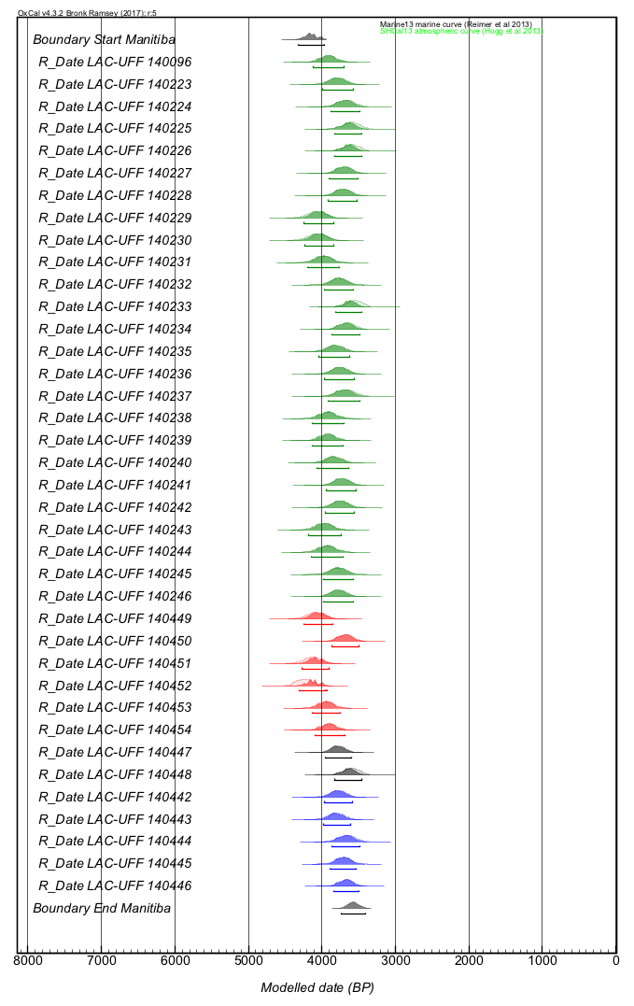

Code 4: OxCal code for Saquarema shellmound

Plot()
{
Curve("Marine13","Marine13.14c");
Curve("SHCal13","SHCal13.14c");
Sequence()
{
Boundary("Start Saquarema");
Phase("Saquarema")
{
Curve("=Marine13");
Delta_R("SaquaremadeltaR", -140, 66);
R_Date("LAC-UFF 140473", 3885, 65)
{
color="green";
};
R_Date("LAC-UFF 140474", 3581, 44)
{
color="green";
};
R_Date("LAC-UFF 140475", 3823, 49)
{
color="green";
};
R_Date("LAC-UFF 140481", 3970, 35)
{
color="green";
};
R_Date("LAC-UFF 140482", 3845, 74)
{
color="green";
};
R_Date("LAC-UFF 140485", 3719, 64)
{
color="green";
};
R_Date("LAC-UFF 140492", 3850, 66)
{
color="green";
};
R_Date("LAC-UFF 140502", 3842, 43)
{
color="green";
};
R_Date("GX-20512", 2550, 60)
{
color="red";
};
R_Date("GX-20513", 3280, 60)
{
color="red";
};
R_Date("LAC-UFF 140466", 3682, 42)
{
color="red";
};
R_Date("LAC-UFF 140467", 3779, 81)
{
color="red";
};
R_Date("LAC-UFF 140468", 3654, 44)
{
color="red";
};
R_Date("LAC-UFF 140469", 3842, 46)
{
color="red";
};
R_Date("LAC-UFF 140470", 3658, 79)
{
color="red";
};
R_Date("LAC-UFF 140471", 3972, 65)
{
color="red";
};
R_Date("LAC-UFF 140472", 3633, 43)
{
color="red";
};
R_Date("LAC-UFF 140476", 3797, 43)
{
color="red";
};
R_Date("LAC-UFF 140477", 3662, 64)
{
color="red";
};
R_Date("LAC-UFF 140478", 3906, 79)
{
color="red";
};
R_Date("LAC-UFF 140479", 3740, 80)
{
color="red";
};
R_Date("LAC-UFF 140480", 3887, 77)
{
color="red";
};
R_Date("LAC-UFF 140483", 3806, 64)
{
color="red";
};
R_Date("LAC-UFF 140484", 4069, 80)
{
color="red";
};
R_Date("LAC-UFF 140486", 3790, 78)
{
color="red";
};
R_Date("LAC-UFF 140487", 3505, 69)
{
color="red";
};
R_Date("LAC-UFF 140488", 3870, 48)
{
color="red";
};
R_Date("LAC-UFF 140489", 3643, 41)
{
color="red";
};
R_Date("LAC-UFF 140490", 3765, 65)
{
color="red";
};
R_Date("LAC-UFF 140491", 3710, 65)
{
color="red";
};
R_Date("LAC-UFF 140493", 3776, 80)
{
color="red";
};
R_Date("LAC-UFF 140494", 3897, 30)
{
color="red";
};
R_Date("LAC-UFF 140495", 3733, 46)
{
color="red";
};
R_Date("LAC-UFF 140496", 3690, 42)
{
color="red";
};
R_Date("LAC-UFF 140497", 3809, 65)
{
color="red";
};
R_Date("LAC-UFF 140498", 3697, 87)
{
color="red";
};
R_Date("LAC-UFF 140499", 3783, 49)
{
color="red";
};
R_Date("LAC-UFF 140500", 3758, 83)
{
color="red";
};
R_Date("LAC-UFF 140501", 3811, 81)
{
color="red";
};
R_Date("LAC-UFF 140503", 3896, 90)
{
color="red";
};
R_Date("LAC-UFF 140504", 3745, 65)
{
color="red";
};
R_Date("LAC-UFF 140505", 3807, 71)
{
color="red";
};
R_Date("LAC-UFF 140506", 3969, 78)
{
color="red";
};
R_Date("LAC-UFF 140507", 3954, 55)
{
color="red";
};
R_Date("LAC-UFF 140508", 3636, 43)
{
color="red";
};
R_Date("LAC-UFF 140509", 4015, 83)
{
color="red";
};
R_Date("LAC-UFF 140510", 4052, 79)
{
color="red";
};
Curve("=SHCal13");
R_Date("LAC-UFF 140511", 3628, 39)
{
color="black";
};
R_Date("LAC-UFF 140512", 3703, 35)
{
color="black";
};
R_Date("LAC-UFF 140513", 3608, 36)
{
color="black";
};
R_Date("LAC-UFF 140514", 3633, 38)
{
color="black";
};
R_Date("LAC-UFF 140515", 3670, 37)
{
color="black";
};
R_Date("LAC-UFF 140516", 3662, 39)
{
color="black";
};
};
Boundary("End Saquarema");
};
};

Figure 4: Multiplot OxCal output for Saquarema shellmound

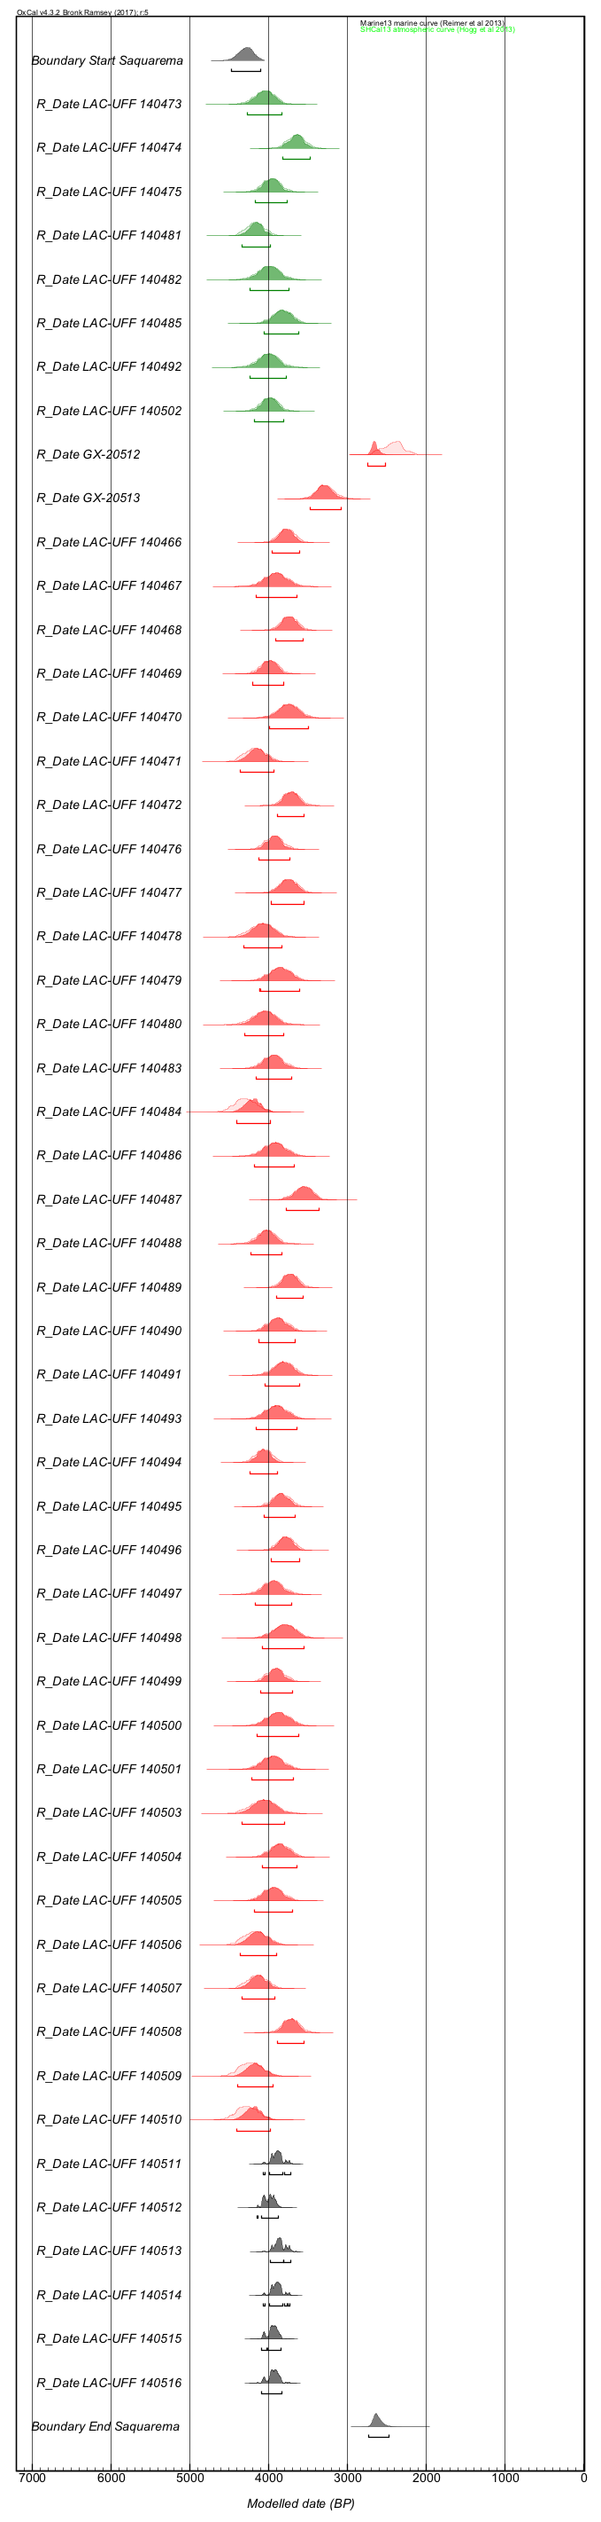
Code 5: OxCal code for Camboinhas shellmound

Plot()
{
Curve("Marine13","Marine13.14c");
Curve("SHCal13","SHCal13.14c");
Sequence()
{
Boundary("Start Camboinhas");
Phase("Camboinhas")
{
Curve("=Marine13");
Delta_R("=geraldeltaR", 32,44);
R_Date("LAC-UFF 140517", 3997, 44)
{
color="green";
};
R_Date("LAC-UFF 140518", 4274, 54)
{
color="green";
};
R_Date("LAC-UFF 140519", 4083, 45)
{
color="green";
};
R_Date("LAC-UFF 140520", 3969, 50)
{
color="green";
};
R_Date("SPC-207", 7958, 224)
{
color="red";
};
R_Date("KNP-001", 4475, 160)
{
color="red";
};
R_Date("KNP-002", 2562, 138)
{
color="red";
};
R_Date("KPN-003", 2328, 136)
{
color="red";
};
R_Date("KPN-004", 1410, 135)
{
color="red";
};
};
Boundary("End Camboinhas");
};
};

Figure 5: Multiplot OxCal output for Camboinhas shellmound

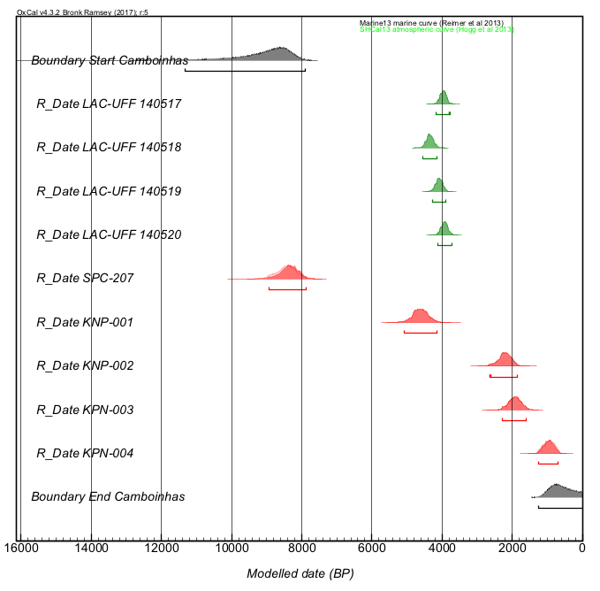

Code 6: OxCal code for Algodão shellmound

Plot()
{
Curve("Marine13","Marine13.14c");
Curve("SHCal13","SHCal13.14c");
Sequence()
{
Boundary("Start Algodao");
Phase("Algodao")
{
Curve("=Marine13");
Delta_R("AcaiadeltaR", -80, 87);
R_Date("LAC-UFF 140521", 3739, 43)
{
color="green";
};
R_Date("LAC-UFF 140522", 2463, 37)
{
color="green";
};
R_Date("LAC-UFF 140523", 2231, 41)
{
color="green";
};
R_Date("LAC-UFF 140524", 3719, 41)
{
color="green";
};
R_Date("LAC-UFF 140525", 3750, 43)
{
color="green";
};
R_Date("LAC-UFF 140526", 3843, 62)
{
color="green";
};
R_Date("LAC-UFF 140527", 3666, 43)
{
color="green";
};
R_Date("LAC-UFF 140528", 3597, 51)
{
color="green";
};
R_Date("BETA-414664", 3570, 30)
{
color="green";
};
Curve("=SHCal13");
R_Date("WSU 3359", 3350, 80)
{
color="black";
};
R_Date("PLID T00-0677", 7860, 80)
{
color="black";
};
};
Boundary("End Algodao");
};
};

Figure 6: Multiplot OxCal output for Algodão shellmound

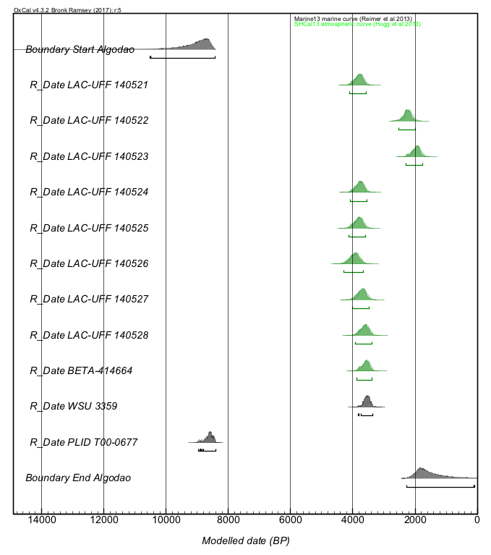

Code 7: OxCal code for Others (Peri, Bigode, Major and Caieira) shellmounds

Plot()
{
Curve("Marine13","Marine13.14c");
Curve("SHCal13","SHCal13.14c");
Sequence()
{
Boundary("Start Others");
Phase("Others")
{
Curve("=Marine13");
Delta_R("=acaiadeltaR");
R_Date("BETA-414665 Peri", 1480, 30)
{
color="green";
};
R_Date("BETA-414666 Bigode", 3530, 30)
{
color="green";
};
R_Date("BETA-414667 Caieira", 2430, 30)
{
color="green";
};
R_Date("BETA-414668 Major", 1270, 30)
{
color="green";
};
Curve("=SHCal13");
R_Date("PLID T00-0678 Peri", 1420, 80)
{
color="black";
};
R_Date("PLID T00-0679 Major", 190, 80)
{
color="black";
};
R_Date("PLID T00-0680 Caieira", 1520, 80)
{
color="black";
};
};
Boundary("End Others");
};
};

Figure 7: Multiplot OxCal output for Others (Peri, Bigode, Major and Caieira) shellmounds

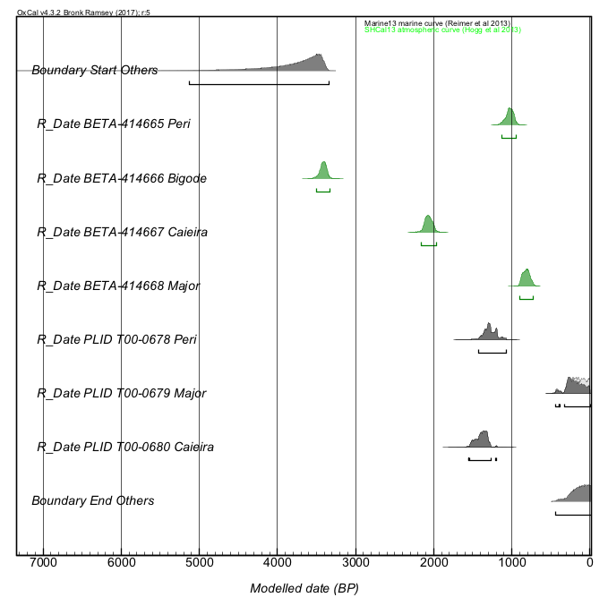

Code 8: OxCal code for Acaiá shellmound

Plot()
{
Curve("Marine13","Marine13.14c");
Curve("SHCal13","SHCal13.14c");
Sequence()
{
Boundary("Start Acaia");
Phase("Acaia")
{
Curve("=Marine13");
Delta_R("=acaiadeltaR");
R_Date("LAC-UFF 160142", 3200, 59)
{
color="green";
};
R_Date("LAC-UFF 160143", 3108, 84)
{
color="green";
};
R_Date("LAC-UFF 170235", 2916, 25)
{
color="green";
};
R_Date("LAC-UFF 170234", 3018, 26)
{
color="red";
};
R_Date("LAC-UFF 170236", 2886, 27)
{
color="red";
};
R_Date("LAC-UFF 170238", 3011, 29)
{
color="red";
};
Curve("=ShCal13");
R_Date("BETA-302993", 2850, 30)
{
color="black";
};
R_Date("BETA-304645", 2790, 30)
{
color="black";
};
R_Date("LAC-UFF 170237", 2866, 28)
{
color="black";
};
};
Boundary("End Acaia");
};
};

Figure 8: Multiplot OxCal output for Acaiá shellmound

