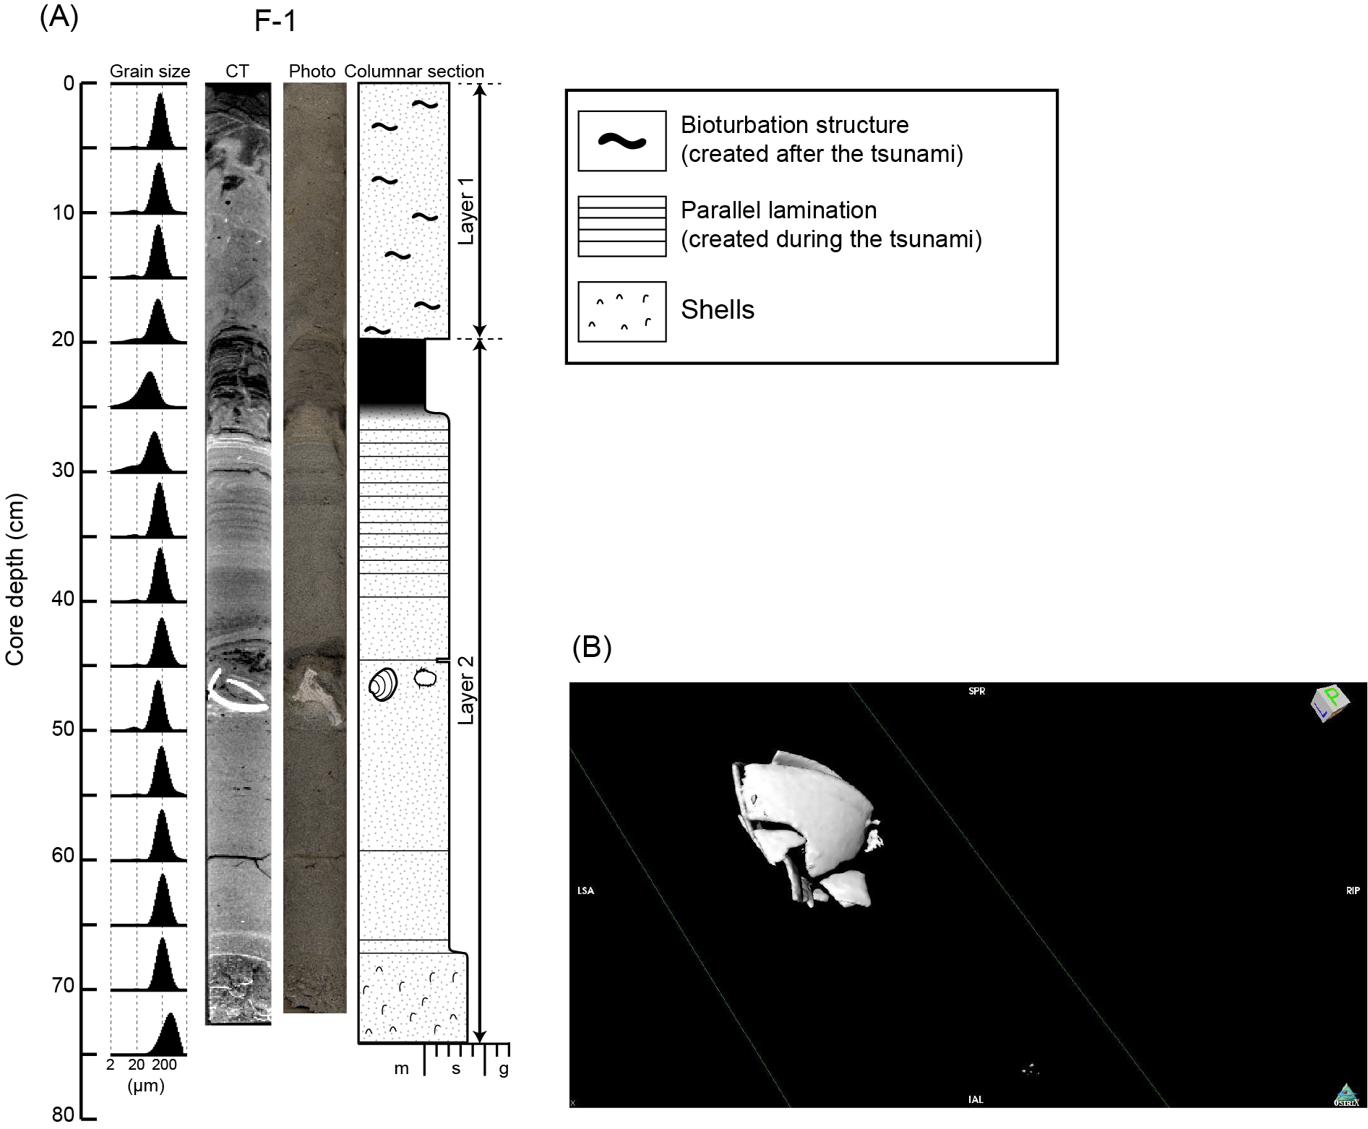
Fig. S1 (A) Grain-size distributions, CT image, photograph, and columnar section of the core collected from Funakoshi Bay in 2014. An articulated dead Mercenaria stimpsoni shell was included in the core at the depth of 47 cm below the seafloor. m, mud; s, sand; g, gravel. (B) CT image of the articulated M. stimpsoni shell. Note that the shell was broken during the coring.

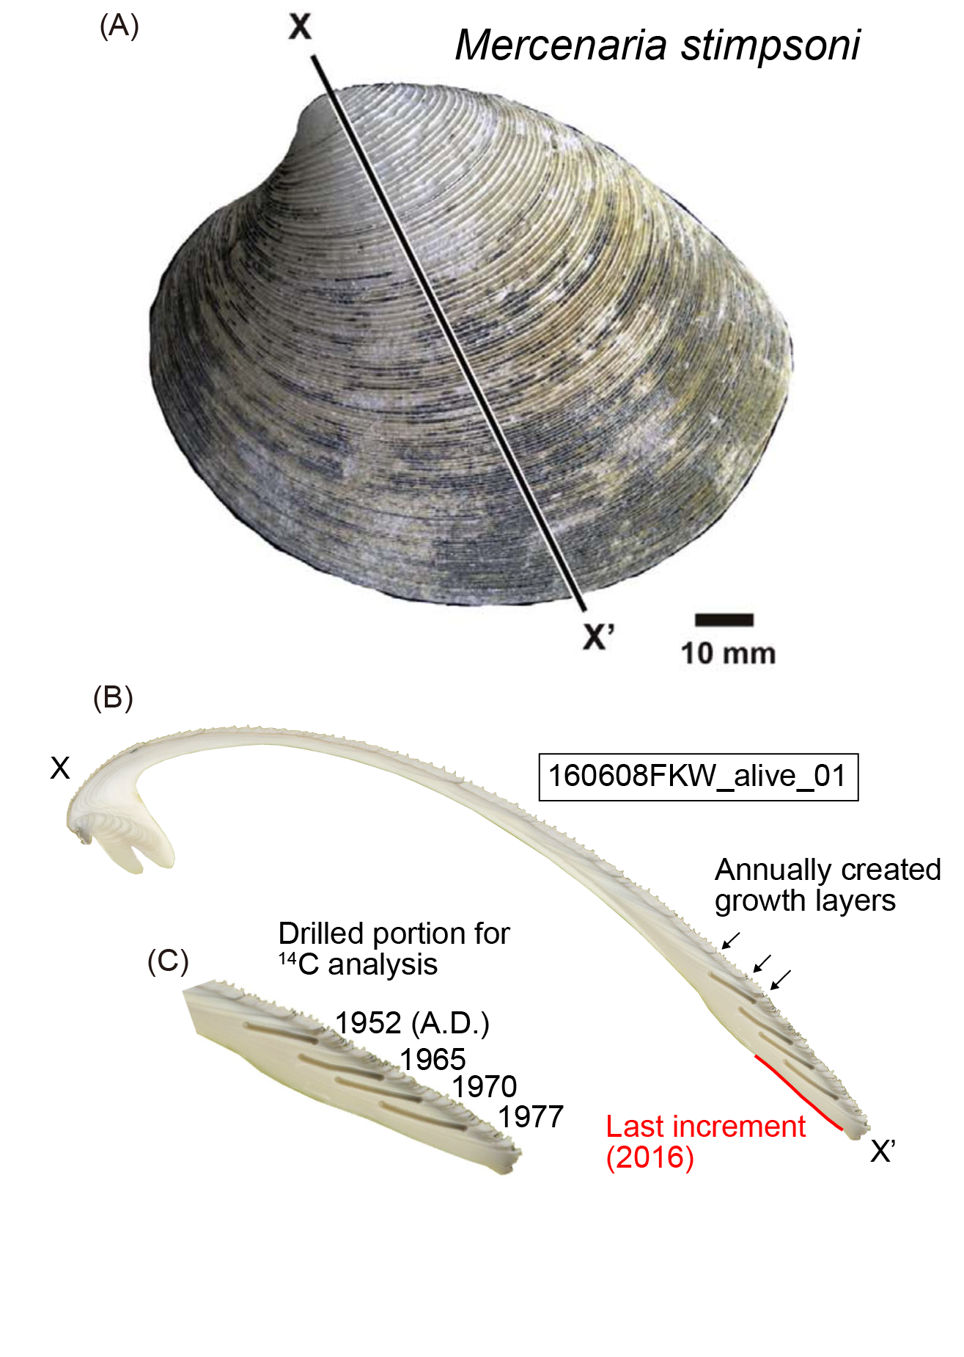
Fig. S2 A figure reprinted with permission from John Wiley & Sons, Inc (Originally Figure 2 of Kubota et al., 2018). (A) Photo of a live-caught Mercenaria stimpsoni specimen. The shell was sectioned along the maximum growth axis (X–X’). (B, C) Photo of the shell cross section showing the annual growth increments. The calendar age of each increment was determined by counting backward from the last increment. The last increment was sampled by using a grinder, and earlier increments were sampled by drilling through the outer shell with a micromilling device GEOMILL326 (see main text).
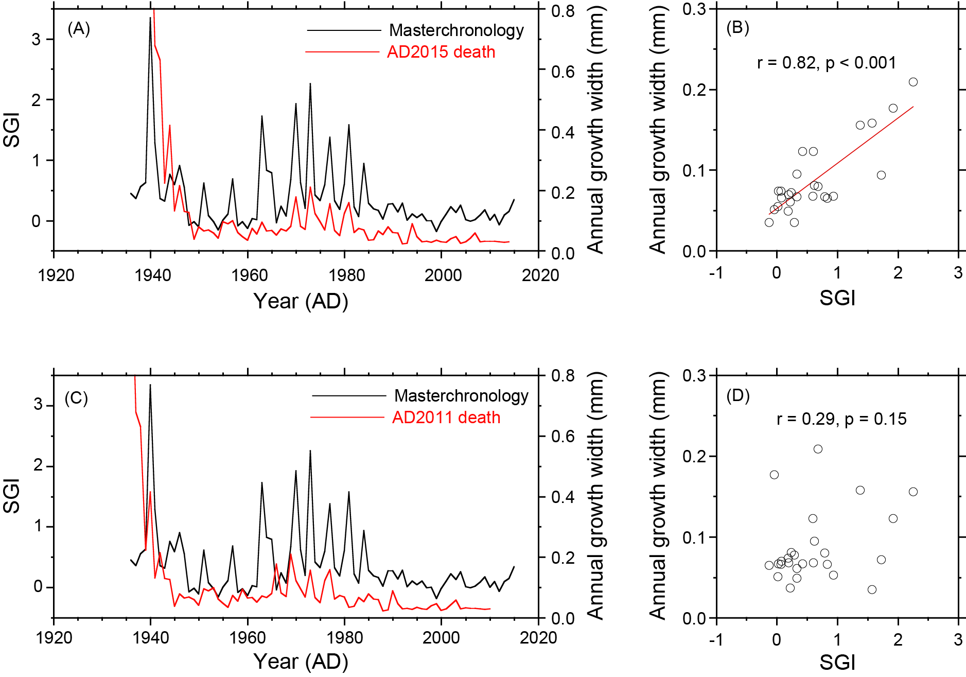
Fig. S3 (A) Comparison of the SGI time series of the dead shell of a clam (160608FKW_dead_A14R) with that of the master chronology, and (B) scatter plot of the annual growth increment width in the master chronology versus the SGI of the specimen, under the assumption that the clam died in 2015. (C, D) Same as A and B, but under the assumption that the clam died in 2011 (i.e., the last increment was added in 2010). The correlation between the annual growth increment width in the master chronology and the SGI of the specimen is statistically significant only if the clam died in 2015.

Table S1.
Radiocarbon measurement results. In addition to F¹⁴C, the age-corrected ∆¹⁴C (Stuiver & Polach 1977) was calculated by using the year of growth determined by annual increment counting:
$Δ^{\text{14}}\text{C }=(F^{\text{14}}C×e^{λ(\text{1950}−x)}−1)×{\text{10}}^{3}(‰)$,
where λ is the decay constant and x is the year that the growth occurred.

Table S2.
The results of calculation of local ¹⁴C reservoir ages.

Table S3.
Comparison of the correlations of between the annual growth width variation of dead shells with the master chronology obtained by assuming that the specimen died in different years between 2005 and 2015. Gray shading indicates the most likely year of death for each shell. Statistically significant correlations are shown by red type.

Supplementary References
Kubota, K., Shirai, K., Murakami-Sugihara, N., Seike, K., Tanabe, K., Minami, M., & Nakamura, T. (2018). Bomb-¹⁴C Peak in the North Pacific Recorded in Long-lived Bivalve Shells (Mercenaria stimpsoni). J. Geophys. Res: Oceans, 123, 2867-2881.
Stuiver, M., & Polach, H. A. (1977). Reporting of ¹⁴C data. Radiocarbon, 19, 355–363.

