Electronic Supplement 7.A. Results from regression of Democracy on climatic harshness, average wealth and parasite stress.

Predictor | VIF | β | t
Climatic harshness | 1.38 | -0.004 (-.12) | -1.78^{ns}
Ln GDP/capita  (average for 1960-2008) | 2.53 | .128 (.23) | 2.41*
Climate*GDP/capita | 1.07 | .009 (.30) | 5.02**
Combined Parasite-Stress | 2.85 | -.109 (-.37) | -3.74**
R² |  | .38
F_{4, 178} |  | 28.11**

Note: VIF = variance inflation factor. Ln = natural-log transformation. Standardized regression coefficients in parentheses. ns is not significant, * is p < 0.05, ** is p < 0.001
Electronic Supplement 7.B. Results of regression analyses considering parasite-stress, average wealth and their interaction for predicting aspects of religiosity and strength of family ties. The rows for the predictor variables contain the standardized beta coefficients. All Variance Inflation Factors are 3.41 or less. All regressions are statistically significant at p < .0001.

 | In-Group Assortativeness | Religious Participation and Value | Proportion of Believers | Strength of Family Ties | Societal Collectivism  (Van de Vliert 2011a)
GDP per capita (GDP/cap) | -.25* | -.16 | -.15 | -.34** | -.68***
Combined Parasite-Stress (PS) | .62*** | .62*** | .51*** | .53*** | -.05
GDP/cap * PS | .22* | .08 | .28*** | .30** | .25**
R² | .58 | .51 | .49 | .56 | .46
F | 28.3 | 29.4 | 41.9 | 27.6 | 32.1
n | 65 | 89 | 135 | 69 | 118

*** p < .001, ** p < .01, * p < .05. Otherwise, the coefficients are not statistically significant.

Electronic Supplement 7.C. Results of regression analyses using two model specifications: 1) both the Gini index and Combined Parasite-Stress are considered independent predictors and 2) includes the addition of the interaction between the Gini index and Combined Parasite-Stress. The rows for the predictor variables contain the standardized beta coefficients. All Variance Inflation Factors are 1.82 or less. All regressions are statistically significant at p < .0001.

 | In-group Assortativeness |  | Religious Participation and Value |  | Proportion of Believers |  | Strength of Family Ties
 | 1 | 2 | 1 | 2 | 1 | 2 | 1 | 2
Gini index (G) | .11 | .19 | .05 | .08 | .22** | .25** | .17 | .27*
Combined Parasite-Stress (PS) | .64*** | .65*** | .67*** | .68*** | .54*** | .46*** | .53*** | .55***
G * PS | ----- | -.21* | ----- | -.10 | ----- | -.24*** | ----- | -.29**
R² | .51 | .55 | .50 | .51 | .48 | .53 | .42 | .49
F | 32.3 | 24.7 | 42.1 | 28.7 | 56.6 | 46.6 | 23.6 | 20.6
n | 64 | 64 | 88 | 88 | 128 | 128 | 68 | 68

*** p < .001, ** p < .01, * p < .05. Otherwise, the coefficients are not statistically significant.

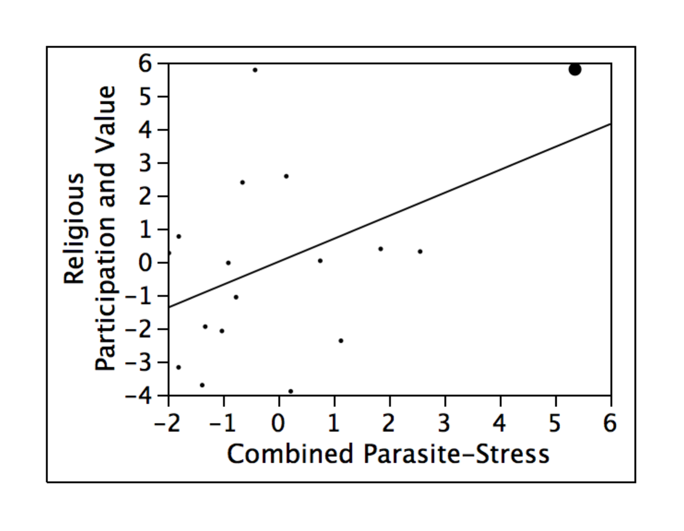
Electronic Supplement 7.D. Religious Participation and Value regressed on Combined Parasite-Stress for the 17 prosperous democracies included in Paul’s sample (2009). The USA datum is the big dot.

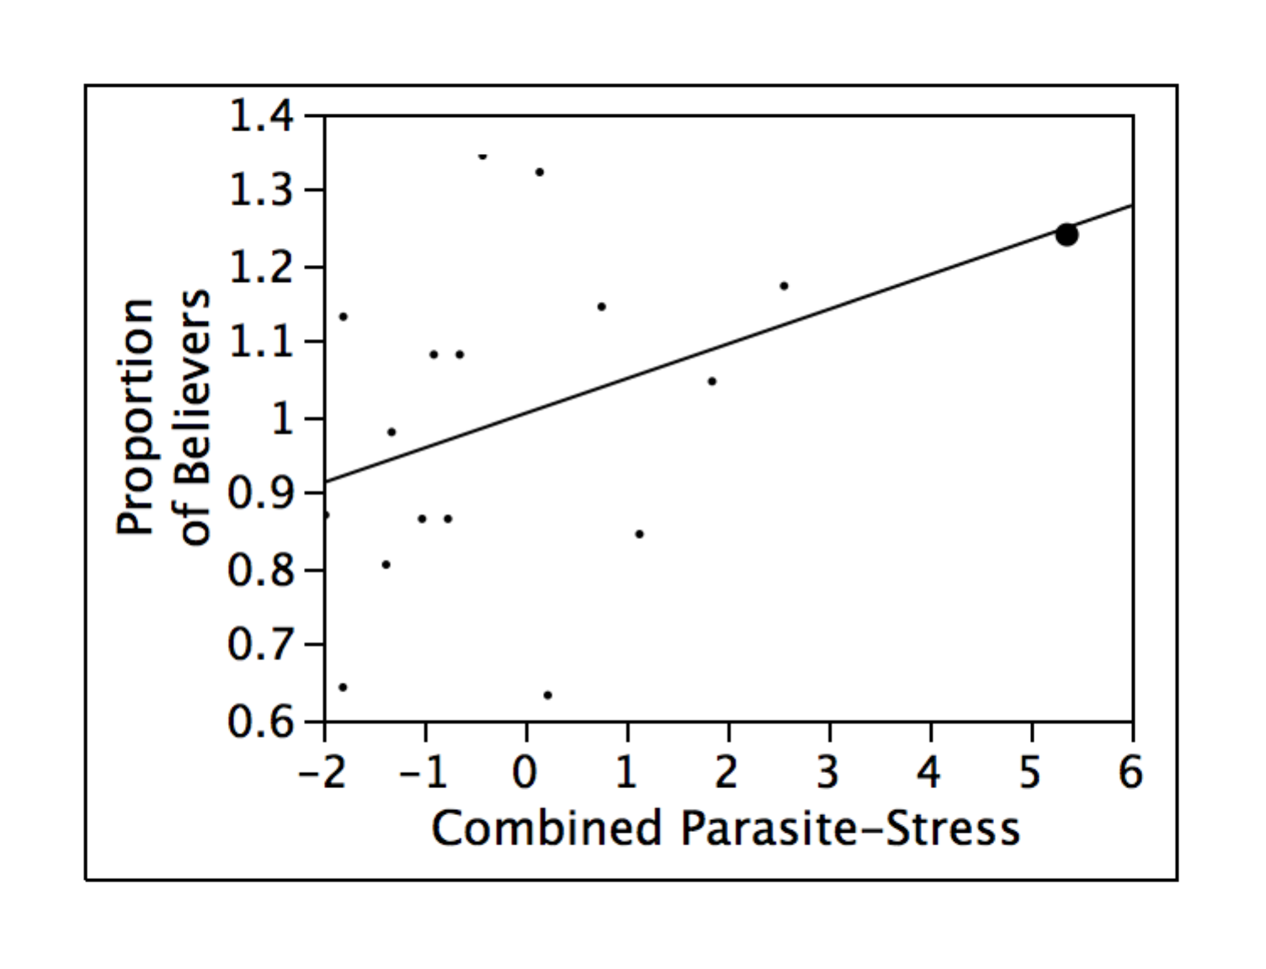
Electronic Supplement 7.E. Proportion of Believers regressed on Combined Parasite-Stress for the 17 prosperous democracies included in Paul’s study (2009). The USA datum is the big dot.

