**Impact of sea ice thickness initialized in April on Arctic sea ice extent predictability with the MIROC climate model**

Jun ONO, Yoshiki KOMURO, Hiroaki TATEBE

*Japan Agency for Marine-Earth Science and Technology, Kanagawa, Japan*

*Corresponding author: Jun Ono (E-mail: jun.ono@jamstec.go.jp)*

*Japan Agency for Marine-Earth Science and Technology, Yokohama, Japan*

*3173-25 Showa-machi, Kanazawa-ku, Yokohama, Kanagawa 236-0001, Japan*

**Contents of this file**

Figures S1 and S2.

The supplementary material contains additional figures and captions S1 and S2.

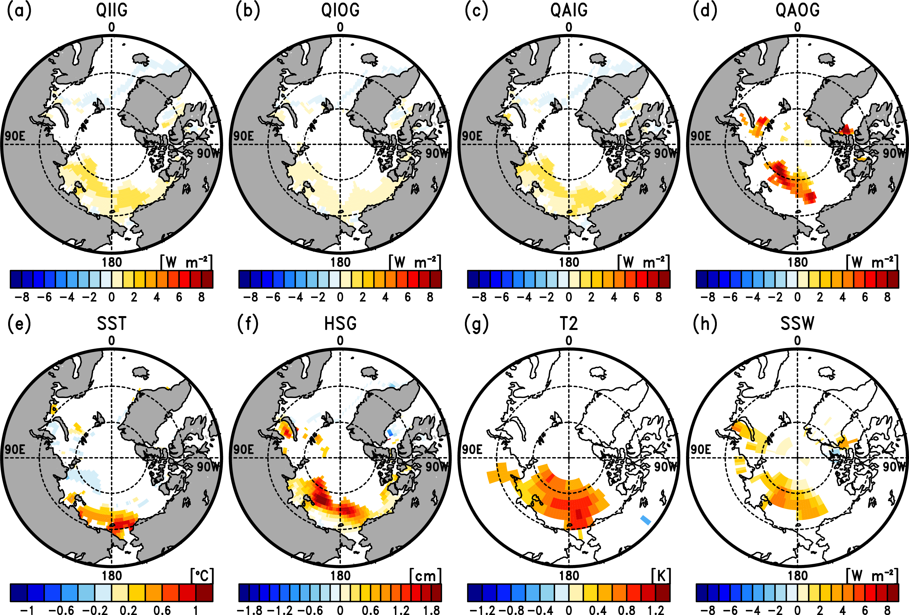**Fig. S1.** Spatial distribution of the difference in the RMSE of (a) conductive heat flux through sea ice, (b) heat flux between the ice and the ocean, (c) heat flux between the atmosphere and ice, (d) heat flux between the atmosphere and ocean, (e) sea surface temperature, (f) snow depth on ice, (g) 2 m temperature, and (h) surface shortwave radiation flux in September (lead months 6) in regions from 60°N to 90°N (Latitude circles of 70°N and 80°N are drawn by dashed circles). All coloured grid points are significant at the 5% level based on a one-sided *F* test.

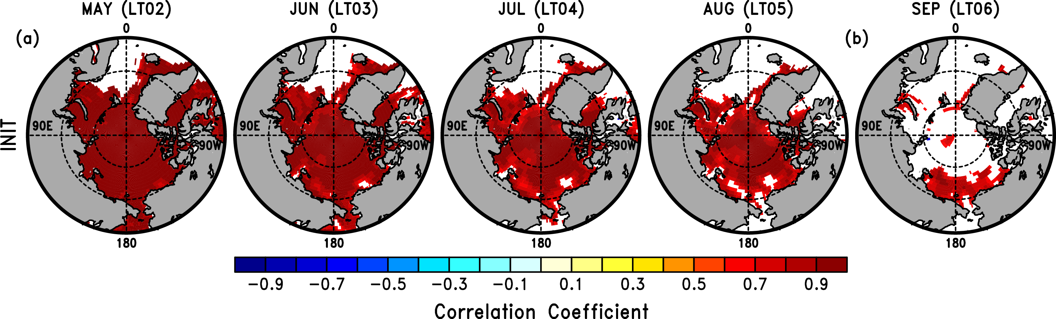**Fig. S2.** (a) Maps of the lagged correlation between the April sea ice thickness anomaly and the May to August (lead time 2 to 5) sea ice thickness anomalies by grid cell in INIT. (b) Same as (a), except for that between the April sea ice thickness anomaly and the September (lead time 6) sea ice concentration anomaly. Regions are from 60°N to 90°N (Latitude circles of 70°N and 80°N are drawn by dashed circles). All coloured grid points are significant at the 5% level based on a two-sided Student’s t test with 8 degrees of freedom.