Supplementary Table 1: Statistical summary of cost (in euros) and effectiveness (QALYs).
Treatment | QALYs (sd) | Cost in euros (sd) | N
d4T+3TC+IND | 0.3958 (0.0639) | 7142.28 (1568.12) | 270
d4T+ddl+IND | 0.4024 (0.0641) | 7302.70 (1702.85) | 95

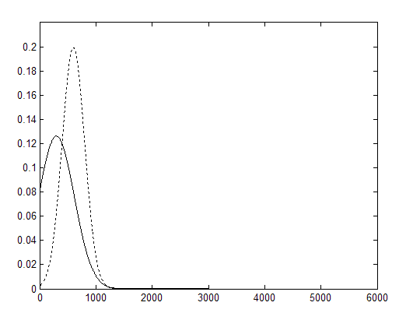
Supplementary Figure 1: Log-normal distributions of Example 2: distribution of c₁ (solid line) and distribution of c₂ (dotted line).

Supplementary Figure 2: (a) Cost-effectiveness plane of T1; (b) Cost-effectiveness plane of T2; (c) Cost-effectiveness plane for treatment’s comparison. Black color: model based on the mean; and Gray color: model based on the posterior distribution of effectiveness and cost. Weak prior information.

Supplementary Figure 3: (a) Cost-effectiveness plane of T1; (b) Cost-effectiveness plane of T2; (c) Cost-effectiveness plane for treatment’s comparison. Black color: model based on the mean; and Gray color: model based on the posterior distribution of effectiveness and cost. Informative prior.

