Supplementary materials
Supplementary Table 1: unit costs material, transportation and personnel input
Material Input
Resource | Value (€/unit)
Print costs per page | 0.04-0.92*
Stamped envelope A4 | 1.01*
Transport | 0.15 (20)
Personnel Input
Resource | Value (€/hour)
Psychologist | 25.65**
Dietician | 20.73**
Physiotherapist | 30.40**
General practitioner | 74 (7)
Cardiologist | 129***
Consultant | 100*
Programmer | 19**
* Hasselt University Records
** Local Hospital Records
*** National Wage Records

Supplementary Table 2: utility values, QALYs and DELTA QALYs
 | Survival rate | Mean baseline utility (±SD) | Mean utility at 6 months (±SD) | Mean utility at 12 months (±SD) | QALY¹ (±SD) | DELTA QALY² (±SD)
Total sample (n=219) | 100% | 0.7669 (±0.09790) | 0.7608 (±0.10400) | 0.7852 (±0.10135) | 0.7684 (±0.08673) | 0.7684 (±0.08702)
Usual Care  (n=72) | 100% | 0.7741 (±0.09503) | 0.7530 (±0.09765) | 0.7792 (±0.08977) | 0.7648 (±0.08196) | 0.7576 (±0.08196)
Intervention (n=147) | 100% | 0.7634 (±0.09940) | 0.7646 (±0.10710) | 0.7882 (±0.10674) | 0.7702 (±0.08919) | 0.7737 (±0.08919)
¹ QALY=(0.5*(baseline utility value +6 months utility value)*6+0.5*(6 months utility value + one year utility value)*6)/12
² DELTA QALY=QALY+ (Mean baseline utility (total sample)-Mean baseline utility of Usual Care/Intervention)

(a) outcomes in DELTA QALYs
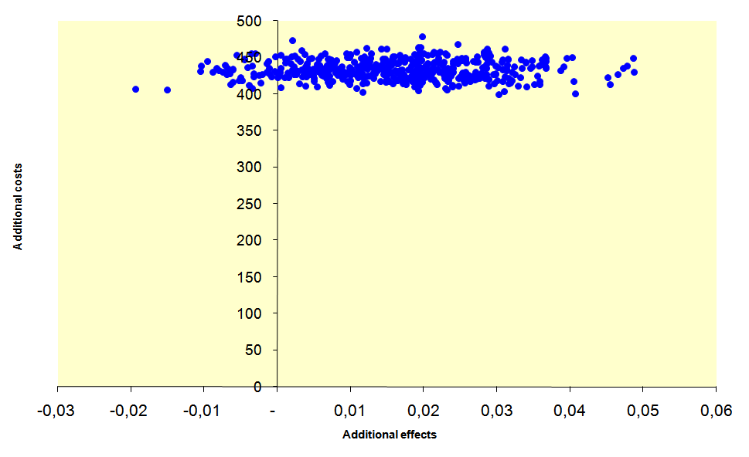
(b) physical activity
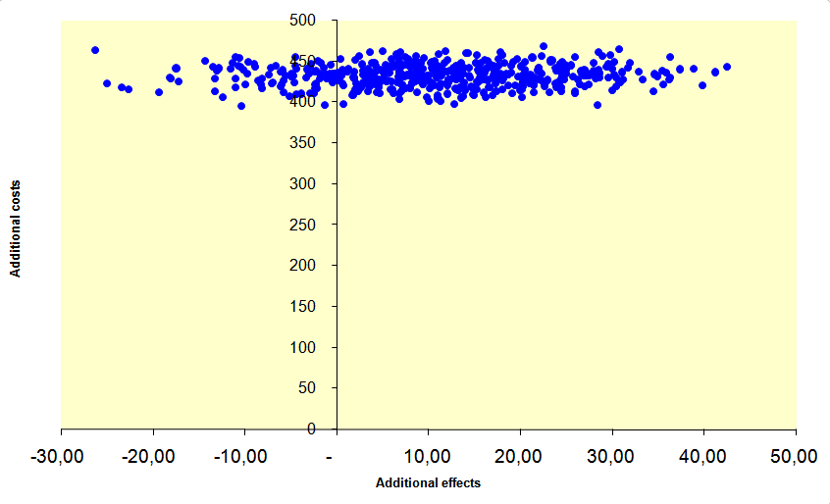
(c) fat intake
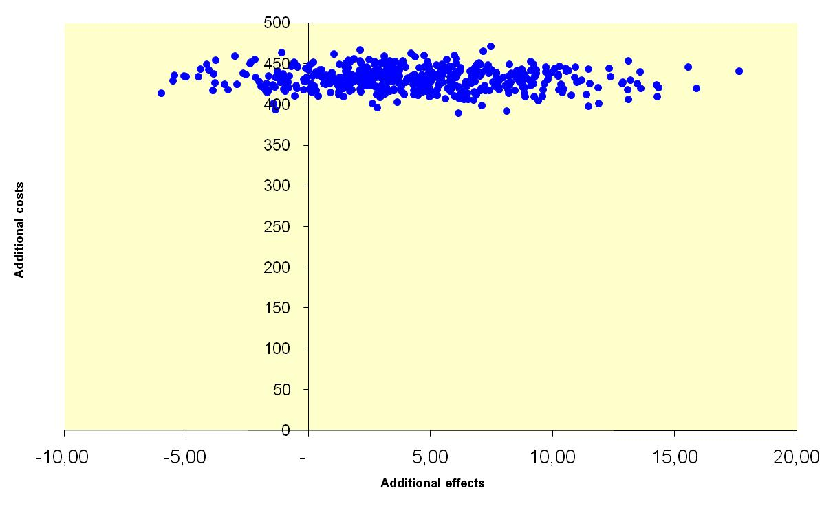
Supplementary Figure 1: cost-effectiveness planes for the outcomes in DELTA QALYs (a), changes in physical activity (b) and changes in fat intake (c)

