Supplementary Fig 1. Outcomes for 20,013 critically ill patients admitted to ICUs, based on data from 200 Italian hospitals [29])
In the model, the patients transferred to wards (same hospital/other hospital) are aggregated.
Supplementary Fig.2. Cost-effectiveness plane for Ala-Gln versus TPN alone in critically ill ICU patients.

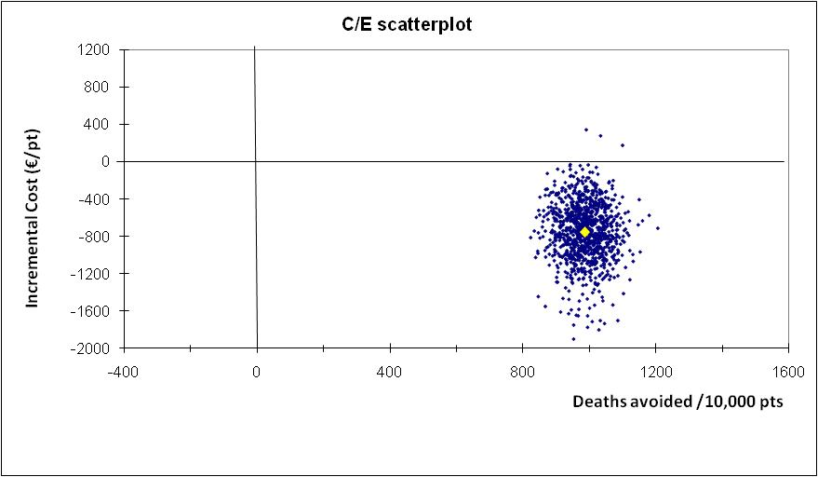

Supplementary Fig.3. Distribution of mean incremental costs for supplementation of TPN with Ala-Glnin critically ill ICU patients. Probabilistic sensitivity analysis with 1,000 simulations.
