Supplementary figure 1 shows the most versus the least scores, three outliners could be identified in this graph (triangular figures); stem cell therapy, HCV vaccination and genetic/genomic biomarkers. These are the emerging technologies with the most preference heterogeneity, in other words this indicates heterogeneity in preferences for these emerging technologies.

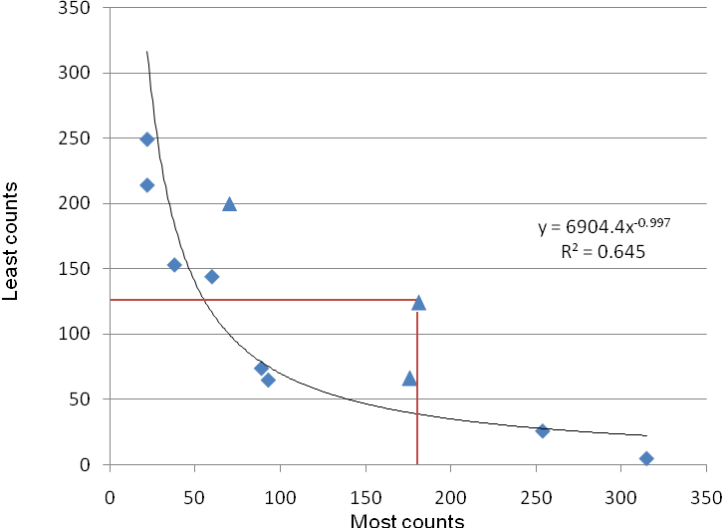
HCC Vaccination
Supplementary Figure 1. Most vs least score for the 11 emerging technologies.

A comparison of estimates from the conditional logit regression against the best/worst scores (supplementary figure 2) indicates how well BWS discriminates among priorities. Supplementary figure 2 outlines the relative difference in the individual level priority scores obtained by these two methods.
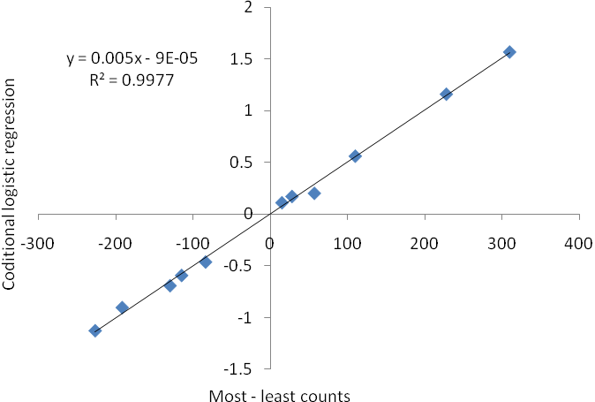

Supplementary Figure 2. Comparison of estimates of subjective priority scores from table 2: conditional logistic regression vs the total most – least counts

