Supplementary Figures

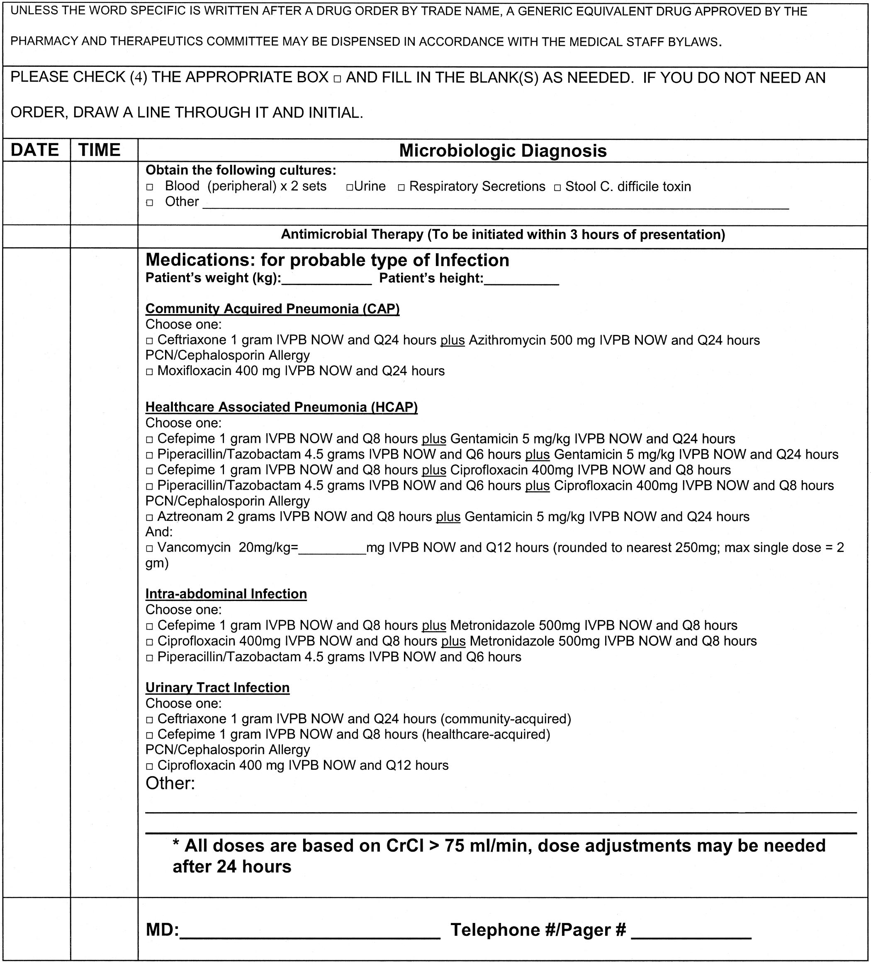

Supplementary Figure 1: Micek et al’s order set for the administration of antibiotic therapy for severe sepsis and septic shock (16).

Supplementary Figure 2: Noschese et al’s order set for standardized diabetes oral medication (18).

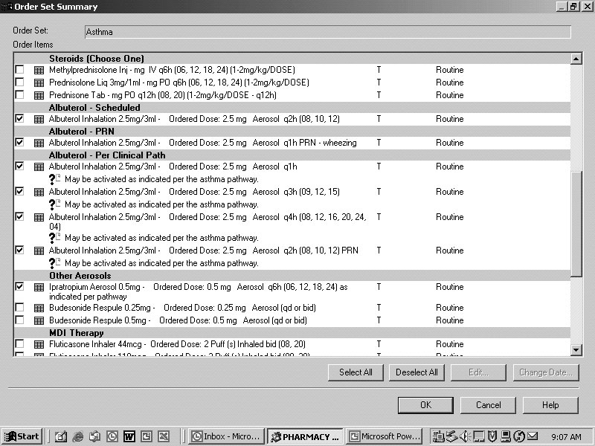
Supplementary Figure 3: Chisolm et al’s CPOE asthma order set (7).

