Supplementary figures
Supplementary figure 1. Structure of the short-term component
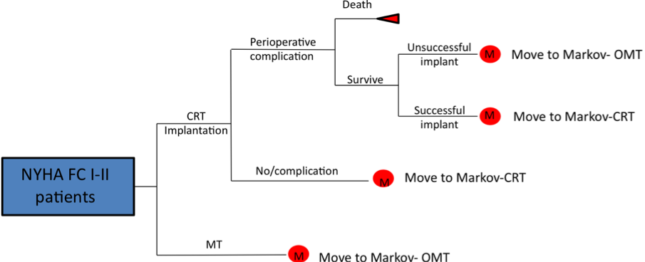

Those patients who received a successful implant moved to the long-term model, either OMT or CRT

Supplementary figure 2. Structure of the Markov model for OMT
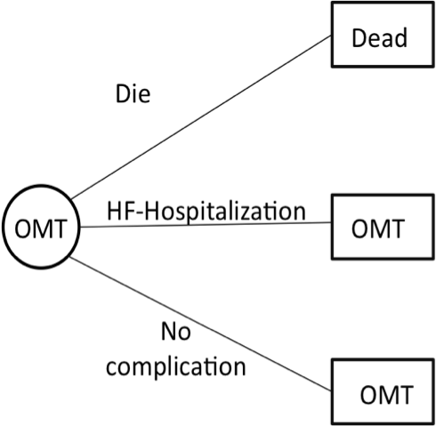

Supplementary figure 3. Structure of the Markov model for CRT

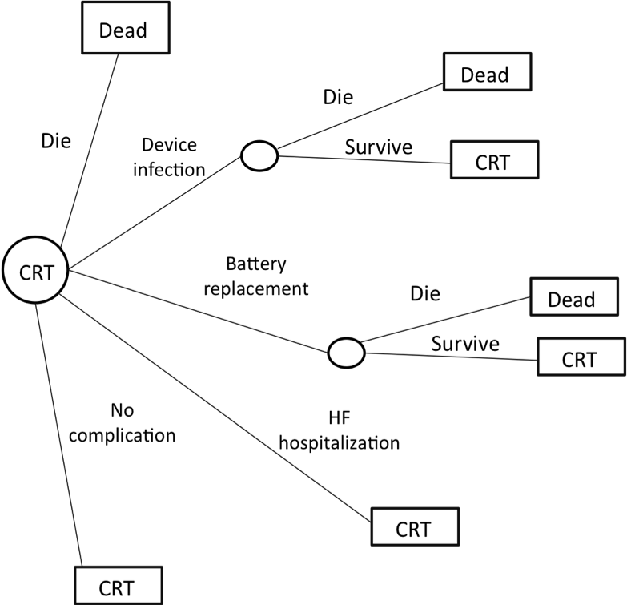

Supplementary figure 4. Meta-analysis of Mortality for any cause
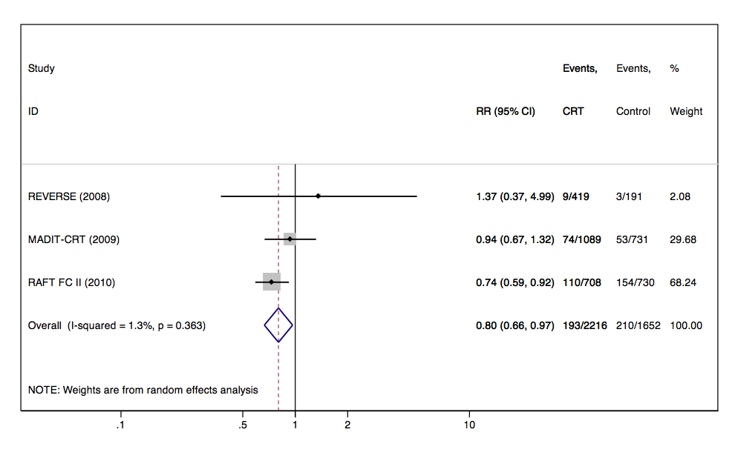

Supplementary figure 5. Meta-analysis of Heart failure admissions
