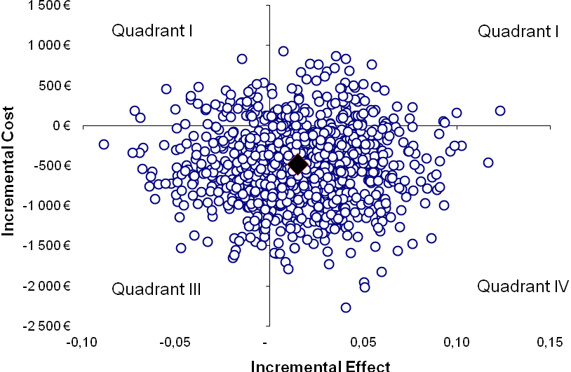
Supplementary Figure 1. Cost-effectiveness plane in hip replacement (diamond stands for the base case result). In 59.5% of simulated cases, SWT was both less costly and more effective (quadrant IV); in 25.4% less costly and less effective (quadrant III); in 10.5% more costly and more effective (quadrant II); in 4.6% more costly and less effective (quadrant I)

