Supplementary Figure 3. Cost-effectiveness Results for Scenario 2

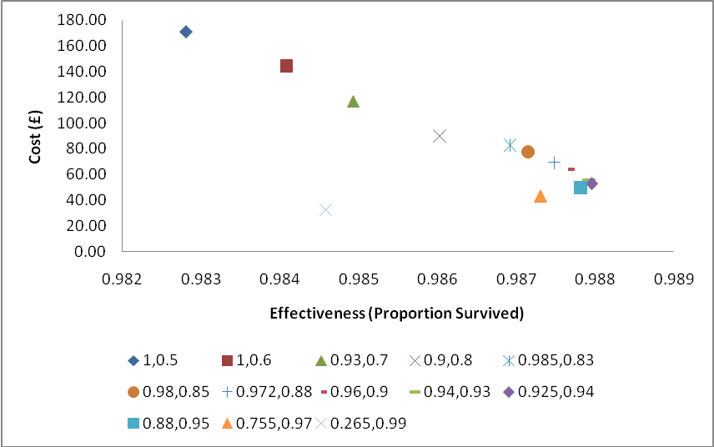
The figure shows the cost and effectiveness results for the range of sensitivity and specificity values for the MCA Doppler in the cost-effectiveness plane.
MCA Doppler, Middle cerebral artery Doppler

