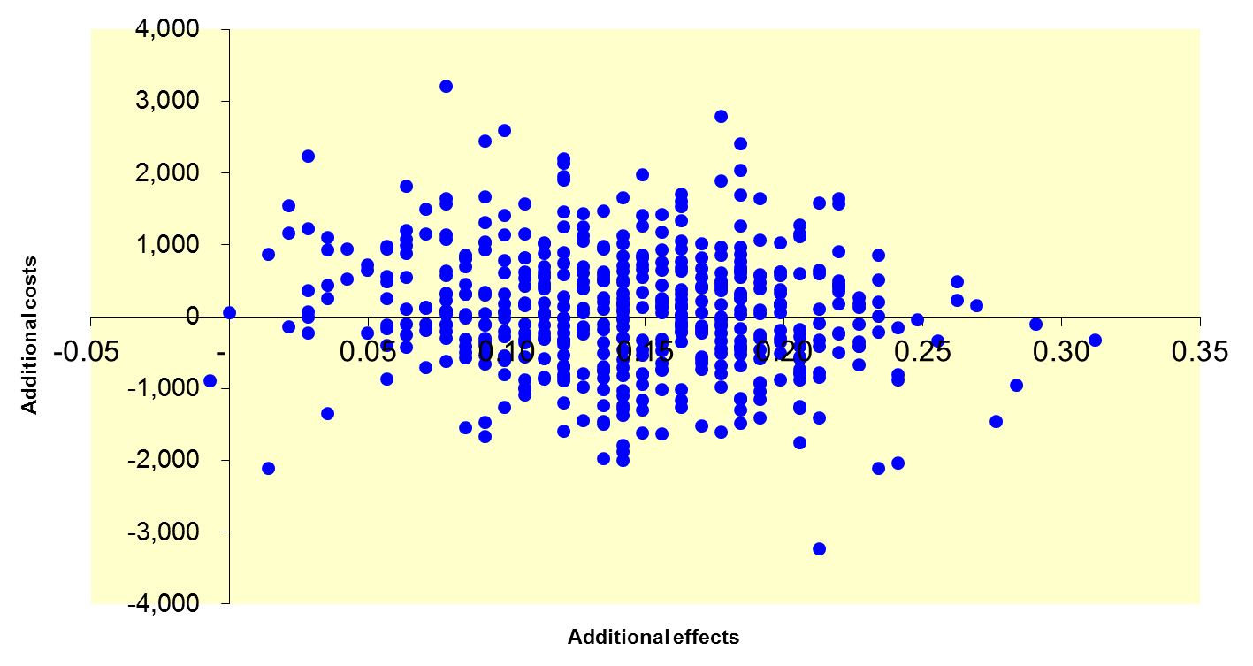
Supplementary figure 2. Cost-effectiveness plane for costs (Euros) versus activity avoidance (base case)

