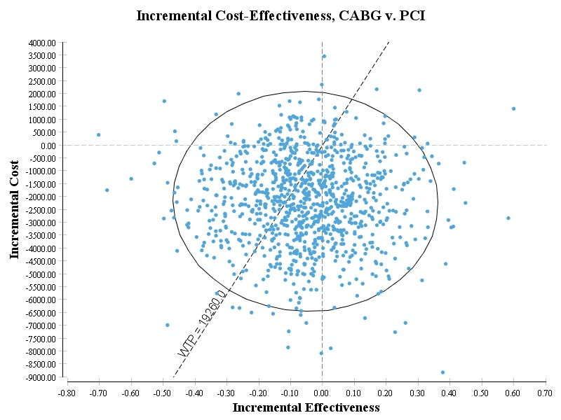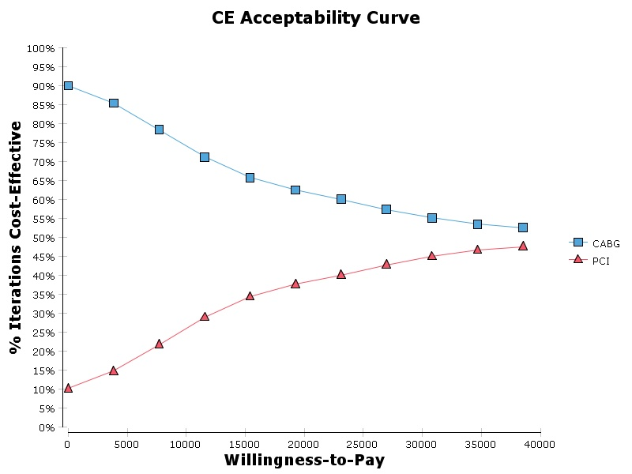
A: Incremental cost effectiveness ratio scatter plot and cost effectiveness acceptability curve in 5 years’ time horizon

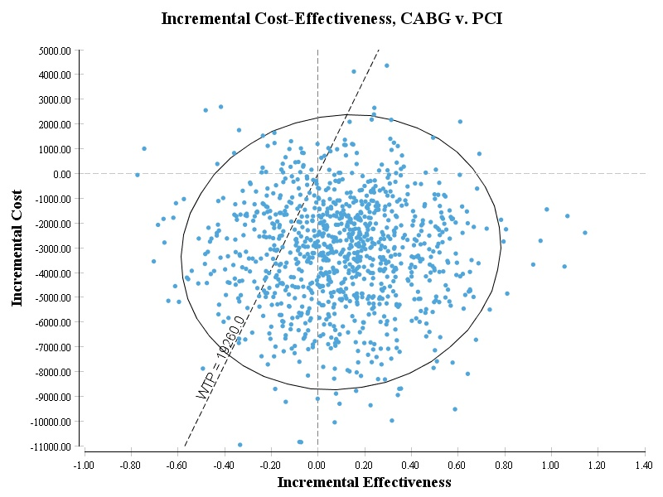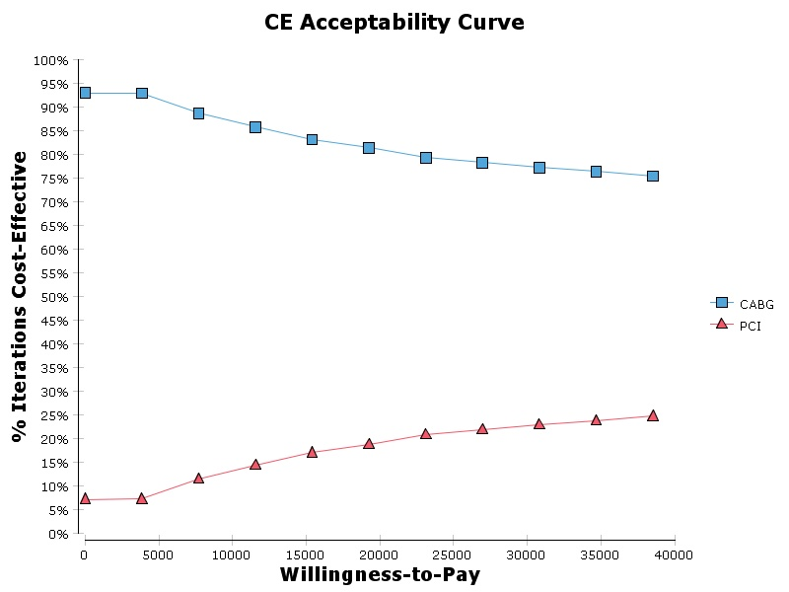
B: Incremental cost effectiveness ratio scatter plot and cost effectiveness acceptability curve in 10 years’ time horizon

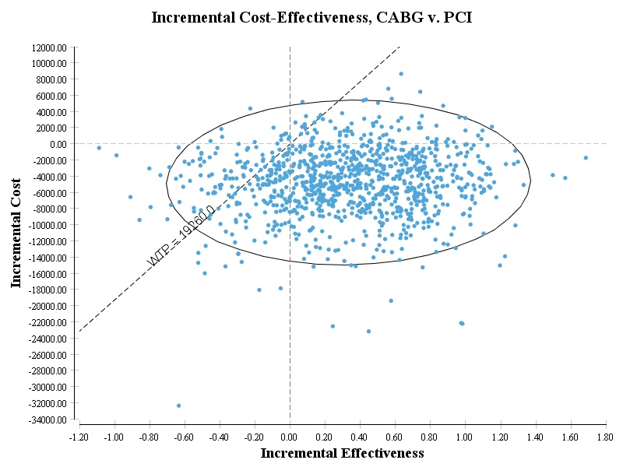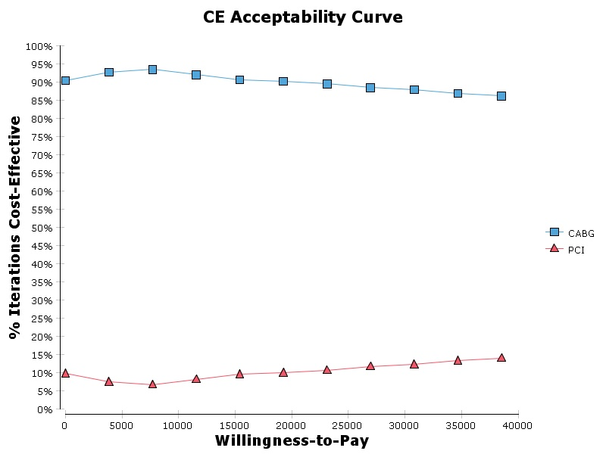
C: Incremental cost effectiveness ratio scatter plot and cost effectiveness acceptability curve in lifetime’s time horizon

Supplementary Figure 1- Results of probabilistic sensitivity analysis in different time horizon (Each point represents the difference in costs and QALYs for CABG vs. PCI in a single simulation), WTO: willingness to pay

