Supplementary figure: Screenshot EUnetHTA Planned and Ongoing (POP) Database
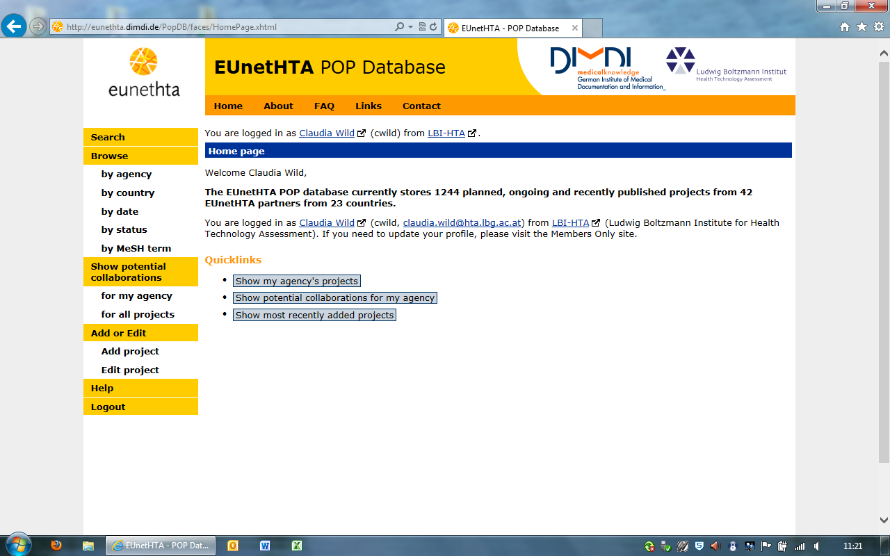
http://eunethta.dimdi.de/PopDB/ (access controlled)

