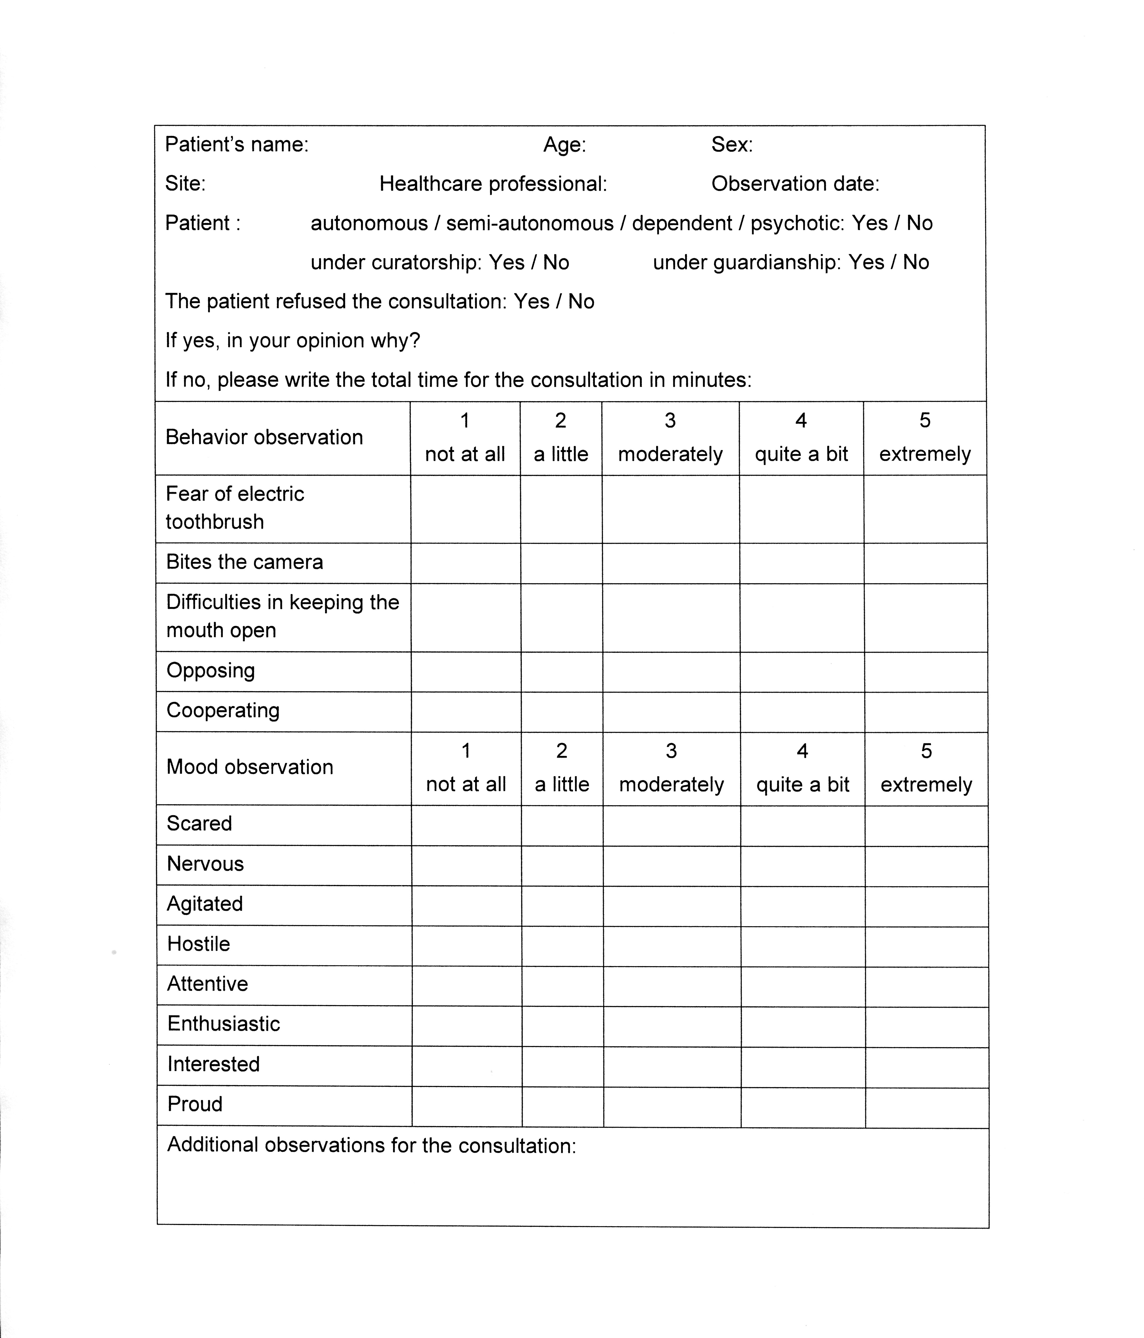

Supplementary Figure 1. The observation form used in the study

