Supplementary Information
Figure S1. Relationship between species richness and relative abundance.
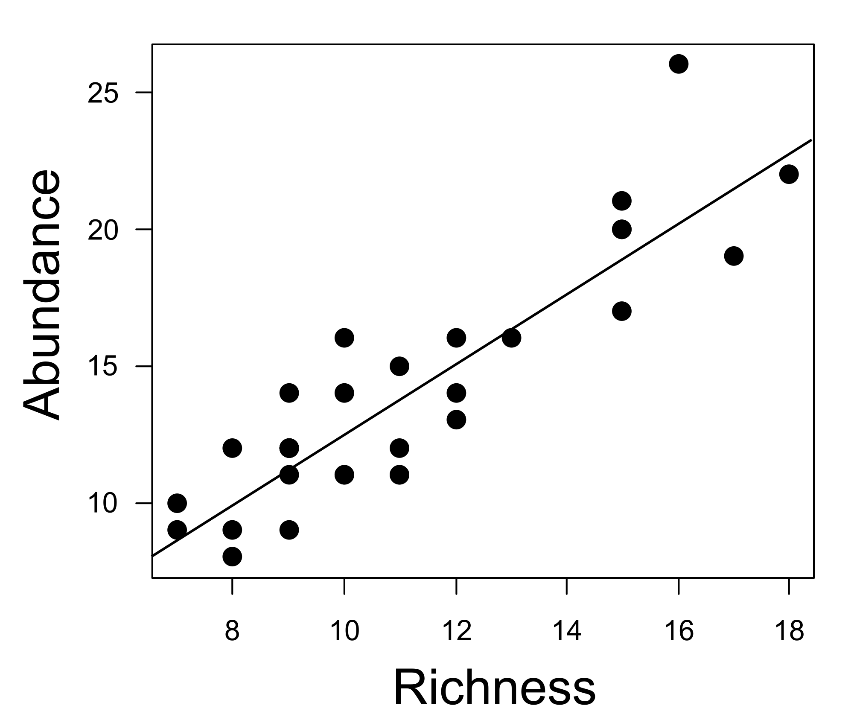
Figure S2. Black arrows showing significant relationship with axes in comparison with gray
arrows.
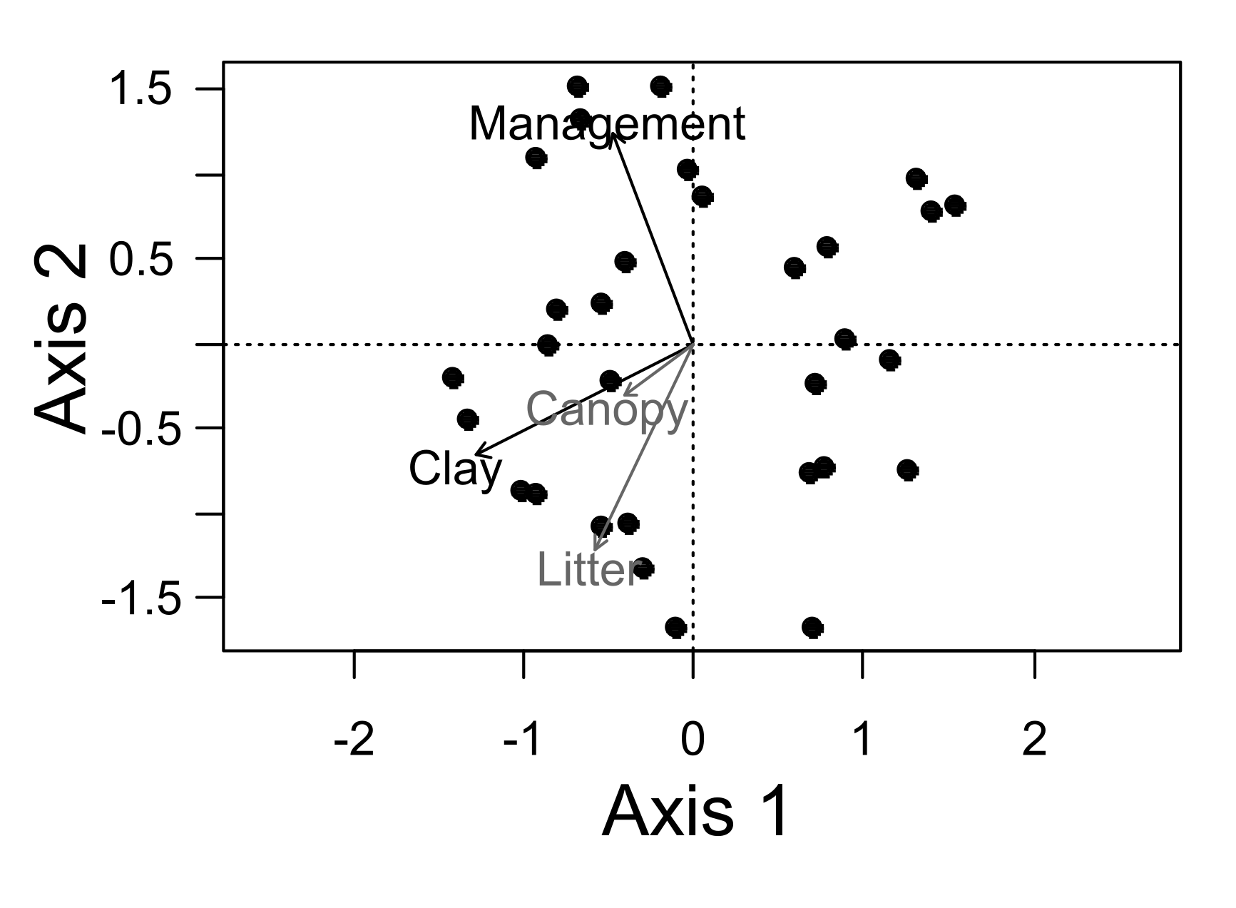

Table S1. Termite species encounters in three modules: module 1, 10 years, module 2, 17 years, module 3, 31 years post-management area. H: Humus-feeders species; I: Intermediate-feeders species; L: Leaf-litter-feeder species; X: Wood-feeders species.
Species | Module 1 | Module2 | Module 3 | Guild
Coptotermes testaceus | 0 | 0 | 1 | X
Anhangatermes macarthuri | 0 | 0 | 2 | H
Cornicapritermes mucronatus | 2 | 2 | 1 | H
Crepititermes verruculosus | 2 | 3 | 1 | H
Angularitermes nasutissimus | 0 | 0 | 1 | H
Angularitermes clypeatus | 1 | 0 | 0 | H
Heterotermes tenuis | 0 | 6 | 2 | X
Neocapritermes unicornis | 0 | 0 | 1 | I
Neocapritermes pumilis | 1 | 4 | 2 | I
Planicapritermes planiceps | 0 | 0 | 1 | I
Rynchotermes diphyes | 1 | 5 | 1 | L
Labiotermes guasu | 0 | 1 | 0 | H
Labiotermes labralis | 0 | 1 | 2 | H
Cylindrotermes flangiatus | 1 | 2 | 0 | X
Cyranotermes karipuna | 0 | 0 | 1 | X
Curvitermes odontognathus | 1 | 1 | 0 | I
Cornitermes sp | 2 | 0 | 2 | L
Dolichorhinotermes sp | 6 | 2 | 3 | X
Microcerotermes cf. strunkii | 0 | 2 | 0 | X
Dentispicotermes sp | 1 | 1 | 4 | I
Termes cf. bolivianus | 0 | 3 | 0 | I
Cyrilliotermes strictinasus | 4 | 1 | 3 | H
Cyrilliotermes angulariceps | 4 | 4 | 3 | H
Embiratermes neotenicus | 5 | 5 | 4 | I
Embiratermes ignotus | 8 | 2 | 3 | I
Mapinguaritermes peruanos | 0 | 0 | 2 | I
Silvestritermes holmgreni | 0 | 1 | 1 | I
Paracurvitermes manni | 0 | 1 | 0 | H
Triangularitermes triangulariceps | 3 | 4 | 0 | I
Atlantitermes oculatissimus | 1 | 1 | 1 | I
Atlantitermes snyderi | 0 | 2 | 0 | I
Atlantitermes sp | 0 | 1 | 1 | I
Rotunditermes rotundiceps | 2 | 3 | 2 | X
Rotunditermes bragantinus | 1 | 3 | 1 | X
Rotunditermes sp | 0 | 6 | 2 | X
Coatitermes cleveland | 1 | 0 | 0 | I
Subulitermes baileyi | 2 | 2 | 1 | H
Ereymatermes sp | 0 | 0 | 1 | I
Nasutitermes gaigei | 3 | 3 | 3 | X
Nasutitermes similis | 8 | 7 | 5 | X
Nasutitermes surinamenses | 0 | 2 | 0 | X
Nasutitermes guayanae | 10 | 11 | 4 | X
Nasutitermes ephratae | 0 | 1 | 0 | X
Nasutitermes octopilis | 0 | 1 | 0 | X
Nasutitermes nigriceps | 2 | 1 | 0 | X
Nasutitermes bivalens | 4 | 0 | 1 | X
Nasutitermes sp1 | 0 | 1 | 0 | X
Nasutitermes sp2 | 0 | 1 | 0 | X
Nasutitermes sp9 | 0 | 1 | 0 | X
Nasutitermes sp13 | 1 | 3 | 1 | X
Nasutitermes sp3 | 0 | 1 | 0 | X
Nasutitermes sp6 | 3 | 1 | 0 | X
Diversitermes sp | 4 | 1 | 0 | I
Velocitermes velox | 3 | 2 | 3 | L
Velocitermes beebei | 2 | 1 | 1 | L
Anoplotermes sp1 | 2 | 4 | 3 | H
Anoplotermes sp2 | 2 | 5 | 2 | H
Anoplotermes sp3 | 7 | 10 | 0 | H
Aparatermes sp1 | 0 | 2 | 0 | H
Longustitermes manni | 1 | 1 | 1 | H
Tetimatermes sp | 0 | 1 | 1 | H
Ruptitermes sp1 | 0 | 0 | 1 | L
Ruptitermes sp2 | 4 | 4 | 1 | L
Ruptitermes sp5 | 1 | 0 | 0 | L
Ruptitermes sp6 | 0 | 0 | 1 | L
Grigiotermes sp1 | 2 | 2 | 2 | H
Genus n1 sp1 | 3 | 1 | 0 | H
Genus n2 sp1 | 1 | 0 | 0 | H
Genus n3 sp1 | 2 | 2 | 0 | H
Genus n4 sp1 | 1 | 6 | 0 | H
Genus n4 sp2 | 1 | 0 | 1 | H
Genus n5 sp1 | 1 | 2 | 0 | H
Abundance | 117 | 147 | 81
Richness | 43 | 55 | 44

Table S2. Coefficients of the association between predictor environmental variables and termite species richness by trophic group. SH: Humus-feeders species richness; SI: Intermediate-feeders species richness; SL: Leaf-litter-feeder species richness; SX: Wood-feeders species richness. Only the model for SH was significantly different from null expectation.
 | Time-management | Clay | Canopy | Litter | F | df | R²
SH | -0.15 | -0.52* | 0.49 | -0.19 | 2.04 | 26 | 0.12
SI | 0.13 | -0.05 | 0.29 | -0.28 | 0.66 | 26 | 0
SL | 0.12 | -0.14 | -0.36 | 0.64** | 2.07 | 26 | 0.12
SX | -0.42** | -0.48* | 0.04 | -0.41* | 6.71 | 26 | 0.43***
***p<0.001, **p<0.01; *p<0.05

