Section A. Grammar Pretest

SP277 FIRST PROFICIENCY TEST

Name ______________________ Section____________________

Part 1. For each sentence please provide the appropriate Spanish translation for all of the underlined words.

 | SENTENCE | ANSWER
1 | I sold my house before the prices went up.
2 | I recognized my math teacher in the grocery store.
3 | He was looking for his glasses when he saw the stain on the carpet.
4 | You found my missing gloves in the car.
5 | After a long disease, her grandmother died.
6 | Marisa and Nicole graduated from Michigan and then completed their residence at Northwestern.
7 | When Linda was living in Mexico she would always write a journal.
8 | She would always work in the lab while her boyfriend talked to his friends in the bar.
9 | My father would always run to the gym while his sister walked.
10 | Lola was preparing dinner when her husband arrived home.
11 | Manuel would always sail from Valencia to Ibiza.
12 | When I was a graduate student I would always travel to Hawaii to learn Hawaiian.
13 | Mariela got married and right afterwards she bought a cat.
14 | They knew she was studying Spanish, but they didn’t know she could speak so well.
15 | My brothers came home complaining today, they are bothered by my parents’ sudden divorce.
16 | Don’t tell the kids they worry too much! They are very responsible and they care about their sickly grandmother.
17 | I’m so happy to be here, don’t you love that view?
18 | My friend Peter doesn’t like reading as much. On the contrary, he is interested in video games.
19 | Don’t leave the room so quickly kids, I think that you have one exam left to prepare for tomorrow.
20 | Lourdes, explain this to us, you only like cats. What about the other animals?
21 | He told me that it is possible that he sends it tomorrow, but it will depend on the weather.
22 | Please clean yourself up, your mother wants you to come to the living room and meet the new neighbors.
23 | You may be very strict with your daughters, but it is true that you are a very good father.
24 | It is irrefutable that we have worked harder on this group project than you have.
25 | As soon as the guests arrive to the hotel tomorrow, Maria wishes that we show them the gardens first.
26 | Maria acknowledges that she is being unfair, but she knows that her girlfriend respects her wishes.
27 | Dear respected Professors, I don’t understand why, but it is obvious that you give me more work than anyone else in the office.
28 | Your father and I will see you at the County Fair unless it rains.
29 | Dear boss, I know things got off to a rough start, nonetheless, Mary and I are happy that you work with us on this.
30 | You heard what the doctor said, if you just ate, he recommends that you wait half an hour before jumping into the pool again.
31 | Dear students, for the final essay, the professor suggests that you think about a topic early in the semester.
32 | Daniel and Enrique need to make more of an effort in their schoolwork because we see that they go to all of the parties but not to his classes.
33 | Sir, you may seem content with this decision, but it’s clear that you want to be the lead engineer.
34 | And Elena told her husband the following: “It angers me that your sister calls me in the middle of the night to ask for money”.
35 | Although I don’t like wearing sneakers, it is obvious that I walk faster with them.
36 | You are only 10 points away from qualifying for this offer, but given your history, it seems to me that we can make an exception.
37 | Dear workers, my father loves your Lamborghinis. He believes that you build them by hand here, in Sant’Agata Bolognese.
38 | The weather is going to be so bad that I don’t think we are going to go to the movies.
39 | Peter doesn’t care what you say, he doubts that there is anyone as honest as my father.
40 | Wait for me in the lobby, as soon as I finish this call I’ll come get you.
41 | I know that the girls want more independence, but it is important that they understand that both of them are still underage.

Part 2. Now you will see another group of sentences in English. Read them carefully and provide the appropriate Spanish translation for all of the underlined words. This time use only ONE word in Spanish for each response.

 | SENTENCE | ANSWER
1 | When I was boy I used to play with toys every day.
2 | After working all day long, they probably were hungry.
3 | After the terrible results of tonight’s auction, John must be devastated.
4 | Where was George when the accident happened? I wonder if he was at home.
5 | When I was a boy, we would go to the movies.
6 | After they arrived they drank lots of water. That day they must have run more than 25 kilometers!
7 | It’s 11 o’clock and María hasn’t arrived yet. She must be sick.
8 | He spent too much money while in Spain. I think he must have spent more than $4000.
9 | Yesterday we arrived to the MLB and Juan wasn’t there. He must have been drinking coffee!
10 | Marcos is throwing up. He must be hungover.

Section B. Supplementary Tables

Table B.1. Vocabulary targets and frequency information.
Word | Session | Word Type | NIM Frequency
emparedado | 1 | noun | 0.18
sombrilla | 1 | noun | 4.26
alberca | 1 | noun | 1.07
sandía | 1 | noun | 1.07
sigiloso | 1 | adjective | 2.13
lancha | 1 | noun | 1.95
frenos | 1 | noun | -
dormilonas | 2 | noun | -
caniches | 2 | noun | 0.36
sobremesa | 2 | noun | 0.71
impúdico | 2 | adjective | 0.89
espejuelos | 2 | noun | -
holgazán | 2 | adjective | 0.18
estantería | 3 | noun | 2.66
vergel | 3 | noun | 1.07
alambrado | 3 | noun | 0.36
boceto | 3 | noun | 1.07
valija | 3 | noun | 2.31
atolondrado | 3 | adjective | 0.18
alhajas | 4 | noun | 1.78
antro | 4 | noun | 1.78
huésped | 4 | noun | 7.46
lingotazo | 4 | noun | 0.18
Note. Session 1 = preterite and imperfect; session 2 = gustar-type verbs; session 3= subjunctive in noun clauses; session 4= conditional mood. Vocabulary words that do not include frequency information are target words that were selected from a regional dialect.

Table B.2. Group Proportion Correct Scores for Vocabulary Recognition and Translation at Immediate Posttest.
Group | Mean | SD | 95% CI
Group Accuracy scores for Recognition

Lesson+Control | 0.569 | 0.119 | [0.541, 0.596]
Lesson+SV | 0.859 | 0.095 | [0.837, 0.881]
Lesson+SG | 0.758 | 0151 | [0.725, 0.791]
No Lesson+SG | 0.788 | 0.106 | [0.765, 0.811]
Group Accuracy scores for Translation

Lesson+Control | 0.182 | 0.141 | [0.149, 0.214]
Lesson+SV | 0.488 | 0.199 | [0.441, 0.534]
Lesson+SG | 0.379 | 0.197 | [0.336, 0.423]
No Lesson+SG | 0.378 | 0.204 | [0.334, 0.422]
Note. CI = confidence interval; SV= Salience on Vocabulary; SG=Salience on Grammar.

Table B.3. Group Proportion Correct Scores for the Vocabulary Translation Delayed Posttest
Group | Mean | SD | 95% CI
Lesson+Control | 0.065 | 0.094 | [0.043, 0.087]
Lesson+SV | 0.085 | 0.115 | [0.058, 0.112]
Lesson+SG | 0.092 | 0.101 | [0.070, 0.114]
No Lesson+SG | 0.094 | 0.105 | [0.071, 0.117]

Table B.4. Group Proportion Correct Scores for Pretest Grammar Translation by Structure.

Group | Mean | SD | 95% CI
Accuracy scores for the preterite and imperfect contrast

Lesson+Control | 0.539 | 0.275 | [0.476, 0.603]
Lesson+SV | 0.488 | 0.276 | [0.423, 0.552]
Lesson+SG | 0.486 | 0.253 | [0.430, 0.541]
No Lesson+SG | 0.556 | 0.281 | [0.496, 0.617]
Accuracy scores for gustar-type verbs

Lesson+Control | 0.308 | 0.274 | [0.245, 0.372]
Lesson+SV | 0.251 | 0.198 | [0.205, 0.298]
Lesson+SG | 0.250 | 0.244 | [0.196, 0.304]
No Lesson+SG | 0.267 | 0.222 | [0.219, 0.315]
Accuracy scores for the subjunctive in noun clauses
Lesson+Control | 0.153 | 0.222 | [0.102, 0.205]
Lesson+SV | 0.184 | 0.243 | [0.128, 0.241]
Lesson+SG | 0.165 | 0.224 | [0.116, 0.214]
No Lesson+SG | 0.196 | 0.229 | [0.147, 0.246]
Accuracy scores for the conditional mood

Lesson+Control | 0.122 | 0.208 | [0.074, 0.170]
Lesson+SV | 0.102 | 0.173 | [0.061, 0.143]
Lesson+SG | 0.089 | 0.147 | [0.056, 0.121]
No Lesson+SG | 0.129 | 0.183 | [0.090, 0.169]

Table B.5. Group Proportion Correct Scores for Immediate Grammar Translation by Structure.
Group | Mean | SD | 95% CI
Accuracy scores for the preterite and imperfect contrast

Lesson+Control | 0.656 | 0.105 | [0.632, 0.680]
Lesson+SV | 0.662 | 0.114 | [0.636, 0.689]
Lesson+SG | 0.642 | 0.136 | [0.612, 0.672]
No Lesson+SG | 0.629 | 0.129 | [0.601, 0.657]
Accuracy scores for gustar-type verbs

Lesson+Control | 0.883 | 0.097 | [0.861, 0.906]
Lesson+SV | 0.875 | 0.099 | [0.852, 0.898]
Lesson+SG | 0.879 | 0.112 | [0.855, 0.904]
No Lesson+SG | 0.814 | 0.157 | [0.780, 0.848]
Accuracy scores for the subjunctive in noun clauses
Lesson+Control | 0.779 | 0.166 | [0.741, 0.818]
Lesson+SV | 0.772 | 0.202 | [0.725, 0.819]
Lesson+SG | 0.750 | 0.207 | [0.704, 0.796]
No Lesson+SG | 0.779 | 0.166 | [0.697, 0.799]
Accuracy scores for the conditional mood

Lesson+Control | 0.881 | 0.279 | [0.817, 0.946]
Lesson+SV | 0.924 | 0.219 | [0.872, 0.975]
Lesson+SG | 0.862 | 0.278 | [0.800, 0.922]
No Lesson+SG | 0.359 | 0.379 | [0.277, 0.440]

Table B.6. Group Proportion Correct Scores for Delayed Grammar Translation by Structure.
Group | Mean | SD | 95% CI
Accuracy scores for the preterite and imperfect contrast

Lesson+Control | 0.685 | 0.145 | [0.651, 0.719]
Lesson+SV | 0.670 | 0.129 | [0.640, 0.701]
Lesson+SG | 0.659 | 0.117 | [0.633, 0.685]
No Lesson+SG | 0.681 | 0.124 | [0.654, 0.707]
Accuracy scores for gustar-type verbs

Lesson+Control | 0.889 | 0.102 | [0.865, 0.914]
Lesson+SV | 0.913 | 0.095 | [0.891, 0.935]
Lesson+SG | 0.885 | 0.084 | [0.866, 0.903]
No Lesson+SG | 0.884 | 0.111 | [0.859, 0.908]
Accuracy scores for the subjunctive in noun clauses
Lesson+Control | 0.838 | 0.126 | [0.809, 0.867]
Lesson+SV | 0.852 | 0.118 | [0.824, 0.879]
Lesson+SG | 0.839 | 0.154 | [0.805, 0.873]
No Lesson+SG | 0.850 | 0.121 | [0.824, 0.876]
Accuracy scores for the conditional mood

Lesson+Control | 0.332 | 0.377 | [0.244, 0.419]
Lesson+SV | 0.279 | 0.379 | [0.189, 0.367]
Lesson+SG | 0.219 | 0.342 | [0.1430.294]
No Lesson+SG | 0.224 | 0.319 | [0.155, 0.293]

Table B.7. Pretest-Delayed Posttest Grammar Translation emmeans contrasts summary for Lesson+SG versus No Lesson+SG.
Time-Pairwise | Group-Pairwise | Coef. Β | SE | z | p
 |  | Contrasts for the Preterite and Imperfect
Pre-test -Delayed Posttest | Control – Vocabulary | 0.149 | 0.128 | 1.164 | 0.245
 | Control – Grammar | 0.114 | 0.127 | 0.898 | 0.369
 | Vocabulary – Grammar | 0.035 | 0.123 | 0.287 | 0.774
 |  | Contrasts for Gustar-type verbs
Pre-test -Delayed Posttest | Control – Vocabulary | 0.630 | 0.209 | 3.005 | 0.002
 | Control – Grammar | 0.289 | 0.205 | 1.413 | 0.158
 | Vocabulary – Grammar | 0.341 | 0.212 | 1.605 | 0.109
 |  | Contrasts for the Subjunctive in Noun Clauses
Pre-test -Delayed Posttest | Control – Vocabulary | -0.113 | 0.199 | -0.569 | 0.569
 | Control – Grammar | -0.030 | 0.201 | -0.153 | 0.878
 | Vocabulary – Grammar | -0.083 | 0.199 | -0.416 | 0.677
 |  | Contrasts for the Conditional
Pre-test -Delayed Posttest | Control – Vocabulary | 0.072 | 0.291 | 0.248 | 0.804
 | Control – Grammar | -0.178 | 0.287 | -0.622 | 0.534
 | Vocabulary – Grammar | 0.251 | 0.301 | 0.832 | 0.405
Note. Control = Lesson+Control; Vocabulary = Lesson+Vocabulary; Grammar = Lesson+Grammar. Results are given on the log odds ratio (not the response) scale. P value adjustment: Tukey method for comparing a family of 3 estimates.

Table B.8. Pretest-Delayed Posttest grammar translation emmeans contrasts summary for Lesson+SG versus No Lesson+SG
Time-Pairwise | Group-Pairwise | Coef. Β | SE | z | p
 |  | Contrasts for the Preterite and Imperfect
Pre-test -Delayed | Lesson+Grammar–  No Lesson+Grammar | -0.217 | 0.120 | -1.808 | 0.070
 |  | Contrasts for Gustar-type verbs
Pre-test -Delayed | Lesson+Grammar–  No Lesson+Grammar | -0.110 | 0.202 | -0.551 | 0.582
 |  | Contrasts for the Subjunctive in Noun Clauses
Pre-test -Delayed | Lesson+Grammar–  No Lesson+Grammar | -0.170 | 0.193 | -0.885 | 0.376
 |  | Contrasts for the Conditional
Pre-test -Delayed | Lesson+Grammar–  No Lesson+Grammar | -0.531 | 0.277 | -1.92 | 0.054
Note. Results are given on the log odds ratio (not the response) scale. P value adjustment: Tukey method for comparing a family of 3 estimates.

Section C. Supplementary Figures

Figure C.1. Illustrated above are representative

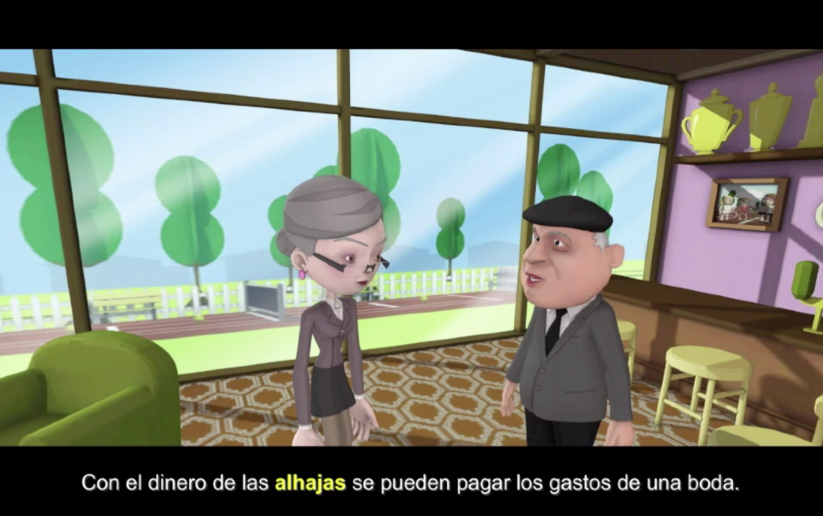
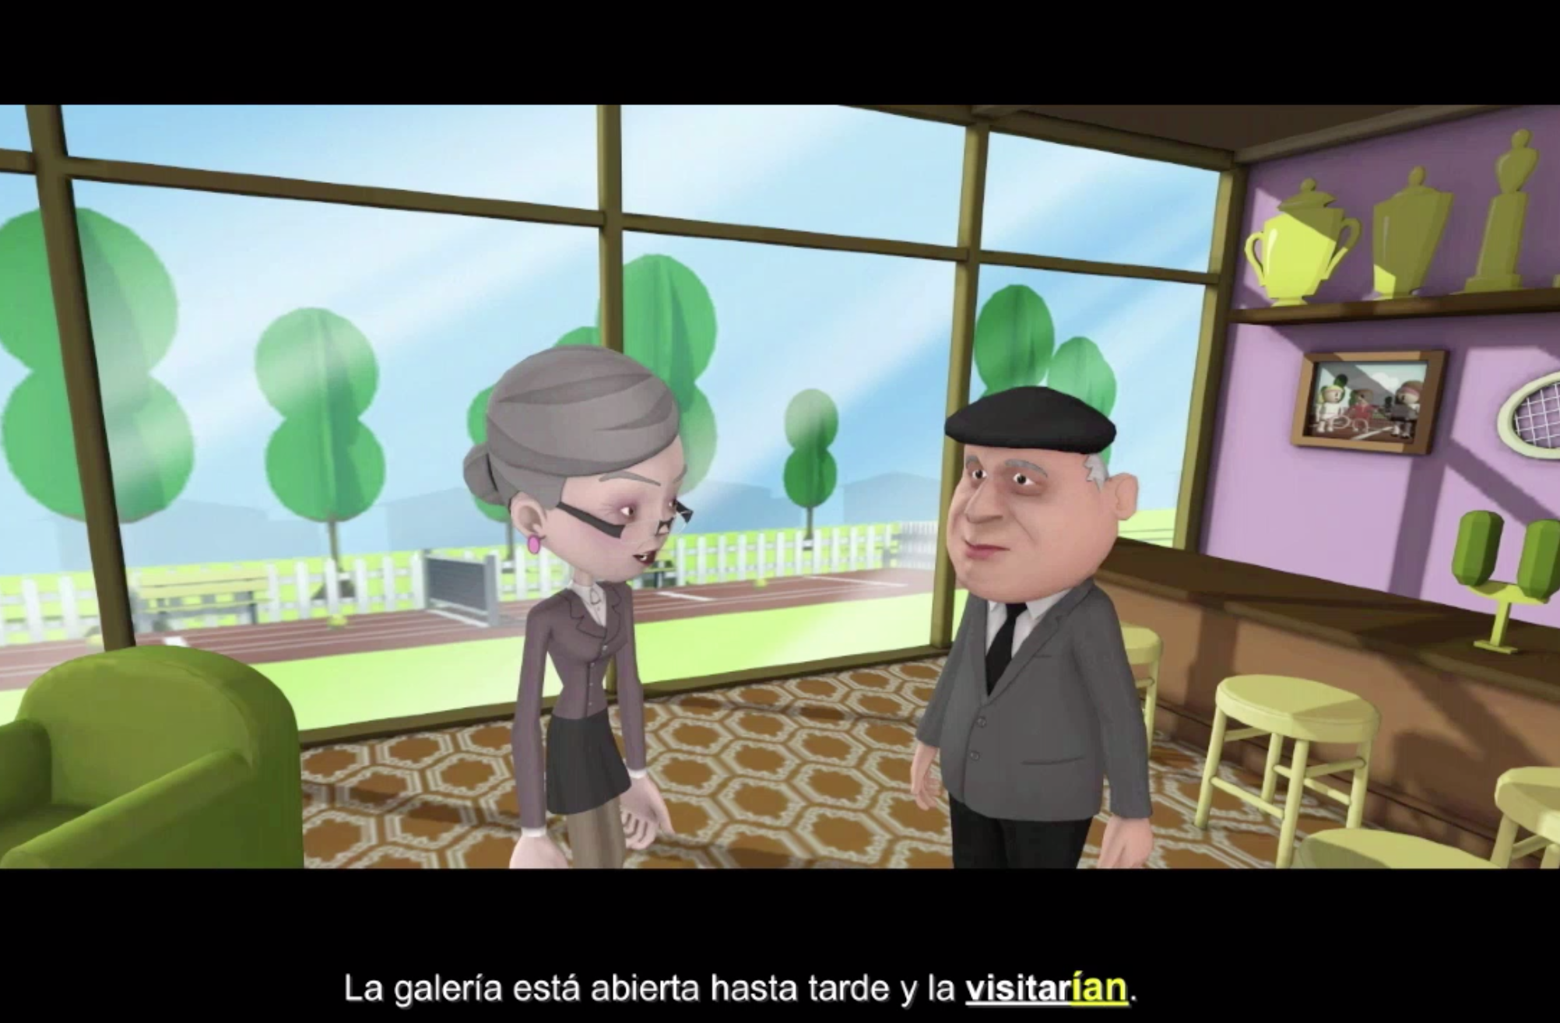

A

B

C

Figure C.2. Illustration of all three condition types taken from the Conditional mood session. (A) Participants in the Lesson+Control group did not receive subtitles in their treatment. (B) Participants in the Lesson+Salience on Vocabulary group received subtitles where the target vocabulary was highlighted in bold and yellow. (C) Participants in the Lesson+Salience on Grammar and the No Lesson+Salience on Grammar groups received subtitles in which the conditional target verb was underlined, and the target morpheme appeared in bold and yellow.

Section D. Spanish Animated Video Script for the Conditional

Note: Highlighted in blue are the target vocabulary items; highlighted in yellow are the conditional target verb instances.

PART 1

[la estación de policía]

- Sherlock: [RING RING] 091 sí dígame.
- Propietaria: ¿Policía?
- Sherlock: Sí, sí esta es la oficina de policía local. Le habla el detective García.
- Propietaria: Necesito que alguien venga a mi hotel . Anoche me robaron las alhajas de mi madre.
- Sherlock: ¿Cómo se llama el hotel?
- Propietaria: Es el Hotel Renaissance
- Sherlock: ¿Y dónde se encuentra?
- Propietaria: Está en la Avenida Villalobos, número 1.
- Sherlock: Necesito un detalle más para completar mi informe. ¿En cuánto cree que estaban valoradas las joyas de su madre?
- Propietaria: Estaban valoradas en 1,000,000 dólares.
- Sherlock: Eso es muchísimo dinero. Estaré allí en 5 minutos. ¡Hasta pronto!
- Propietaria: Le espero. Muchas gracias.

[en el hotel]

- Propietaria: Detective García, gracias por venir.
- Sherlock: No hay problema. A ver, dígame, entonces ayer hubo un robo en su hotel. Por casualidad, ¿vió quién lo hizo?
- Propietaria: No, pero tengo 6 huéspedes en el hotel. Quizás fue alguno de ellos.
- Sherlock: Vayamos con calma. ¿Quiénes se quedaron en su hotel ayer por la noche?
- Propietaria: Se quedaron 3 parejas: Carmen y Laura (secretaria), Pablo y Lola, y Carlos y Ana.
- Sherlock: Son muchos clientes para un hotel pequeño. ¿Dónde cree que están ahora?
- Propietaria: Señor, pues ahora no hay nadie en el hotel pero espero que vuelvan a lo largo del día.
- Sherlock: Eso espero yo también. Pues cuando vuelvan dígales que permanezcan en la recepción del hotel porque la policía quiere hablar con ellos.
- Propietaria: Claro que sí, Sr. detective.
- Sherlock: Por ahora son todos posibles sospechosos y no pueden ir a ninguna parte hasta que sean investigados.
- Propietaria: No se preocupe. Les diré que tienen que hablar con la policía.
- Sherlock: Hablemos un poco sobre cada cliente. ¿Quién es el primer cliente que se quedó en su casa anoche?
- Propietaria: La primera es Carmen Ochoa, una clienta habitual. No la vi en toda la noche!
- Sherlock: Vamos a ver. ¿dónde cree usted que estaría (1) Carmen anoche?
- Propietaria: Pues no lo sé, pero vamos a pensar. Yo sé que a Carmen le gusta tomarse un buen lingotazo antes de irse a dormir.
- Sherlock: ¿Y se lo bebería (1) aquí?
- Propietaria: No. Ella iría (1) a Eclipse, el antro que frecuenta de costumbre.

[Imagen de Carmen bebiendo sola en la barra del bar]

- Sherlock: Supongo que Carmen bebería(2) muchas copas de vino anoche y se divertiría(1) en Eclipse.
- Propietaria: Pero conozco bien a Carmen. Ella es una arquitecta muy rica y un 1,000,000 de dólares no es nada para ella.
- Sherlock: Nunca se sabe, no solo se roba por dinero en esta vida ¿Fue Carmen a Eclipse con alguien?
- Propietaria: Supongo que iría (2) con su acompañante, Laura.
- Sherlock: ¡Eso es muy importante! Entonces Carmen no estaba sola.
- Propietaria: Bueno, no. Carmen llegó con una acompañante y yo las vi salir juntas.

[Imagen de Carmen y Laura bebiendo en el restaurante]

- Sherlock: Veamos, ¿y quién más se hospedó anoche en el hotel?
- Propietaria: Pues una pareja, Pablo y Lola.
- Sherlock: Veamos, entonces, ¿dónde cree usted que estarían (2) Pablo y Lola cuando ocurrió el robo, ayer por la noche?
- Propietaria: Pues Pablo y Lola preguntaron por una galería de arte que tiene una exposición de Botero. La galería está abierta hasta tarde y la visitarían(1) .
- Sherlock: Con el dinero del robo podrían(1) comprarse incluso un cuadro de Botero. ¿Qué más? ¿Quién más se quedó en el hotel anoche?
- Propietaria: Otra pareja, Carlos y Ana.
- Sherlock: ¿Y que cree que harían(1) ellos?
- Propietaria: Ellos quieren casarse aquí, seguramente visitarían(2) el salón de celebraciones que tenemos en la propiedad.
- Sherlock: ¿También tiene un salón de celebraciones aquí?
- Propietaria: Sí, pero no está en este edificio.
- Sherlock: ¿Y a cuánto tiempo está?
- Propietaria: Está a 40 minutos a pie y el camino es precioso.
- Sherlock: Pues pasearían(1) un buen rato. Con el dinero de las alhajas se pueden pagar los gastos de una boda.
- Propietaria: No lo sé. Yo quería venderlas para remodelar mi hotel y hacerlo más grande. ¡Necesito su ayuda Sherlock! [lágrimas]
- Sherlock: Bueno mujer, no se preocupe. Yo le ayudaré a encontrar al ladrón. Ahora hay que investigar lo que hicieron sus huéspedes ayer por la noche.
- Propietaria: [asiente con la cabeza] ¡Mucha suerte Sherlock!

PART 2

[Sherlock visita en este orden el salón de celebraciones y habla con la encargada y comprueba que Carlos y Ana sí estuvieron allí ayer]

- Sherlock: Buenos días, soy el detective García de la policía local. Estoy haciendo una investigación.
- Encargada: Sí señor ningún problema.
- Sherlock: Quería saber si una pareja vino aquí ayer por la noche.
- Encargada: Pues, ayer vino mucho gente durante el día pero no por la noche. ¿Cómo se llamaban?
- Sherlock: ¿Le dice algo el nombre de Carlos y Ana?
- Encargada: Pues la verdad es que no, Además ¿para qué vendrían(1) aquí de noche? El salón cerró ayer a las 6:00 de la tarde.
- Sherlock: Creo que buscaban un lugar para celebrar su boda. Quizás lo querían ver iluminado. A la gente le gusta hacer ese tipo de cosas!
- Encargada: Ahora que lo dice, cuando iba para mi casa vi a una parejita tomándose un piscolabis en el jardín. Tenían puestas velas y todo.
- Sherlock: Imagino que se divertirían(2) mucho en el jardín. ¿Son estos? [enseña la foto en su móvil].
- Encargada: Sí sí esa es la pareja.
- Sherlock: Entonces Carlos y Ana sí estuvieron aquí. Mmm, muchas gracias y hasta la próxima.

[Después se va a al museo y determina que Pablo y Ana sí estuvieron participando en el tour nocturno de la galería]

- Sherlock: Buenos días, soy el detective García de la policía local.
- Manager: Hola, buenos días.
- Sherlock: Una pregunta ¿vió anoche a esta pareja [saca el teléfono con la foto de Pablo y Ana]?
- Manager: Sí, ellos estuvieron aquí, toda la noche.
- Sherlock: ¿Está seguro?
- Manager: Sí, completamente, después de la cena, yo mismo hice de guía por las habitaciones de la galería. Ahora tenemos una exposición de Botero y anoche había un buen número de visitantes.
- Sherlock: Entonces Pablo y Ana sí estuvieron aquí. Bueno, muchas gracias y hasta la próxima. Ahora voy a visitar el antro del pueblo.
- Manager: Ohhh, pues que se divierta, detective García!

[Finalmente, Sherlock va al antro Eclipse y comprueba que Carmen no estuvo acompañada en el bar]

- Sherlock: Buenas, soy el Detective García de la policía local. ¿Reconoce a esta mujer?
- Camarera: Claro que sí, sigue allí sentada.
- Sherlock: ¿Cómo?
- Camarera: Sí, mire a su derecha. Lleva aquí toda la noche bebiendo.
- Sherlock: [camina hacia Carmen] ¿Es usted Carmen Ochoa?
- Carmen: Sí, soy yo. ¿Qué quiere?
- Sherlock: Soy el detective García de la policía local.
- Carmen: [lo interrumpe]. ¿Y por qué vendría(2) aquí un detective? Nadie está haciendo nada malo.
- Sherlock: Precisamente ha habido un robo en el Hotel Renaissance
- Carmen: ¿Sí? ¡Qué extraño!
- Sherlock: Pues sí, alguien robó joyas anoche por valor de 1,000,000 de dólares.
- Carmen: Eso es muchísimo dinero para un hotel tan pequeño
- Sherlock: Se ve que eran joyas muy valiosas. Pero cuénteme, ¿cuánto tiempo lleva aquí?
- Carmen: No lo sé, un buen rato supongo.
- Sherlock: Creo que ha bebido suficiente.
- Carmen: ¿Yo? Si sólo llevo un par de lingotazos.
- Sherlock: Sí, claro, los últimos.
- Carmen: Déjeme en paz! Me gusta beber. Esto es un país libre, ¿verdad? Me ayuda con la creatividad, soy una gran arquitecta. ¿Acaso no me conoce?
- Sherlock: Eso no es importante ahora ¿Vino sola aquí anoche?
- Carmen: No! Vine con mi secretaria, Laura, que por cierto, ¿qué haría(2) esa chica toda la noche? No la veo desde las 2:00 de la mañana?!?!?
- Sherlock: Pero ya han pasado 8 horas!
- Carmen: Pues desde entonces no la he vuelto a ver.
- Sherlock: Aha, ya tengo a mi ladróna! [detective music]
- Carmen: Ladrona ¿pero de qué habla usted señor?
- Sherlock: Carmen, usted no está en condiciones de entender esta situación, pero de todos los huéspedes del hotel la única que no puede explicar su paradero es Laura.
- Carmen: A ella siempre le ha gustado el dinero. Creo que por eso trabaja conmigo.
- Sherlock: Pues ahora mismo voy a poner una orden de búsqueda y captura para Laura, su secretaría.
- Carmen: Vaya hombre, pues ahora me tengo que buscar una secretaria nueva.

Section E. English Translation Animated Video Script for the Conditional

PART 1

[Police station]

- Sherlock: [RING RING] 091 Yes, hello.
- Owner: Police?
- Sherlock: Yes, this is the local police office. Detective García speaking.
- Owner: I need someone to come to my hotel. Last night my mother’s jewelry was stolen.
- Sherlock: What is the hotel called?
- Owner: Hotel Renaissance.
- Sherlock: And where is it?
- Owner: It is on Villalobos Avenue, number 1.
- Sherlock: I need one more detail to complete my report. How much were your mother’s jewels valued at?
- Owner: They were valued at 1,000,000 dollars.
- Sherlock: That is a lot of money. I will be there in 5 minutes. See you soon!
- Owner: I will wait for you. Thank you very much.

[In the hotel]

- Owner: Detective García, thank you for coming.
- Sherlock: No problem. Let’s see, tell me, yesterday there was a robbery in your hotel. By chance, did you see who did it?
- Owner: No, but I have 6 guests in the hotel. Maybe it was one of them.
- Sherlock: Let’s stay calm. Who stayed in your hotel last night?
- Owner: 3 couples stayed: Carmen and Laura (secretary), Pablo and Lola, and Carlos and Ana.
- Sherlock: A lot of clients for a small hotel. Where do you think they are now?
- Owner: Well, sir, there is no one in the hotel right now, but I hope that they return throughout the day.
- Sherlock: I hope so too. Well, when they return, tell them to remain in the reception of the hotel because the police want to talk to them.
- Owner: Of course, Mr. Detective.
- Sherlock: For now, all of them are possible suspects and cannot go anywhere until they are investigated.
- Owner: Do not worry. I will tell them that they have to talk with the police.
- Sherlock: Let’s talk a Little about each client. Who is the first client that stayed in your house last night?
- Owner: The first is Carmen Ochoa, a regular client. I did not see her all night!
- Sherlock: We will see. Where do you think Carmen would have been (1) last night?
- Owner: Well, I don’t know, but let’s think. I know that Carmen likes a good drink before going to sleep.
- Sherlock: And she would have drunk (1) it here?
- Owner: No. She would have gone (1) to Eclipse, the bar that she usually frequents.

[Image of Carmen drinking alone at the bar]

- Sherlock: I suppose that Carmen would have drunk (2) many glasses of wine last night and would have had fun (1) in Eclipse.
- Owner: But I know Carmen well. She is a very rich architect and 1,000,000 dollars is nothing for her.
- Sherlock: You never know, you don’t just steal for money in this life. Was Carmen at Eclipse with anyone?
- Owner: I suppose that she would go with her companion, Laura.
- Sherlock: That is really important! Then Carmen was not alone.
- Owner: Well, no. Carmen arrived with a companion and I saw them leave together.

[Image of Carmen and Laura drinking in a restaurant]

- Sherlock: We’ll see, and who else stayed in the hotel last night?
- Owner: Well, a couple, Pablo and Lola.
- Sherlock: Let’s see, then, where do you think Pablo and Lola would have been (2) when the robbery occurred, yesterday at night?
- Owner: Well Pablo and Lola asked about an art gallery that has an exhibition by Botero. The gallery is open until late and they would have visited (1) it.
- Sherlock: With the money from the robbery, they even would have been able to (1) buy a painting by Botero. What else? Who else stayed in the hotel last night?
- Owner: Another couple, Carlos and Ana.
- Sherlock: And what do you think they would have done (1)?
- Owner: They wanted to get married here, surely they would have visited (2) the celebration hall that we have on the property.
- Sherlock: You also have a celebration hall here?
- Owner: Yes, but it is not in this building.
- Sherlock: And how long does it take to get there?
- Owner: It takes 40 minutes by foot and the walk is precious.
- Sherlock: Well, they would have walked (1) a good while. With the money from the jewels they can pay the expenses of a wedding.
- Owner: I don’t know. I wanted to sell them to remodel my hotel and make it bigger. I need your help Sherlock! [cries]
- Sherlock: Well ma’am, don’t worry. I will help you find the thief. Now it is necessary to investigate what your guests did last night.
- Owner: [Nodding head] Good luck Sherlock!

PART 2

[Sherlock visits in this order the celebration hall and speaks with the manager and checks that Carlos y Ana were there yesterday]

- Sherlock: Good day, I am Detective García from the local police. I am doing an investigation.
- Manager: Yes sir, no problem.
- Sherlock: I wanted to know if a couple came here last night.
- Manager: Well, yesterday many people came during the day but not at night. What were their names?
- Sherlock: Do the names Carlos and Ana mean anything to you?
- Manager: Well, the truth is no. Besides, why would they have come (1) here at night? The hall closed yesterday at 6:00 p.m.
- Sherlock: I think they were looking for a place to celebrate their wedding. Maybe they wanted to see it illuminated. People like to do that type of thing!
- Manager: Now that you say it, when I was leaving for my house, I saw a couple having a snack in the garden. They had put candles and everything.
- Sherlock: I imagine that they would have had a lot of fun (2) in the garden. Is this them? [Shows the picture on his phone.]
- Manager: Yes, that is the couple.
- Sherlock: Then Carlos and Ana were here. Mmm, thank you very much and see you next time.

[After he goes to the museum, he determines that Pablo and Ana were participating in a night tour of the gallery]

- Sherlock: Good day, I am Detective García from the local police.
- Manager: Hello, good day.
- Sherlock: A question, did you see this couple last night? [Takes out the phone with the picture of Pablo and Ana.]
- Manager: Yes, they were here all night.
- Sherlock: Are you sure?
- Manager: Yes, completely. After dinner, I myself was a guide for the rooms of the gallery. We currently have an exhibition of Botero and last night there was a good number of visitors.
- Sherlock: Then Pablo and Ana were here. Well, thank you very much and see you next time. Now I am going to visit the town bar.
- Manager: Ohhh, well have fun, Detective García!

[Finally, Sherlock goes to Eclipse and checks that Carmen was not accompanied in the bar]

- Sherlock: Good day, I am Detective García of the local police. Do you recognize this woman?
- Waitress: Of course, she is still sitting there.
- Sherlock: What?
- Waitress: Yes, look to your right. She has been here all night drinking.
- Sherlock: [Walks to Carmen] Are you Carmen Ochoa?
- Carmen: Yes, I am. What do you want?
- Sherlock: I am Detective García of the local police.
- Carmen: [Interrupts] And why would a detective have come (2) here? No one is doing anything bad.
- Sherlock: Precisely, there has been a robbery in the Hotel Renaissance
- Carmen: Really? How strange!
- Sherlock: Well yes, somebody robbed jewels valued at 1,000,000 dollars last night.
- Carmen: That is a lot of money for such a small hotel.
- Sherlock: You see that they were very valuable jewels. But tell me, how much time have you spent here?
- Carmen: I don’t know, a good while I suppose.
- Sherlock: I think you have drunk enough.
- Carmen: Me? Only if I have a couple of drinks.
- Sherlock: Yes, of course, the last ones.
- Carmen: Leave me alone! I like to drink. This is a free country, right? It helps me with creativity. I am a great architect. Maybe you don’t know me?
- Sherlock: That is not important now. Did you come here alone last night?
- Carmen: No! I came with my secretary, Laura, which by the way, what would that girl have done (2) all night? I have not seen her since 2 in the morning?!?!?
- Sherlock: But 8 hours have passed already!
- Carmen: Well since then I haven’t seen her.
- Sherlock: Aha, I already have my thief! [Detective music]
- Carmen: Thief, but what are you talking about sir?
- Sherlock: Carmen, you are not in the condition to understand this situation, but of all of the guests of the hotel, the only one that cannot explain their whereabouts is Laura.
- Carmen: She has always liked money. I think that is why she works with me.
- Sherlock: Well now I am going to put out an order of search and capture for Laura, your secretary.
- Carmen: Oh man, now I have to look for a new secretary.

