**Supplementary material**

**Methods**

**Patient selection**

From PPMI cohort, patients were selected if had available DaTscan© data in more than 2 visits. Of these, only patients with available baseline CSF-sphingolipid and serum NfL biomarkers were selected. Mass spectroscopy results of sphingolipids were measured at the laboratory in University of Iowa, and PPMI researchers have provided the exact delay times from collection to analysis dates. Based on the RUNDATE variable of the sphingolipids the difference between enrollment date resulting in a mean storage time of 2468.5 (SD= 239) days.

**Results**

A total of 240 patients had longitudinal DaTscan© data, adding up to a total of 788 scans from which Specific binding ratio (SBR) scores for ipsilateral putamen and ipsilateral caudate were analyzed along multiple visits. A total of 191 PD cases had baseline biomarkers and 44 patients were excluded due to missing CSF and/or serum biomarkers at baseline. Lastly, five patients were excluded due to diagnoses different from PD determined at follow up visits (3 multiple system atrophy, 1 Alzheimer’s disease, 1 corticobasal syndrome).

**Supplementary figure.** Diagram of patient, images and biomarkers selected for analyses.

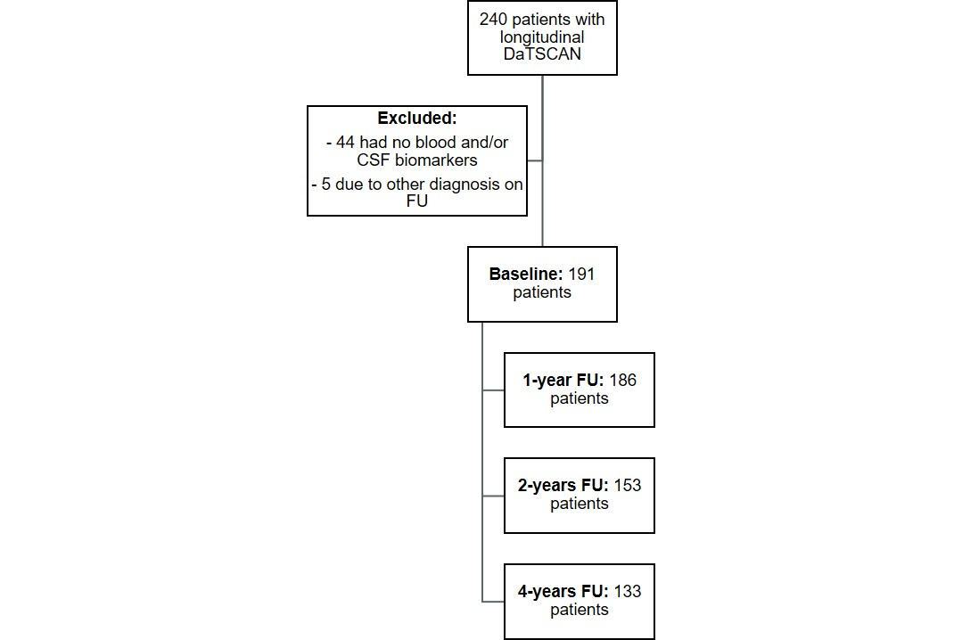

**Supplementary table 1.** Full results of primary mixed-model analyses with longitudinal DaTscan or ipsilateral-putamen SBR values as outcomes.



**Supplementary table 2.** Secondary mixed-model analyses with longitudinal MoCA scores or ipsilateral-caudate SBR values as alternative outcomes.

