The biodiversity implications of changes in coastal tourism due to climate change
EMMA G. COOMBES, ANDY P. JONES and WILLIAM J. SUTHERLAND
Environmental Conservation 35(4): pp 319-330

Supplementary Material

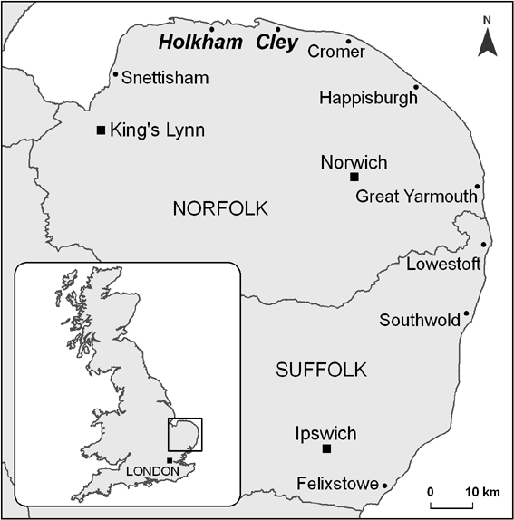
Figure S1 Map of the East Anglian coastline, which shows Holkham and Cley and the location of the study sites within the UK (inset).

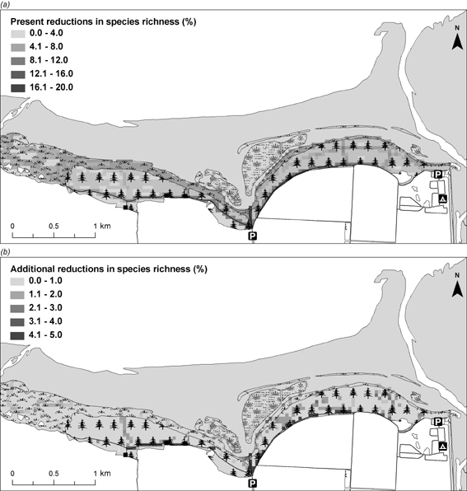
Figure S2 (a) Current visitor impacts on species richness at Holkham and (b) predicted additional reductions
in species richness by 2080 based on predicted visitor use under the UKCIP high emissions scenario for 2080 (Hulme et al. 2002).

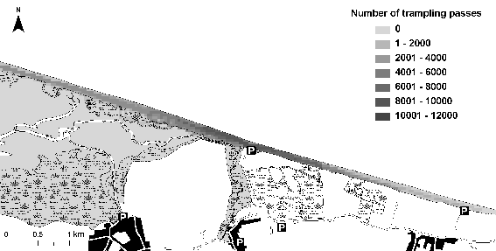

Figure S3 Intensity of visitor use across Cley beach based on visitor routes recorded during surveys.

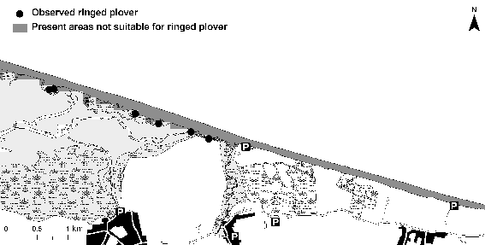

Figure S4 The distribution of ringed plover territories at Cley and current visitor impacts on the suitability of areas
for ringed plover, where the area over which suitability was assessed is shown in grey.

