Avian species richness, human population and protected areas across Italy's regions

MARCO PAUTASSO and MARCO DINETTI

Environmental Conservation 36(1): 22-32

APPENDIX
Fig. S1. Distribution of human population density (2006) in Italy’s regions (density classes: yellow: 30 ≤ d < 50 n km⁻²; light orange: 50 ≤ d < 100 n km⁻²; dark orange: 100 ≤ d < 180 n km⁻²; light red: 180 ≤ d < 280 n km⁻²; dark red: 280 ≤ d < 410 n km⁻²).
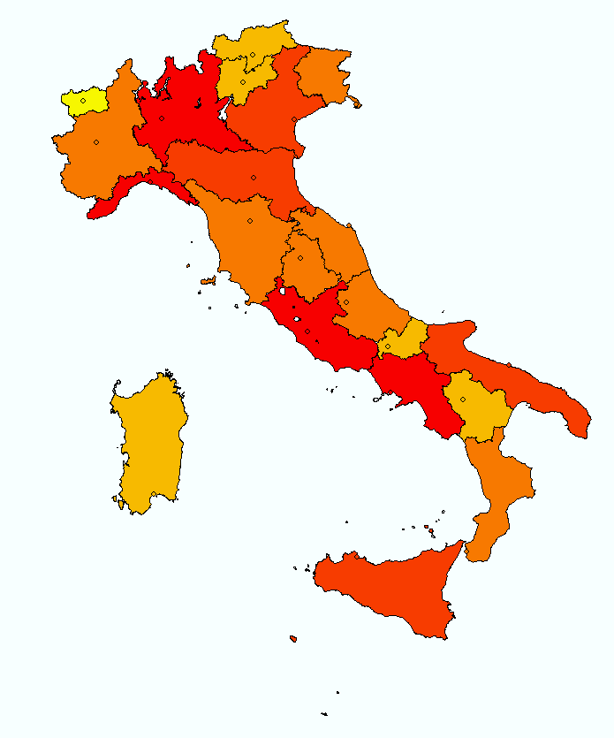

Fig. S2. Distribution of total bird species richness in Italy’s regions (classes: white: no information; aquamarine: 250 ≤ n < 300; light turquoise: 300 ≤ n < 340; dark turquoise: 340 ≤ n < 370; light blue: 370 ≤ n < 400; dark blue: 400 ≤ n < 410).
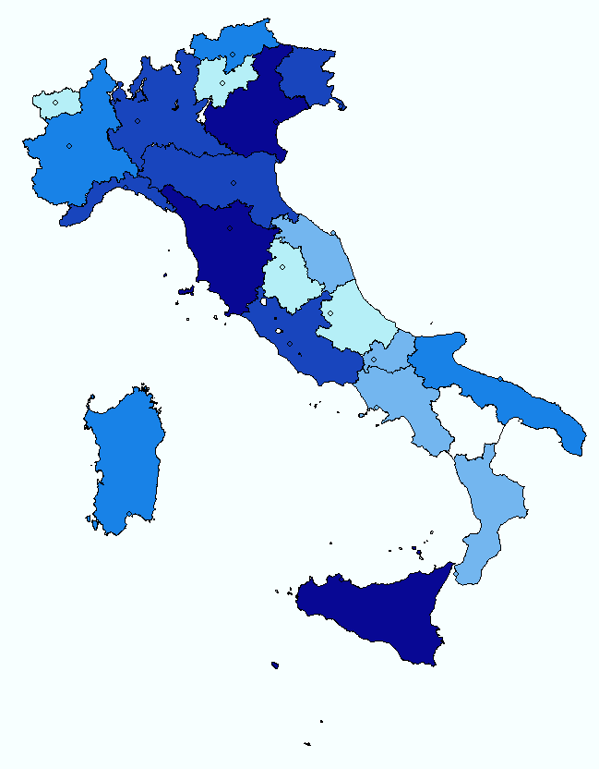
Fig. S3. Distribution of breeding bird species richness in Italy’s regions (classes: light pink: 120 ≤ n < 135; pink: 135 ≤ n < 155; light purple: 155 ≤ n < 165; purple: 165 ≤ n < 180; dark purple: 180 ≤ n < 220).
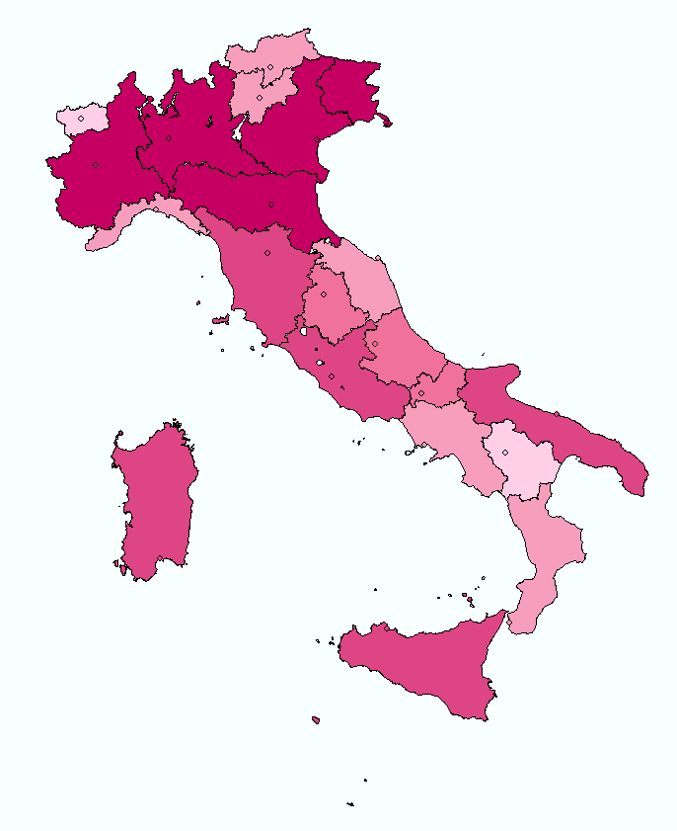

Fig. S4. Distribution of the number of threatened bird species (n) in Italy’s regions (classes: white: no information; dark green: 2 ≤ n ≤ 4; light green: 5 ≤ n ≤ 6; yellow: 7 ≤ n ≤ 8; orange: 9 ≤ n ≤ 10; red: 11 ≤ n ≤ 13).
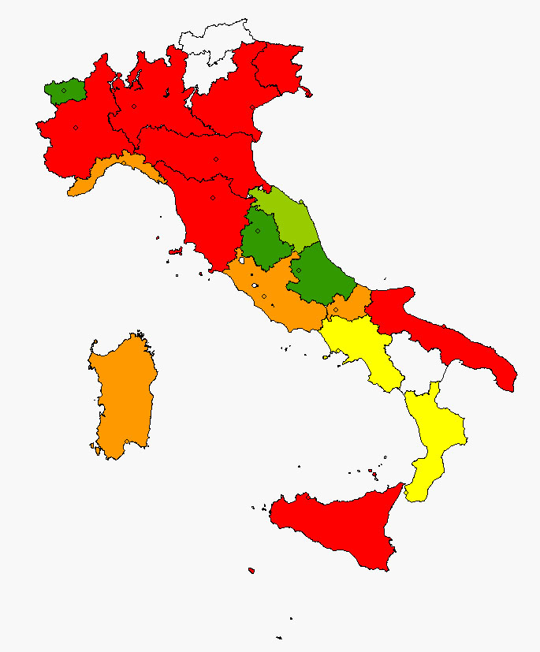

Fig. S5. Distribution of protected areas in Italy’s regions (classes: red: 1–< 5%; orange: 5–< 8%; yellow: 8–< 12%; light green: 12–< 18%; green: 18–< 29%).
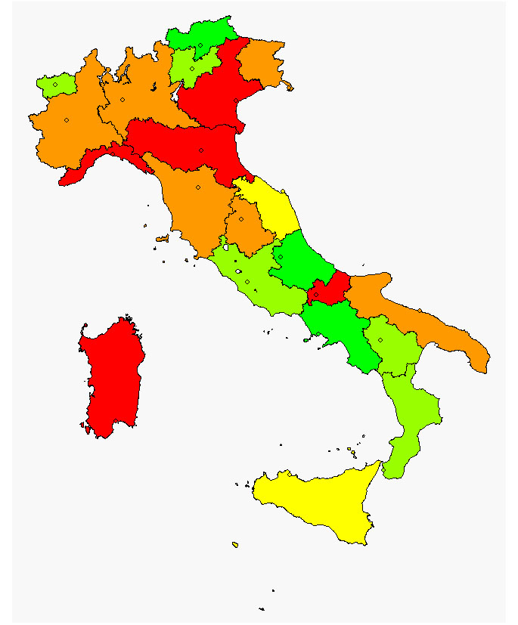

Fig. S6. Distribution of the proportion of mountainous area in Italy’s regions (classes: yellow: 1 ≤ % < 14; green: 14 ≤ % < 36; sea-green: 36 ≤ % < 48; light blue: 48 ≤ % < 65; dark blue: 65 ≤ % ≤ 100).
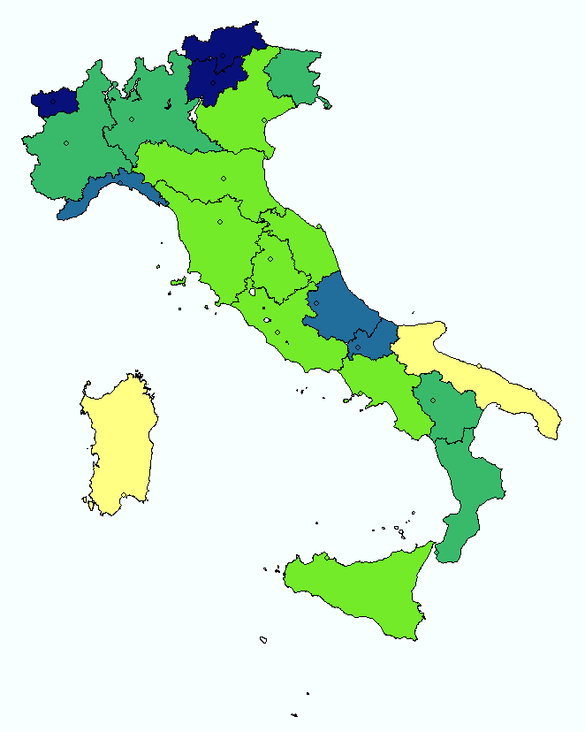

Fig. S7. Distribution of the proportion of forest area in Italy’s regions (classes, from lighter to darker green: 6 ≤ % < 9; 9 ≤ % < 20; 20 ≤ % < 27; 27 ≤ % < 41; 41 ≤ % < 54).
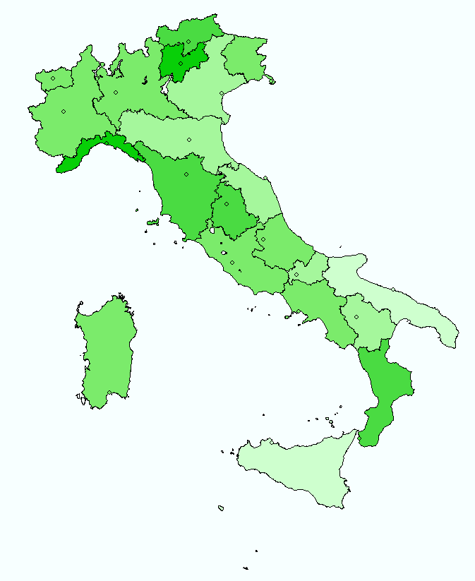

Fig. S8. Distribution of the proportion of agricultural area in Italy’s regions (classes, from lighter to darker brown: 9 ≤ % < 23; 23 ≤ % < 36; 36 ≤ % < 45; 45 ≤ % < 52; 52 ≤ % < 63).
