Rapid primary productivity changes in one of the last coastal rainforests: The case of Kahua, Solomon Islands

IRENE GARONNA, IOAN FAZEY, MOLLY E. BROWN and NATHALIE PETTORELLI

Environmental Conservation, 36 (3), pp 253-260

APPENDIX 1
Average precipitation (in mm) for 1998–2000 at location NZ52700 (Kira Kira). NZ52700 is located at -10.25° latitude and 161.55° longitude. Rainfall data were extracted from the Pacific Rainfall Database (PACRAIN; see URL http://pacrain.evac.ou.edu/).

APPENDIX 2

Smoothing the MODIS data for the Kahua region, Solomon Islands

We performed manual smoothing, by visualizing the data for each pixel and checking for rapid ‘drops’ (of 0.3 or more from one composite to the next) in NDVI values which were followed by a rapid return to higher values. These ‘drops’ were attributed to environmental noise, because factors such as water, clouds and shadow give rise to reduced NDVI values. Once we identified all contaminated values, we replaced them with the average of the previous and following values, so as to ‘smooth’ the annual NDVI curve for that pixel (see Figure). If more than one ‘drop’ value was present consecutively, the average of the closest higher NDVI values was calculated. If more than three consecutive ‘drop’ values were present, we did not smooth that pixel, which was consequently discarded from the dataset. Before discarding a pixel, we checked that the NDVI time series of this pixel displayed both sudden NDVI drops and increases (i.e. NDVI differences of more than 0.3 from one date to another), which characterize contaminated pixels. Most of the excluded pixels were either near by the coast or at high altitudes (see Fig. 1 in text), where cloud contamination and mixed-pixels contamination are highly likely. We are therefore confident that we only removed contaminated pixels. Out of the 6066 original pixels considered, only 3229 pixels contained enough information to be used for subsequent analysis.

Figure The smoothing procedure. Bi-monthly NDVI values are represented as a function of the 15-day composite date. JANUARYa corresponds to the NDVI value attributed to a given pixel, for the period 1 January–15 January.

NDVI value

APPENDIX 3
Average Spearman’s rank correlation coefficient (r_{s}) between the year and NDVI (April 2000–November 2008) for the 3229 MODIS pixels considered (area corresponds to square area delineated on Makira island in Fig. 1 in text). Brown squares represent pixels where the average correlation was negative and inferior to -0.174, orange pixels represent pixels where the average correlation was negative and inferior to -0.101, yellow pixels represent pixels where the average correlation was negative and inferior to 0, while green squares represent pixels where the correlation was positive. Houses represent the locations of the villages, which are mostly located along the coast. Big houses are villages with a population size equal or higher than 101, while smaller houses represent villages of 100 inhabitants or less.
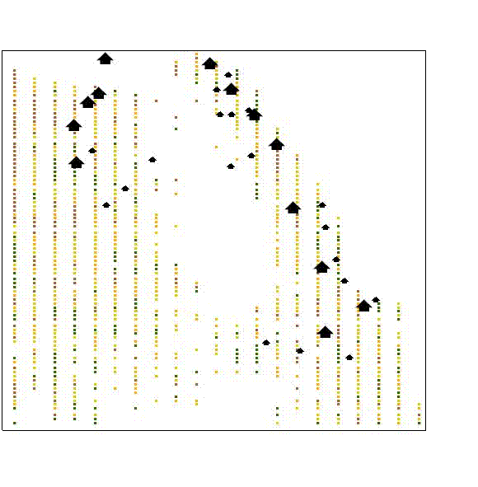

APPENDIX 4
Log exports (m³) from the historic natural forest in Makira province 1995–2005. Source: URS Sustainable Development (2006) Solomon Islands Forestry Management Project II: Solomon Islands National Forest Resource Assessment Update 2006, Department of Forest, Environment and Conservation [www document]. URL http://www.melanesiangeo.org/resources/Solomon%20Islands%20National%20Forest%20Resource%20Assessement%20Update%202006.pdf

Log exports (m³)
Year

