APPENDIX 1
WWF ecoregions were graphically discriminated by the multidimensional scaling performed on each of the 13 environmental domain classifications (EDC). EDCs selected for further analysis are highlighted in grey.
Number of EDC | Stress | Number of discriminated ecoregions
53 | 0.102 | 13
104 | 0.121 | 9
152 | 0.111 | 8
200 | 0.125 | 10
249 | 0.124 | 9
300 | 0.139 | 17
349 | 0.141 | 16
397 | 0.140 | 15
442 | 0.141 | 17
493 | 0.146 | 15
541 | 0.121 | 15
589 | 0.139 | 14
638 | 0.138 | 16

APPENDIX 2
Graph showing the distance between WWF ecoregions obtained by the multidimensional scaling performed on each environmental domain classification (EDC). As an example, results are shown for the 53 (diamonds), 152 (squares), 349 (triangles), and 541 (circles) EDCs. WWF ecoregions can be partially discriminated by the different EDC given that many ecoregions were separated by small distances at the centre of the graph. For the 53, 349 and 541 EDCs, 13 to 16 different ecoregions showed distances that allowed discrimination. Eight ecoregions could be identified for the 152 EDC. Each geometric point represents a different WWF ecoregion.

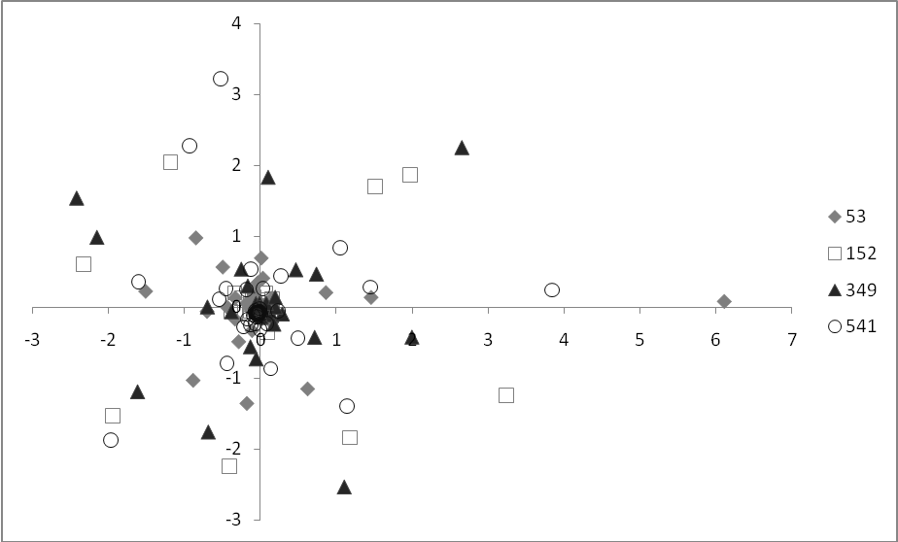:

APPENDIX 3
Percentage representation in the PAs of (a) the WWF ecoregions, (b) 53 EDC, (c) 349 EDC and (d) 541 EDC.
