APPENDIX 1
Map showing the North Pennines location within the UK.

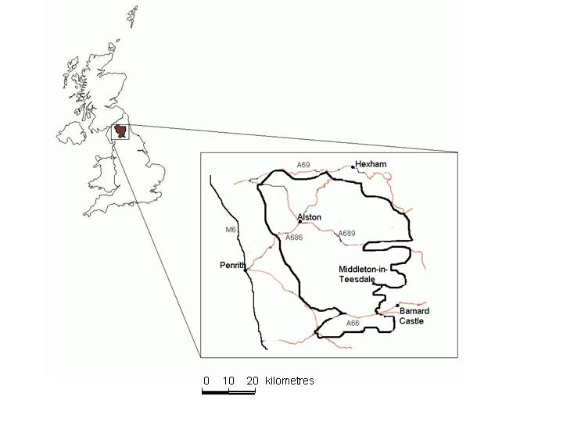
APPENDIX 2
Choices as presented to respondents for landscape changes, and for biodiversity changes.
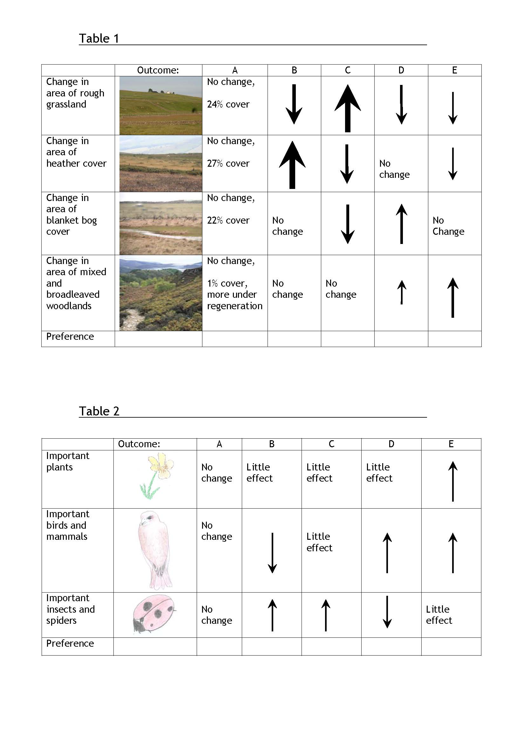
APPENDIX 3
Supplementary information provided to respondents. This is the ‘additional information’ set which contains more information than the basic information provision, as part of the experimental element of the survey.
