Supplementary Material

Evaluating the relative effectiveness of alternative conservation interventions in influencing stated behavioural intention: the saiga antelope in Kalmykia (Russia)

Authors: Caroline Howe, Ruslan Medzhidov, E.J. Milner-Gulland

APPENDIX 1

Data collection

Information regarding data collection is provided in Table 1 and Figure 1.

Figure 1 Map illustrating the location of Kalmykia and Astrakhan within the Russian Federation. The eight study villages are shown with arrows. The white shaded area indicates the location of the Chernye Zemli Reserve in Kalmykia and the grey shaded area the boundary of the Stepnoi Sanctuary. The bold oval indicates the region exposed to the media campaign, the dotted circle highlights the villages under the social engagement project and the dashed circle encloses the area under the traditional conservation intervention (Map adapted from Multimap 2007).

Table 1 Conservation interventions for saiga antelope carried out between 1990 and 2006 in Kalmykia and Astrakhan.

Conservation programme | Dates | Location | Main funding body
Using saiga antelope to improve rural livelihoods | 2003–2006 | Khulkhutta, Tavn-Gashun | Darwin Initiative (Defra)
Rotating cows project | 2006–onwards | Khulkhutta, Tavn-Gashun | Small Environmental Projects (Defra)
Evaluating approaches to public engagement to saiga conservation | 2006–2007 | Utta, Erdnevskiy, Molodozhnye, Adyk | Darwin Initiative (Defra)
Chernye Zemli Reserve: support and capacity building | 1990–onwards | Kalmykia | Russian Federation,  UNESCO
Stepnoi Sanctuary: anti-poaching and population monitoring | 2000–onwards | Astrakhan | Atrakhan Province,  INTAS

APPENDIX 2

Questionnaires

The final versions of the Attitude and Perception Questionnaire, Basic Household Questionnaire are provided below.
Attitudes and Perceptions Questionnaire

Name: Age: Sex:
Occupation(s):
Education Level:

[Using the map provided explain the following regions before commencing the questionnaire]

Throughout this questionnaire we will refer to different geographical areas. These are:

- 5km radius of your village
- Your raion
- Kalmykia/Astrakhan [depends on location of village]
- Russia

- Exposure and knowledge of status of saiga antelope

  - When did you last see saiga in:

    - A 5km radius of this village?

    - This Raion?

    - Kalmykia/Astrakhan oblast?

  - On this last occasion, what were the most saigas that you saw at one time?

Numbers | Location
Numbers | 5km radius | Raion | Kalmykia/Astrkhan
a. One hundred thousand
b. Thousands
c. Hundreds
d. 100–50
e. 50–10
f. 10–0 [ask them to be precise where possible]

  - Do you think there have been changes in saigas (e.g. numbers, behaviour, migratory routes, sex ratio etc.) in:
    - A 5km radius of this village?
    - Raion?
    - Kalmykia/Astrakhan?

Area | Change | When did the changes start? | How has the change progressed over time? | Reason
5km radius of village
Raion
Kalmykia/Astrakhan

- General perception and attitudes towards saiga antelope

  - Using the scale below, please tell me whether you agree or disagree with the following statements:

1. Strongly agree
2. Agree
3. Neither agree nor disagree
4. Disagree
5. Strongly disagree
6. Don’t know

1. ‘I have more important things to think about than the future of the saiga antelope’

2. ‘If the saiga was lost from Russia I would not mind’

3. ‘Saiga should be protected for future generations even if than means making sacrifices now’

  - Has your attitude towards/opinion of saiga changed over time? If YES, how has it changed?

Before |  | After |  | Why
Time | Opinion | Time | Opinion

  - Amount pledged for saiga conservation

The current saiga population is considerably smaller than historic levels and is also no longer reproducing healthily. If current levels of hunting pressure are maintained or increased in this region the saiga will be lost from Russia.

An annual household voluntary contribution has been considered as a means of raising money to support the conservation and protection of the saiga antelope.

Which of the amounts below best describes your household’s maximum amount they are willing to pledge, every year, through a voluntary contribution, to prevent the loss of saiga from Russia? Please think carefully about how much you can really afford and where the additional money would come from and try to be as realistic as possible.

Place a tick (√) next to the amount your household would be willing to pledge. When you reach an amount that you are not sure of being willing to pledge then leave it BLANK. When you reach an amount that you are almost certain you would not pay, then place a cross (x)

Roubles/Year | Amount Pledged
0
50
100
200
400
800
1,600
3,200
6,400
12,800
25,600
50,000
>50,000

  - Follow up questions

    - Possible reasons why interviewee does NOT want to pledge any money (True √; False x)

- Our household cannot afford to pay
- I am not very interested in saiga antelope and feel that their conservation is not a priority
- I don’t believe a contribution scheme is workable
- The government or international community should pay for this
- I need more information/time to answer the question

    - Possible reasons why interviewee wants to pledge an amount (True √; False x)

- I am interested in the saiga antelope and feel that it is important to conserve them
- I get satisfaction from giving to a good cause
- We should protect the saiga for future generations
- I feel we should protect our wildlife and environment in general

- Knowledge and opinion of conservation

  - Do you know of any saiga conservation taking place at this moment in:
    - This raion?
    - Kalmykia/Astrakhan?
    - Russia?

Area | Where | Who | When | What/how | Opinion
Raion
Kalmykia/Astrakhan
Russia

  - Any suggestions for how to improve the conservation of saigas in:

    - This raion?

    - Kalmykia/Astrkhan?

    - Russia?

- Knowledge and opinion of public awareness

  - When was the last time that you or any family members received any information about anything to do with saiga antelopes?

  - What was the medium through which you gained this information (e.g. t.v., radio, friends etc)?

  - What was that information about? (e.g. ecology, poaching, culture etc?)

  - In the last year, about how many times have you received information of any sort about saigas, from where and what was it?

Who received information | Last time received | Medium (From whom/where from) | What  (ecology, poaching, culture etc.) | Frequency | Opinion

    - Do you feel that this information has altered your attitude/behaviour towards saiga and their management?

YES/NO

    - If YES, how?

  - Have you or someone you know received any benefits related to saiga conservation?

Who received benefits | What | From whom/where from | When | Opinion

    - Do you feel that these benefits have altered your attitude/behaviour towards saiga and their management?

YES/NO

    - If YES, how?

- Opinion on costs of conservation

  - Have you or someone you know suffered any costs related to saiga conservation?

Who suffered costs | What | From whom/where from | When | How did they affect you

    - Do you feel that these costs have altered your attitude/behaviour towards saiga and their management?

YES/NO

    - If YES, how?

  - What suggestions would you make to help to lessen these costs?
Basic Household Questionnaire

Date: Village: Household no.:

- Demographics

  - How many years have your family lived in the village?

  - Where did your family live before?

  - Why did your family move here?

  - Household structure [circle respondent]

Relation to head | Sex | Age | Social status | Education

- Household income

  - What are the dominant livelihood activities of your household in each season of the year?

  - What income is derived from each of the activities in the different seasons?

Livelihood activity | Income

  - Does this household receive any additional income (e.g. from family members in town, pensions)? If YES, where from?

  - Do you own any animals? If YES, how many and what kind?

Type of animal | Income from other animal products/year (wool, milk, eggs etc)

  - Does your household own any vehicles? If YES, what and how many?

Type of vehicle | Number | Year of purchase
Motorbike
Non off-road car
Off-road car
Bus, Minibus
Tractor/Machinery

APPENDIX 3

Distribution of dependent variables

Distributions of amount pledged for saiga conservation and ‘population knowledge’ are illustrated in Figures 2 and 3.

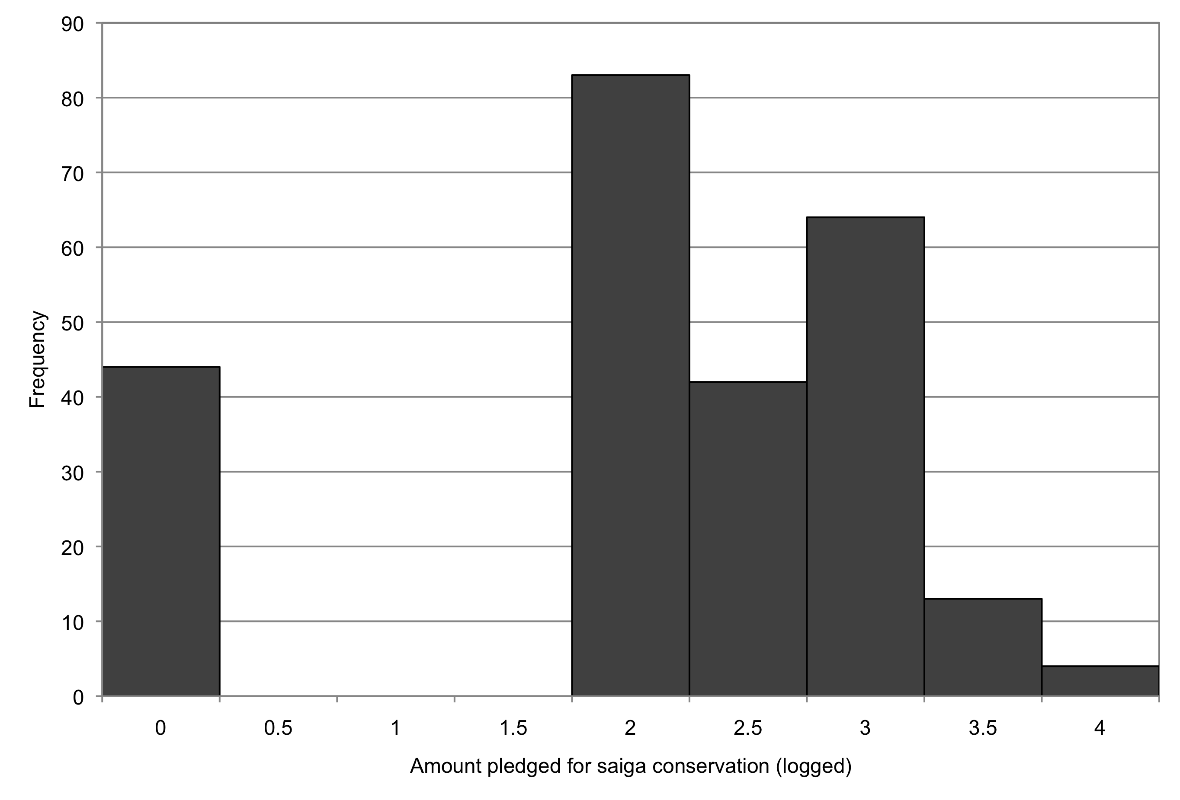

Figure 2 Distribution of amount pledged for saiga conservation (logged).

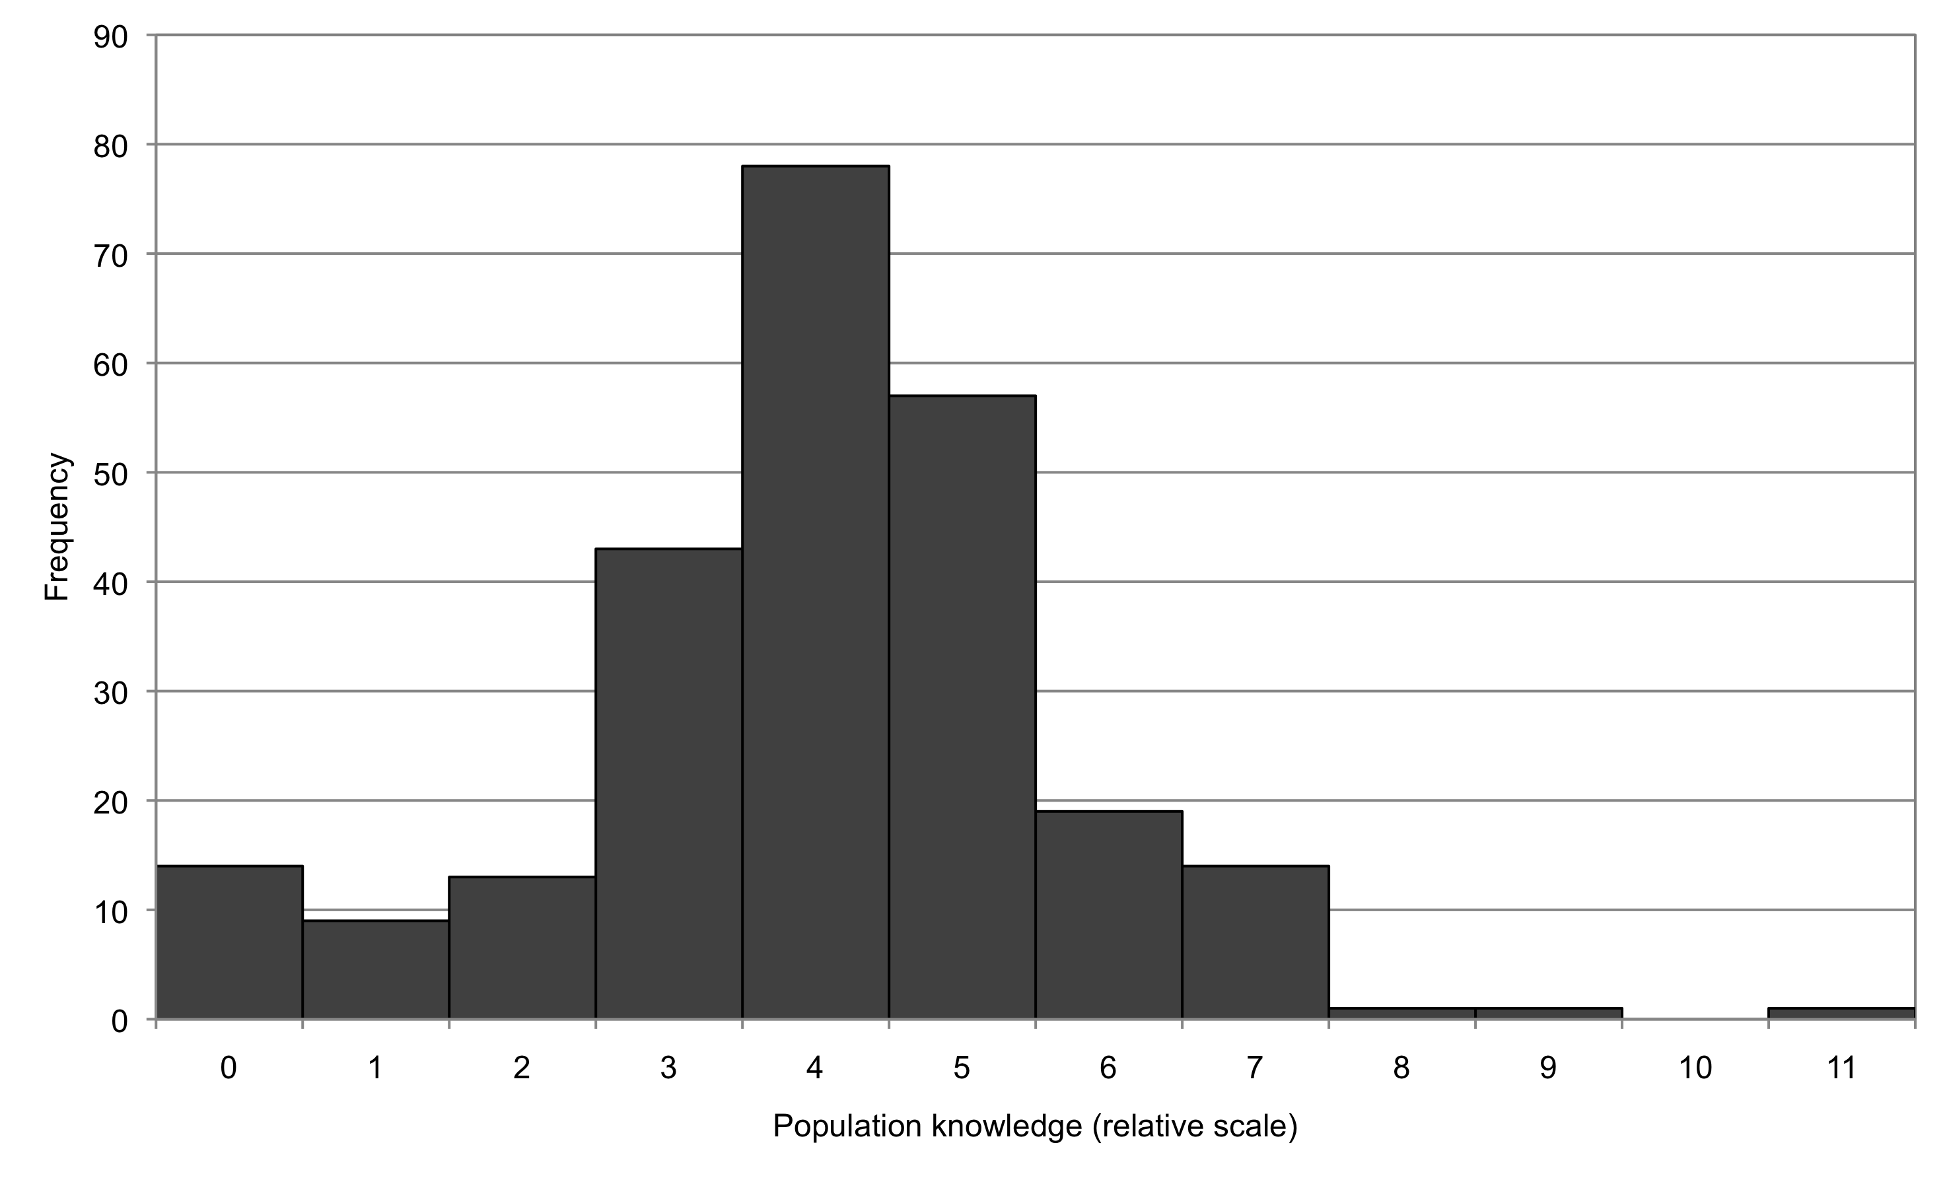

Figure 3 Distribution of ‘population knowledge’ regarding saiga population fluctuations.
APPENDIX 4

Calculation of variables

Variables

Table 2 provides a list of the variables used in the analysis. The units, range and method of calculation are also given.

Table 2 Details of explanatory variables. Age and sex were also included. N = nominal; O = ordinal.

Variable | Units | Range | Calculation | Type
Village | 1 = Utta; 2 = Khulhutta; 3 = Tavn-Gashun; 4 = Bacy; 5 = Zenzeli; 6 = Molodozhnye; 7 = Erdnevskiy; 8 = Adyk | NA | NA | N
Intervention | 1 = media campaign  2 = social intervention and media campaign  3 = traditional conservation | NA | Media campaign = coverage in local and national media  Social intervention = Rotating Cows under DEFRA’s Small Environmental Projects Scheme + detailed socio-economic questionnaire carried out 2003 + media coverage  Traditional conservation = anti-poaching activities. No major media campaign. | N
Wealth | 1 = low; 5 = high | 1–5 | See Appendix 2.2 | O
Formal education | 1 = none/primary; 2 = full secondary; 3 = technical secondary; 4 = higher education | 1–4 | NA | O
Nationality | 1 = Kalmyk; 2 = Russian; 3 = Other | NA | NA | N
Residence time in village | 1 = up to half their life; 2 = over half their life; 3 = all of their life | 1–3 | Length of time resident in the village as a proportion of life span | O
Exposure level to saiga | 1 = low; 3 = high | 1–3 | See Appendix 2.3 | O
Conservation knowledge | 0 = none; 5 = high | 0–5 | See Appendix 2.4 | O

Wealth

Wealth was calculated taking into account employment ratio, farm ownership, large livestock and poultry ownership, pensions/allowances received and vehicle ownership (Kuhl et al., 2009). Each sub-category was scored as in Table 3 and then the total score was added together. Wealth was then ranked according to the following 5-point scale: 1 = 1–4 points; 2 = 5–8 points; 3 = 9–12 points; 4 = 13–16 points; 5 = 17 or more points.

Table 3 Summary of variables contributing to wealth calculation.

Variable | Scoring | Calculation
Employment ratio | 1 = < 1; 2 = 1.1–2  3 = 2.1–3; 4 = 3.1–4  5 = 4.1–5; 6 = 5.1–6; 7 = > 6 | The number of people, per household, earning a wage, was divided by the number of dependents in that household
Farm ownership | 0 = no farm; 2 = farm | Farm ownership was a significant indicator of wealth (personal observation) and therefore the scoring system was weighted to reflect this.
Large livestock ownership | 0 = 0; 1 = >50; 2 = 50–100; 3 = 100–200; 4 = 200–500; 5 =>500 | Respondents were asked to provide the number of animals they owned and the income size received directly from animal ownership.
Poultry ownership | 0 = no animals; 1 = subsistence number; 2 = income earned (generally >50 animals) | Respondents were asked to provide the number of animals they owned and the income size received directly from animal ownership. Poultry ownership was not scored as highly as large livestock ownership to reflect the greater wealth earned by large livestock farming.
Pensions/  Allowances | 0 = no pensions/allowances  1 = 1 per household  2 = 2 per household | Pensions/allowances were taken into consideration alongside employment ratio, as they were considered as a source of income for the household (personal observation)
Vehicle ownership | 0 = no vehicles; 1 = one > 20 yrs; 2 = two > 20 yrs or one 10–20 yrs; 3 = one 5–10 yrs or two 10–20 yrs or three > 20 yrs; 4 = one < 5yrs or 2 5–10 yrs; 5 = one foreign 5–10 yrs or two < 5yrs or three 5 –10 yrs or four > 10 years; 6 = one or two foreign >10 yrs or three < 5yrs; 7 = two to four foreign < 5yrs | Vehicle ownership was a significant indicator of wealth (personal observation). Scoring was rated on the number of vehicles owned, the age of the vehicles and whether they were foreign or imported (which cost significantly more than Russian vehicles).

Exposure level to saigas

Exposure level was defined as the level of exposure that individuals had had to saigas. Exposure level was calculated based on the date and location of last sighting, the number of animals seen and the total number of sightings. Each sub-category was scored as in Table 4 and the total was summed together. Exposure was then ranked on a 3-point scale: 1 = 0–10 points; 2 = 11–14 points; 3 = 15–18 points.

Table 4 Summary of variables contributing to the calculation of exposure level to saigas.

Variable | Scoring | Calculation
Date of last exposure (years) | 0 = never  1 = >20.01  2 = 10.01–20.00  3 = 5.01–10.00  4 = 2.01–5.00  5 = 1.01–2.00  6 = 0.51–1.00  7 = 0.11–0.50  8 = 0.00–0.01 | Respondents were asked to recall the date when they last saw saigas. More recent dates were given a higher rating in terms of exposure. This was done as it was assumed that the more recent the sighting the greater the effect of the sighting on the respondent in terms of exposure.
Location of last sighting | 0 = no sightings  1 = outside the republic  2 = raion/republic  3 = village | Interviewees stated where their last sighting was. Higher scores were given to those who had sighted saigas most locally. It was assumed that seeing animals close to home would have a greater influence as it would have a more immediate effect.
Number of animals in last sighting | 0 = no animals  1 = 0–10  2 = 10–50  3 = 50–100  4 = 100s  5 = 1000s  6 = 100 000 | Respondents were asked to recall roughly how many animals they had seen at the last sighting. Greater numbers were awarded higher scores as it was assumed that seeing many animals (such as large herds) would have a more dramatic effect on those observing it.
Number of sightings | 0 = no sightings  1 = 1  2 = 2  3 = 3 | Interviews were scored on whether they had seen saigas in all three locations: village, raion/republic and outside the republic. Larger numbers of sightings were not used as it was not felt that recall was accurate enough.
Conservation knowledge

This was considered to be the level of knowledge regarding the number of conservation projects at the regional, republic and national scales. Respondents were scored on how many conservation interventions they knew about. The total score was summed together.

- 1 mark for each intervention mentioned
- 0.5 mark if they thought they had heard about a specific intervention but were not 100% sure (this was only awarded if they were in fact correct)
- 1 extra mark was given for mentioning an intervention not in the local vicinity or district, but either elsewhere in the republic or Russia as a whole

Population knowledge

Population knowledge was an individual's level of knowledge regarding the direction, timing and reasons for population fluctuations. Reasons for decline and increase were assessed against information from an in-country expert (A. Lushchekina, personal communication) and are given in Table 5. Table 6 was constructed based on population data gathered since 1978.

- Direction of change: 1 mark was given for stating a decline or increase over a correct time period
- Timing of change: Marks for accuracy in timing of commencement of trends were awarded according to the table below
- Reasons for decline: 1 mark was given per correct reason for decline (see for reasons)
- No marks were awarded to those who stated that nothing had happened to the population over time, or those who did not have any knowledge regarding population trends

Table 5 Reasons for decline and increase as assessed by an in-country expert (A.A. Lushchekina, personal communication).

 | Reasons given for decline | Reasons given for increase
Anthropogenic | - Overhunting and poaching  - Government, lack of state protection (more detail required)  - Rangers: do not have necessary funding to do their job; dishonest, failing to do their job  - Poverty, lack of alternative livelihoods  - Extensive irrigation channel network (Volga water channel (more detail required))  - Uncontrolled increase of livestock and overgrazing of pastures, (artificial pastures?–as far as we know there are some fields for producing fodder for domestic animals but they are not artificial pastures) | - Chernye Zemli Biosphere Reserve and other protected areas to cover the migration routes and rutting/lambing areas  - Social improvements  - Total control of poachers and ban of hunting up to restoration of saiga numbers
Ecological | - Changing natural conditions due to: desertification, cold winters and summer drought fires decreasing capacity of grasslands  - Wolves  - Migrational changes | - Improving habitats by restoration measures

Table 6 Scoring sheet for accuracy in knowledge regarding saiga population trends over time. Based on data in Milner-Gulland et al. (2001).
Year | Decline | Increase
1978 | 0.5 | 0
1979 | 1 | 0
1980 | 2 | 0
1981 | 2 | 0
1982 | 2 | 0
1983 | 1 | 0
1984 | 0.5 | 0
1985 | 0 | 0.5
1986 | 0 | 1
1987 | 0 | 1
1988 | 0 | 1
1989 | 0.5 | 0.5
1990 | 1 | 0
1991 | 1 | 0.5
1992 | 1 | 1
1993 | 0.5 | 2
1994 | 0.5 | 2
1995 | 1 | 2
1996 | 2 | 1
1997 | 2 | 0.5
1998 | 2 | 0
1999 | 1 | 0
2000 | 0.5 | 0
2001 | 0 | 0
2002 | 0 | 0.5
2003 | 0 | 1
2004 | 0 | 1
2005 | 0 | 1
2006 | 0 | 0.5
1980s | 1 | 0.5
1990s | 1 | 1
2000s | 0 | 0.5

References

Kuhl, A., Balinova, N., Bykova, E., Esipov, A., Arylov, I.A., Lushchekina, A. & Milner-Gulland, E. (2009) The role of saiga poaching in rural communities: linkages between attitudes, socio-economic circumstances and behaviour. Biological Conservation 142(7): 1442–1449.

Milner-Gulland, E., Kholodova, M., Bekenov, A., Buhreeva, O., Grachev, I. A., Amgalan, L. & Lushchekina, A. (2001) Dramatic decline in saiga antelope populations. Oryx 35(4): 340–345.

