Paying the forest for electricity: a modelling framework to market forest conservation as payment for ecosystem services benefiting hydropower generation
MAURICIO E. ARIAS¹, THOMAS A. COCHRANE^{1*}, KEITH LAWRENCE², TIMOTHY J. KILLEEN² AND TRACY A. FARRELL²

APPENDIX 1

Terrain, soils, precipitation and land use data from the Pursat 1 catchment used for predicting sediment yields with the SWAT model. Elevations are in metres above mean sea level, area estimates in hectares and rainfall in millimetres. Data from Aruna Technology Ltd (2006) and MRC (2009b).

Terrain | Elevation range (m) | Elevation mean (m) | Elevation std dev | Area slope 0–5% (ha) | Area slope 5–20% (ha) | Area slope 20–345% (ha) | Slope median
Terrain | 155–1700 | 406 | 267 | 50763 | 30188 | 30423 | 15%
Soils | Class |  | Area | % clay | % silt | % sand | Hydrologic group
Soils | Red-yellow podzols |  | 35863 | 3 | 16 | 81 | A
Soils | Acid lithosols |  | 61555 | 18 | 39 | 43 | D
Rainfall | Min annual (mm) | Max annual (mm) | Mean annual (mm) | Min month (mm) | Max month (mm)
Rainfall | 1179 | 1580 | 1380 | 0 (Jan) | 454 (Oct)
Land use (in 2006) | Class |  | Area (ha) | % area
Land use (in 2006) | Agricultural |  | 3014 | 2.7
Land use (in 2006) | Deciduous forest |  | 26976 | 24.2
Land use (in 2006) | Evergreen forest |  | 67141 | 60.3
Land use (in 2006) | Mixed forest |  | 415 | 0.4
Land use (in 2006) | Reservoir |  | 13830 | 12.4

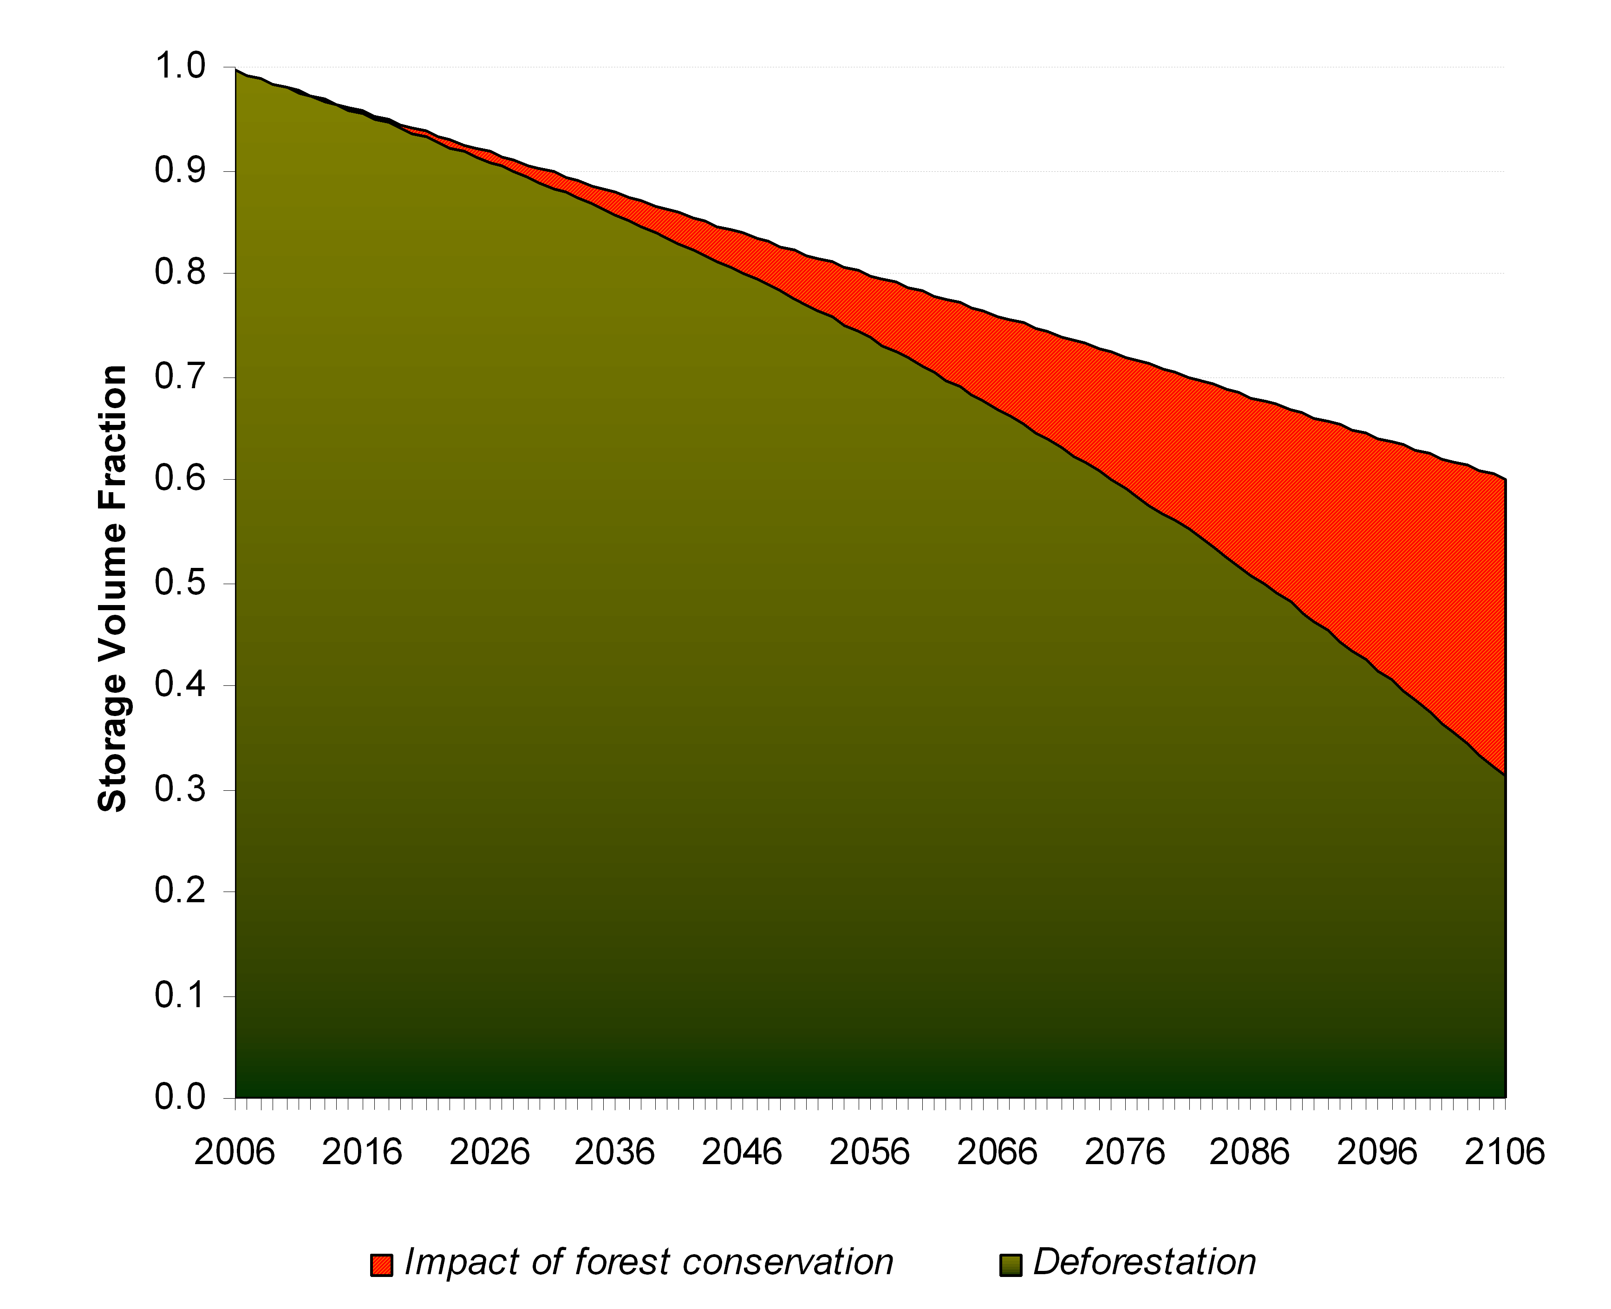
Figure 1A Predicted fraction of original reservoir storage for the forest conservation and deforestation scenario.

