Economic benefits of forest conservation: assessing the potential rents from Brazil nut concessions in Madre de Dios, Peru, to channel REDD+ investments
FELIPE NUNES, BRITALDO SOARES-FILHO, RENZO GIUDICE, HERMANN RODRIGUES, MARIA BOWMAN, RAFAELLA SILVESTRINI AND ELSA MENDOZA

APPENDIX 1

Modelling approach

The first part of our model simulated the spatial distribution of Brazil nut trees in the concessions of Madre de Dios, Peru. It did this, first by integrating the effects of a series of biophysical factors to determine the geographical favourability of Brazil nut trees in the region, and then by simulating their spatial pattern according to the statistical distribution of the location of trees in sampled plots. Next, the model assigned productivity values to each simulated tree by using probability distribution functions calibrated with data from tree inventories; finally, the model merged the simulated occurrence of trees of different productivity classes with data on costs of production, sale prices and transportation costs to points of sale under three scenarios of different types of production (unshelled, processed/shelled or shelled-certified Brazil nuts) to estimate the potential net rent for a particular forest parcel (a raster cell of 0.25 ha). According to the Malthusian definition, land rent is the portion of the value of the whole produce which remains to the owner of the land after all outgoings belonging to its cultivation, of whatever kind, have been paid, including the profits of the capital employed. In the case of Brazil nut rents, they are concessionary rents, because they are accruing to the concessionaire, who does not own the land, but profits from it.

Data collection

We compiled data from governmental and non-governmental organizations in Madre de Dios (Peru), including Brazil nut concession management plans (POA [Plan Operativo Anual] registered with the former National Institute of Natural Resources [INRENA]) with data collected from surveys and questionnaires (Table S1). Data were collected by the Association for the Conservation of the Amazon Basin (ACCA) and INRENA, as part of a project entitled Formalizing Forest Access and Implementing Sustainable Brazil Nut Management in Madre de Dios, Peru: Bridging Phase, and were collected between the 1 February 2005 and 30 April 2008 in 252 398 ha of concessions in Madre de Dios.
In order to obtain georeferenced data on the concessions as part of this process, technicians from each concession were responsible for mapping and georeferencing the concessions. This process included mapping concession boundaries and the number of productive and non-productive trees in accordance with government standards for documentation of potential harvestable volume and determination of the fee paid for extractive rights to the concession. The database of 104 651 georeferenced trees includes 100 988 mature trees (diameter at breast height [DBH] ≥ 50 cm) and 3663 juvenile specimens (DBH < 50cm). Data were also collected on the concession itself, including location, area in hectares, number of trees, type and layout of roads, camps, infrastructure and annual production.
The dataset also included economic data, such as production costs, processing coefficients, sale prices per kg and georeferenced data for individual trees within the concession, including GPS points, DBH, crown structure, position in the canopy, identification codes, production in buckets of unshelled nuts (one bucket = 10 kg) and health status of trees (illness or parasites). In addition to these concession-level data, we gathered information pertaining to the economics of the Brazil nut production chain by interviewing and distributing questionnaires to owners of distribution centres (centros de acopio) and concessionaires along the Interoceánica Sur highway between Puerto Maldonado and Iñapari, during the harvest season of 2008–2009. We used the information we collected in our model, including costs of extraction and transport, sale prices, types of transportation used to transport Brazil nuts and the different categories of product that are sold (unshelled, processed/shelled and shelled-certified nuts).

Table S1 Database components and sources.
Collection method | Geographic scope | Source
Interviews | Brazil nut concessionaires along Interoceánica highway from Iñapari to Puerto Maldonado
Questionnaires | Concessionaires living in Puerto Maldonado
Maps | Madre de Dios | IIAP, INRENA
Location of concessions | Georeferenced concessions (2008) | ACCA, INRENA
Forest management plans (PGMF) and Operative annual plans (POA) from Brazil nut concessions | Georeferenced concessions (2008) | INRENA
Questionnaires | Impactos de la Pavimentación de la Carretera Inter-Oceánica – Madre de Dios, Perú: Resultados del Estudio Socio-económico de las Encuestas a Nivel de Familia | University of Florida, Universidad Federal del Acre (UFAC), Universidad Nacional Amazónica de Madre de Dios, Universidad Amazónica de Pando Bolivia, UNSAAC y SENAMHI
Processing plants and certification | Budget for building Brazil nut processing plants and certifying production | Proyecto de inversión en planta de procesamiento mecánica de castaña, Bosques Amazónicos
Investments to improve production and lower costs | Costs to build trails, roads, and nut storage barns | Programa de Mejoramiento y Adecuación de La Producción de Castaña in Pando, Bolivia

From our georeferenced database of Brazil nut concessions, we selected two subsamples using the following criteria: (1) sample covers a large area of contiguous concessions and (2) existence of continuous spatial data on tree distribution. The samples chosen for analysis lay within the provinces of Tahuamanu and Tambopata. We analysed distributions of productivity and diameter at breast height for individual trees within these samples (Figs S1 and S2).

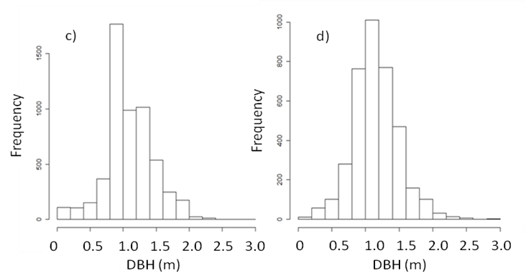
Figure S1 Distributions of productivity in terms of (a, b) number of buckets and (c, d) diameter at breast height (DBH) for (a, c) Tahuamanu and (b, d) Tambopata samples, respectively.

Simulating the geographic distribution of Brazil nut trees

First we determined the biophysical variables correlated with the distribution of Brazil nut trees in the region (Tables S2). Weights of evidence (W⁺_{Bn}) were calculated for each category of a spatial variable (B) and represent an estimate of the influence of the variable category (n) on the probability of occurrence of a Brazil nut tree (Bonham-Carter 1994). The larger the value of the coefficient of the weight-of-evidence, the stronger the association between the explanatory variable and the probability of occurrence of a cell with (a) Brazil nut tree(s). By the same logic, negative coefficients indicate an inhibitory effect, and values close to zero are consistent with no association (Fig. S3 and Tables S3 and S4).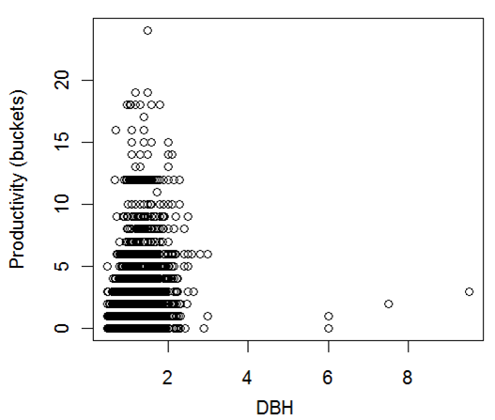
Figure S2 Scattergram of DBH equal or greater than 50 cm with productivity of Brazil nut trees. Spearman's rank correlation = 0.34, n = 8948.

Table S2 Spatial data used for modelling the probability of occurrence of Brazil nut trees.
Layer | Source
Mean annual precipitation and temperature | Madre de Dios Regional Government  Research Institute of the Peruvian Amazon – IIAP (2001)
Vegetation classes | Madre de Dios Regional Government  Research Institute of the Peruvian Amazon – IIAP (2005)
Geomorphology | Madre de Dios Regional Government  Research Institute of the Peruvian Amazon – IIAP (2005)
Hydrology | National Institute of Natural Resources – INRENA (2005)
Elevation | NASA - Shuttle Radar Topography Mission (2000)
Slope | NASA - Shuttle Radar Topography Mission (2000)

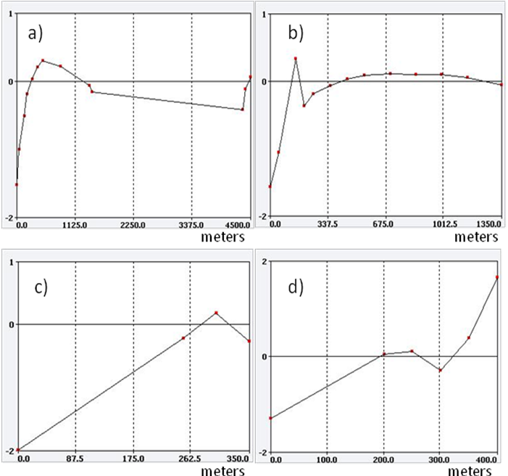
Figure S3 Weights of evidence as a function of (a, b) distance to streams and (c, d) elevation for (a, c) Tahuamanu and (b, d) Tambopata, respectively.

Table S3 Weights of evidence as a function of geomorphology.
Classes | W⁺
High hills | -0.07381
Low hills | 0.251349
Seasonally-flooded plains | -4.26251

Table S4 Weights of evidence as a function of vegetation classes.
Classes | W⁺
Bamboo forest | -0.84037
Terra Firme dense forest | 0.216522
Palm forest | -2.31108
Flooded forest | -2.17243

Simulating the spatial pattern of Brazil nut trees

With the probability map of tree occurrence as an input, we simulated the spatial pattern of Brazil nut trees using the observed distribution of tree locations in the sampled plots. To help determine the spatial distribution of Brazil nut trees in both sampled areas we applied a Chi-squared test to check for spatial dependence in the probability of tree occurrence. Within a 95% confidence interval, we rejected the null hypothesis of no spatial dependence between sampled trees. Hence, we applied the K-function and G-function (Baddeley 2008) to determine the level of spatial dependence between individual trees in each sample (Figs S4 and S5). As a result, when we compare the estimated curves and (K-function estimated using a border correction method and G-function estimated using the Kaplan Meier method) with the theoretical curves, and , for the sample areas; they both exhibited values characteristic of a clustered spatial distribution: and (Baddeley 2008).
Figure S4 Estimated (a) K-functions and (b) G-functions for different distance buffers (in metres) for trees in the Tahuamanu sample superimposed on theoretical K and G functions. Both functions suggest an aggregate or clustered distribution of Brazil nut trees.

Figure S5 Estimated (a) K-functions and (b) G-functions for different distance buffers (in metres) for trees in the Tambopata sample superimposed on theoretical K and G functions (dashed line). Both functions suggest an aggregate or clustered distribution of Brazil nut trees. km = estimated using the Kaplan Meier method; rs = estimated using the ‘reduced sample’ method; han = estimated using the Hanisch-Stylee method ; theo = theoretical curve (Baddeley 2008).

To calibrate the probability of occurrence of a Brazil nut tree as a function of the distance from a cell with another Brazil nut tree, we used the probability of occurrence of a tree derived from the frequency distribution of the distance from the nearest neighbouring tree. In this way, the model assumes probability of occurrence values for cells with Brazil nut trees of 0.5 and 0.9, respectively, for distance buffers of 50 m and 100 m from cells with previously-simulated Brazil nut trees. This approach is supported by higher observed frequencies of Brazil nut trees for these distance buffers (Fig. S6). The model also employs a saturation parameter of four trees per hectare, which corresponds to the observed maximum number of trees per hectare in more than 90% of our sample area (Table S5, for a comparison of datasets see Table S6).

Figure S6 Frequency distributions of distance classes from the nearest neighbour Brazil nut tree in metres for (a) Tahuamanu and (b) Tambopata samples.

Table S5 Landscape metrics of the sampled areas.
Parameters | Tahuamanu | Tambopata
Mean size and standard deviation (±) of clusters in ha (1 tree per 50 × 50 m cell) | 0.87 ± 1.16 | 0.53 ± 0.46
Mean size and standard deviation (±) of clusters in ha (2 trees per 50 × 50 m cell) | 0.35 ± 0,20 | 0.27 ± 0.0
Mean size and standard deviation (±) of cluster in ha (3 trees per 50 × 50 m cell) | 0.29 ± 0.11 | 0.25 ± 0.00
Mean tree density (trees ha⁻¹) | 0.85 | 0.40
Mean distance to nearest neighbour (m) | 35.31 | 54.88

Table S6 Comparison of sites and sampling sizes of Brazil nut inventories. na = not available.
Variable | Sites
Variable | Seringal Cachoeira and Nova Esperança, Acre, Brazil | Reserva El Tigre and El Sena, Beni, Bolivia | Colocação Rio de Janeiro in Seringal Filipinas, Acre, Brazil | Colocação Rio de Janeiro in Seringal Filipinas, Acre, Brazil | São João de Baliza and Caracarai, Roraima, Brazil | Tahuamanu, Tambopata, Madre de Dios, Peru
Source | Viana et al. (1998) | Zuidema (2003) | Wadt et al. (2005) | Kainer et al. (2007) | Tonini et al.( 2008) | This study
Number of plots | 51 | 2 | na | Na | 3 | 2
Plot area | 1 ha each | 12 ha; 6 ha | 420 ha | 420 ha | 9 ha each | 6489 ha; 9359 ha
Number of trees inventoried | na | 93 | 568; 140 for productivity | 568; 140 for productivity | 274 | 5500; 3787
Duration of inventory | na | 5; 3 years | 5 years | 5 years | 3 years | mostly 1 year

Assigning productivity values to simulated Brazil nut trees

For each productivity class (non-productive (NP), low productivity (LP; 1– 3 buckets) and very productive (VP; > 3 buckets) (Fig. S7), the model assigned productivity values to each simulated tree by using cumulative probability distribution functions for distances from trees of a certain productivity class. These probability functions (Gcrossx,y_{(r)}) can be interpreted as the probability of finding a Brazil nut tree of a particular productivity class x as a function of the radial distance in metres from another tree of productivity class y (Fig. S8).

Figure S7 Frequency of productivity classes for (a) Tahuamanu and (b) Tambopata.

Figure S8 Estimated cumulative probability functions of occurrence of different productivity classes of Brazil nut trees as a function of distances from trees of particular productivity classes for the Tahuamanu sample. km = estimated using the Kaplan Meier method; rs = estimated using the ‘reduced sample’ method; han = estimated using the Hanisch-Stylee method ; theo = theoretical curve (Baddeley 2008).

Decomposition of costs and calculation of potential rents

The model calculated the potential rent for each cell at a resolution of 0.25 ha by first determining the total volume of Brazil nuts that can be extracted from a cell (productivity per tree multiplied by number of trees in each cell) and then multiplying the resulting volume by the average sale price of Brazil nuts per product type. Depending upon the scenario, the price is for either unshelled, shelled (processed) or certified-shelled nuts. Next, the model deducted the average costs of production and the transportation costs to points of sale, distribution centres, and processing firms per kilogram of product. The sale price per product type and average production costs are expressed in US$ per kg of product (2008 exchange rate: 1.00 Soles = US$ 0.33). The prices at points of sale used in the rent calculation are averages of those reported by concessionaires in the interviews, questionnaires and management plans. Total production costs (Table S7) were calculated as follows:
(1)
where C_{x} is the total cost of production per product type x in US$ kg⁻¹, P_{x} is the cost of production per product type in US$ kg⁻¹, T_{x} is the transportation costs from the place of collection to the point of sale per product type in US$ kg⁻¹km⁻¹, and S_{x} is the cost of processing in US$ kg⁻¹.

Table S7 Average costs for concessions in Madre de Dios.
Type of costs | US$ kg⁻¹ | Source
Production costs | 0.40 | Interviews/questionnaires
Transportation costs | 0.03 | Management plans
Processing costs | 0.24 | Management plans

To calculate production costs, we used data collected from interviews with producers and questionnaires, in addition to management plan data (POA [Plan Operativo Annual]) and data from Proyecto de inversión en planta de procesamiento mecánica de castaña, Bosques Amazónicos (Table S8).

Table S8 Disaggregated production costs per activity. *2008 exchange rate: 1.00 Soles = US$ 0.33. ** These include costs of Ordenamiento Castañero, Plan General de Manejo Forestal, and Plan Operativo Anual. *** Organica IMO and FLO certification (Bosques Amazónicos). Costs did not include upfront investments.
Activity | Costs in Soles* per 70 kg of unshelled nuts
Road clearing | 3.94
Silvicultural practices | 2.08
Infrastructure maintenance | 1.73
Equipment maintenance | 0.83
Food | 20.31
Medicine | 0.54
Fuel and oil | 1.07
Inputs | 0.07
Tools | 0.76
Labour for fruit collection | 1.54
Labour for seed extraction | 24.68
Labour for shelling | 21.83
Drying and storage | 0.68
Transportation | 2.65
Legal services | 1.10
Administrative costs** | 0.96
Certification costs*** | 0.51
Others | 1.59

To estimate transportation costs from the collection place to point of sale, we used a cost friction surface that represents the relative cost of transporting a kilogram of unshelled Brazil nuts across a cell with a particular land use (for example forest, dirt road, paved road or navigable river). In our model, the friction values also vary as a function of mode of transport (Table S9). Using the friction maps we developed, the model calculated accumulated cost surfaces for each mode of transport and product from the place of collection to points of sale. Finally to calculate the total transportation costs for each forest cell, the model assumed that transport occurs via the least-cost pathway to the closest point of sale. In the case of roads and trails, the cost of transport was an average of the cost of transportation by motorcycle and truck.

Table S9 Disaggregated transportation costs by type of product and mode of transport. *Transportation costs are estimated for the collecting season, from December to April.
Product* | Mode of transport | Land use | US$ per 70kg km⁻¹
Unshelled Brazil nuts | Motorcycle | forest | 0.08
Unshelled Brazil nuts | Truck | roads | 0.38
Unshelled Brazil nuts | Boat | navigable rivers | 0.03
Shelled (processed) Brazil nuts | Motorcycle | forest | 0.27
Shelled (processed) Brazil nuts | Truck | roads | 1.32
Shelled (processed) Brazil nuts | Boat | navigable rivers | 0.12
Shelled-certified Brazil nuts | Motorcycle | forest | 0.27
Shelled-certified Brazil nuts | Truck | roads | 1.32
Shelled-certified Brazil nuts | Boat | navigable rivers | 0.12

Estimating potential CO₂ emission reductions from Brazil nut concessions

We performed a comparison of deforestation within 10 km buffers immediately inside and outside areas in different land uses (Fig. S9) following Soares-Filho et al. (2010b). To compensate for differences in deforestation probabilities in areas of pairwise comparison, we derived a probability map of deforestation by integrating the effects of series of spatial determinants as calculated using the weights of evidence method, and used this map to adjust the odds ratio of deforestation according to the method developed by Soares-Filho et al. (2010b), which differentiates the effects of a land use on deforestation from de jure effect (due to its designation) from de facto effect (only due to its remoteness) (Table S10). In order to calculate the deforestation probability map, we used spatial determinants such as elevation, urban attraction (Soares-Filho et al. 2006), population density, slope, distance to previously deforested land, distance to paved roads, distance to unpaved roads, distance to rivers, geomorphology, soils and vegetation.
As part of its nationally appropriate mitigation actions (NAMAs), Peru has proposed to reduce net deforestation to zero by 2021 (UNFCCC [United Nation Framework Convention on Climate Change] 2011), but it did not say where and how this target would be achieved. In our REDD+ deforestation scenario, we propose a 20% progressive reduction per year. The historical deforestation baseline of 6655 ha per for the entire Madre de Dios region was calculated integrating deforestation data from 2000 to 2005 from Killeen et al. (2008) and the Tropical Forest Carbon Assessment (see http://dge.stanford.edu/) (Fig. S10). In our REDD+ scenario, we assumed that the deterring effect of Brazil nut concessions would not only persist, but would also be enhanced through the sustainable management of Brazil nut collection, especially if the certified-shelled process was expanded to all areas under concessions (Fig. S11).
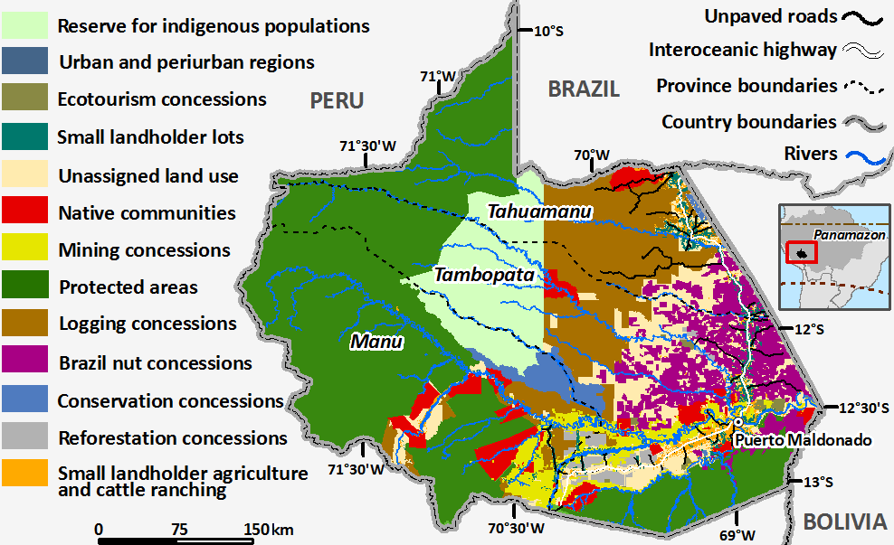
Figure S9 Current land use and land use zoning in Madre de Dios.

Figure S10 Historical and baseline deforestation for Madre de Dios. Baseline is an average of annual rates between 2000 and 2005 from (1) the Tropical Forest Carbon Assessment (see http://dge.stanford.edu/) and (2) Killeen et al. (2008). Deforestation projection under a BAU (business-as-usual) scenario comes from Soares-Filho et al. (2006). The proposed REDD target involves a progressive reduction of 20% per year.

Table S10 Odds ratios of deforestation for land use zones in Madre de Dios. *Before and after adjustment to compensate for differences in deforestation probabilities in areas of pairwise comparison. x = non-significant values within 95% confidential interval. Values < 1 are indicative of an inhibitory effect.

Land use zones | Before adjustment* |  |  |  |  | After adjustment*
Land use zones | 1997 | 2000 | 2005 | Mean | 1997 |  | 2000 | 2005 | Mean
Urban and periurban areas | 4.37 | 0.00 | 0.0 | 1.46 | 6.15 |  | 2.17 | 5.40 | 4.57
Mining concessions | 0.10 | 0.64 | 2.4 | 1.05 | 1.26 |  | 1.62 | 1.51 | 1.46
Small-scale cattle ranching | 0.37 | 4.13 | 15.3 | 6.60 | 1.42 |  | 1.20 | 1.28 | 1.30
Small landowner lots | 0.21 | 2.23 | 11.4 | 4.61 | 1.02 |  | 0.99 | 1.55 | 1.19
Brazil nut concessions | 0.02 | 0.12 | 0.4 | 0.19 | 0.76 |  | 0.67 | 0.49 | 0.64
Logging concessions | 0.00 | 0.03 | 0.9 | 0.31 | 2.84 |  | 3.28 | 4.29 | 3.47
Native communities | 0.00 | 0.02 | 0.3 | 0.12 | 0.77 |  | 1.20 | 1.35 | 1.11
Reforestation concessions | 0.00 | 0.01 | 1.0 | 0.32 | 0.19 |  | 0.39 | 0.93 | 0.51
Conservation concessions | 0.00 | 0.05 | 0.2 | 0.07 | 3.85 |  | 2.78 | 2.06 | 2.89
Ecotourism concessions | 0.01 | 0.05 | 4.0 | 1.36 | 0.08 |  | 0.08 | 0.76 | 0.31
Protected areas | 0.00 | 0.01 | 0.2 | 0.09 | 4.85 |  | 8.27 | 5.55 | 6.22
Indigenous reserves | 0.00 | 0.00 | 1.3 | 0.43 | 0.20 |  | 0.02 | x | 0.11
Unassigned land use | 0.01 | 0.16 | 1.8 | 0.65 | 0.96 |  | 0.94 | 1.17 | 1.02

Figure S11 Projected CO₂ emissions under BAU, historical baseline and REDD+ target deforestation scenarios for Madre de Dios (MD) and Brazil nut concessions (BNC).

Logging in the Brazil nut concessions

Since the establishment of Brazil-nut concessions, timber extraction has been allowed as a complementary activity to Brazil nut collection for commercial or industrial purposes (Decreto Supremo N°044-2002-AG). Concessionaires must file an Annual Complementary Management Plan, in which they have to state, among other things, the species and volumes to be harvested in that year, the plan for extraction, transport and silvicultural practices, a financial analysis and a map with the location of each tree to be harvested (Resolución Jefatural n° 055-2003-INRENA). Once this Plan is approved by the regional forestry authority, the concessionaire is allowed to harvest and commercialize the timber. Subsequently, in 2003, a volume cap was set in order to limit timber extraction from these concessions at 5 m³ ha⁻¹ (Resolución De Intendencia [RI] N°294-2004-INRENA-IFFS). Nevertheless, the volume cap was removed in 2007 (RI N°254-2007-INRENA-IFFS), based on the argument that there were no indications that logging has a negative impact on Brazil-nut stands (Peña 2010). The regional forestry authority must inspect the location and volumes of trees to be harvested prior to extraction, as a safeguard for the legal origin of timber and for the environmental impact on the Brazil-nut stand (Cossío-Solano et al. 2011). We calculated the logging rent in Madre de Dios by integrating economic data from POAs of 27 concessions in Madre de Dios (Table S11). Net present value was calculated over 25 years using a discount rate of 7.35%. An estimated NPV of US$ 544 ha⁻¹ for sustainable logging considered the rents of two harvests within a 20-year rotation cycle.

Table S11 Economic data from POAs of logging concessions in Madre de Dios. Source: Administración Técnica Forestal y de Fauna Silvestre de Tambopata-Manu y Tahuamanu. Data were obtained in July 2010 and correspond to the information presented in the POAs (Planes Operativos Anuales) of 27 concessionaires for 2008–2009.
Logging concession |  | Annual harvest area (ha) | Potential harvest (m³) | Total costs (US$) |  | Total profit (US$) | Mean profit (US$ ha⁻¹)
1 | Forestal Amazonica | 383 | 1420 | 63 058 |  | 34 368 | 90
2 | Inversiones Apolo 2008 | 234 | 3277 | 106 557 |  | 17 516 | 75
3 | Inversiones Apolo 2009 | 210 | 6623 | 156 217 |  | 81 417 | 387
4 | Forestal Camisea 2008 | 256 | 4171 | 119 932 |  | 67 339 | 263
5 | Forestal Camisea 2009 | 394 | 2176 | 115 472 |  | 40 412 | 103
6 | EMAVISJUG 2008 | 217 | 4716 | 119 542 |  | 122 479 | 564
7 | EMAVISJUG 2009 | 217 | 4232 | 125 426 |  | 124 870 | 575
8 | EPEFOMSG 2008 | 277 | 4900 | 155 241 |  | 110 018 | 396
9 | ESPERANZA 2008 | 877 | 3029 | 115 278 |  | 85 749 | 98
10 | ESPINTANA 2008 | 547 | 4301 | 136 812 |  | 43 446 | 79
11 | EXTRAMA 2008 | 338 | 1603 | 32 440 |  | 48 888 | 145
12 | G&SP 2008 | 476 | 5381 | 92 096 |  | 759 644 | 1594
13 | Maderera Huascar | 259 | 1940 | 35 798 |  | 52 564 | 203
14 | INBACO B-005-02 | 99 | 952 | 30 202 |  | 1925 | 20
15 | INBACO B-006-02 | 173 | 1178 | 27 976 |  | 23 006 | 133
16 | Villagaray Gutierrez | 288 | 2991 | 57 495 |  | 42 178 | 146
17 | Maderera Kalinowski | 247 | 2239 | 74 247 |  | 21 511 | 87
18 | Maderera Lidia | 304 | 2076 | 83 445 |  | 147 483 | 485
19 | MADEBOL | 1305 | 9994 | 175 506 |  | 140 680 | 108
20 | MADEFOL | 580 | 7001 | 174 794 |  | 198 917 | 343
21 | PARIAMARCA | 212 | 2105 | 94 651 |  | 70 143 | 331
22 | SHIHUAHUACO | 1232 | 10 016 | 238 623 |  | 245 672 | 199
23 | SERVINFOREST | 213 | 1184 | 71 893 |  | 10 252 | 48
24 | TAWARI | 1042 | 12 608 | 274 097 |  | 1 244 046 | 1194
25 | Texi Valencia 41-B | 307 | 5221 | 217 791 |  | 34 950 | 114
26 | Texi Valencia 2008 | 660 | 4611 | 154 030 |  | 218 456 | 331
27 | Texi Valencia 2009 | 300 | 3670 | 173 395 |  | 15 172 | 51
 | Mean |  |  |  |  |  | 302
 | Standard deviation |  |  |  |  |  | 357

Forest Stewardship Council certification
As part of the FSC (Forest Stewardship Council) forest management certification, concessionaires must undertake the following activities in order become FSC certified (Quaedvlieg 2009):
- The areas where Brazil nuts are collected must be clearly delimited and protected by the concessionaire from illegal harvesting and from the development of agriculture and cattle ranching, fire occurrence, and any other activity that might affect the resource.
- Concessionaires must monitor growth and population dynamics of the species in order to determine a sustainable harvest level to be included in the Management Plan. For example, ASCART does not collect more than 90% of available Brazil-nut fruits.
- Concessionaires are not allowed to harvest or hunt any endangered species of flora and fauna. Hunting is only allowed for subsistence purposes. Moreover, concessionaires must take the necessary precautions to protect key ecological features within the concessions, such as lakes. The use of fire must be kept to a minimum.
- Concessionaires are allowed to clear forests that are not of high conservation value. Plans detailing trail openings, campsites, sites of nut collection, and waste management must be developed. The use of any kind of herbicide, pesticide or chemical fertilizer is not allowed.
The concessionaires, in exchange for compliance, receive a price premium of around 0.17 US$ per kg of Brazil nuts exported through a certified market (Quaedvlieg 2009).

Rent sensitivity analysis

We did a sensitivity analysis of our rent estimates by varying prices: input costs ratios from 2005 to 2008. Input costs were deflated or inflated from 2008 costs according to Peru's inflation rates (Table S12). All model components were designed and run on Dinamica EGO freeware (Soares-Filho et al. 2010a).

Table S12 Rents as a function of output price/input costs and production scenarios. * Source: Banco Central de Reserva del Perú: http://www.bcrp.gob.pe/estadisticas/cuadros-anuales-historicos.html. **23% of increase from upgrading production chain. NPV = net present value over 25 years; discount rate of 7.35% per year.
Rents | Year
Rents | 2005 | 2006 | 2007 | 2008 | 2009
Peruvian inflation (%)* | 1.6 | 2.0 | 1.8 | 5.8 | 2.9
Output price by production type (US$ kg⁻¹)
Unshelled | 0.85 | 0.66 | 0.57 | 0.37 | 0.26
Shelled | 5.94 | 4.62 | 3.96 | 2.55 | 1.81
Shelled-certified | 6.31 | 4.90 | 4.20 | 2.72 | 1.92
NPV of rents (US$ ha⁻¹)
Unshelled | 114.5 | 82.6 | 68.0 | 34.9 | 18.5
Shelled | 243.7 | 183.3 | 152.9 | 87.4 | 53.0
Shelled-certified | 260.5 | 196.0 | 163.8 | 95.1 | 58.0
Improved shelled- certified** | 320.5 | 241.1 | 201.5 | 117.0 | 71.3

References
Baddeley, A. (2008) Analysing spatial point patterns in R. Workshop Notes Version 3.
Bonham-Carter, G.F. (1994) Geographic Information Systems for geoscientists: Modelling with GIS. New York, USA: Pergamon.
Cossío-Solano, R.E., Guariguata, M.R., Menton, M., Capella, J.L., Ríos, L. Peña, P. (2011) El aprovechamiento de madera en las concesiones castañeras (Bertholletia excelsa) en Madre de Dios, Perú: un análisis de su situación normativa. Documento de trabajo 56. CIFOR, Bogor, Indonesia.
Decreto Supremo N°044-2002-AG [www document] URL http://www.minag.gob.pe/dgffs/index.php?option=com_content&view=article&id=117&Itemid=144
Kainer, K.A., Wadt, L.H.O. & Staudhammer, C.L. (2007) Explaining variation in Brazil nut fruit production. Forest Ecology and Management 250: 244–255.
Killeen, T. J., Guerra, A., Calzada, M., Correa, L., Calderon, V., Soria, L., Quezada, B. & Steininger, M. K. (2008). Total historical land-use change in eastern Bolivia: who, where, when, and how much? Ecology and Society, 13: 36.
Peña, P. (2010) La castaña y la shiringa en Madre de Dios: análisis del marco legal y propuestas participativas para su mejora. Cuaderno de Investigación N°3. Sociedad Peruana de Derecho Ambiental (SPDA), Lima, Perú.
Quaedvlieg, J. (2009) Certification of Brazil nuts: a catalyst or obstacle for sustainable forest management? A case study about the effects of the FSC, organic, and Fair Trade certification systems on the Brazil nut industry of Madre de Dios, Peru. MSc Thesis, University of Amsterdam.
Resolución Jefatural N°055-2003-INRENA [www document] URL http://www.minag.gob.pe/dgffs/index.php?option=com_content&view=article&id=109&Itemid=132
Resolución De Intendencia N°294-2004-INRENA-IFFS [www document] URL http://www.minag.gob.pe/dgffs/index.php?option=com_content&view=article&id=102&Itemid=124
Resolucion De Intendencia N°254-2007-INRENA-IFFS [www document] http://www.minag.gob.pe/dgffs/index.php?option=com_content&view=article&id=71&Itemid=95
Soares-Filho, B.S., Nepstad, D.C., Curran, L.M., Cerqueira, G.C., Garcia, R.A., Ramos, C.A., Voll, E., McDonald, A., Lefebvre, P. & Schlesinger, P. (2006) Modelling conservation in the Amazon basin. Nature 440: 520–523.
Soares-Filho, B.S., Rodrigues, H.O. & Costa., W.L. (2010a) Modeling environmental dynamics with DINAMICA EGO [www document]. URL http://www.csr.ufmg.br/dinamica
Soares-Filho, B.S., Moutinho, P., Nepstad, D., Anderson, A., Rodrigues, H., Garcia, R., Dietzsch, L., Merry, F., Bowman, M., Hissa, L., Silvestrini, R. & Maretti, C. (2010b) Role of Brazilian Amazon protected areas in climate change mitigation. Proceedings of the National Academy of Sciences USA 107: 10821–10826.
Tonini, H., Costa, P. & Kaminski, P. (2008) Manejo de produtos florestais não madeireiros na Amazônia. Castanheira-do-Brasil. Boletim de Pesquisa e Desenvolvimento 2. Embrapa Boa Vista. Boa Vista, Roraima, Brazil
UNFCC (2011) Ad Hoc Working Group on Long-term Cooperative Action under the Convention Compilation of information on nationally appropriate mitigation actions to be implemented by Parties not included in Annex I to the Convention [www document]. URL http://unfccc.int/resource/docs/2011/awglca14/eng/inf01.pdf
Viana, V.M., Mello, R.A., Morales, L.M. & de Mendes, N.T. (1998) Ecologia e manejo de populações de Castanha-do-Pará em reservas extractivistas Xapuri, Estado do Acre. In: Floresta Amazônica: Dinâmica, Regeneração, e Manejo, ed. C. Gascon & P. Moutinho, pp. 277–292. Manaus, Brazil: Instituto Nacional de Pesquisa da Amazônia.
Wadt, L.H.O., Kainer, K.A., Staudhammer, C.L. & Serrano, R.O.P. (2008) Sustainable forest use Brazilian extractive reserves: natural regeneration of Brazil nut in exploited populations. Biological Conservation 141: 332–346.
Zuidema, P.A. & Boot, R.G.A. (2002) Demography of the Brazil nut tree (Bertholletia excelsa) in the Bolivian Amazon: impact of seed extraction on recruitment and population dynamics. Journal of Tropical Ecology 18: 1–31.

