**A tale of two villages: assessing the dynamics of fuelwood supply in communal landscapes in South Africa**

RUWADZANO MATSIKA, BAREND F.N. ERASMUS AND WAYNE C. TWINE

**APPENDIX 1**

**Table S1** Stem size class frequency distribution and size class distribution slope comparisons for Welverdiend woodlands in 1992 and 2009. Regressions were compared for significance using ANCOVA.

|  |  |  |  |  |  |  |  |  |  |  |  |  |  |  |  |
| --- | --- | --- | --- | --- | --- | --- | --- | --- | --- | --- | --- | --- | --- | --- | --- |
| *Species* | *Harvest duration* | *SCD regression analyses* | | | | | | | | | | | | | |
| *1992* | | |  | *2009* | | |  | *Slope comparison* | |  | *Intercept comparison* | | *Slope*  *classification* |
| *Slope* | *Intercept* | *r2* |  | *Slope* | *Intercept* | *r2* |  | *p-value* | *Pooled*  *slope* |  | *p-value* | *Pooled*  *intercept* | *Group* |
| *Albizia harveyi* | 1992/2009 | –0.11 | 4.92 | 0.79 |  | –0.10 | 4.32 | 0.56 |  | 0.96 | –0.11 |  | 0.61 | 4.62 | 3 |
| *Dichrostachys cinerea* | 1992/2009 | –0.10 | 4.30 | 0.61 |  | –0.11 | 4.51 | 0.61 |  | 0.94 | –0.10 |  | 0.91 | 4.41 | 3 |
| *Combretum collinum* | 1992/2009 | –0.07 | 3.31 | 0.82 |  | –0.04 | 2.03 | 0.21 |  | 0.67 | –0.06 |  | 0.33 | 2.67 | 2 |
| *Acacia exuvialis* | 1992/2009 | –0.08 | 3.14 | 0.56 |  | –0.09 | 3.69 | 0.52 |  | 0.82 | –0.08 |  | 0.76 | 3.41 | 2 |
| *Acacia gerrardii* | 1992/2009 | –0.07 | 3.06 | 0.60 |  | –0.02 | 1.03 | 0.17 |  | 0.32 | –0.05 |  | 0.17 | 2.05 | 2 |
| *Combretum apiculatum* | 1992/2009 | –0.05 | 2.45 | 0.88 |  | –0.03 | 1.29 | 0.17 |  | 0.63 | –0.04 |  | 0.26 | 1.87 | 1 |
| *Combretum hereroense* | 1992/2009 | –0.03 | 1.30 | 0.21 |  | –0.05 | 2.04 | 0.36 |  | 0.69 | –0.04 |  | 0.60 | 1.67 | 1 |
| *Terminalia sericea* | 1992/2009 | –0.04 | 2.05 | 0.84 |  | –0.08 | 3.66 | 0.60 |  | 0.37 | –0.06 |  | 0.21 | 2.85 | 2 |
| *Philenoptra violacea* | 1992 | –0.04 | 1.72 | 0.61 |  | –0.01 | 0.72 | 0.14 |  | 0.40 | –0.03 |  | 0.26 | 1.22 | 1 |
| *Sclerocarya birrea* | 2009 | –0.05 | 2.26 | 0.47 |  | –0.05 | 2.04 | 0.50 |  | 0.86 | –0.06 |  | 0.89 | 2.15 | 2 |
| *Acacia nilotica* | Not harvested | –0.02 | 0.90 | 0.33 |  | –0.06 | 2.63 | 0.56 |  | 0.34 | –0.04 |  | 0.13 | 1.76 | 2 |
| *Dalbergia melanoxylon* | Not harvested | –0.05 | 2.21 | 0.35 |  | –0.07 | 2.82 | 0.57 |  | 0.84 | –0.06 |  | 0.59 | 2.47 | 2 |
| *Diospyros mespiliformis* | Not harvested | –0.05 | 1.99 | 0.87 |  | –0.02 | 0.85 | 0.67 |  | 0.39 | –0.03 |  | 0.17 | 1.42 | 1 |
| *Zizyphus mucronata* | Not harvested | –0.03 | 1.35 | 0.36 |  | –0.02 | 0.73 | 0.20 |  | 0.57 | –0.03 |  | 0.56 | 1.04 | 1 |

**Table S2** Stem size class frequency distribution and size class distribution slope comparisons for Athol woodlands in 1992 and 2009. Regressions were compared for significance using ANCOVA.

|  |  |  |  |  |  |  |  |  |  |  |  |  |  |  |  |  |
| --- | --- | --- | --- | --- | --- | --- | --- | --- | --- | --- | --- | --- | --- | --- | --- | --- |
| *SPECIES* | *Harvest duration* |  |  |  | |  | | *SCD regression analyses* | | | | | | | | |
| *1992* | | |  | *2009* | | |  | *Slope comparison* | |  | *Intercept comparison* | |  | *Slope*  *classification* |
| *Slope* | *Intercept* | *r2* |  | *Slope* | *Intercept* | *r2* |  | *p–value* | *Pooled*  *slope* |  | *p–value* | *Pooled*  *intercept* |  | *Group* |
| *Terminalia sericea* | 1992/2009 | –1.19 | 6.67 | 0.76 |  | –1.20 | 6.76 | 0.70 |  | 0.99 | –1.20 |  | 0.92 | 6.72 |  | 4 |
| *Acacia exuvialis* | 1992/2009 | –1.26 | 5.65 | 0.91 |  | –0.24 | 1.29 | 0.13 |  | 0.05 | –0.75 |  | 0.14 | 3.47 |  | 4 |
| *Combretum collinum* | 1992/2009 | –0.27 | 1.96 | –0.08 |  | –0.90 | 4.14 | 0.75 |  | 0.35 | –0.58 |  | 0.74 | 3.05 |  | 4 |
| *Combretum apiculatum* | 1992/2009 | –0.83 | 4.26 | 0.68 |  | –1.14 | 6.13 | 0.62 |  | 0.63 | –0.98 |  | 0.28 | 1.38 |  | 4 |
| *Dichrostachys cinerea* | 1992/2009 | –1.41 | 6.64 | 0.88 |  | –1.17 | 6.45 | 0.71 |  | 0.66 | –1.29 |  | 0.47 | 6.54 |  | 4 |
| *Dalbergia melanoxylon* | 1992/2009 | –1.35 | 6.46 | 0.90 |  | –1.15 | 5.81 | 0.87 |  | 0.60 | –1.25 |  | 0.92 | 6.14 |  | 4 |
| *Combretum hereroense* | 1992/2009 | –0.18 | 1.27 | 0.08 |  | –0.28 | 1.49 | 0.13 |  | 0.86 | –0.22 |  | 0.91 | 1.38 |  | 4 |
| *Acacia gerrardii* | 1992/2009 | –0.83 | 3.49 | 0.79 |  | –1.34 | 6.14 | 0.89 |  | 0.21 | –1.08 |  | 0.08 | 4.82 |  | 4 |
| *Sclerocarya birrea* | 1992/2009 | –0.78 | 3.72 | 0.91 |  | 0.23 | 1.69 | 0.07 |  | 0.32 | –0.50 |  | 0.62 | 2.70 |  | 4 |
| *Diospyros mespiliformis* | 1992 | –0.14 | 1.04 | 0.08 |  | –0.05 | 0.43 | 0.05 |  | 0.76 | –0.09 |  | 0.41 | 0.74 |  | 4 |
| *Gymnosporia buxifolia* | 2009 | –0.75 | 3.72 | 0.30 |  | –1.27 | 6.01 | 0.74 |  | 0.09 | –1.01 |  | 0.14 | 4.87 |  | 4 |
| *Vanguerai infausta* | Not harvested | –0.73 | 3.37 | 0.88 |  | –0.19 | 1.28 | 0.10 |  | 0.20 | –0.46 |  | 0.44 | 2.33 |  | 4 |
| *Acacia nigrescens* | 2009 | –0.53 | 2.50 | 0.80 |  | –0.59 | 3.29 | 0.44 |  | 0.88 | –0.56 |  | 0.31 | 2.89 |  | 4 |
| *Philenoptra violaceae* | 1992 | –0.45 | 1.91 | 0.79 |  | –1.06 | 4.72 | 0.86 |  | 0.07 | –0.76 |  | 0.09 | 3.32 |  | 4 |

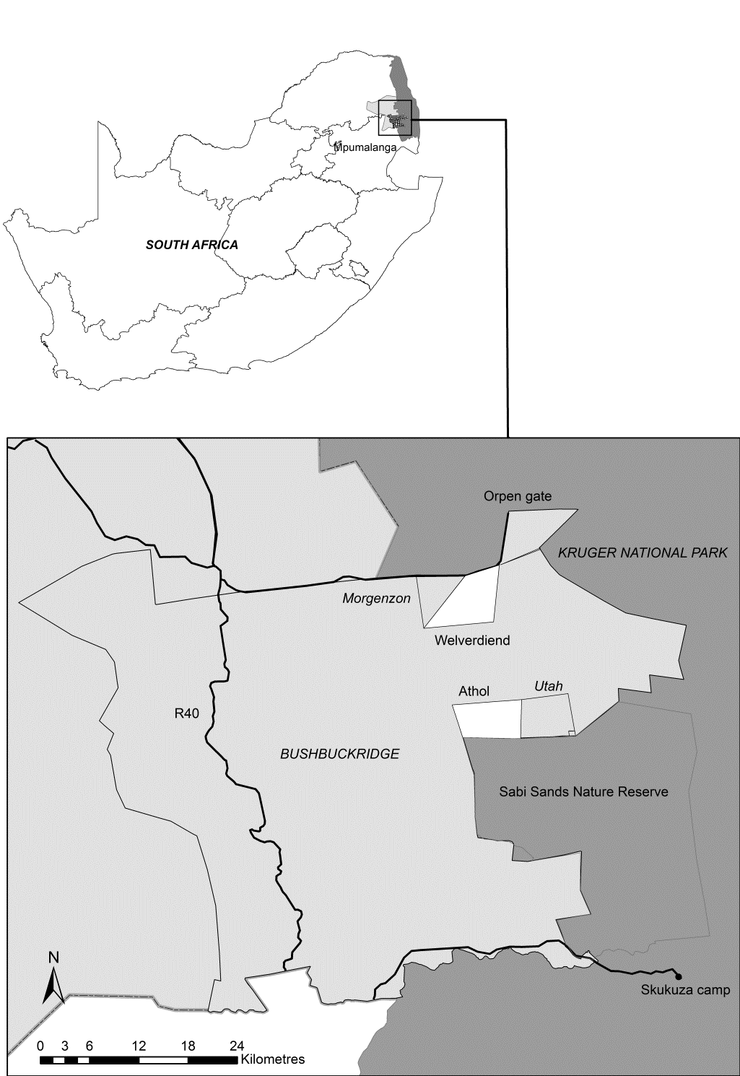

**Figure S1** The locations of Welverdiend and Athol villages relative to the Kruger to Canyons Biosphere Reserve and the Kruger National Park in South Africa. Clear polygons show the extent of the original farm boundaries of each settlement.

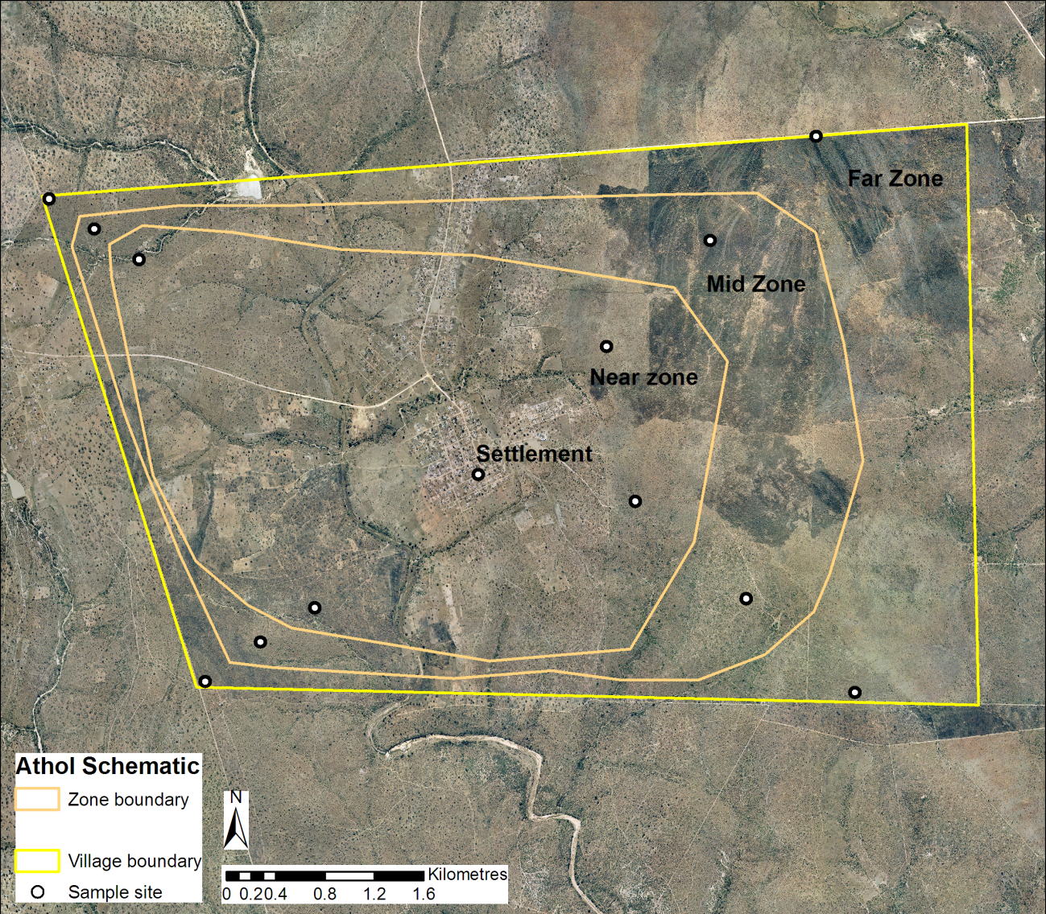

**Figure S2** The location of the woodland sampling plots and the woodland ’zones‘ used to divide the communal woodlands into rings of average biomass density; shown here around Athol village.

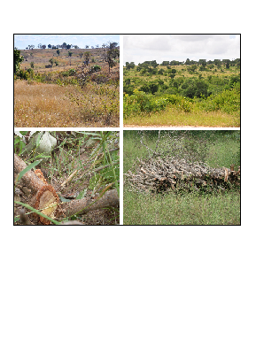

**Figure S3** The top two habitat photographs show the structural heterogeneity observed in communal woodlands within the study area. The bottom left photograph shows a freshly cut stem in Welverdiend. The photograph in the bottom right shows a freshly cut fuelwood pile in Welverdiend; live wood is often cut and left to dry in the woodlands, then collected at a later date to avoid penalties for harvesting live stems.