Forest ecosystem services and biodiversity in contrasting Himalayan forest management systems
INGER E. MÅREN, KHEM R. BHATTARAI AND RAM P. CHAUDHARY

APPENDIX 1

Table S1 Estimated climate data for the core forest areas sampled at Panchase Mountain, based on data from Lumle Agricultural station (1978–2007), using a laps rate of 0.51°C 100 m⁻¹ (Vetaas 2000).
 | Mean temperature (°C) | Maximum average temperature (°C) | Minimum average temperature (°C) | Precipitation  (mm)
Summer | 12.3 | 13.6 | 11.3 | 3734.0
Winter | 6.8 | 8.3 | 5.3 | 1720.0
Yearly | 10.6 | 11.6 | 9.7 | 5454.0

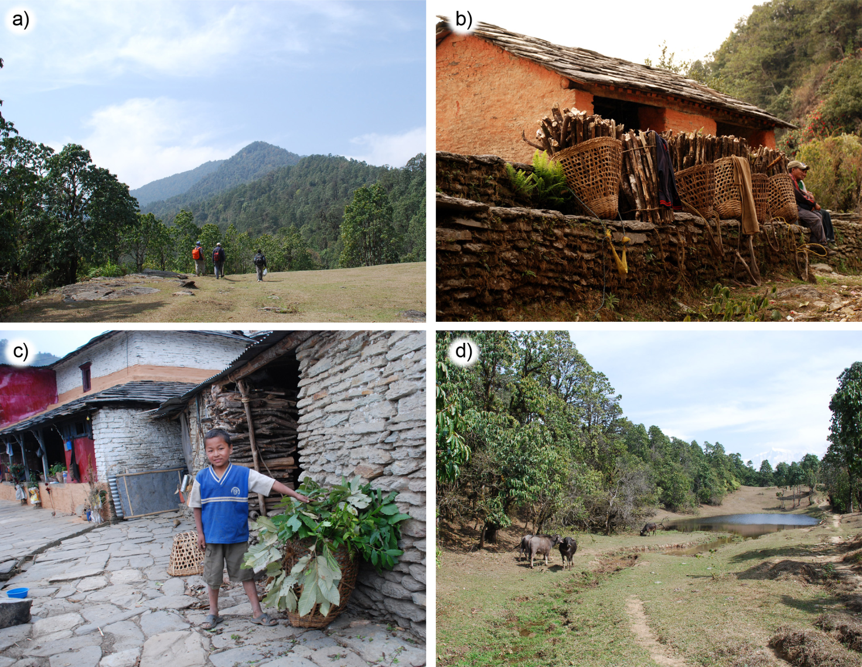
Figure S1 Pictures taken in Panchase. (a) Buffalo grazing grounds and the Panchase Peak (2517 m above sea level). (b) Fuelwood collection on the southern slopes of Panchase, mostly constituting Rhododendron arboretum. (c) Boy with harvested lopped fodder for stall fed goats at Badhaure. (d) Livestock grazing grounds and small pond at c. 2100 m above sea level in the community forest.
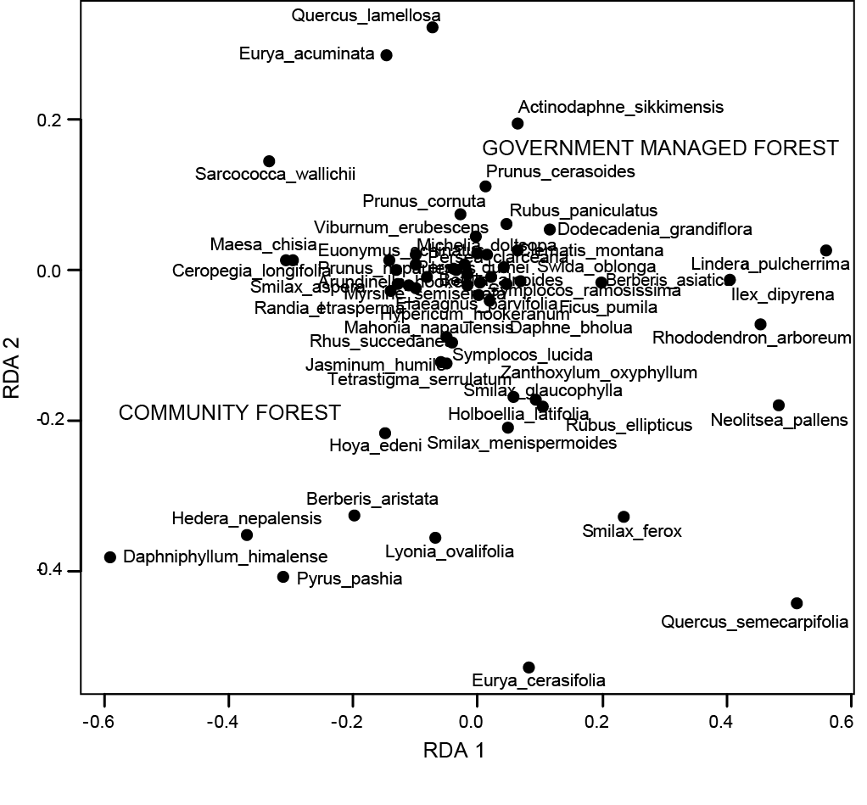
Figure S2 Multivariate redundancy analysis (RDA) ordination diagram showing the spread of the species composition in relation to measured anthropogenic disturbances in community forests and government managed forests at the Panchase Mountain in Central Nepal.

Reference

Vetaas, O.R. (2000) Comparing species temperature response curve: population density versus second-hand data. Journal of Vegetation Science 11: 659–666.

APPENDIX 2

Questionnaire used to interview villagers about farming system forest use around the Panchase Mountain, Central Nepal.

Household survey 2010, Panchase area, NEPAL
Date:___ Questioner:_______ Caste ________ Gender ____ Age ____ Household no. ______
VDC____________ Settlement/ward _____________ Masl_______ Protection (0/1) _______ ⁪

- Household
Ethnic group:………………………………………………………………………….………..
No. of ethnic groups in village:……………………………………………………….………..
No. of persons in the household:…………………………………………………….…………
No. of households in village:………………………………………………………….………..
- Crops
Main types of crops:………………………………………………………………….…………
On-farm planted fodder trees:………………………………………………………….……….
Crop damaging wildlife:………………………………….……………………………………..
Quantify crop damage 1-5;………………
(1=never, 2=rarely, 3=sometimes, 4=often, 5=always)
- Livestock
No of livestock (no. and type):…………………………………………………………………
Livestock damaging wildlife:…………………………………………………………………..
Quantify livestock damage 1-5;………………
(1=never, 2=rarely, 3=sometimes, 4=often, 5=always)
- Forest use – forest ecosystem services
Walking distance to forest (in min):………….
Previous big disturbance events in the forest:……………………………………….…………..
Species preferred/used for lopping fodder:……………………………………………….……..
Species preferred/used for fuelwood:……………………………………………………………
Species preferred/used for timber:……………………………………………………………….
Species preferred/used for litter collection:………………………………………………..……..
Species preferred/used as medicinal plants:…………………………………………….….…….
Species preferred/used as edible plants:…………………………………………………….……
For what purpose is the forest most important (rank 1-5)?
Firewood:…, Fodder:…, Litter:…, Edible plants:…, Medicinal plants:….
Forest quality compared to 10 years ago (Increasing (1), stable (2), decreasing (3)):
Government Managed Forest:………………
Community Forest:…………………………
Conservation measures?:…………………………………………………………………………

