Supplementary material: Appendix S4
Cristescu, B., Stenhouse, G.B., Symbaluk, M., Nielsen, S.E. & Boyce, M.S. Wildlife habitat selection on landscapes with industrial disturbance.
Appendix S4 contains mapped predictions of grizzly bear habitat selection based on top models for each bear by reproductive class (male, solitary female, female with cubs), study phase (during mining, post mining) and scale of availability (home-range level, study area-level).

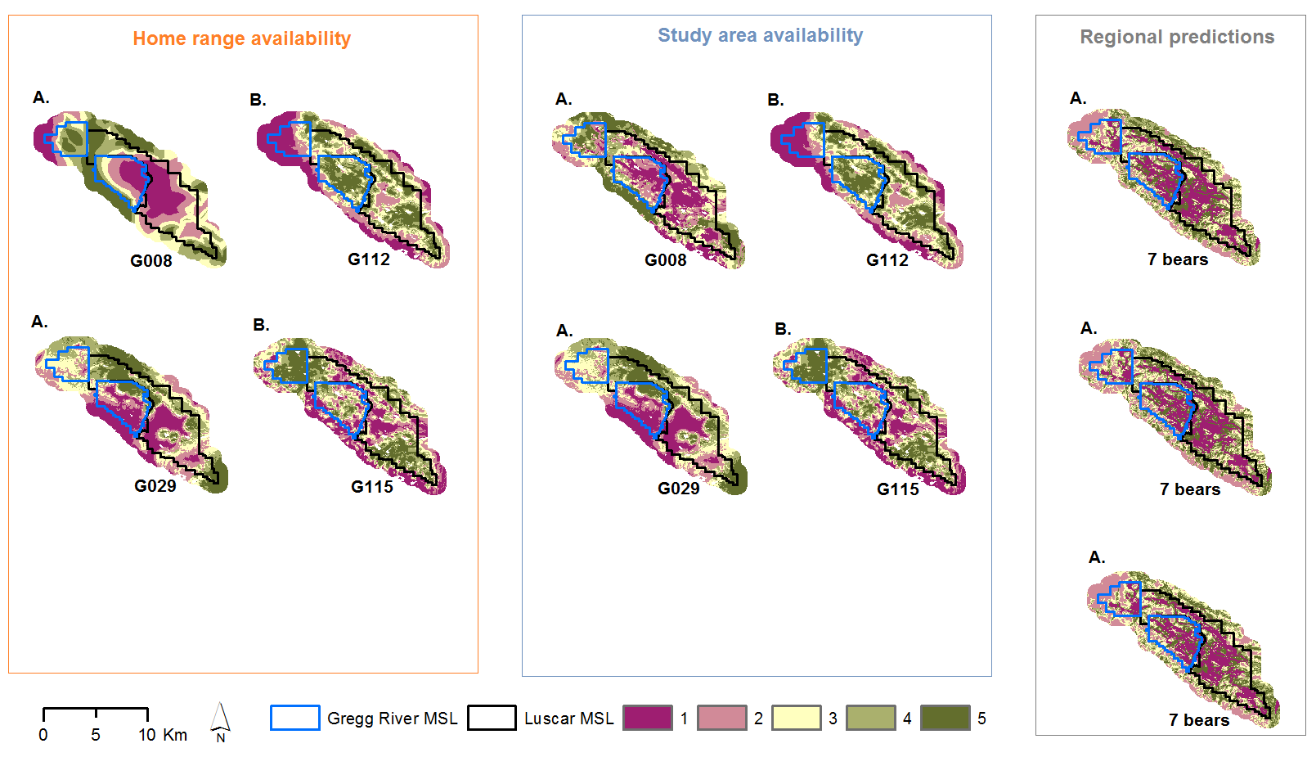

Fig. 1 Appendix S4. Relative probability of male grizzly bear habitat selection on open-pit MSLs and adjacent 1 km buffer, west-central Alberta, Canada, based on site-specific (fine-scale) habitat modelling with availability drawn at home range and study area levels. Predictions are presented during (A. n = 2) and post mining (B. n = 2). Regional level RSF surfaces for three seasons based on home range level availability for males (Nielsen 2005) were clipped to our study area extent and are also illustrated in the figure. Scores for RSFs are binned from low (1) to high (5) probability of selection.

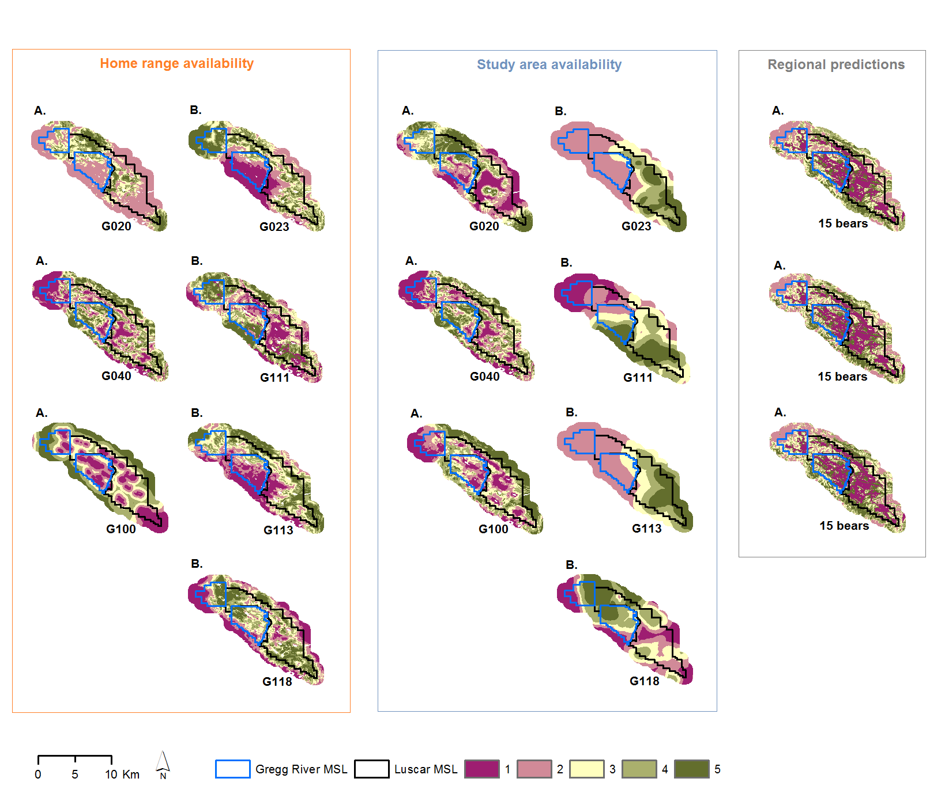

Fig. 2 Appendix S4. Relative probability of solitary female grizzly bear habitat selection on open-pit MSLs and adjacent 1 km buffer, west-central Alberta, Canada, based on site-specific (fine-scale) habitat modelling with availability drawn at home range and study area levels. Predictions are presented during (A. n = 3) and post mining (B. n = 4). Regional level RSF surfaces for three seasons based on home range level availability for pooled females with/without cubs (Nielsen 2005) were clipped to our study area extent and are also illustrated in the figure. Scores for RSFs are binned from low (1) to high (5) probability of selection.

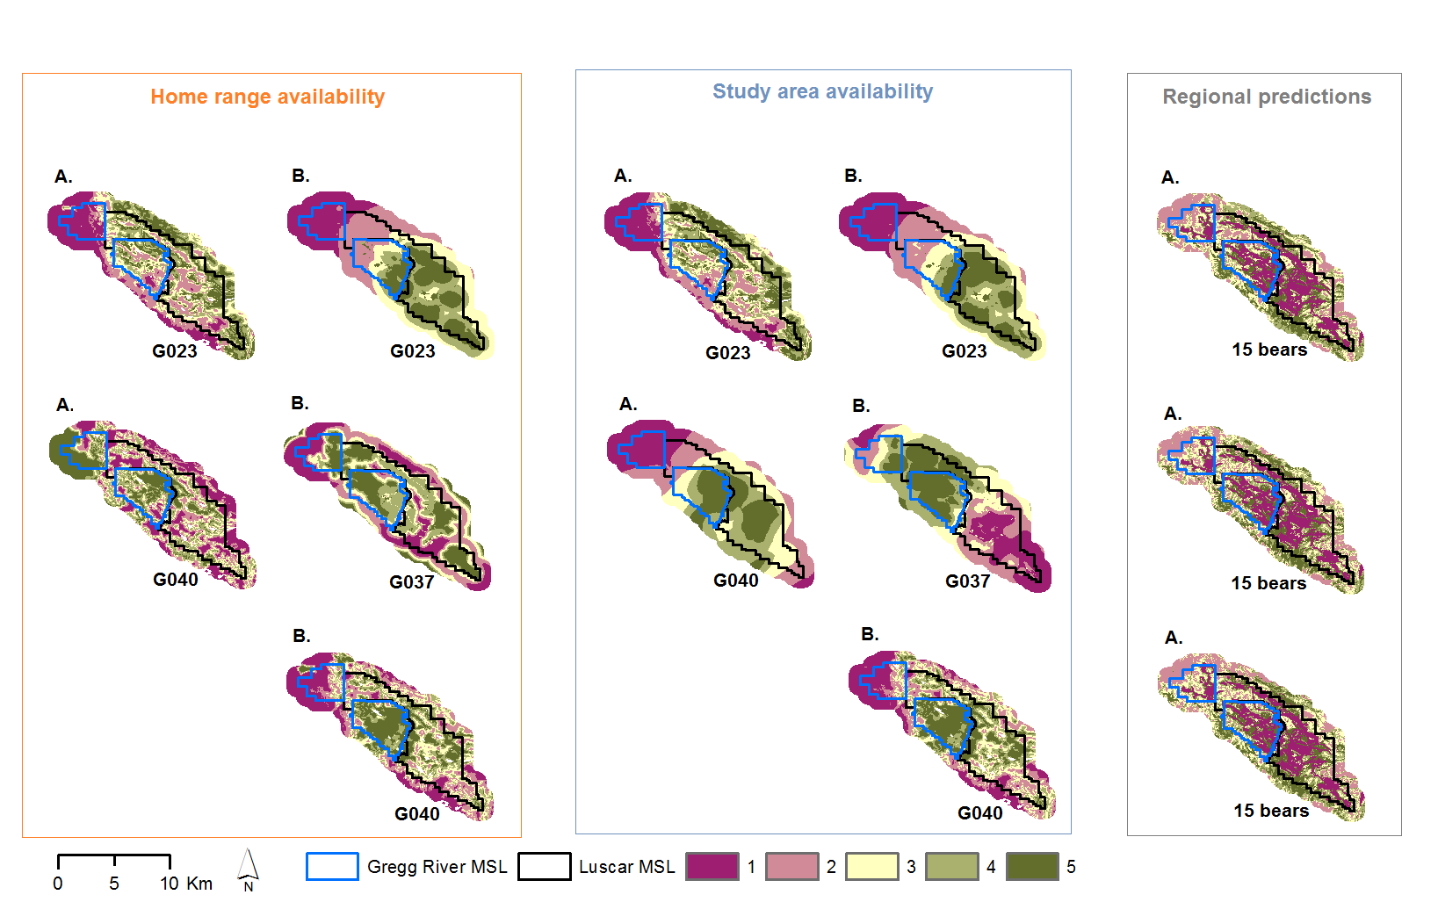

Fig. 3 Appendix S4. Relative probability of female grizzly bear with cubs habitat selection on open-pit MSLs and adjacent 1 km buffer, west-central Alberta, Canada, based on site-specific (fine-scale) habitat modelling with availability drawn at home range and study area levels. Predictions are presented during (A. n = 2) and post mining (B. n = 3). Regional level RSF surfaces for three seasons based on home range level availability for pooled females with/without cubs (Nielsen 2005) were clipped to our study area extent and are also illustrated in the figure. Scores for RSFs are binned from low (1) to high (5) probability of selection.

