Supplementary material
Cristescu, B., Stenhouse, G.B., Symbaluk, M., Nielsen, S.E. & Boyce, M.S. Wildlife habitat selection on landscapes with industrial disturbance.

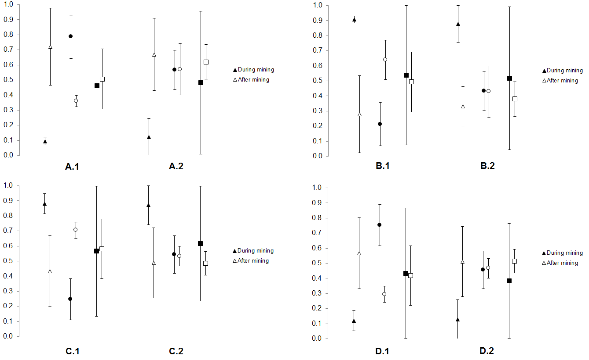

Fig. S1. Predictive power of grizzly bear Resource Selection Functions averaged within reproductive class during versus post mining. Models contrasted habitat features at bear GPS radiocollar fixes and available locations drawn randomly from within the study area or individual bear home range. Proportion of predictions are presented for true positives (A), false negatives (B), true negatives (C) and false positives (D) for home range (1) and study area availability (2). Reproductive classes include males ( ), solitary females
( ) and females with cub(s) ( ). Data represent means ± SE.

