Supplemental materials

Text:

T1: Landscape connectivity is defined as vegetation patterns that contribute to the linked and interwoven capacity of the overall landscape, which may help facilitate species movement throughout that region (Rudnick et al. 2012); habitat connectivity focuses on specific species and their habitat patches, while ecological connectivity regards larger ecosystem and hydrologic processes, such as watershed functioning, carbon storage, climate regulation, soil quality, erosion control, and many more . Lastly, evolutionary connectivity is concerned with genetic flow between populations (Lindenmayer & Fischer 2006).

T2: Article 4 of Executive Decree No. 40043 of the Ministry of Environment, Energy, and Telecommunications (MINAE) defines a biological corridor as a “delimited territory whose objective is to provide ecological connectivity between landscapes, ecosystems, and habitat, natural or modified, to assure the maintenance of biodiversity and ecological and evolutionary processes” (MINAE 2008). In 2014, Article 4 of Executive Decree No. 39660 identified properties within biological corridors as high priority PES locations (MINAE 2014).

T3: Goals of this program include: (1) Strengthening the national biological corridor network; (2) promoting conservation of biodiversity and restoring ecological connectivity; (3) encouraging environmentally friendly development within corridors; (4) increasing collaboration among institutions and actors within corridors (MINAE 2006; SINAC 2009).

T4: Due to climatic variability in the region, these images were coincidentally the only regional relatively cloud-free imagery products. While mainly cloud-free, some clouds were still present in the imagery and classification. The clouded areas in the 2012 classification, which primarily occurred over protected area forests due to local climate and topography, were mosaicked with the 2008 classification of those regions; so effectively, we replaced clouded areas (majority in protected areas) in 2012 with the same forested protected areas from 2008. The land use surface contained seven classes, including forest, low vegetation, pasture, urban, water, cloud, and bare ground.

T5: Slope surface was derived from the 30-m resolution Digital Elevation Model (DEM) from ASTER using the slope tool in ArcGIS 10.2 (ESRI 2011). Slope in the study area ranges from 0 to 88 degrees (with a maximum of 90 degrees). The road network layer was provided by FONAFIFO (Fondo de Financiamiento Forestal de Costa Rica), and included information on primary, secondary, tertiary, and quaternary roads.

T6: To create cost surfaces, we weighted each pixel surface using a scale of 1-10 (Supplemental materials, Table S1), and used addition in the raster calculator to create a raster surface in ArcGIS 10.2. ). For the land use surface we determined weights and values (1-10) of each land use (Table S1). For slope surface we weighted steeper slopes with a higher cost value because dispersal across steep surfaces is less preferable, but not impossible (Alexander & Waters 2000). Larger, heavily traveled roads (Benítez-López et al. 2010) had a higher cost value than narrow dirt roads because roads may disrupt landscape connectivity and wildlife are less likely to traverse large paved roads (Forman & Alexander 1998; Forman & Deblinger 2000). Within the resulting surfaces, lower pixel values (i.e. lower resistance) represent more favorable areas for connectivity (more native forested vegetation, less and fewer roads, lower slopes), while higher pixel values represented less favorable areas for connectivity (less native forest vegetation, more and larger roads, higher slopes).

T7: Land Use Classifications: Forest is described as areas with primary or mature secondary forest. Low vegetation is undergrowth below five meters in height. Pasture is actively grazed grassland, mainly used for dairy production. Urban describes built up areas such as cities, roads, and towns. Water is largely comprised of high gradient streams and rivers. Bare ground indicates areas cleared of vegetation, including burned areas, coffee shade structures, and construction that exposes bare soil.

T8: Least-Cost Path: To understand where current densities linearly flow and to prioritize important locations within the corridor that align with ease of connectivity, we conducted a least-cost path (LCP) analysis. This method creates a path of least resistance across a minimum number of barriers between two points; both stepping-stones and linear forest fragments can be features within the path of least resistance, and the least cost path is solely dependent on the distances and values of the weighted surface. We created the cost surface using raster algebra, and the direction raster was produced using the ArcGIS Toolbox cost raster, with the protected areas to the east and west used as source and destination localities. The LCP analysis was parameterized with the same variables as the cost surface from Scenario B 2012 in the Circuitscape model. Cost paths were created from west to east and east to west. This identified the most direct path between the two protected areas to specify areas of conservation priority, and also provided additional regions of potential conservation concern. The bidirectional path was displayed as the main route, and only one path met this criterion. Finally, we clipped a 1 km buffer around the bidirectional LCP, and calculated land use in the 1 km LCP, comparing it to the vegetation composition of the general landscape (Supplemental materials, Figure S3).

T9: The bidirectional, or main least-cost path was consistent with Circuitscape mapping, showing similar connections across the CBPN (Figure 2, map A and B). Within the 1 km buffered LCP, forest cover was the highest land cover (56%), followed by low vegetation (26%), pasture (8%), bare ground (6%), and urban areas (3%) (Table 1, Fig S3). Comparing these values to overall regional land cover or land cover within the CBPN, we see that both CBPN and the overall region had more forest than the LCP. Surprisingly, within the LCP, forest was less dominant than in the larger landscape, and low vegetation was marginally higher when compared to the overall landscape (Table 1).

References (not listed in main text)

ESRI (2011) *ArcGIS Desktop 10*. Redlands, CA, USA: Environmental Systems Research Institute.

Rudnick D, Ryan SJ, Beier P, Cushman SA, Dieffenbach F, Epps C, Gerber LR et al. (2012) *The Role of Landscape Connectivity in Planning and Implementing* Conservation and Restoration Priorities. Issues in Ecology. Report No. 16. Washington, DC, USA: Ecological Society of America.

Supplementary materials: Tables

*Table S1.* Parameterization of cost surfaces, with each weight, transformed to the scale of 1-10, with 1 being most favorable for conductance, and 10 being least favorable for electrical conductance.

|  |  |  |  |  |  |
| --- | --- | --- | --- | --- | --- |
| Slope |  | Road |  | Land use |  |
| Category (degrees) | Weight | Category (road size) | Weight | Category (class) | Weight |
| 0-40 | 1 | Primary | 8 | Forest | 1 |
| 40-60 | 5 | Secondary | 6 | Cloud | 1 |
| 60-80 | 8 | Tertiary | 4 | Water | 2 |
| 80-90 | 9 | Quaternary | 3 | Low vegetation | 5 |
|  |  |  |  | Pasture | 7 |
|  |  |  |  | Bare | 9 |
|  |  |  |  | Urban | 10 |

Supplementary Materials: Figures

*Figure S1*. The conceptual design for our corridor specific analysis. If connectivity within the biological corridor is not affected by the policy implementation, then the post implementation values for landscape connectivity will be unchanged against the fixed baseline, as represented by the black line. If the National Biological Corridor Program does enhance connectivity, then post implementation values for landscape connectivity will be higher, represented by the dotted line (Bull et al., 2014; Wunder 2005). There is also the possibility for improving or declining baselines associated with outside activities impacting the corridor, such as the recent general reforestation trend in Costa Rica.

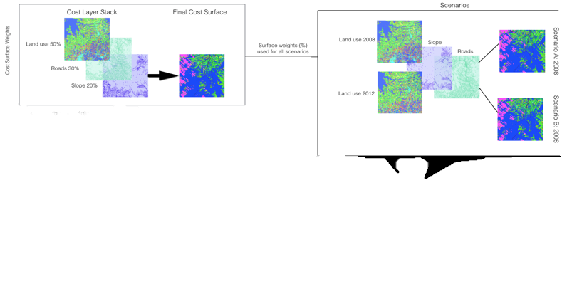

Scenario 2008

Scenario 2012

*Figure S2.* On the left, land cover variable layers are assigned weights and then stacked to develop a final cost (resistance) surface for 2008 and 2012. The right side of the figure shows the Circuitscape model inputs (weighted cost layers) and outputs (2008 and 2012 connectivity maps). Cost layers include land use, roads, and slope surfaces. The land use layer was created for 2008 and 2012 using object-oriented classification of Terra Advanced Spaceborne Thermal Emission and Reflection Radiometer (ASTER) imagery, produced by NASA with 30-meter resolution. Slope surface was derived from the 30-m resolution Digital Elevation Model (DEM) from ASTER using the slope tool in ArcGIS 10.2. The road network layer was provided by FONAFIFO (Fondo de Financiamiento Forestal de Costa Rica), and included information on primary, secondary, tertiary, and quaternary roads. To account for potential cost surfaces biases, we performed multiple iterations of surface weights to determine the appropriate weights for the final model. In the final model, land use was weighted at 50%, slope at 20%, and the road network at 30%. The final cost layers were used to analyze landscape connectivity using the Circuitscape tool in ArcGIS.

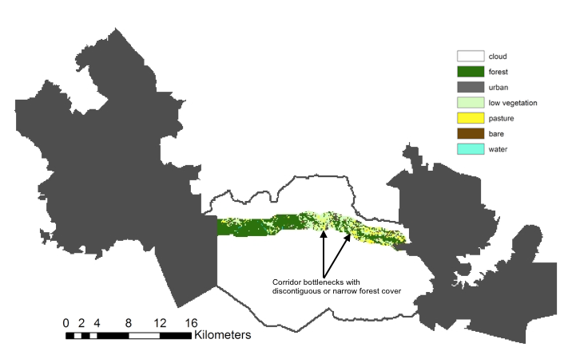

*Figure S3.* The least cost path between eastern and western protected areas, which are represented in solid black. The Paso de las Nubes Biological Corridor border is outlined in the center in black. And the least cost path with 1km buffer is shown within the corridor, with land uses from 2012 displayed within that buffer.

*Figure S4.*  The difference values show the changes between 2012 and 2008 connectivity density maps, with green representing positive changes to connectivity and brown representing negative changes to connectivity.