Supporting Information
for
Solvent-Vapor Annealing-Induced Growth, Alignment and Patterning of π-Conjugated Supramolecular Nanowires

by
Hin-Lap Yip,† Hong Ma,† Yanqing Tian,† Neil M. Tucker,§ Orb Acton, † Alex K.-Y. Jen,*,†,§
†Department of Materials Science and Engineering, § Department of Chemistry, University of Washington, Seattle, WA 98195

Contents List

Synthetic procedure of HATNA-1 and HATNA-2 -S2-3

AFM images of SVA effect using different solvent-vapor systems on the reorganization of HATNA-2 -S5

AFM images of solvent-vapor annealing effect on pre-organized HATAN-2 nanowires -S6

Temperature-dependent UV-vis absorption spectrum of HATNA-2 -S6

SEM image of aligned nanowires in FET device -S7

Materials synthesis
Scheme S1. Synthesis of hexaazatrinaphthylene (HATNA) derivatives
All chemicals were purchased from Aldrich and used as received unless otherwise specified. Chloroform and triethylamine (Et₃N) were distilled over P₂O₅ and CaH₂, respectively. ¹H NMR spectra were recorded on a Bruker-300 FT NMR (300 MHz) spectrometer with tetramethylsilane (TMS) as internal reference. Purity of compounds was determined by a combination of thin-layer chromatography (TLC) on silica gel plates (Whatman) with fluorescence indicator and high pressure liquid chromatography (HPLC) using a Varian PrepStar SD-1 high-pressure liquid chromatograph. Elemental analysis was determined at Midwest Microlab, LLC (Indianapolis, IN). 5,6,11,12,17,18-hexaazatrinaphthylene-2,8,14(15)-tricarboxylic acid was synthesized following the reported method.¹ 2,8,14(15)-Tri(1-dodecylaminocarbonyl)-5,6,11,12,17,18- hexaazatrinaphthylene (HATNA-2) was prepared according to our previously published paper.²
2,8,14(15)-Tri(1-dodecanoxycarbonyl)-5,6,11,12,17,18-hexaazatrinaphthylene (HATAN-1). 5,6,11,12,17,18-hexaazatrinaphthylene-2,8,14(15)-tricarboxylic acid (2.0 g, 3.8 mmol) was stirred and refluxed in thionyl chloride (50 mL) for 24 hours. After evaporating to dryness, the obtained tricarbonyl chloride was used directly for next step reaction without further purification. Tricarbonyl chloride (270 mg, 0.46 mmol) and dodecanol (500 mg, 2.7 mmol) were dissolved into dry chloroform (20 mL). Dry triethyl amine (3 mL, 30 mmol) was added into the above solution, and the reaction mixture was stirred at room temperature overnight. After the solvent was removed, the residue was washed with methanol. The solid was collected and purified twice by using silica gel column chromatography with CH₂Cl₂/CH₃OH (20/1 by volume) as eluent to obtain yellow solid (150 mg, 32%). ¹H NMR (CDCl₃, ppm): δ 9.48 and 9.46 (dd, J = 1.2 Hz, 3H), 8.79 (d, J = 5.7 Hz, 1H), 8.77 (d, J = 5.4 Hz, 2H), 8.69 (m, 2H), 8.67 (m, 1H), 4.51 (t, J = 6.6 Hz, 6H), 1.90 (m, 6H), 1.30 (b, 54H), 0.91 (t, J = 7.2 Hz, 9H). C₆₃H₈₄N₆O₆: Calcd C 74.08, H 8.29, N 8.23. Found C 73.79, H 8.15, N 8.25.

SEM image of HATNA-2 nanowires

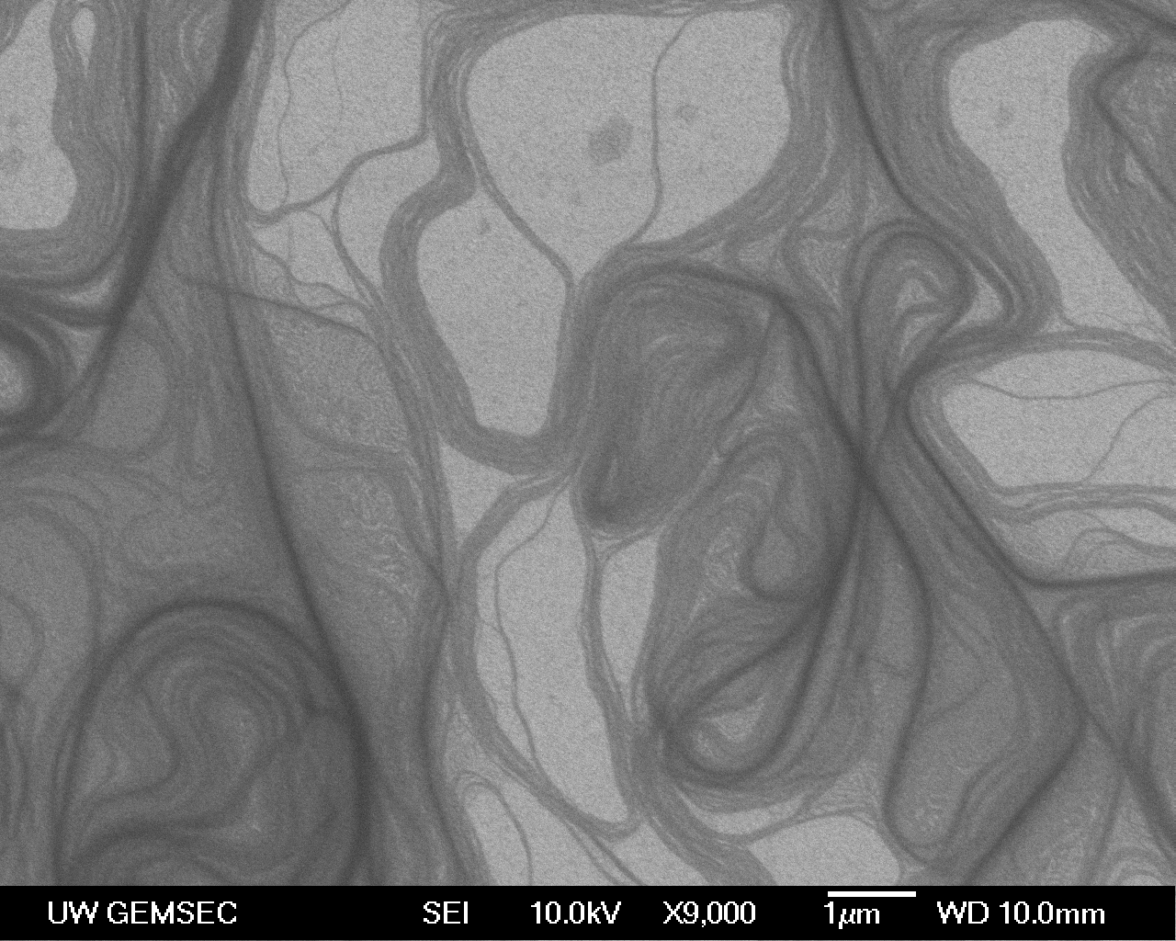

Figure S1. SEM image of HATNA-2 after CHCl₃-vapor annealing for 20 hours.

AFM images of SVA effect using different solvent-vapor systems on the reorganization of HATNA-2
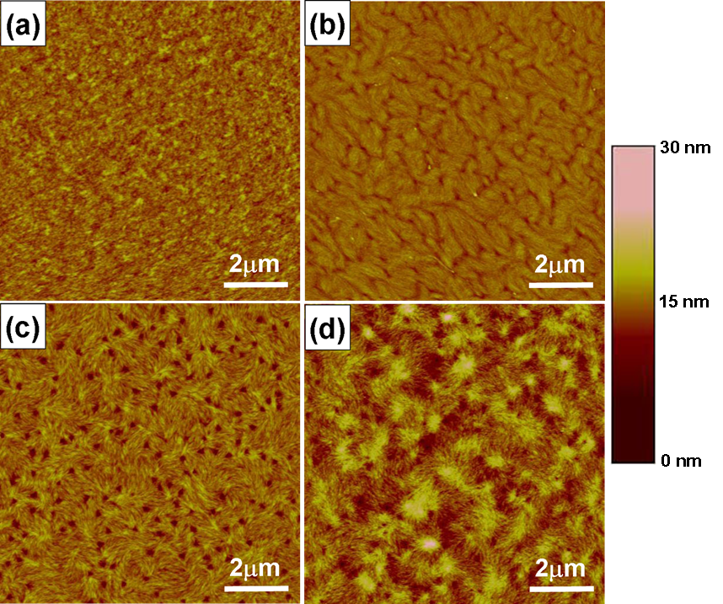
Figure S2. Tapping-mode AFM images of thin film of HATNA-2 after 20 hours annealing from the vapor of a) MeOH, b) hexane, c) CHCl₃:MeOH (v/v = 1.06 : 1) and d) CHCl₃:hexane (v/v = 1 : 2.58) . The volume ratio in c) and d) were adjusted so that the partial pressures of each solvent are equal.

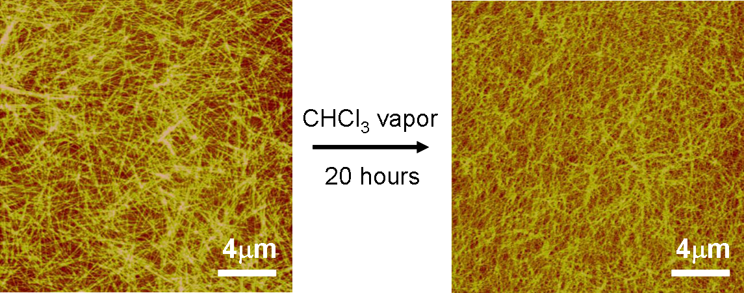
AFM images of solvent-vapor annealing effect on pre-organized HATNA-2 nanowires
Figure S3. Tapping-mode AFM images of HATNA-2 spincasted from CHCl₃/Hexane(v/v = 1:1) on SiO₂/Si. The spin speed and concentration were 3000 rpm and 5 g / L, respectively. The nanowire network is a thermodynamically stable structure, exposure of this robust structure to CHCl₃ vapor for 20 hours did not show destructive change of the network organization.

Temperature-dependent UV-vis absorption spectrum of HATNA-2
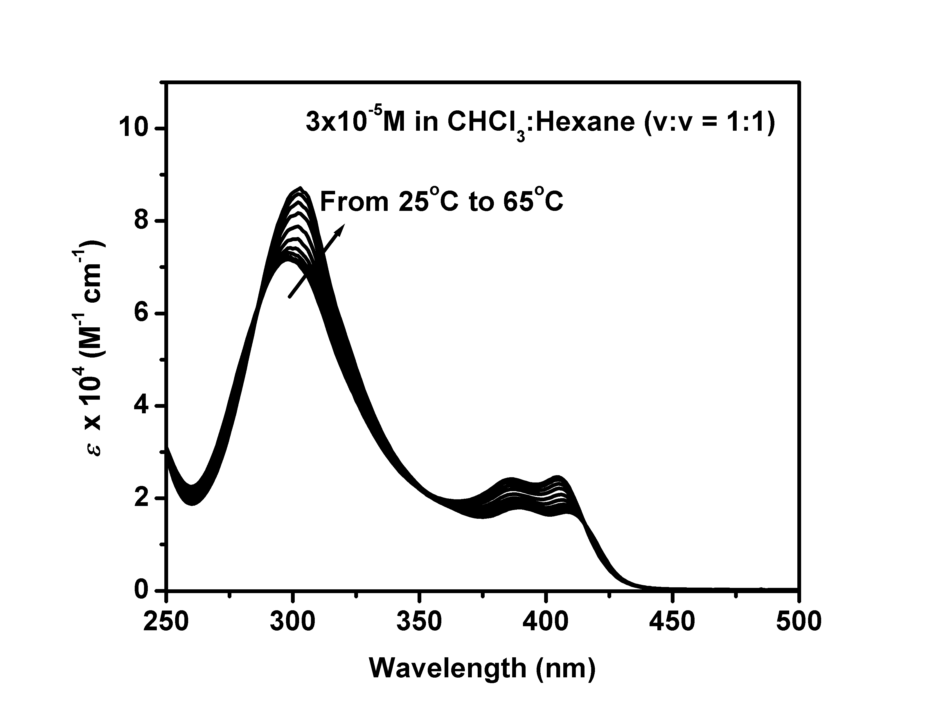
Figure S4. Temperature-dependent UV-vis absorption spectrum of 3 x 10⁻⁵ M of 2 in CHCl₃:Hexane (v:v = 1:1). Increasing the temperature of the solution resulted in the partial dissociation of the aggregated 2. At 60 ºC, the main peak red-shifted from 298 nm (at 25 ºC) to 302 nm and the ratio of peak intensity between the 0-0 (406nm) and 0-1 (387nm) transitions is equal to 1. For the solution with molecularly dissolved 2, the main peak appeared at 304 nm and the ratio of the peak intensity between the 0-0 and 0-1 transitions is equal to 1.1 (Figure 2e).
SEM image of aligned nanowires in FET device

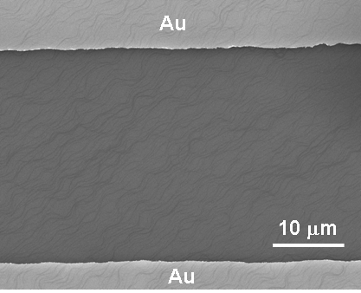
Figure S5. SEM image of aligned nanowires on SiO₂/Si substrate pre-patterned with Au electrodes in a bottom contact field-effect transistor configuration. The starting thin film was prepared from spincoating a solution of HATNA-2 (10 g / L) in CHCl₃ :hexane (v:v = 1:1) at 60 ºC on SiO₂/Si at 3000 rpm followed by 10 hours of CHCl₃-vapor annealing.

References
(1) Bock, H.; Babeau, A.; Seguy, I.; Jolinat, P.; Destruel, P. Chemphyschem 2002, 3, 532-535.
(2) Yip, H. L.; Zou, Y. J.; Ma, H.; Tian, Y. Q.; Tucker, N. M.; Jen, A.-K. Y. J. Am. Chem. Soc. 2006, 128, 13042-13043.

