Supporting information

Morphology dependence of static magnetic and microwave electromagnetic characteristics of polymorphic Fe₃O₄ nanomaterials

Guoxiu Tong^{a,}∗, Wenhua Wuª, Ru Qiaoª, Jinhao Yuanª, Jianguo Guan^{b}, and Haisheng Qianª

ª College of chemistry and life sciences, Zhejiang Key Laboratory for Reactive Chemistry on Solid Surface, Zhejiang Normal University, Jinhu 321004, PR China
^{b} State Key Laboratory of Advanced Technology for Materials Synthesis and Processing, Wuhan University of Technology, Wuhan 430070, PR China

Mossbauer spectra were measured using a constant acceleration transmission mode with a ⁵⁷Co/Rh source at room temperature. The velocity was calibrated by 25 μm α-Fe foil, and the Isomer Shift (I.S.) was relative to the center of α-Fe at room temperature. The spectra were fitted using MossWinn.¹
The room temperature transmission Mössbauer spectra of three samples in FIG. S1 are in accordance with reported literature,² from which we can ﬁnd that the spectra is well ﬁtted by two magnetic sextets, corresponding to Fe³⁺ ions at site A and (Fe²⁺, Fe³⁺) ions at site B, respectively. Thus, this indicates that the resulting products are Fe₃O₄.
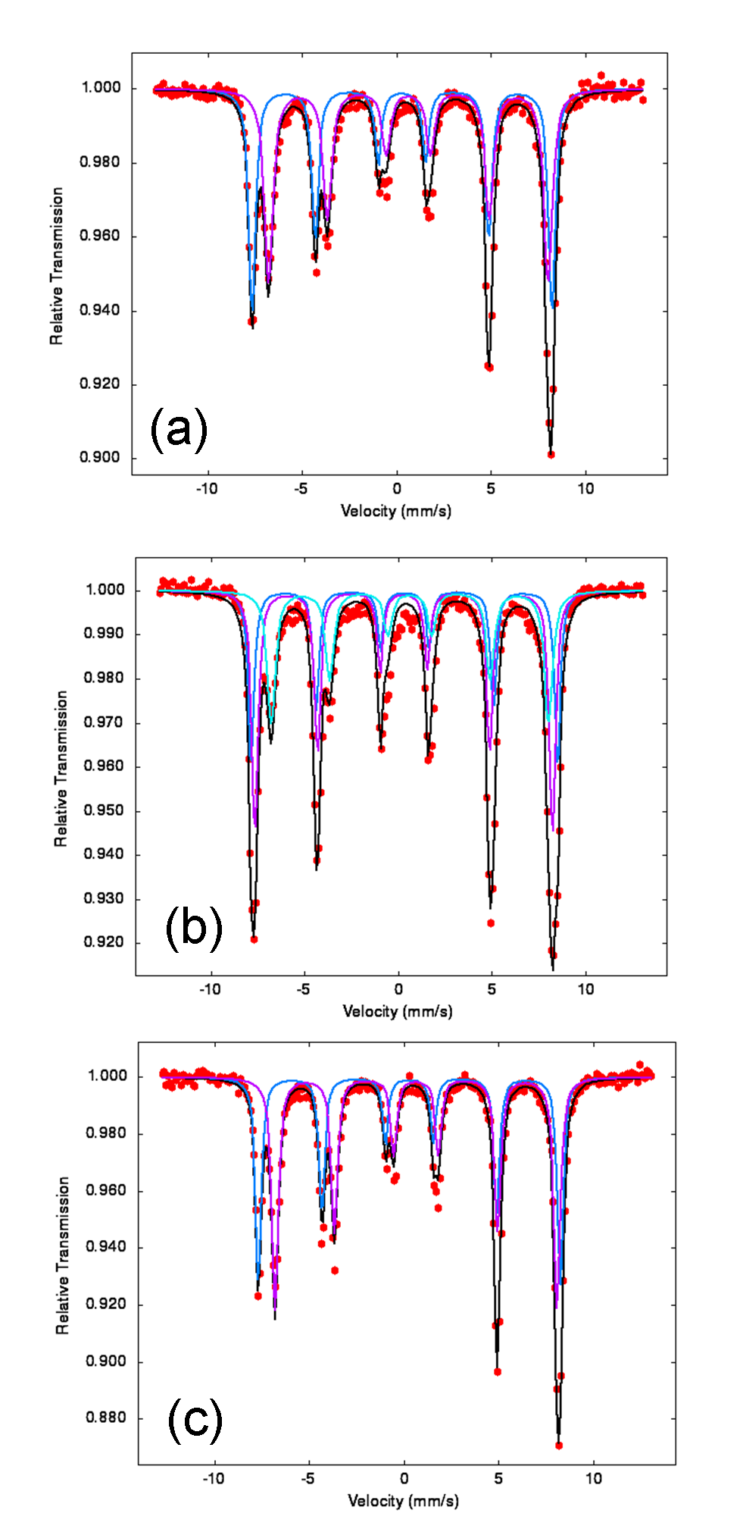
FIG. S1. Mössbauer spectra o of Fe₃O₄ nanospheres (a), sponges (b), and urchins (c).

1 Z. Klencsar, E. Kuzmann, A. Vertes: User-friendly software for Mössbauer spectrum analysis. J. Rad. Nucl. Chem. 210 (1), 105 (1996).
2 H. Zheng, Y. Yang, M.J. Zhou, F.S. Li: Microwave absorption and Mössbauer studies of Fe₃O₄ nanoparticles. Journal Hyperfine Interactions, 189 (1–3), 131 (2009).

 Corresponding author. Tel.: +86-579-82282269; Fax: +86-579-82282269; E-mail address: tonggx@zjnu.cn (G. X. Tong).

