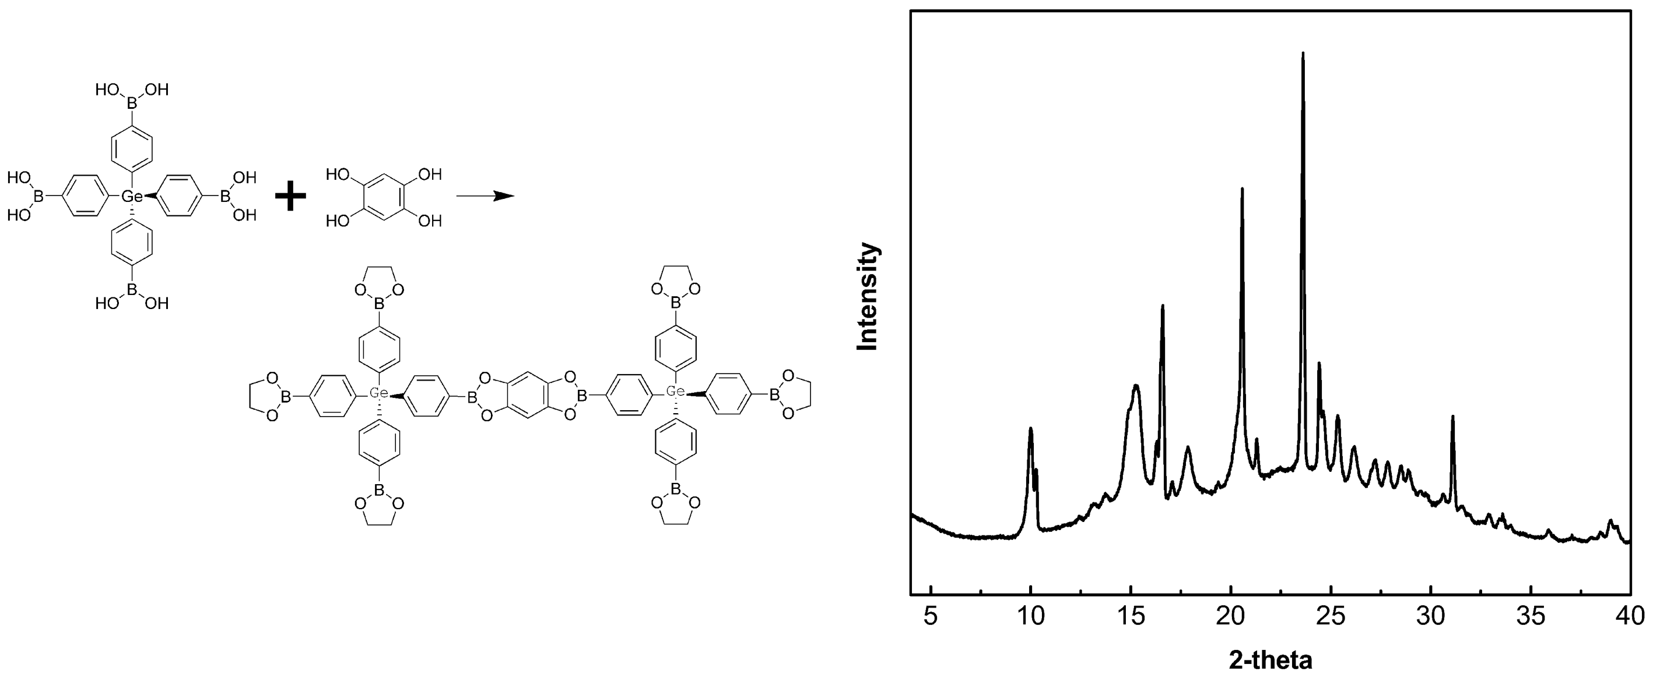
Based on the tetrahedral unit TBPG and linear linker THB, a metal centered crystalline porous aromatic framework CPAF-13 was targeted synthesized successfully, which displays high crystallinity and considerable H₂ capacity.

