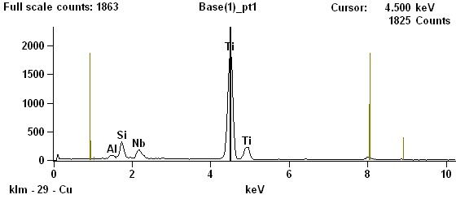
Supplemental Figure 1. Raw EDS spectrum on Ti_{1-x}Nb_{y}O₂ film.

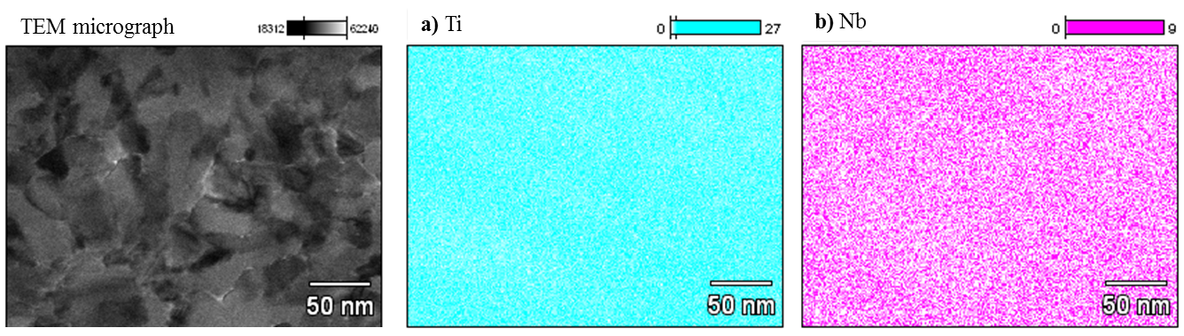
Supplemental Figure 2. X-ray maps from Ti_{1-x}Nb_{y}O₂ thin film for a) Ti and b) Nb.
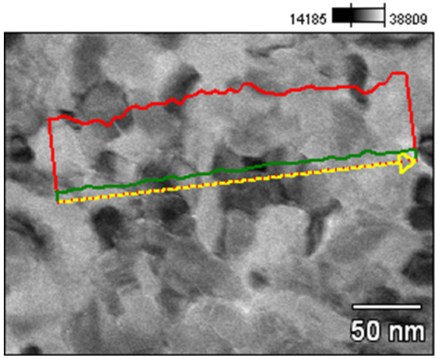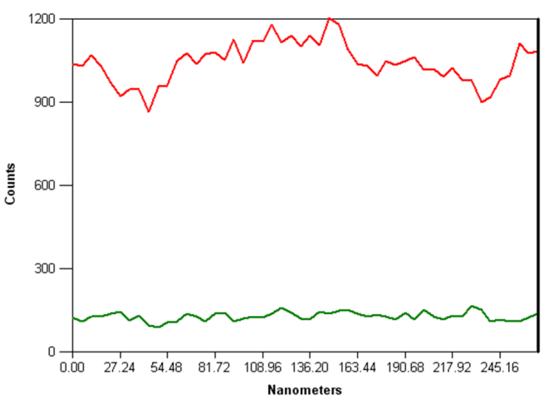
Supplemental Figure 3. EDS line scan from Ti_{1-x}Nb_{y}O₂ thin film. Raw Ti counts are shown in red and raw Nb counts are shown in green.

