Supplemental material:
Strain Relaxation Defects in Perovskite Oxide Superlattices
Meng Gu, Michael D. Biegalski, Hans M. Christen, Chengyu Song, Craig R. Dearden, Nigel D. Browning and Yayoi Takamura*

This supplemental material provides more detailed information regarding the structural analysis by x-ray diffraction (XRD) and atomic resolution scanning transmission electron microscopy as discussed in the main text.

High-resolution XRD was used to confirm the strain state of the superlattices. Fig. S1(a) compares the ω-2θ scans around the (002) peak of the three superlattices. Satellite peaks and thickness fringes indicate the presence of sharp interfaces and a regular repeat unit for all superlattices. The 0th order superlattice peak for the fully-strained [6LSFO][3LSMO]10 superlattice is shifted to slightly higher 2θ value compared to the SrTiO₃ (STO) substrate, indicating a slight reduction of the out-of-plane lattice parameter due to the tensile strain imposed from the underlying STO substrate. In contrast, the 0th order superlattice peak for the partially-relaxed [6LSFO][3LSMO]10 superlattice as well as the micron thick [6LSFO][6LSMO] superlattice nearly overlaps with the STO substrate peak. Reciprocal space maps (RSM) around the (-303) peak were used to determine the in-plane lattice parameters of the fully-strained and partially-relaxed [6LSFO][3LSMO]10 superlattices (Fig. S1(b) and (c)). Both superlattices retain the same in-plane lattice parameter as the STO substrate, indicating a slight tetragonal distortion for the fully-strained superlattice, and a nearly cubic lattice for the partially-relaxed superlattice.

Fig S2 shows the EEL spectra obtained from the A and B/O atomic columns of the normal perovskite and defect regions in a LSFO sublayer located near the LSFO/LSMO interface of the partially-relaxed [6LSFO][3LSMO]10 superlattice. This region is depicted in the EELS map in Fig. 3. The A atomic columns in the normal region have a larger La signal and a smaller Fe signal than the defect region, while the B/O atomic columns in normal region have a larger Fe signal and a smaller La signal than the defect region.

By using atomic resolution imaging over different regions of the film, we confirmed that no defect contours due to dislocations or stacking faults were present in the micron-thick [6LSFO][6LSMO] superlattice. A representative pair of atomic resolution Z-contrast image and bright field image is shown in Fig S3.

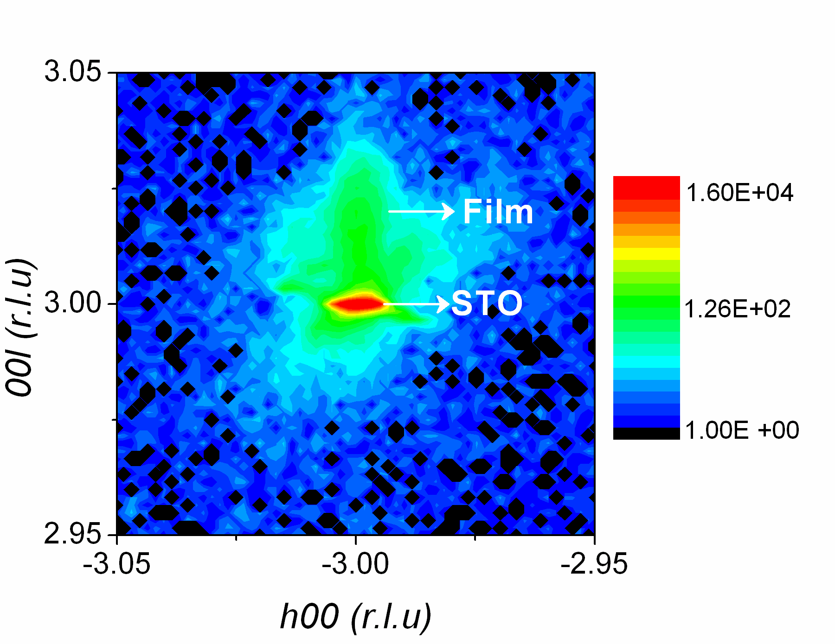
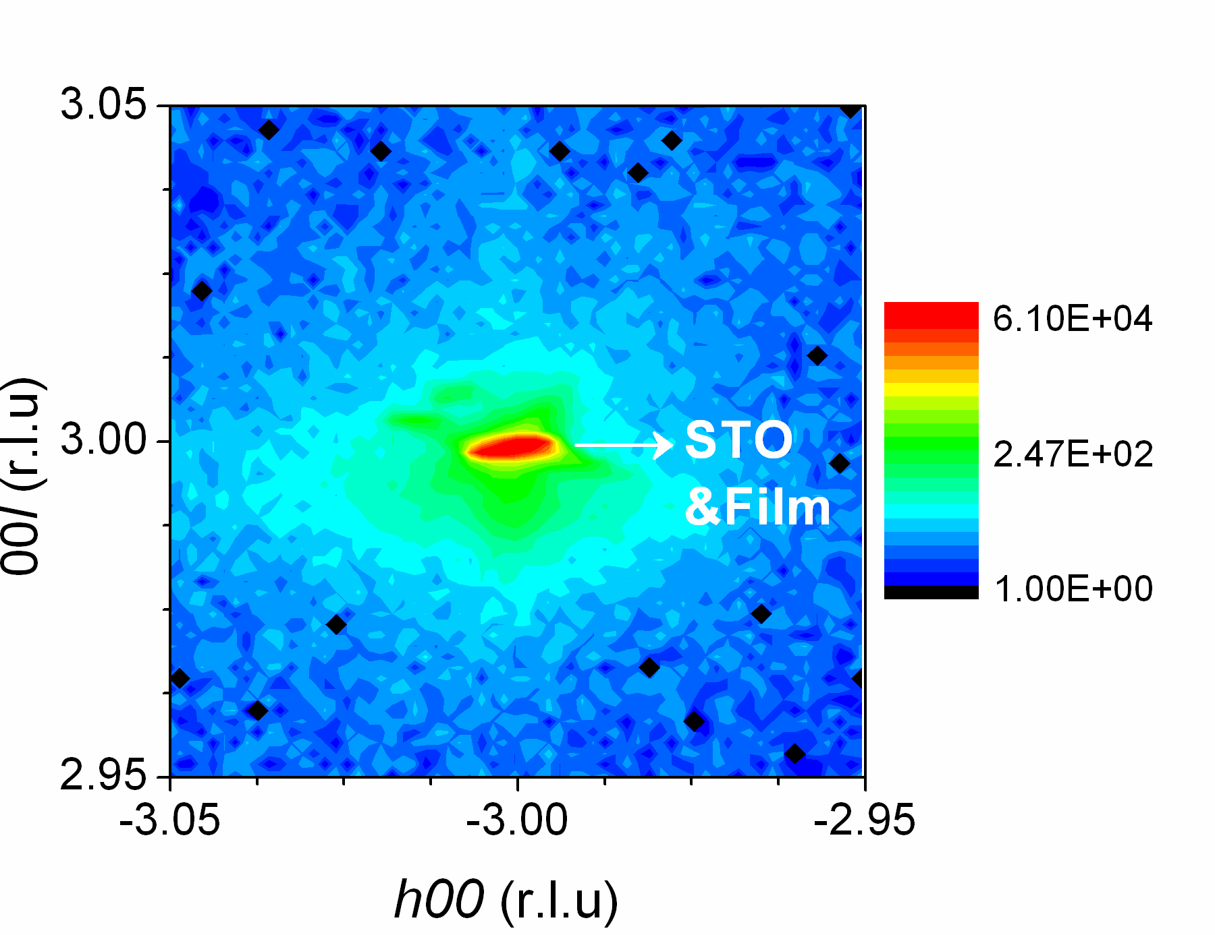
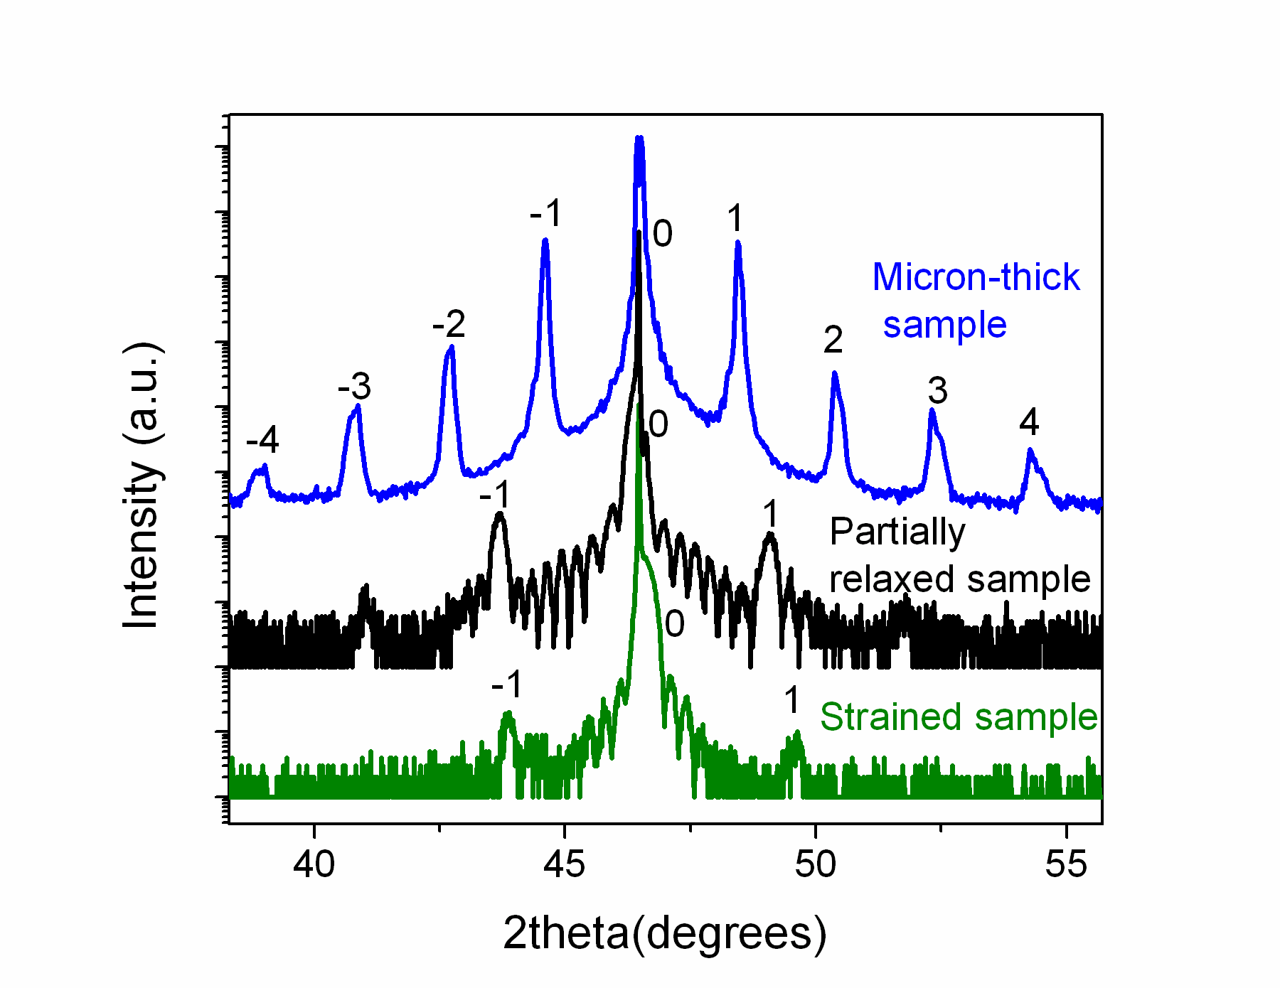
(c)
(b)
(a)

Fig.S1 (a) ω-2θ scans around the (002) peak of the fully strained (green) and partially relaxed (black) [6LSFO][3LSMO]10 superlattices, and micron-thick [6LSFO][6LSMO] superlattice (blue). Satellite peaks and thickness fringes indicate the presence of sharp interfaces and a regular repeat unit for all superlattices. (-303) RSM from the (b) fully strained and (c) partially relaxed [6LSFO][3LSMO]10 superlattices. The location of the film and substrate (sub) peaks are indicated by the arrows.

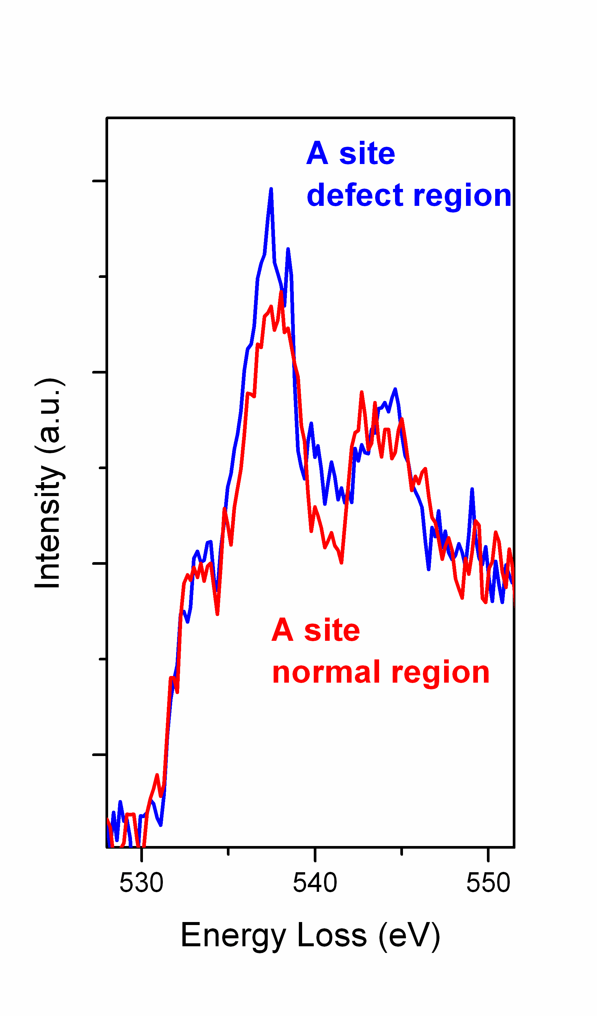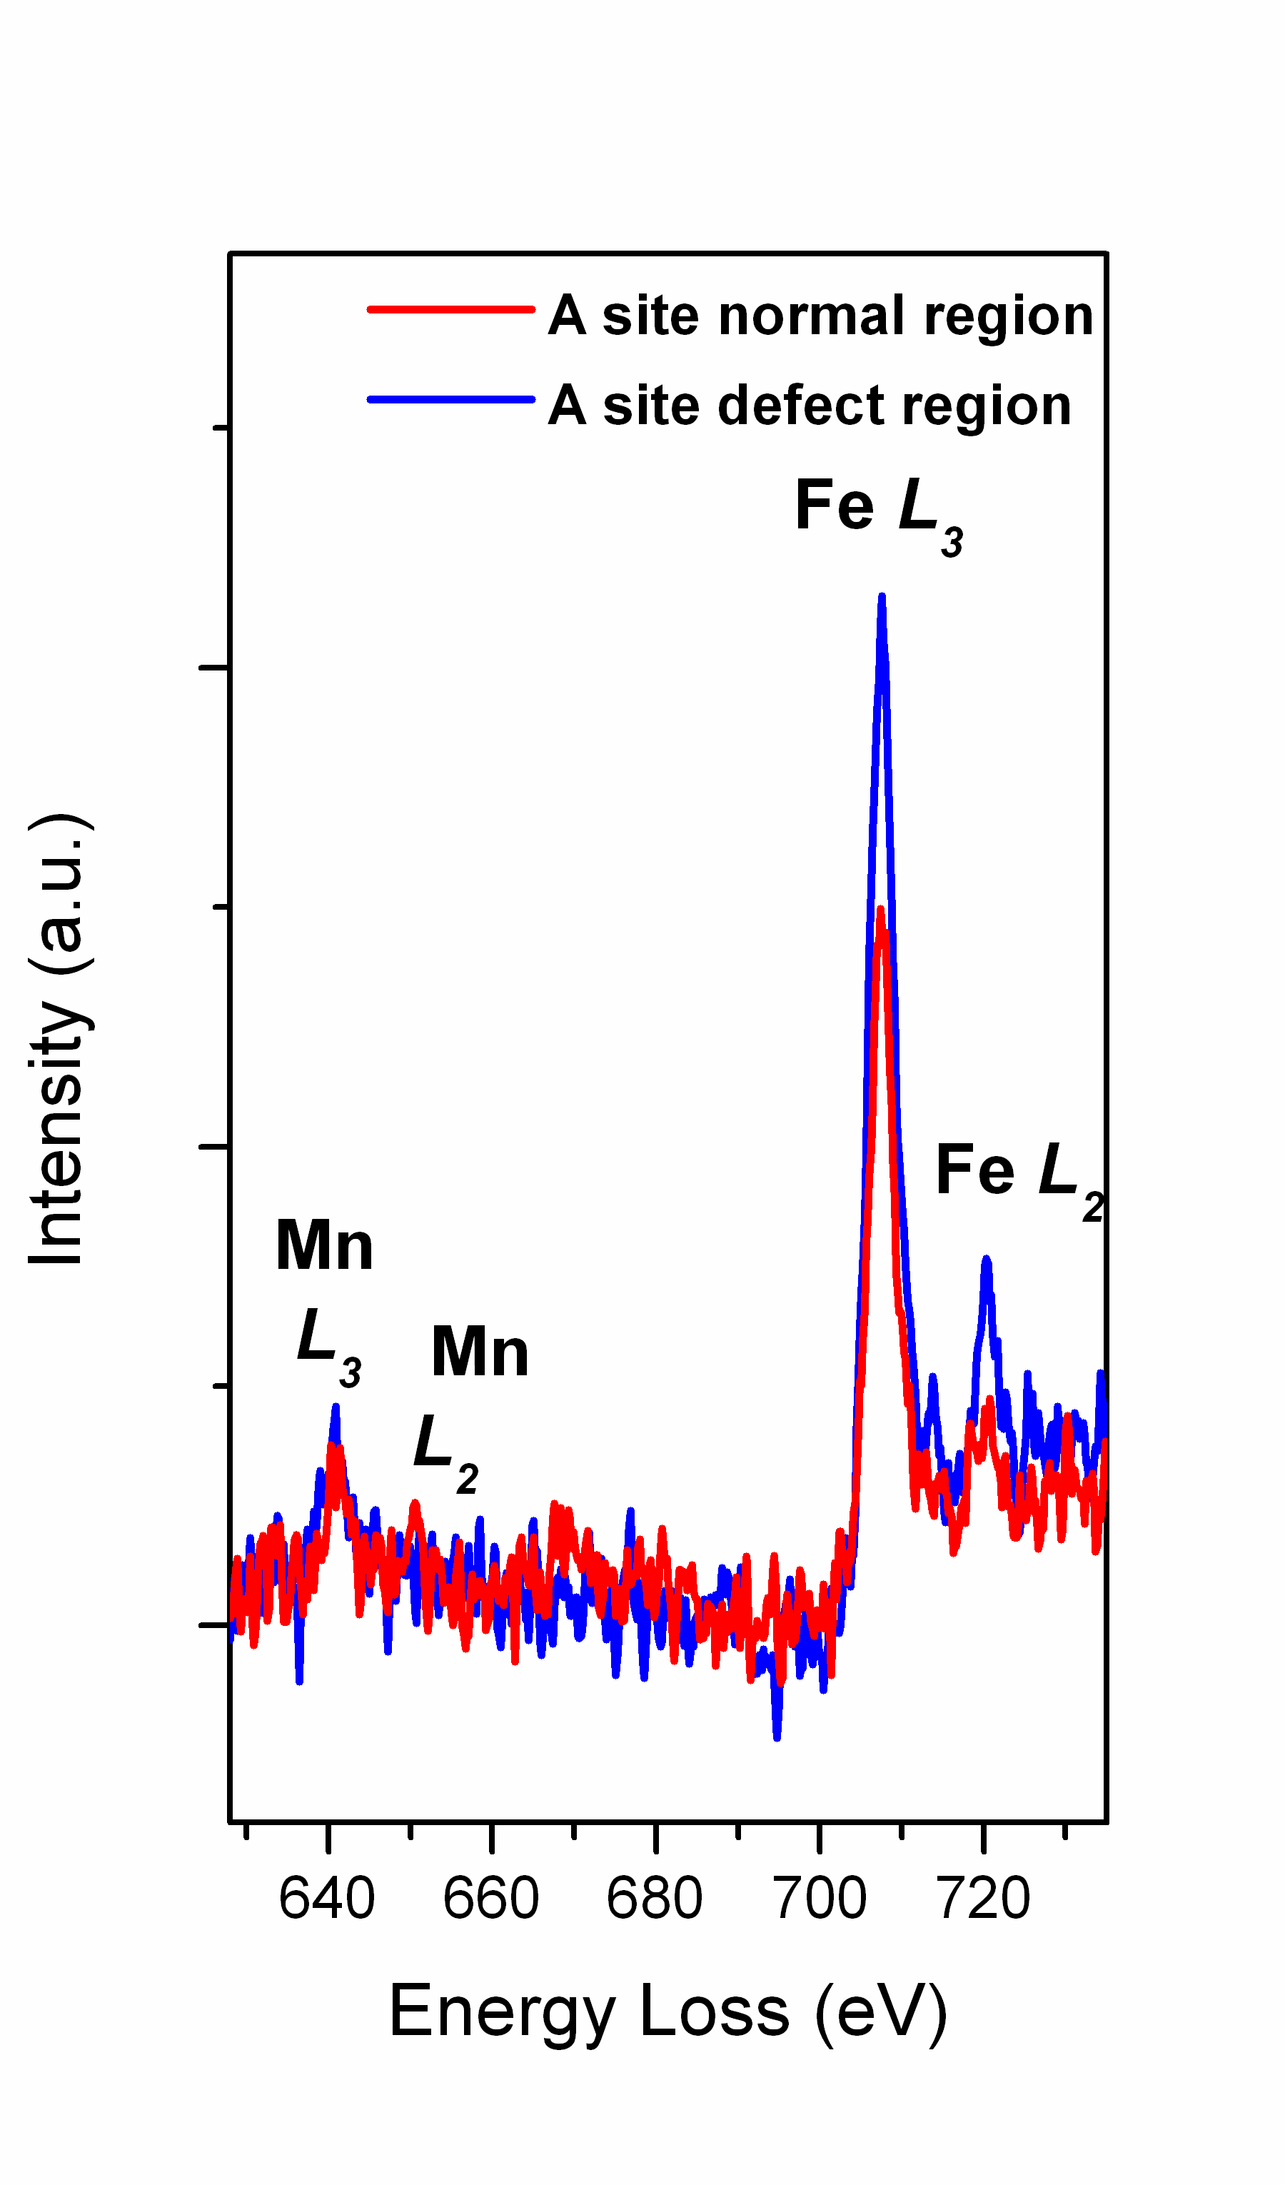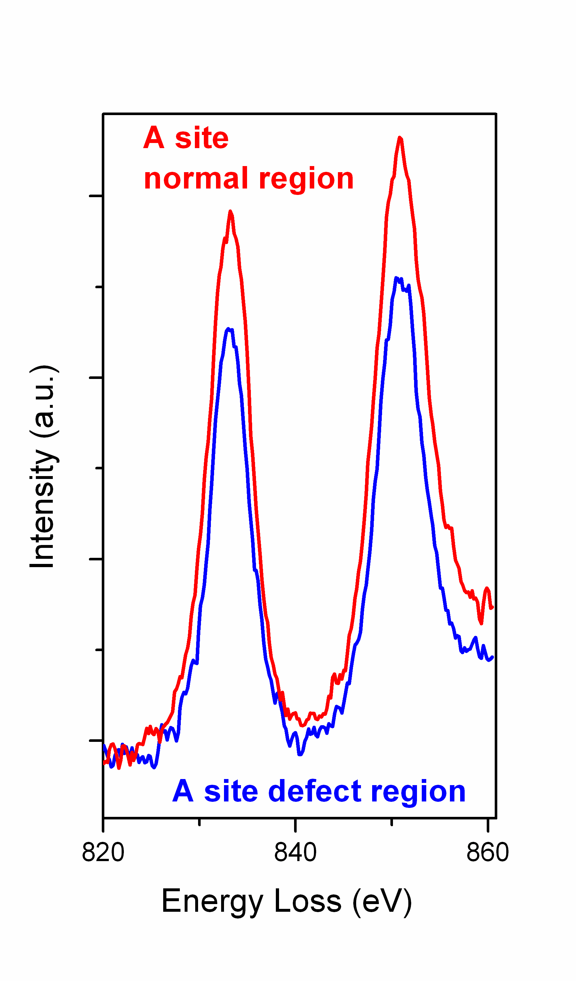
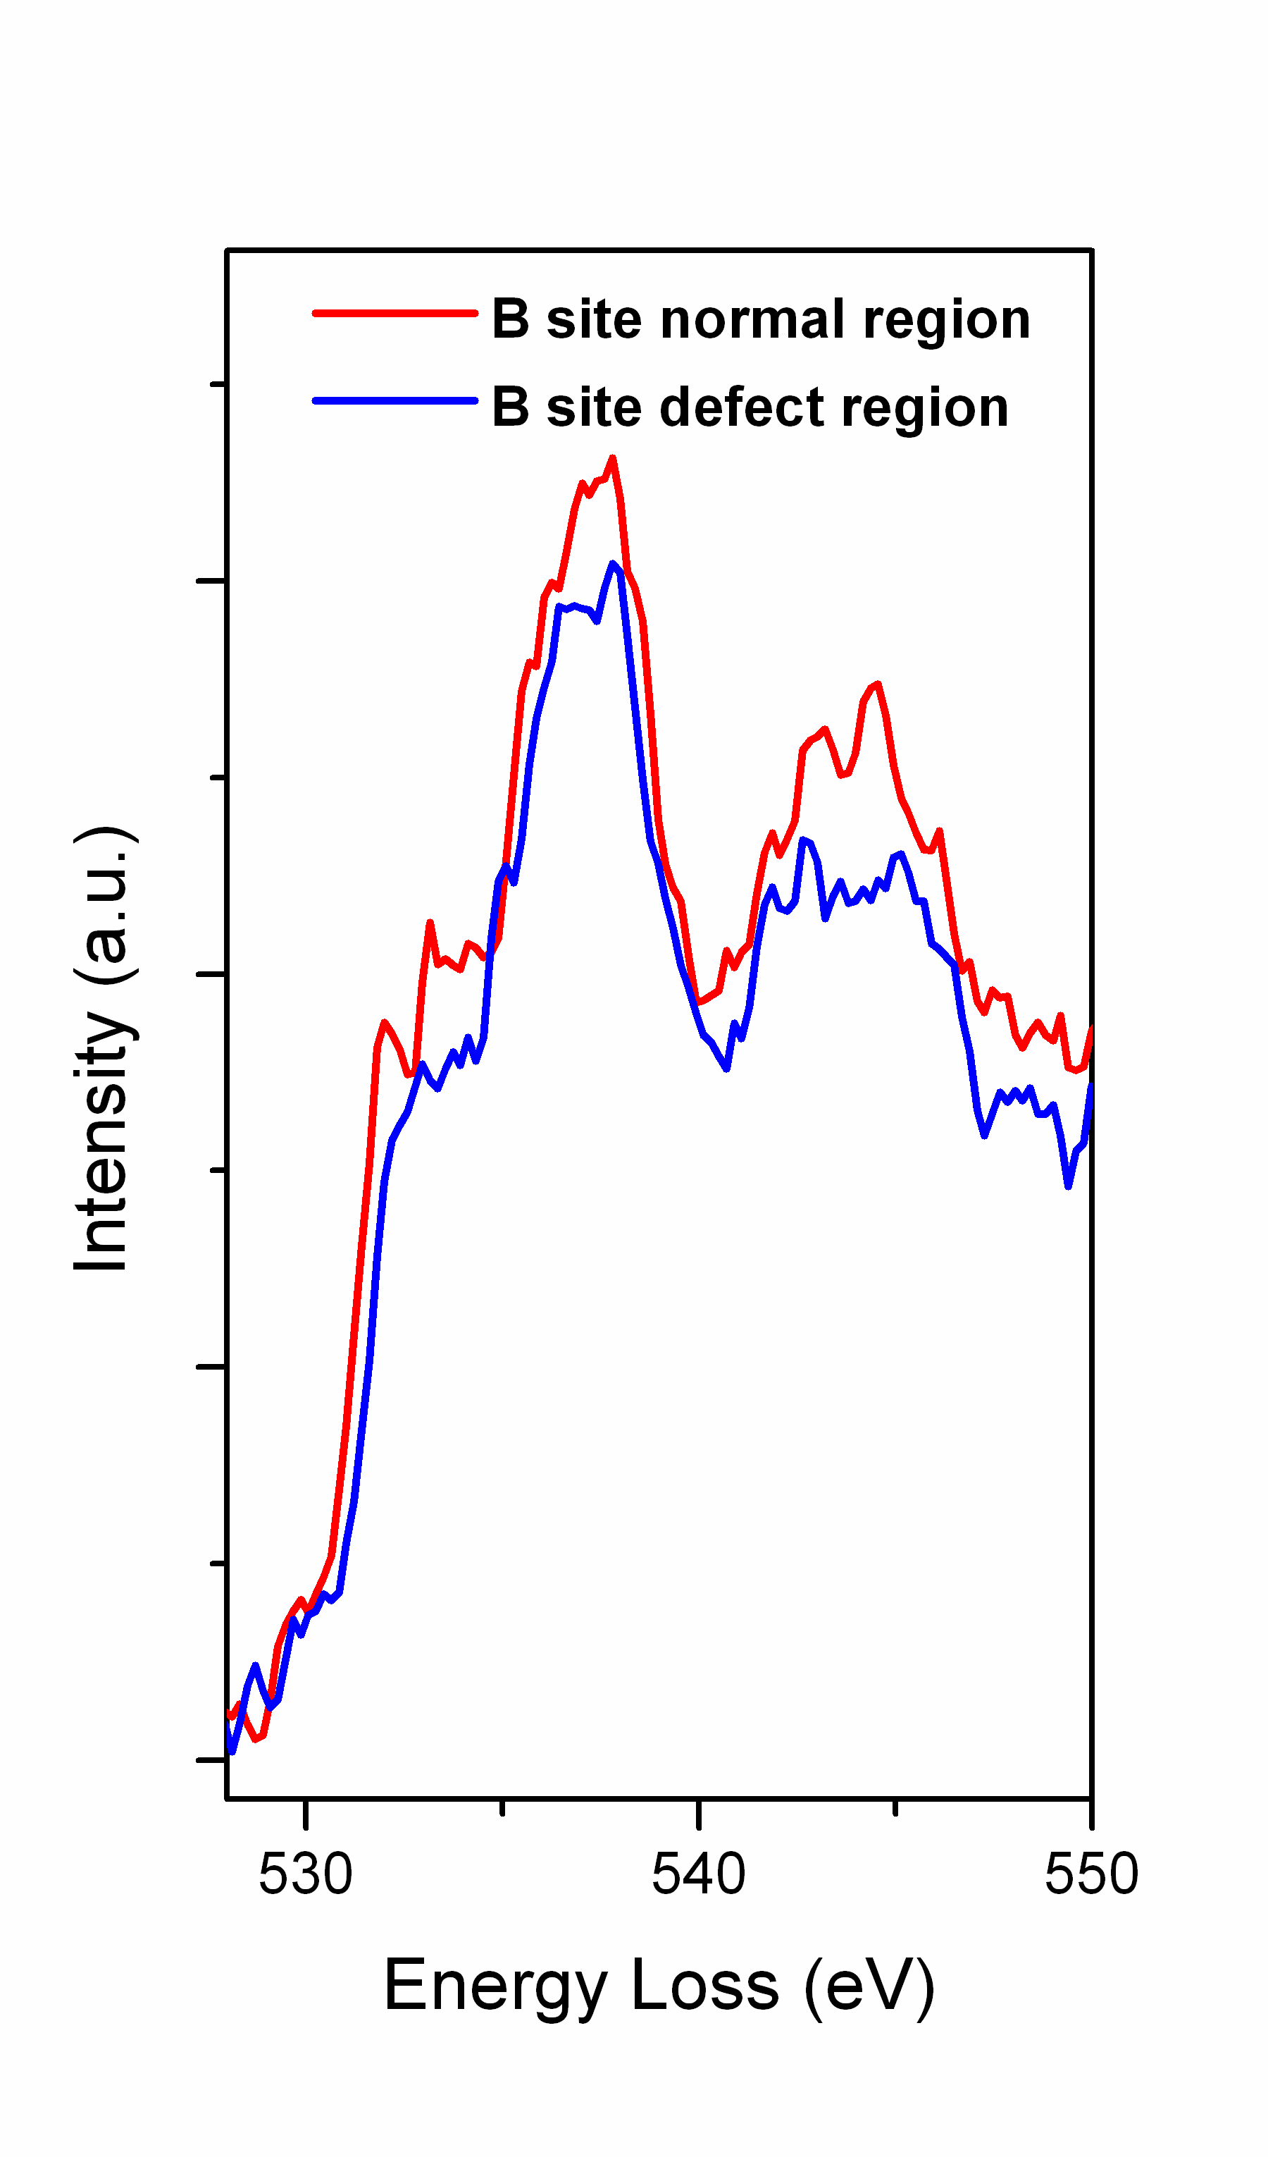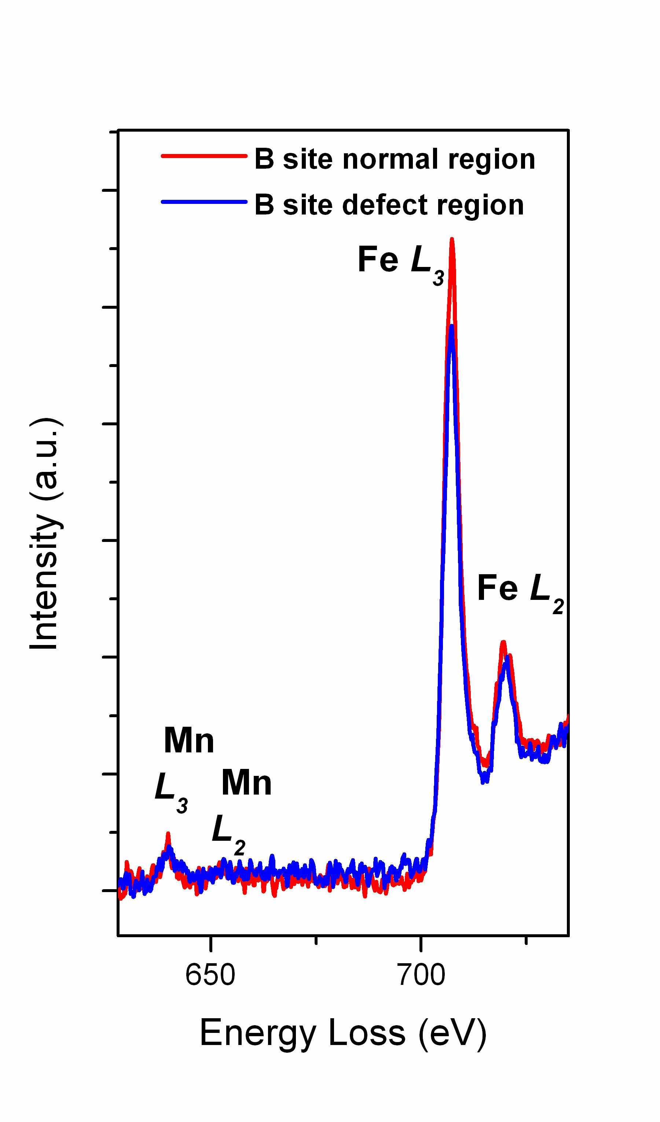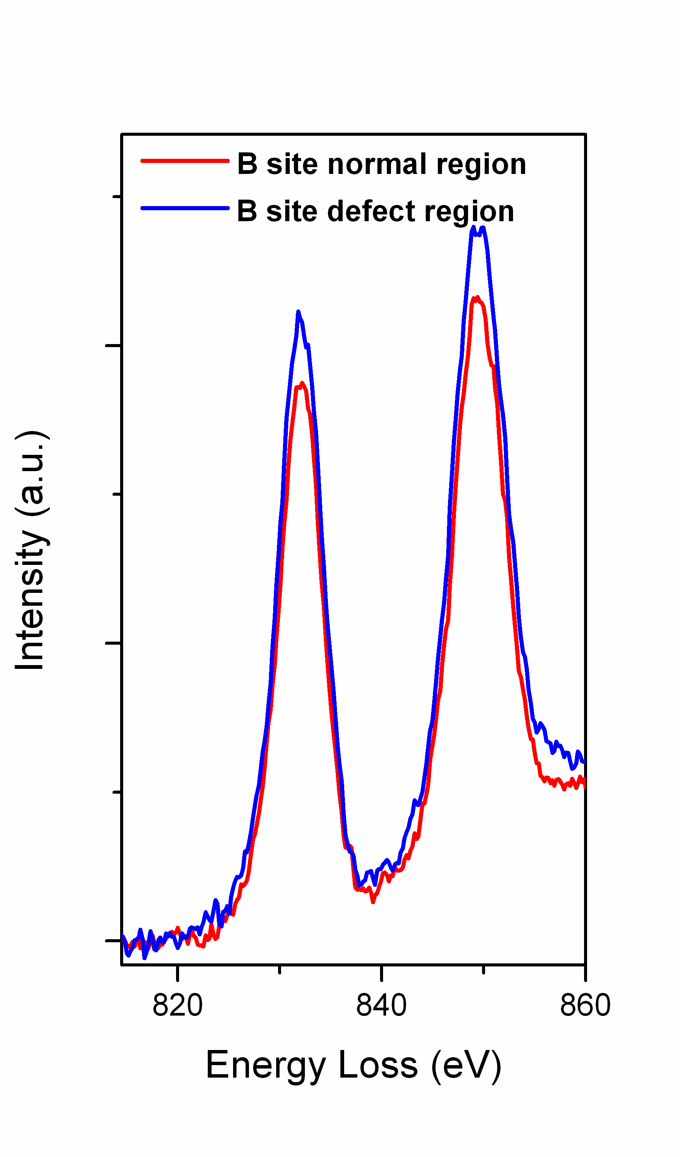
(a)
(b)
(c)
(d)
(e)
(f)
Fig S2. (a) O K edge, (b) Mn and Fe L edge and (c) La M edge comparison from A atomic columns and (d) O K edge, (e) Mn and Fe L edge and (f) La M edge comparison from B/O atomic columns in the LSFO sublayer close to the LSFO/LSMO interface the partially-relaxed [6LSFO][3LSMO]10 superlattice. EEL spectra were acquired from line scans with 0.2 eV/channel, 80 kV, 2 s/spectra, and collection semi-angle 90mrad.

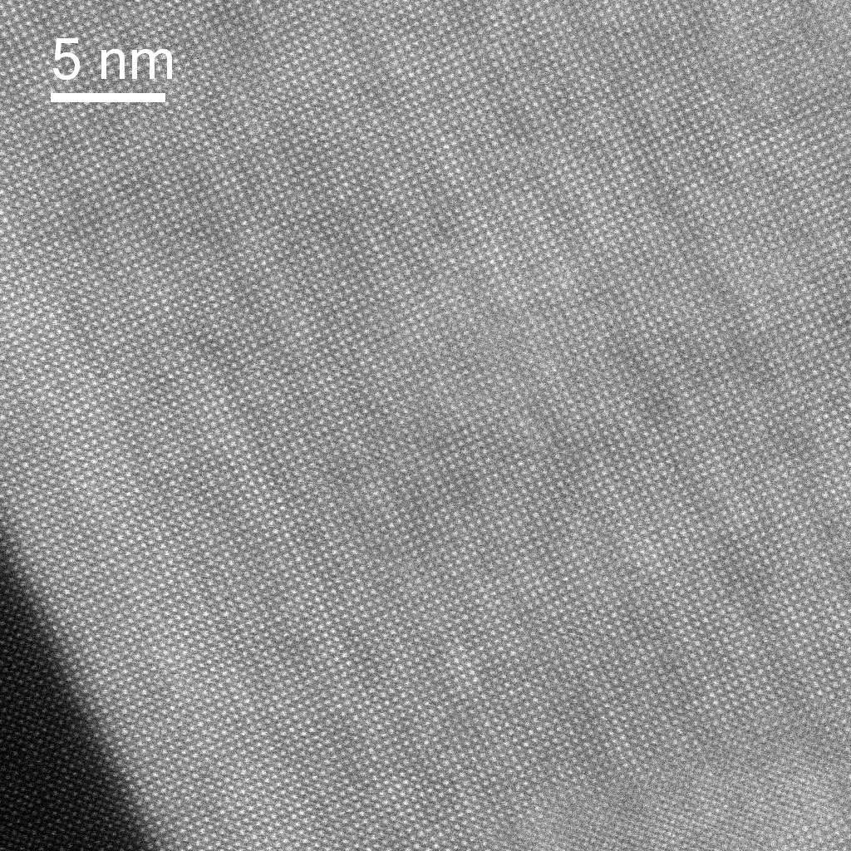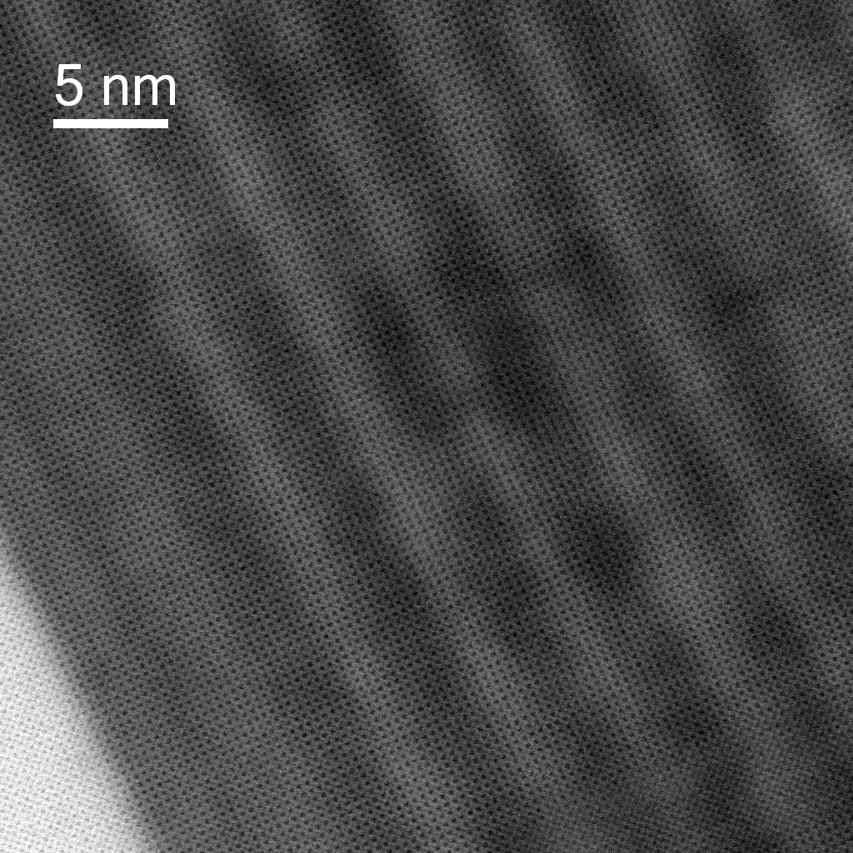
STO
STO
(a)
(b)
Fig S3(a) Atomic resolution Z-contrast image with collection semi-angle of 80-210 mrads using JEOL 2100 at 200kV and (b) bright field phase contrast image of the interface region between the micron-thick [6LSFO][6LSMO] superlattice and substrate (the bottom left corner is the STO substrate region).

