Supplementary information

CV was employed to measure the EASA of all the catalysts. Figure. S1. shows representative CV curves of the optimized Pt/PAA-w-MWCNTs and commercial E-TEK obtained in 0.5M H₂SO₄. The electric charge for hydrogen desorption was used to measure the active surface area of Pt. The calculated values are given in Table 1.

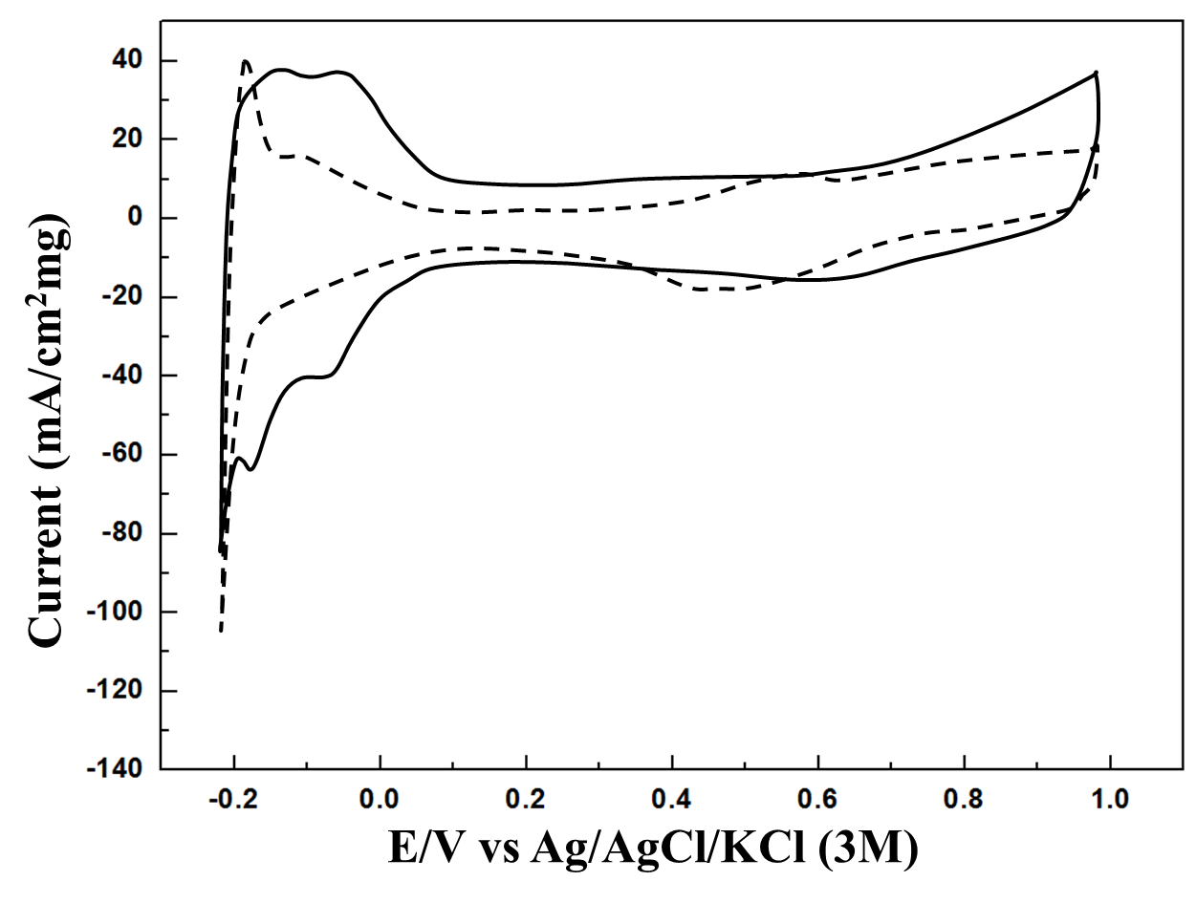
FIG. S1. Cyclic voltammetry curves of the optimized Pt/PAA-w-MWCNTs(solid line) and commercial E-TEK(dashed line) in 0.5 M H2SO4 (Scan rate = 50 mVs-1).

