Supporting Information

Dense TiO₂ Films Grown by Sol-Gel Dip-Coating on Glass, F-Doped SnO₂ and Silicon Substrates

Jan Prochazkaª, Ladislav Kavan^{a*}, Marketa Zukalovaª, Pavel Jandaª, Jaromir Jirkovskyª, Zuzana Vlckova Zivcovaª, Ales Poruba^{b}, Mélanie Bedu^{c}, Markus Döbbelin^{d} and Ramón Tena-Zaera^{d}

ªJ. Heyrovsky Institute of Physcial Chemistry, Academy of Sciences of the Czech Republic, v.v.i. Dolejskova 3, CZ-18223 Prague 8, Czech Republic

^{b}Solartec, s.r.o., Televizní 2618, CZ-756 61 Rožnov pod Radhoštěm, Czech Republic

^{c}SOLVIONIC S.A. Chemin de la Loge, F-31078 Toulouse, France

^{d}CIDETEC, Centre for Electrochemical Technologies, Paseo Miramón 196, Donostia-San Sebastian 20009, Spain

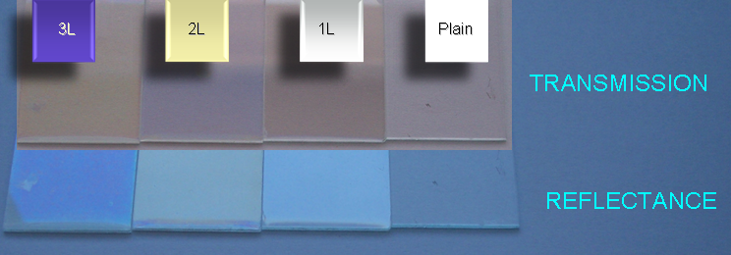

FIG. S1. Photographic images of the used samples of dense titania coating on glass taken in transmission (top) or reflectance (bottom) modes of the snap. They illustrate the actual appearance of our sample films for 3-layers, 2-layer, 1-layer of TiO₂ and bare glass for comparison.

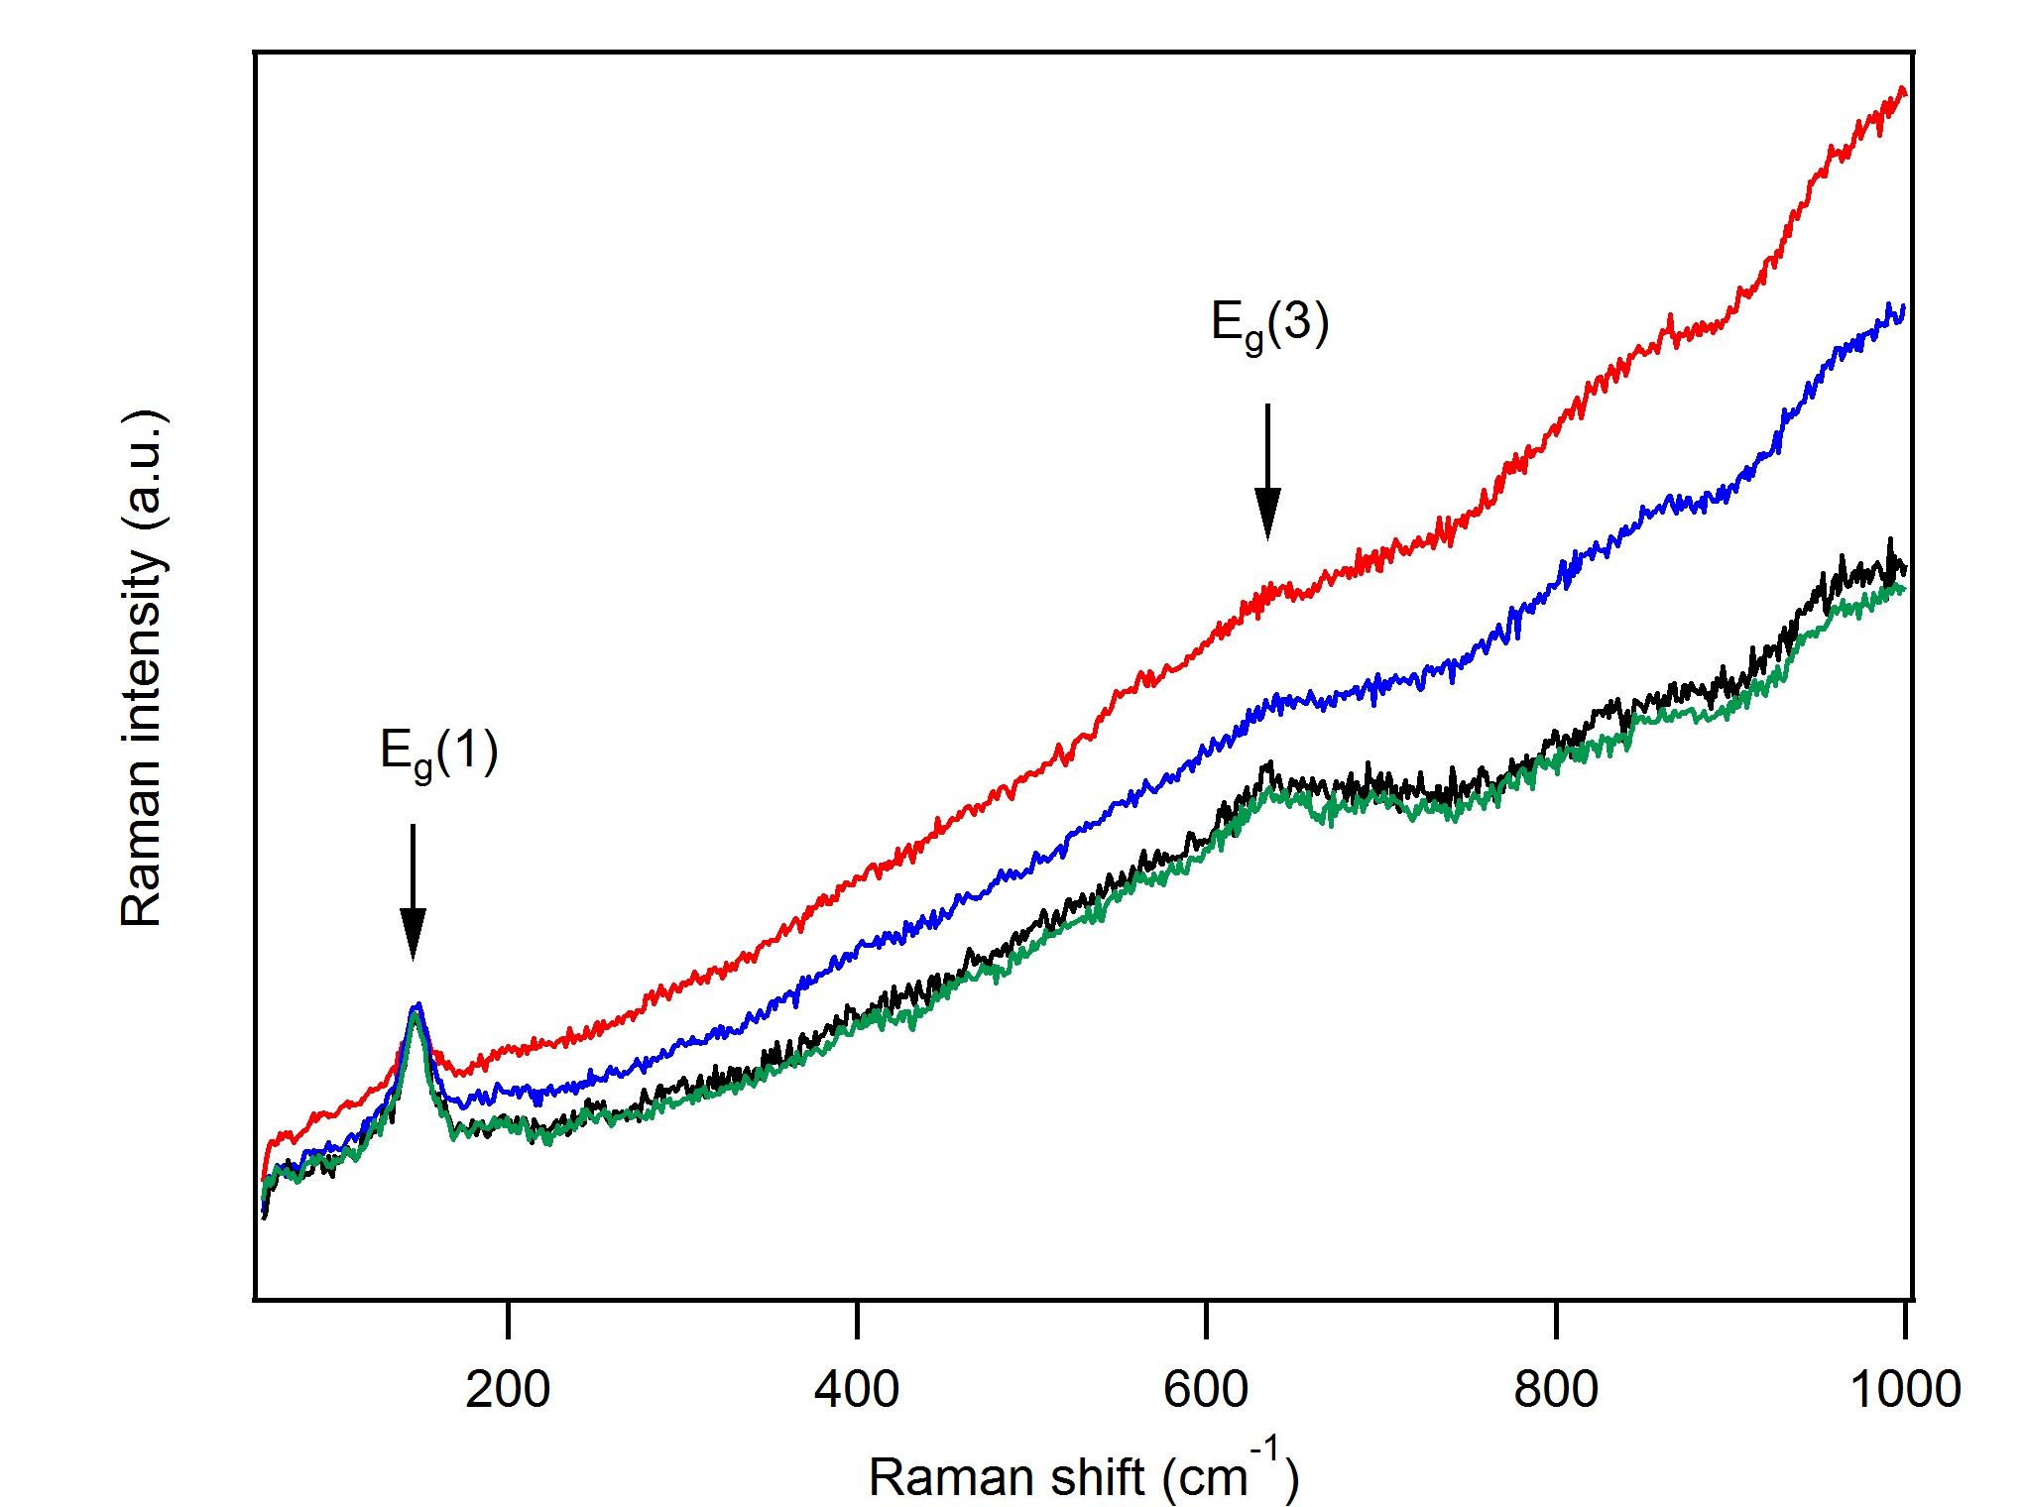

FIG. S2. Raman spectra of TiO₂ dense 5-layer film on glass (measured in different points on the sample). Positions of the two strongest lines of anatase TiO₂ are indicated, E_{g}(1) and E_{g}(3). However, monoclinic TiO₂(B) has also strong lines at the same positions.

FIG. S3. Optical spectrum of TiO₂ layer on top of plain Si (111) substrate. Plot for the determination of indirect band-gap.

FIG. S4. SEM images of films grown on FTO substrate from the Ti-precursor sol containing A) butyl-methylimidazolium acetate; B) butyl-methylimidazolium acetate + phosphoric acid; C) 1H,1H,2H,2H-perfluoro-decyl-1-methylimidazolium iodide; D) 1H,1H,2H,2H-perfluoro-decyl-1-methylimidazolium bis(trifluoromethane) sulfonamide.

FIG. S5. SEM images of films grown on FTO substrate from the Ti-precursor sol containing methyl methacrylate. (A) Film grown at room temperature by the standard dip-coating protocol; B) Film grown from the sol modified by addition of phosphoric acid. Temperature of the sol for dip-coating was 40-50ºC.

