Supporting Imformation

Facile Preparation of Superhydrophobic and Superoleophilic Sponge for Fast Removal of Oils from Water Surface

Guohua Jiang ^{a,b,}∗, Ruanbing Hu ^{a,b}, Xiaoguang Xi ^{a,b}, Xiaohong Wang ^{a,b}, Rijing Wang ^{a,b}

ª Key Laboratory of Advanced Textile Materials and Manufacturing Technology (ATMT), Ministry of Education, Zhejiang Sci-Tech University, Hangzhou 310018, P. R. China

^{b} Department of Materials Engineering, College of Materials and Textile, Zhejiang Sci-Tech University, Hangzhou 310018, P. R. China

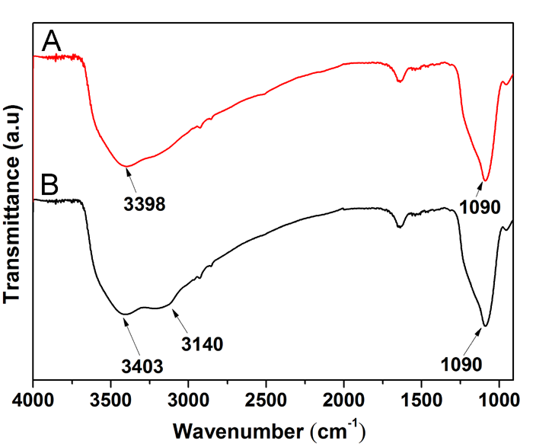

Figure S1. FT-IR spectra of (A) SiO₂ and (B) amine-functionalized SiO₂.

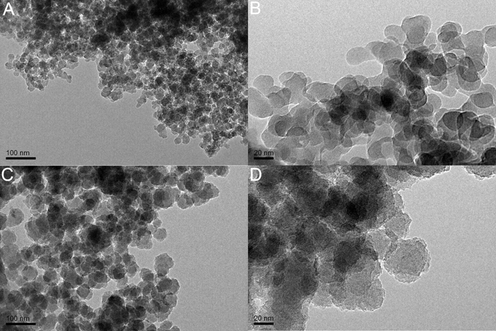
Figure S2. (A) TEM image of amine-functionalized SiO₂, (B) The higher magnification images of (A); (C) TEM image of SiO₂ NPs, (D) The higher magnification images of (C).

 To whom correspondence should be addressed. Tel: +86 571 86843527; E-mail address: polymer_jiang@hotmail.com (G. Jiang)

