Supporting information for

Assembled Graphene Oxide and Single Walled Carbon Nanotube Ink for Stable Supercapacitors
Shirui Guo¹, Wei Wang², Cengiz S. Ozkan^{2,3*}, Mihrimah Ozkan^{1,4*}
¹Department of Chemistry, ²Materials Science and Engineering Program, ³Department of Mechanical Engineering, ⁴Department of Electrical Engineering, University of California Riverside, CA 92521 (USA)
*Contact email: Prof. M. Ozkan mihri@ee.ucr.edu, Prof. C. S. Ozkan cozkan@engr.ucr.edu
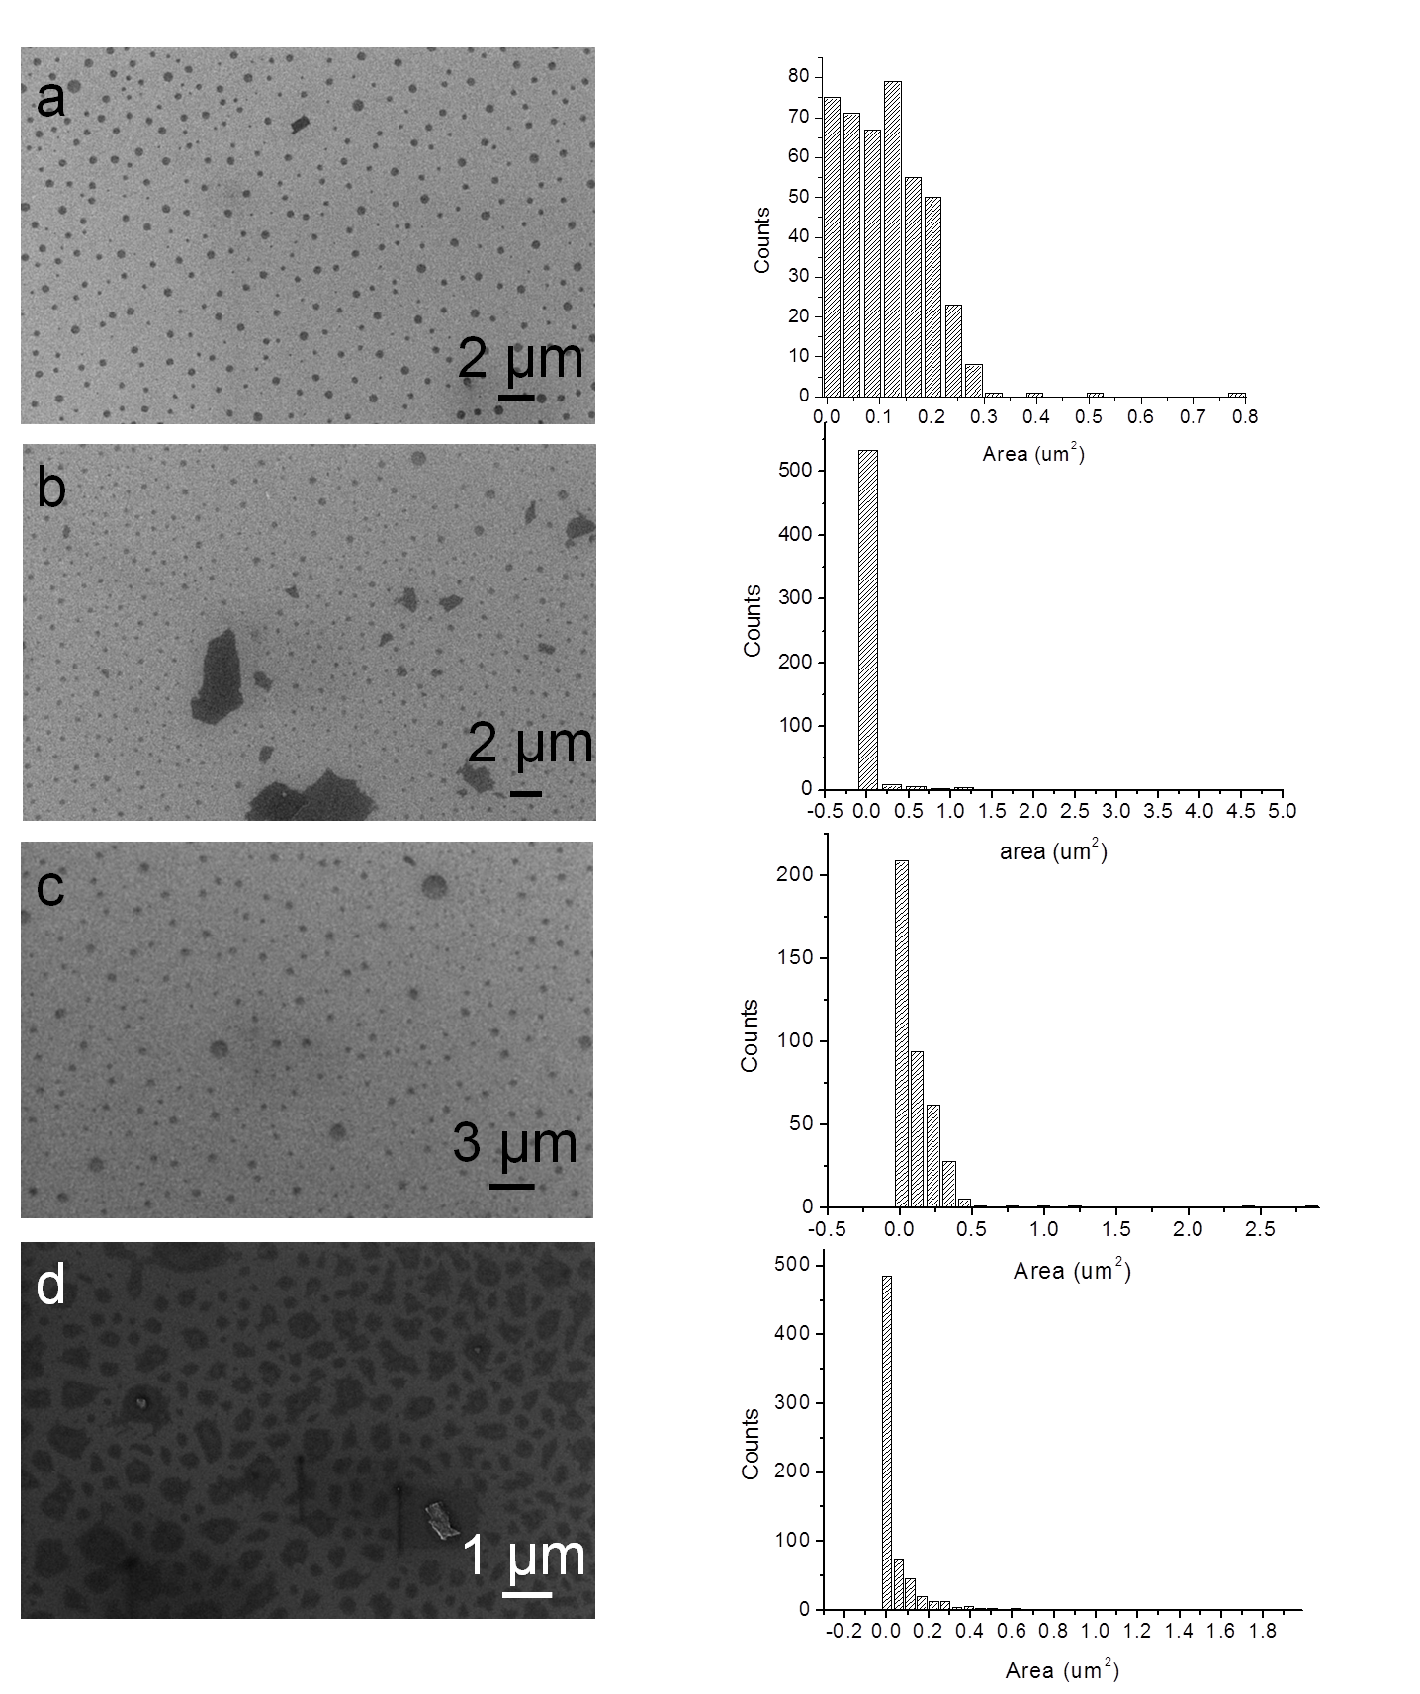
Figure s1. SEM images GO flakes with different size distribution.

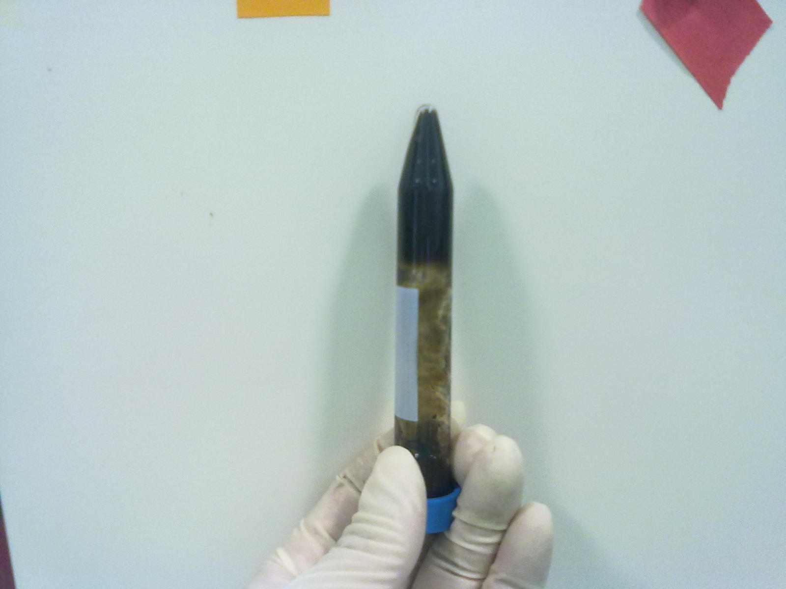
Figure s2. High concentration of GO/SWNT (10mg/ml) forms a gel-like material.

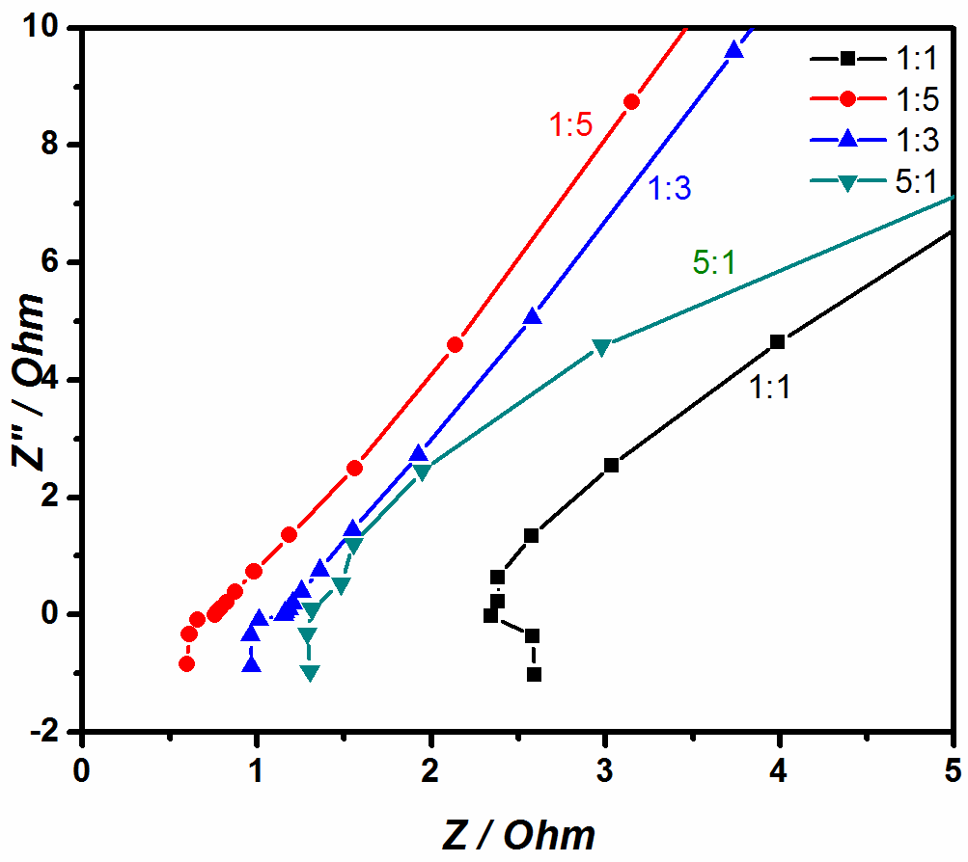
Figure s3. EIS of GO/SWNT materials at different weight ratios. With an increase in the amount of SWNT, the internal resistance decreases.

