Controlled Synthesis of Hollow GdOF: Yb³⁺, Er³⁺ nanosphere with Up-Conversion Luminescence property
Yu Wang^{2*}, Tong Liu¹, Xuesi Wang¹, and Hongwei Song¹*

¹State Key Laboratory on Integrated Optoelectronics, College of Electronic Science and Engineering, Jilin University, 2699 Qianjin Street, Changchun, 130012, People’s Republic of China, ²State Key Laboratory of Inorganic Synthesis and Preparative Chemistry, College of Chemistry, Jilin University, 2699Qianjin Street, Changchun, 130012, People’s Republic of China,

Supporting Information

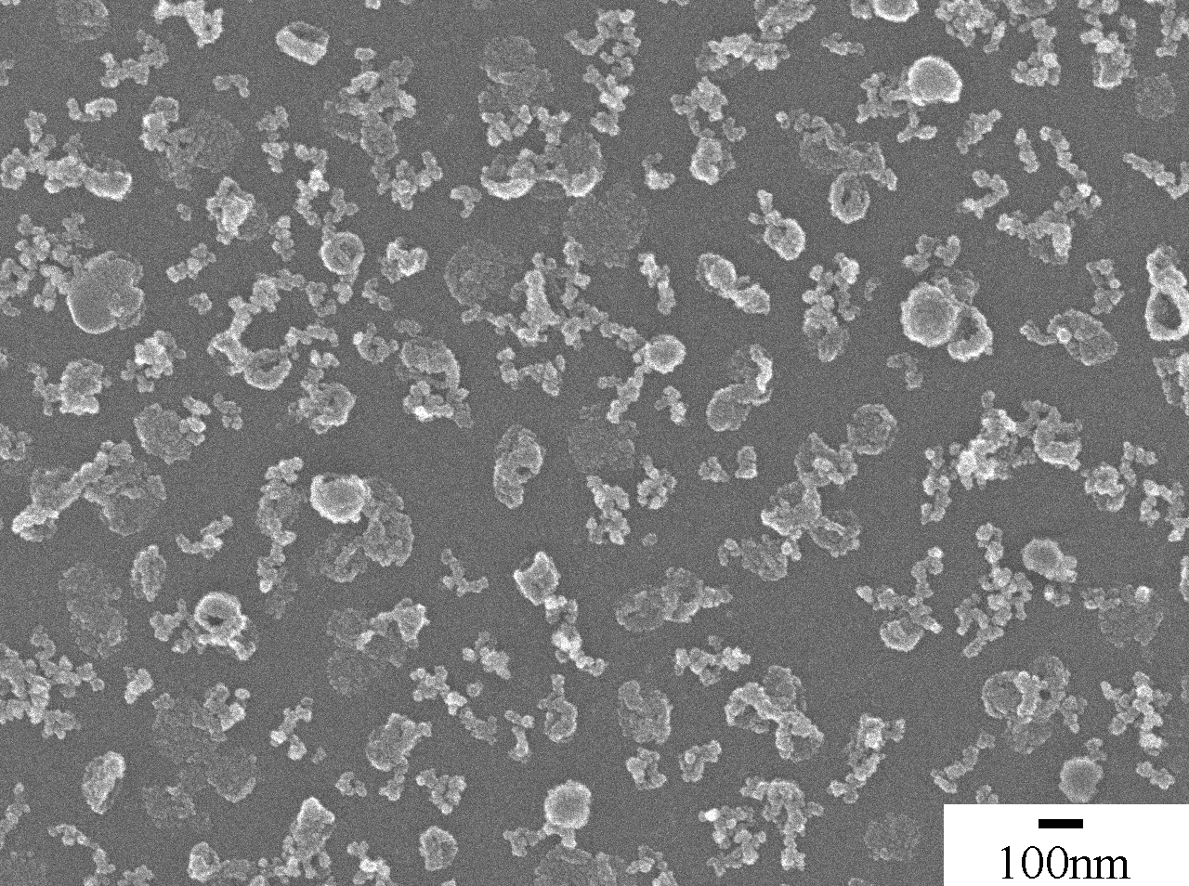

Fig. S1. SEM image of the morphology of GdOF obtained at 200 °C for 4 h.

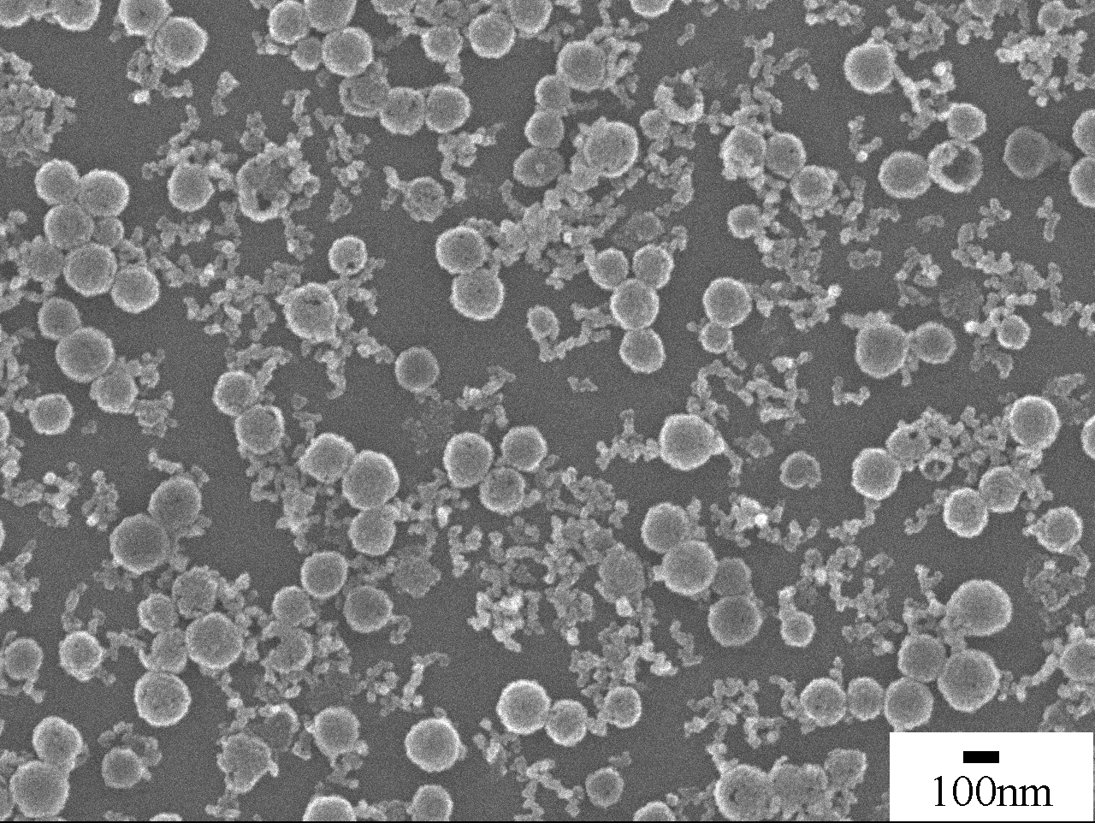

Fig. S2. SEM image of the morphology of GdOF obtained at 150°C for 16 h .

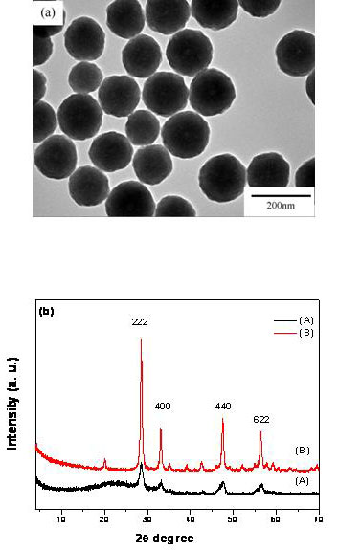

Fig. S3 (a) The TEM image of the product obtained at 150°C for 4 h by using NH₄F as fluorine source, (b) the XRD patterns of the samples of (A) the product obtained by using NH₄F as fluorine source, and (B) the Gd₂O₃.

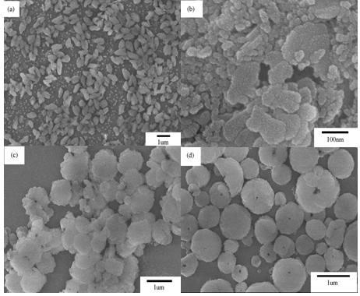

Fig. S4 A series of evolutional SEM images of the as synthesized GdF₃ samples with different amount of HF acid as fluorine source: (a) 20 μL, (b) 40 μL, (c) 60 μL, and (d) 100 μL, and (e) corresponding XRD patterns.

