Structure Replication and Growth Development of Three-Dimensionally Ordered Mesoporous-Imprinted Zeolites during Confined Growth

Huiyong Chen ^{a1 c1}, Pyung-Soo Lee ^{a2 c2}, Xueyi Zhang ^{a3}, Dan Lu ^{a4}
^{a1} School of Chemical Engineering, Northwest University, Xi’an, Shaanxi, People’s Republic of China 710069;
^{a2} Korea Research Institute of Chemical Technology, Research Center for Environmental Resources & processes 141 Gajeongro, Yuseong, DaeJeon 305-600 Korea;
^{a3} Department of Chemical Engineering and Materials Science, University of Minnesota, Minneapolis, Minnesota, USA, 55455;
^{a4} Department of Chemical Engineering and Technology, LiRen College of Yanshan University, Qinhuangdao, Hebei Province, People’s Republic of China, 066004.

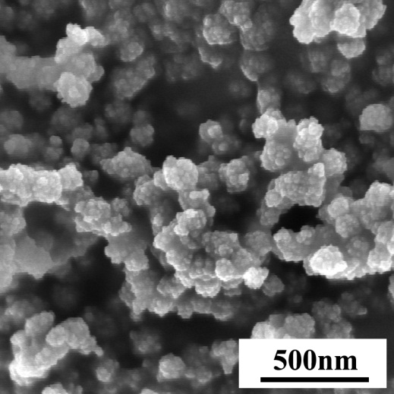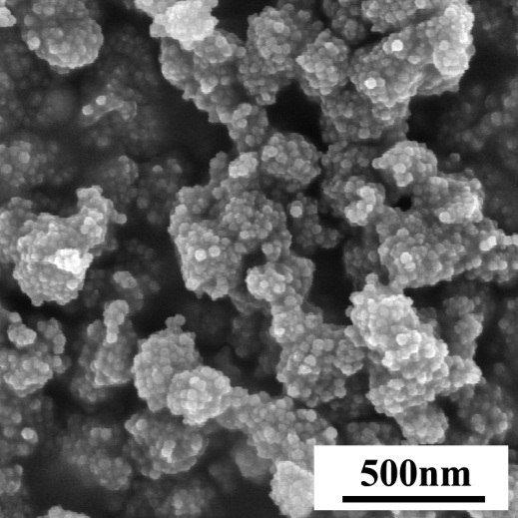
(a) (b)
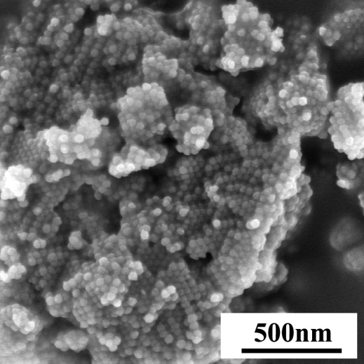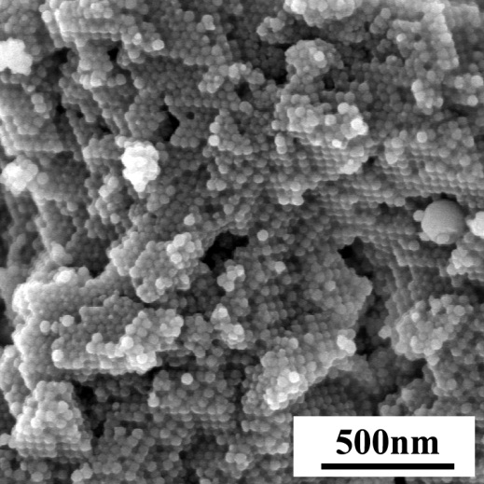
(c) (d)
FIG. S1 SEM images of 35 nm 3DOm-i BEA zeolites after (a) 1st cycle, (b) 2nd cycle, (c) 3rd cycle, (d) 4th cycle.

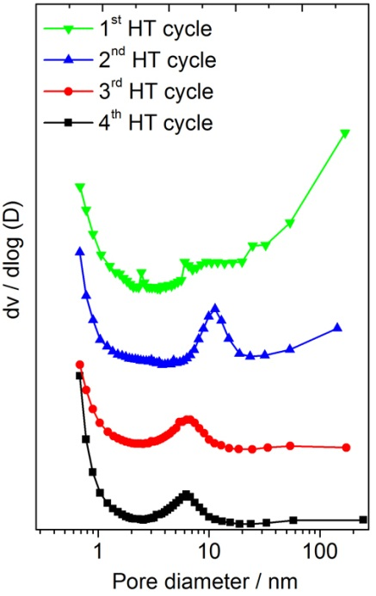
FIG. S2 BJH pore size distributions calculated from the adsorption isotherms of 3DOm-i BEA after every synthesis cycle (The curves are offset vertically for clarity).

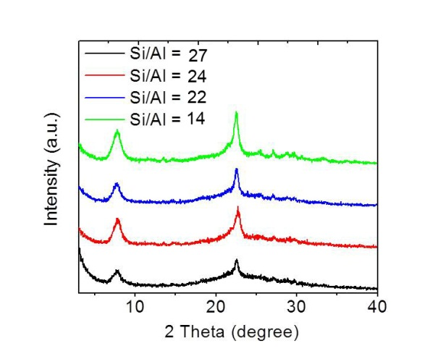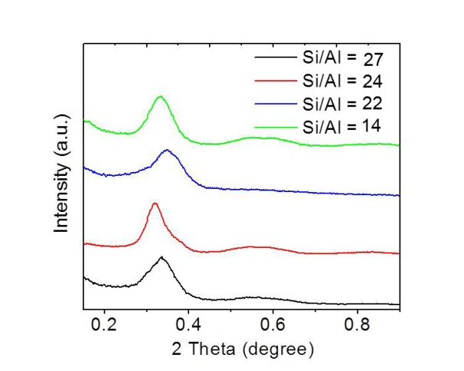
(a) (b)
FIG. S3 (a) Wide-angle, (b) small-angle XRD patterns of the 35 nm 3DOm-i BEA zeolites with various Si/Al ratios (The curves are offset vertically for clarity).
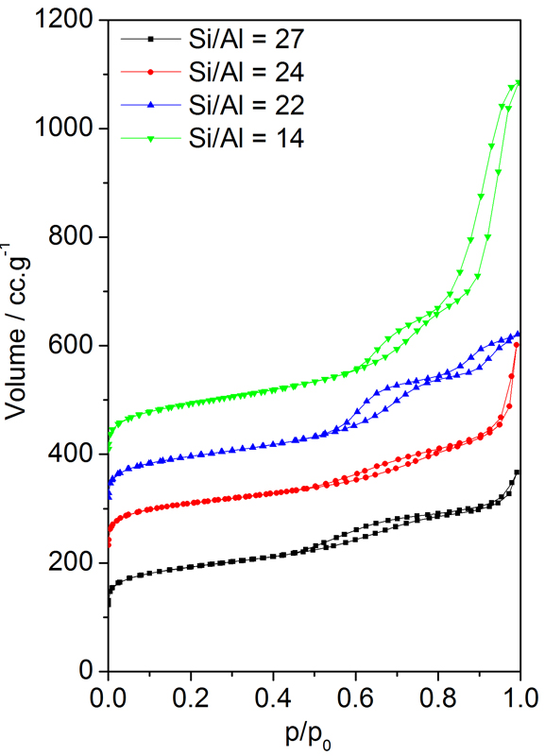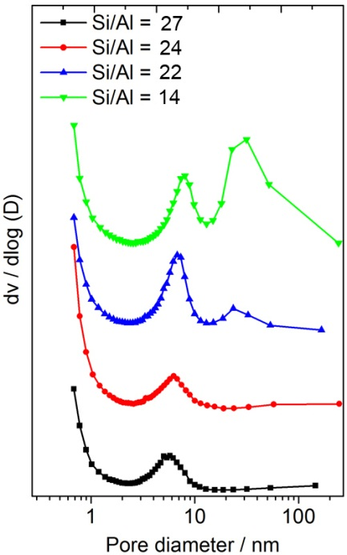
(a) (b)
FIG. S4 (a) Nitrogen adsorption-desorption isotherms and (b) BJH pore size distribution calculated from the adsorption isotherms of 35 nm 3DOm-i BEA zeolites with various Si/Al ratios. The carbon template was removed by calcination before the measurements (The curves are offset vertically for clarity).

TABLE S1 Chemical compositions of the initial synthesis solution and synthesis parameters used to prepare 3DOm-i BEA zeolites with variation of the Si/Al ratio.
Synthesis Temperature  [ºC] | Synthesis Time  of Each Cycle  [hour] | Na₂O | (TEA)₂O | Al₂O₃ | SiO₂ | H₂O | Si/Al  (gel)
115 | 72 | 0.35 | 4.5 | 0.50 | 25 | 330 | 25
100 | 96 | 0.35 | 4.5 | 0.25 | 25 | 330 | 50
115 | 96 | 0.35 | 4.5 | 0.167 | 25 | 330 | 75
115 | 120 | 0.35 | 4.5 | 0.125 | 25 | 330 | 100

TABLE S2 Textural and mesopore analysis of silica colloidal crystals
and the replicated 3DOm-i zeolites.
Materials | Nominal size  [nm] | D_{c-c}  [nm] | V_{T}  [cc.g⁻¹] | D_{(Th)}  [nm] | D_{(Oh)}  [nm] | D_{(Ave)}  [nm] | D_{BJH}  [nm]
silica colloidal crystal | 10 | 14 | 0.21 | 3.1 | 5.8 | 4.5 | 4 ± 1
silica colloidal crystal | 20 | 22 | 0.21 | 4.9 | 9.0 | 7.0 | 5 ± 1
silica colloidal crystal | 35 | 37 | 0.23 | 8.3 | 15.2 | 11.8 | 11 ± 2
3DOm-i BEA | 10 | 12 | 0.72 | 2.7 | 5.0 | 3.8 | 4 ± 2
3DOm-i BEA | 20 | 18 | 0.72 | 4.1 | 7.5 | 5.8 | 5 ± 2
3DOm-i BEA | 35 | 34 | 0.57 | 7.7 | 14.1 | 10.9 | 6 ± 5
3DOm-i MFI by SAC | 10 | 13 | 0.34 | 2.9 | 5.4 | 4.2 | 6 ± 2
3DOm-i MFI by SAC | 20 | 16 | 0.52 | 3.6 | 6.6 | 5.1 | 7 ± 2
3DOm-i MFI by SAC | 35 | 35 | 0.64 | 7.9 | 14.5 | 11.1 | 9 ± 3
3DOm-i MFI by MHT | 35 | 34 | 0.36 | 7.7 | 14.2 | 11.0 | 9 ± 3
D_{c-c} (center-to-center distance), V_{T} (total pore volume), D_{(Th)} (diameter of tetrahedral hole), D_{(Oh)} (diameter of octahedral hole), D_{(Ave)} (average value of D_{(Th)} and D_{(Oh)}), D_{BJH} (average mesopore size by BJH model)

TABLE S3 Textural analysis of 35 nm 3DOm-i BEA zeolites after every HT synthesis cycle
Materials | HT Synthesis Cycle | S_{mic}  m²/g | S_{external}  m²/g | S_{BET}  m²/g | V_{mic}  cm³/g | V_{total}  cm³/g
40 nm 3DOm-i BEA | 1 | 91 | 628 | 719 | 0.05 | 0.73
40 nm 3DOm-i BEA | 2 | 332 | 378 | 720 | 0.18 | 0.77
40 nm 3DOm-i BEA | 3 | 359 | 227 | 586 | 0.20 | 0.48
40 nm 3DOm-i BEA | 4 | 445 | 220 | 665 | 0.25 | 0.55
Conventional BEA¹ | n/a | 472 | 122 | 594 | 0.26 | 0.40
Conventional BEA² | n/a | 347 | 221 | 568 | 0.19 | 0.65
Si (surface area of micropores (i = mic), mesopores (i = exteral) by t-plot method), SBET (Surface area by Brunnauer-Emmet-Teller method), Vmic (micropore volume by t-plot method), VT (total pore volume)
(1) Conventional BEA¹ was prepared from a synthesis solution with a molar composition of 25SiO2: 0.25Al2O3:4.5(TEA)₂O : 0.35Na2O : 330H2O at 100ºC for 4 days.
(2) Conventional BEA² (CP814E) was purchased from Zeolyst Int.

TABLE S4 Textural analysis of 35 nm 3DOm-i BEA zeolites with variation of Si/Al ratio
Material | Si/Al  (gel) | Si/Al  (zeolite) | S_{mic}  [m²/g] | S_{ext}  [m²/g] | S_{BET}  [m²/g] | V_{mic}  [cc/g] | V_{T}  [cc/g]
40nm 3DOm-i BEA | 25 | 14 | 347 | 242 | 589 | 0.19 | 0.48
40nm 3DOm-i BEA | 50 | 22 | 445 | 220 | 665 | 0.25 | 0.55
40nm 3DOm-i BEA | 75 | 24 | 338 | 270 | 608 | 0.18 | 0.61
40nm 3DOm-i BEA | 100 | 27 | 290 | 316 | 606 | 0.16 | 0.96
Conventional BEA¹ | 50 | n/a | 472 | 122 | 594 | 0.26 | 0.40
Conventional BEA² | n/a | 25 | 347 | 221 | 568 | 0.19 | 0.65
Si (surface area of micropores (i = mic), mesopores (i = exteral) by t-plot method), SBET (Surface area by Brunnauer-Emmet-Teller method), Vmic (micropore volume by t-plot method), VT (total pore volume)
(1) Conventional BEA¹ was prepared from a synthesis solution with a molar composition of 25SiO2: 0.25Al2O3:4.5(TEA)₂O : 0.35Na2O : 330H2O at 100ºC for 4 days.
(2) Conventional BEA² (CP814E) was purchased from Zeolyst Int.

