SUPPORTING INFORMATION
Facile synthesis of hydrodynamic solid lubricant MoS₂ from molybdenum trioxide nanorods

M. G. Sibi, B. S. Rana, L. N. Sivakumar Konathala, G. D. Thakre , S. Saran, A. K. Sinha*
CSIR-Indian Institute of Petroleum, Dehradun – 248005, India.
*Corresponding Author. E-mail: asinha@iip.res.in, Fax:+91-135-266-203;Tel:+91-1352525842

S1. TGA analysis of (a) MoO₃, (b) MoS₂, (c) MoS₂ (hard template)
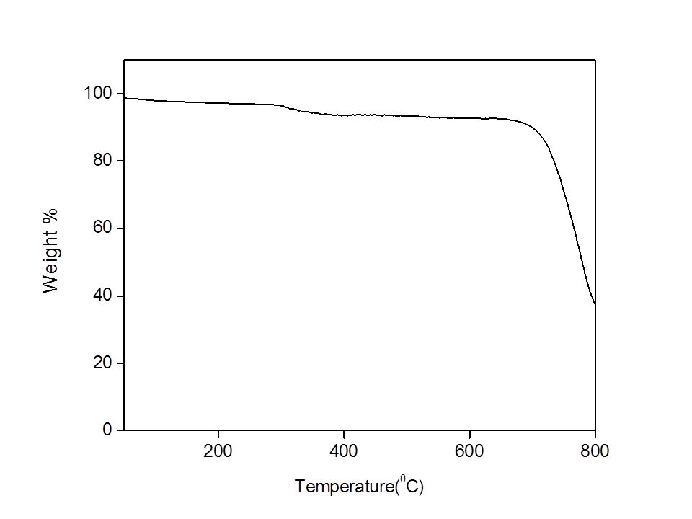
(a)
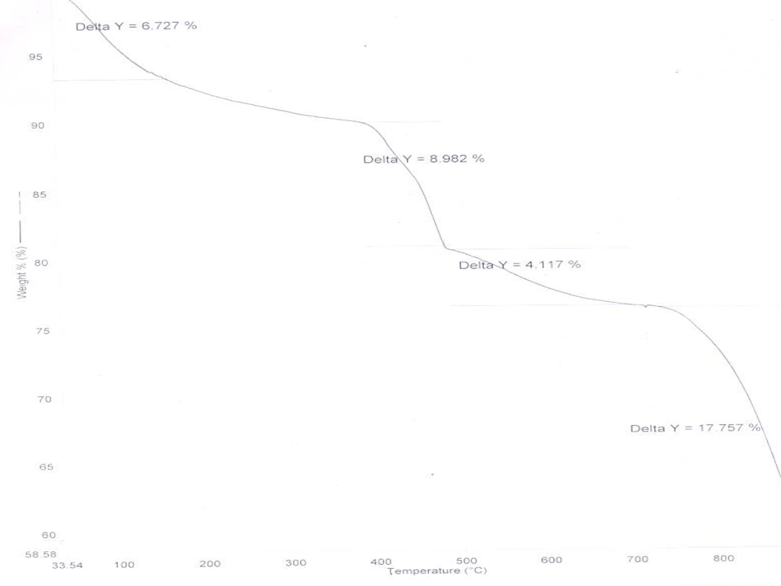
(b)

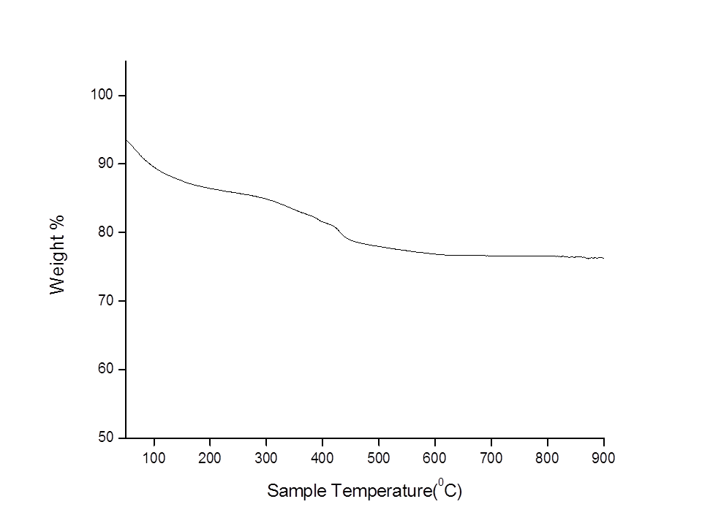
(c)

