An active surface enhanced Raman scattering substrate using carbon nanocoils
Dawei Li, Lujun Pana), Shifa Wu and Shuai Li
School of Physics and Optoelectronic Technology, Dalian University of Technology, No.2 Linggong Road, Ganjingzi District, Dalian 116024, PR China

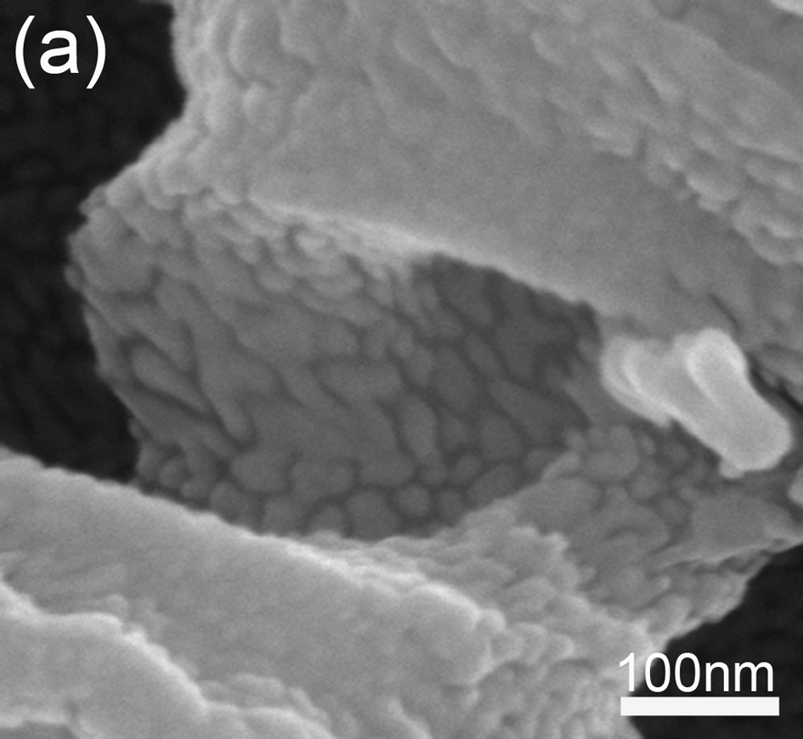
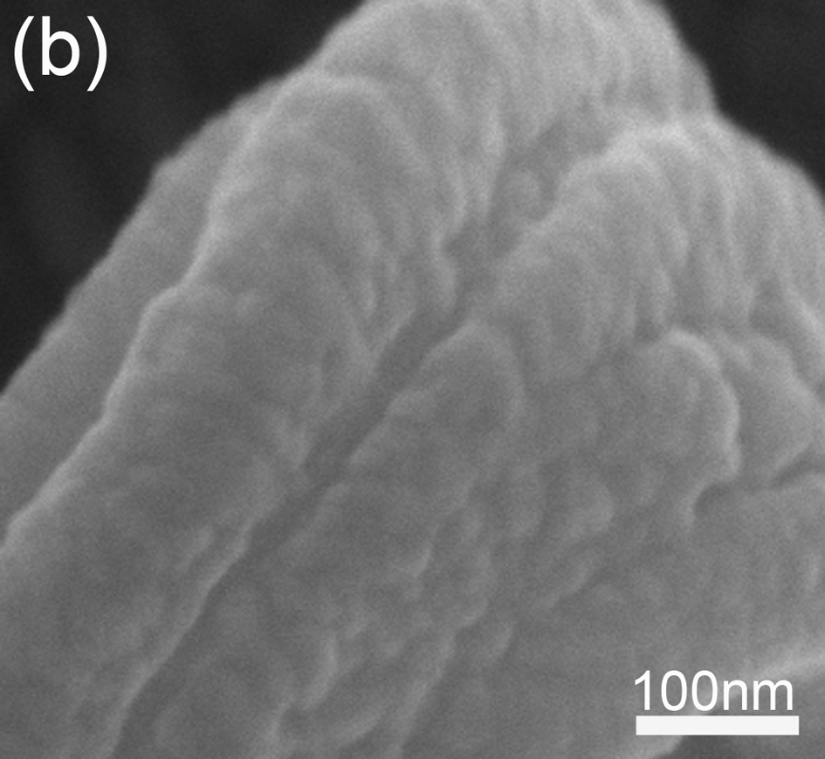
Supplementary Information
FIG. S1. Magnified SEM images of CNCs coated with AgNPs by RFMS for (a) 4 min, (b) 12 min.

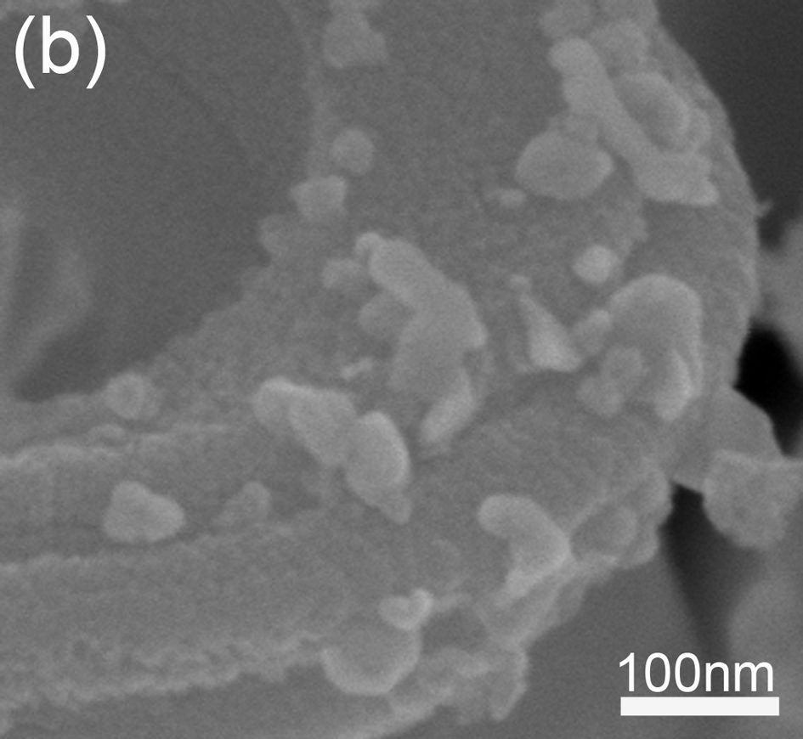
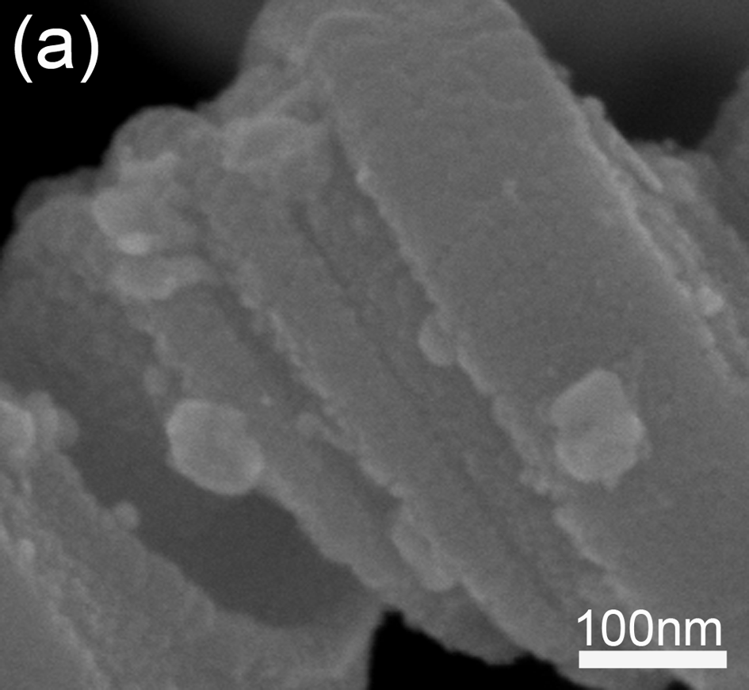
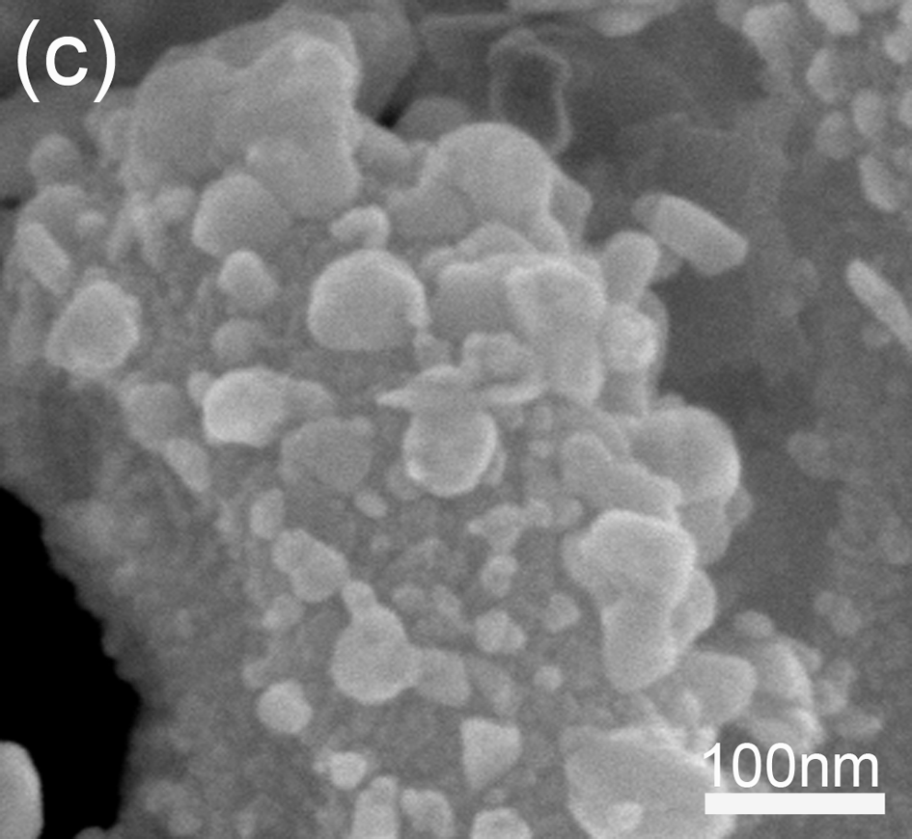
FIG. S2. More magnified SEM images of AgNPs on TiO₂-CNCs substrates, formed in 3 mM AgNO₃ solution with UV light irradiation for 2 h, where TiO₂ is formed by sputtering for (a) 15 min, (b) 60 min, and (c) 150 min.

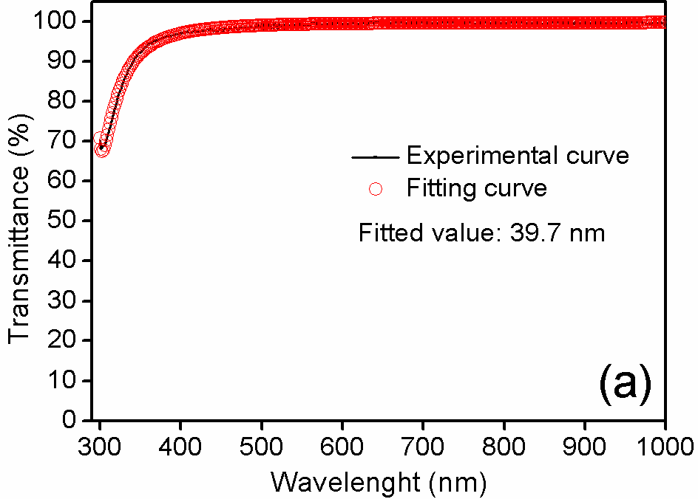
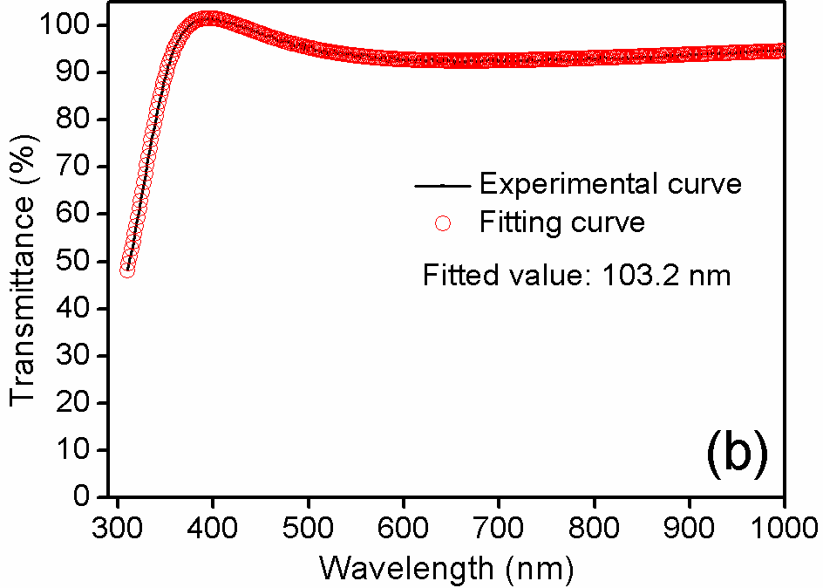
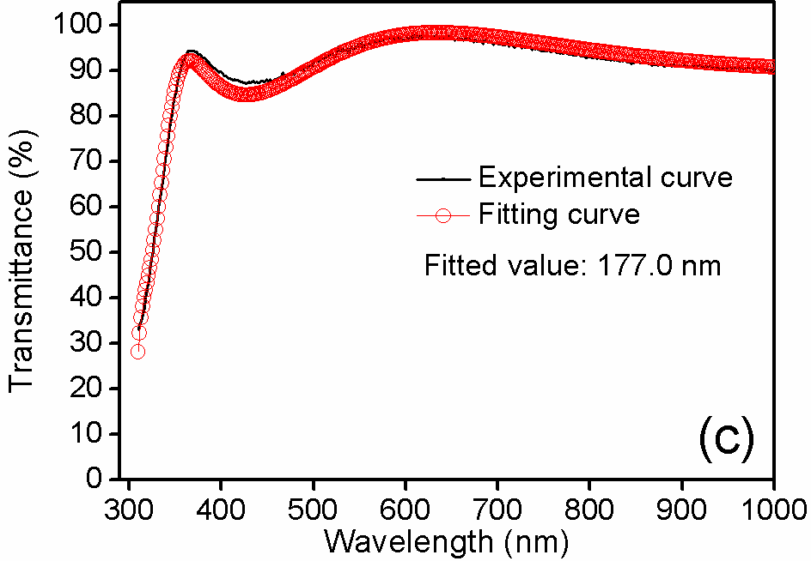
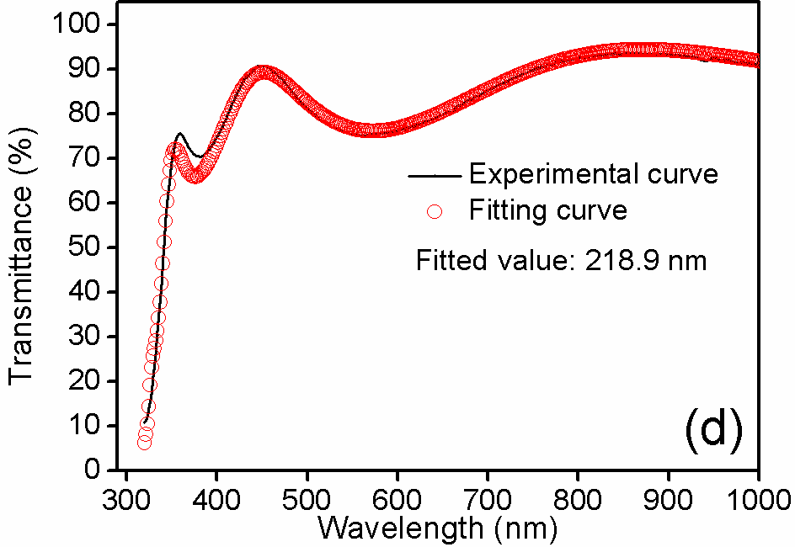
FIG. S3. Optical transmission spectra of TiO₂ film prepared by RFMS for (a) 15 min, (b) 60 min, and (c) 150 min. (d) Optical transmission spectra of calcined TiO₂ film prepared by a spin-coating. The continuous line represents experimental data and the hollow circle line is the corresponding fitting curve by envelop method. The thicknesses of TiO₂ films in Figure S3(a-d) can be measured using the above method, which are calculated to be approximately 40, 103, 177, and 220 nm, respectively.
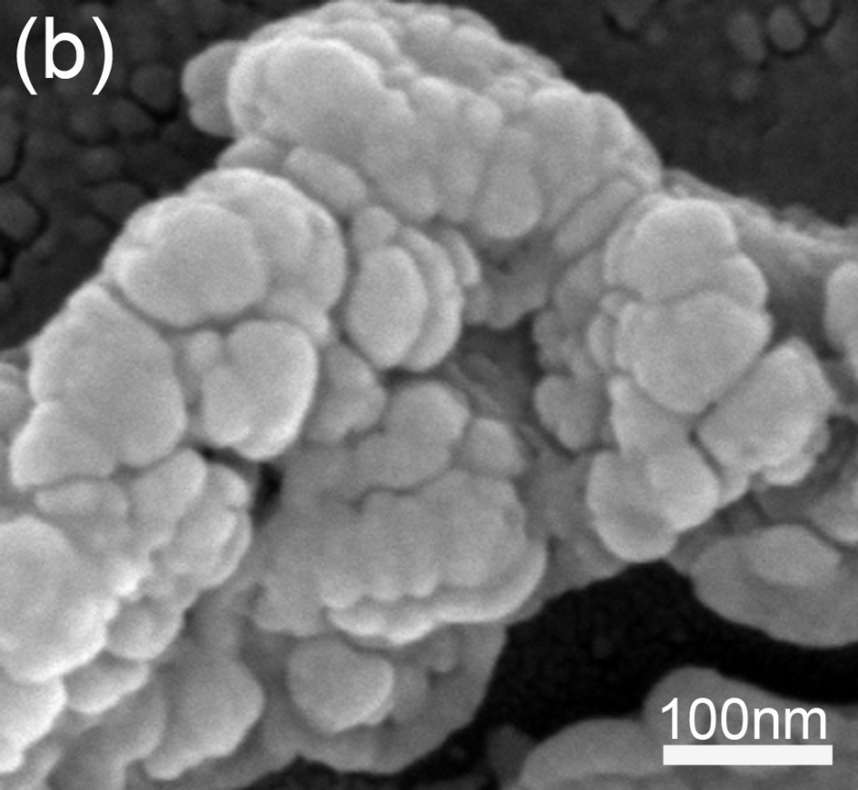
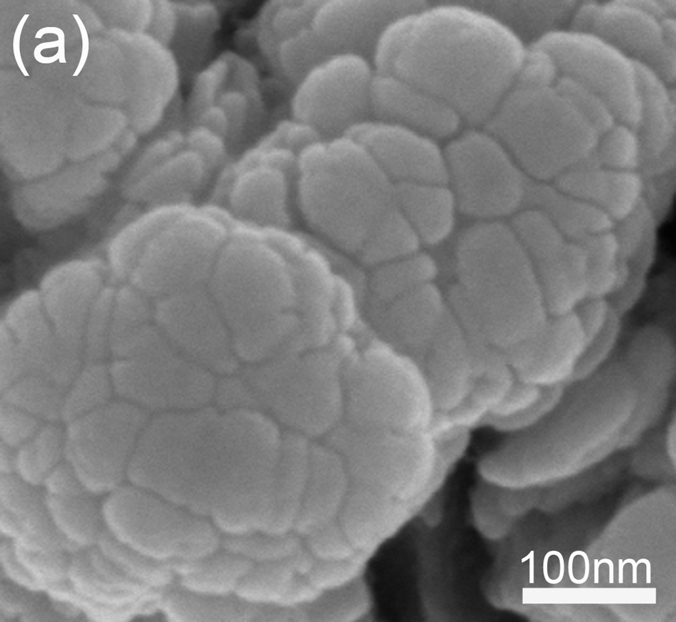
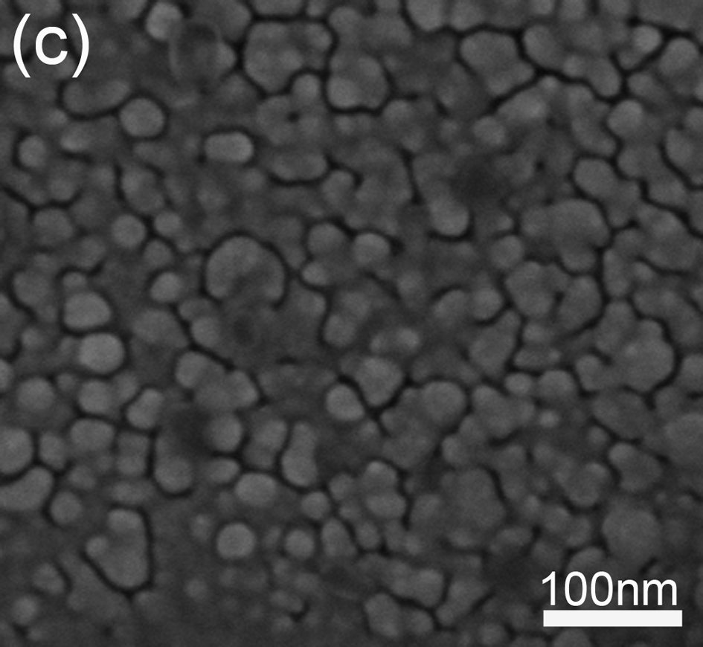
FIG. S4. (a) and (b) More magnified SEM images of single B-nanostructure. (c) Magnified SEM image of AgNPs formed in the planar area without CNCs.

a) Address all correspondence to this author. e-mail: lpan@dlut.edu.cn

